Direct Line: (01536) 534398
Email: anneireson@kettering.gov.uk
Our Ref: AI
Your Ref:
Date: 19th April 2004

Dear Councillor

You are summoned to a meeting of Kettering Borough Council to be held in the Council Chamber, Municipal Offices, Bowling Green Road, Kettering on Wednesday, 28th April 2004 at 7.00 pm.

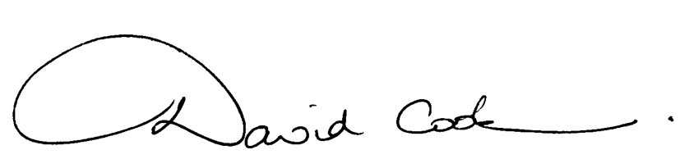Yours faithfully

D Cook
Chief Executive

A G E N D A

1. Apologies.

2. Minutes of the meeting of the Council held on 25th February 2004 to be approved as a correct record and signed by the Mayor.

3. Declarations of Interest.

4. To receive a presentation from Geddington School on the subject of their recent successes as an eco-school.

5. To receive any announcements from the Mayor and/or the Leader of the Council.

6. Report of the Chief Executive.

7. To receive questions from, and provide answers to, the public in relation to matters which have been included on the Agenda.

8. To consider any reports from the Monitoring Officer or Chief Finance Officer:-

- Annual Investment Strategy - 2004/05

9. To receive reports from the Council's Executive and Committees, and receive questions and answers on any of those reports:

- Urgent items approved by the Executive - January to March 2004

10. To consider any motions received in accordance with Council Procedure Rule 16.

11. Any matters of urgency that the Mayor decides should be considered.

16.4.04
Fire Alarm

All meetings shall be adjourned immediately on the sounding of the fare alarm. The alarm is a continuous two-tone siren. On hearing the alarm please leave the building by the nearest emergency exit. There are emergency exits at both ends of the corridor outside the meeting rooms. On leaving the building please cross the car park and assemble on the grassed area by the church. Do not attempt to drive out of the car park as this may impede the arrival of emergency vehicles. Please do not return to the building until you are told it is safe to do so by a Council employee.

Toilets and Baby Changing Facilities

There are toilets and baby changing facilities in the corridor off the main entrance to the building you came through to get to the meeting room. The Council actively supports breastfeeding mothers. If you wish to use a private area please ask a member of staff.

Access for Disabled People

There are allocated parking bays outside the main entrance to the Municipal Offices for disabled people. The meeting rooms are located on the ground floor and access is gained for wheelchair users via the main entrance. If you require assistance, please ask the attendant on duty in the reception area.

No Smoking

Smoking is not permitted in the Municipal Offices.

