 | Direct Line: (01536) 534200  Email: ianwhite@kettering.gov.uk  Our Ref: IW  Your Ref:  Date: 5th December 2007

Dear Councillor

You are summoned to a meeting of Kettering Borough Council to be held in the Council Chamber, Municipal Offices, Bowling Green Road, Kettering on Wednesday, 12th December 2007 at 7.00 pm.

Please note that I am pleased to welcome the Latimer Arts College Choir who will be singing carols prior to the commencement of the formal part of the meeting and, as usual the Mayor has kindly invited all members to a reception in the Parlour after the meeting.

Yours faithfully

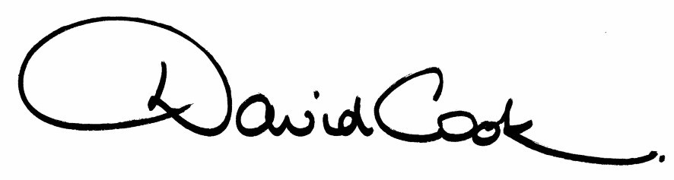

D Cook
Chief Executive

A G E N D A

1. Apologies.

2. Minutes of the meeting of the Council held on 19th September 2007 to be approved as a correct record and signed by the Mayor.

3. Declarations of Interest:
(a) Personal
(b) Prejudicial

4. To receive any announcements from the Mayor and/or the Leader of the Council.

5. Reports of the Chief Executive

6. The Mayor to ask members of the public present if they want to speak on any item on the agenda.

7. Reports

(a) Post Office Closures
(b) East Midlands Trains – Draft December 2008 Timetable
(c) Mayoralty
(d) Adoption of the Statement of Licensing Policy as required by the Licensing Act 2003

8. To receive questions from members.

9. Any matters of urgency that the Mayor decides should be considered.

Fire Alarm

All meetings shall be adjourned immediately on the sounding of the fire alarm. The alarm is a continuous two-tone siren. On hearing the alarm please leave the building by the nearest emergency exit. There are emergency exits at both ends of the corridor outside the meeting rooms. On leaving the building please cross the car park and assemble on the grassed area by the church. Do not attempt to drive out of the car park as this may impede the arrival of emergency vehicles. Please do not return to the building until you are told it is safe to do so by a Council employee.

Toilets

There are toilets in the corridor off the main entrance to the building you came through to get to the meeting room.

Breastfeeding and Baby Changing Facilities

The Council actively supports breastfeeding mothers. If you wish to use a private area please ask a member of staff. There are baby changing facilities in the corridor off the main entrance adjacent to the toilets.

.Access for Disabled People

There are allocated parking bays outside the main entrance to the Municipal Offices for disabled people. The meeting rooms are located on the ground floor and access is gained for wheelchair users via the main entrance. If you require assistance, please ask the attendant on duty in the reception area.

No Smoking

Smoking is not permitted in the Municipal Offices.

