To all Members | Direct Line: (01536) 534398  Email: anneireson@kettering.gov.uk  Our Ref: AI  Your Ref:  Date: 19th June 2007

Dear Councillor

You are summoned to a meeting of Kettering Borough Council to be held in the Municipal Offices, Bowling Green Road, Kettering on Wednesday, 27th June 2007 at 7.00 pm.

From 6.15 pm to 6.45 pm there will be a short training session for Members entitled “Debates and Full Council”. The session will be led by Jonathan Eatough, Head of Democratic and Legal Services.

Yours faithfully

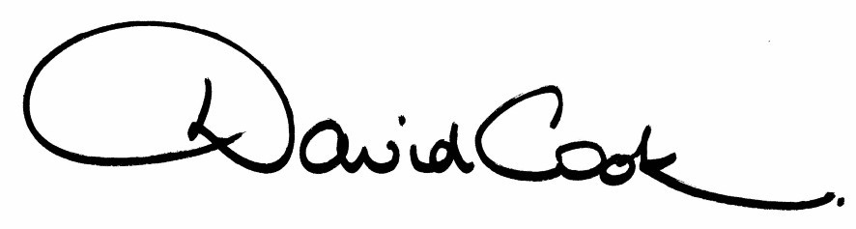

D Cook
Chief Executive

A G E N D A

1. Apologies.

2. Minutes of the Annual Meeting of the Council held on 16th May 2007 to be approved as a correct record and signed by the Mayor

3. Declarations of Interest:
- Personal
- Prejudicial

4. To receive any announcements from the Mayor and/or the Leader of the Council.

5. Report of the Chief Executive.

6. The Mayor to ask members of the public present if they want to speak on any item on the agenda.

7. To receive questions from members.

8. Independent Review Panel – Members’ Allowances (referral from the Executive Committee)

9. Kettering Borough Council Improvement Plan (referral from the Executive Committee)

10. Statement of Accounts 2006/07 (covering report attached, Statement of Accounts to follow)

11. To consider any motions received in accordance with Council Procedure Rule 16.

Proposed by Councillor Cedwien Brown and Seconded by Councillor David Soans:
“This Council welcomes the continuing priority being given to Green issues by the new administration.

We welcome the drive to reduce the Council’s carbon footprint and to encourage residents, businesses and the Council to go further and progress in line with the principles of “one planet living”.

12. Any matters of urgency that the Mayor decides should be considered.

19.6.07
Fire Alarm

All meetings shall be adjourned immediately on the sounding of the fire alarm. The alarm is a continuous two-tone siren. On hearing the alarm please leave the building by the nearest emergency exit. There are emergency exits at both ends of the corridor outside the meeting rooms. On leaving the building please cross the car park and assemble on the grassed area by the church. Do not attempt to drive out of the car park as this may impede the arrival of emergency vehicles. Please do not return to the building until you are told it is safe to do so by a Council employee.

Toilets

There are toilets in the corridor off the main entrance to the building you came through to get to the meeting room.

Breastfeeding and Baby Changing Facilities

The Council actively supports breastfeeding mothers. If you wish to use a private area please ask a member of staff. There are baby changing facilities in the corridor off the main entrance adjacent to the toilets.

.Access for Disabled People

There are allocated parking bays outside the main entrance to the Municipal Offices for disabled people. The meeting rooms are located on the ground floor and access is gained for wheelchair users via the main entrance. If you require assistance, please ask the attendant on duty in the reception area.

No Smoking

Smoking is not permitted in the Municipal Offices.

Private and Confidential Items

The press and members of the public can be excluded from business of the meeting on the grounds that it involves items of business which include the likely disclosure of exempt information as defined by Paragraphs 1-7 of the Local Government (Access to Information) (Variation) Order 2006 in respect of Schedule 12A to the Local Government Act 1972. The reason for discussing the issue in private is indicated on the Order of Business.

