TO ALL MEMBERS | Direct Line: (01536) 534200  Email: anneireson@kettering.gov.uk  Our Ref: AI  Your Ref:  Date: 6th December 2004

REVISED AGENDA

Dear Councillor

You are summoned to a Meeting of Kettering Borough Council to be held at 7.00 pm in the Council Chamber, Municipal Offices, Bowling Green Road, Kettering on Wednesday, 15th December 2004.

Yours faithfully

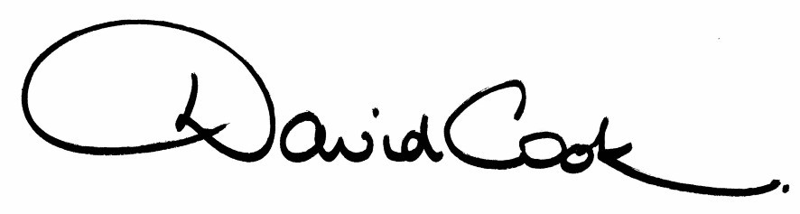

Chief Executive

A G E N D A

1. Apologies.

2. Minutes of the Extraordinary Meeting and Special Debate Meeting held on 24th November 2004 to be approved as a correct record and signed by the Mayor.

3. Declarations of Interest.

4. To receive any announcements from the Mayor and/or the Leader of the Council.

5. Report of the Chief Executive.

6. The Mayor to ask members of the public present if they want to speak on any item on the agenda.

7. To deal with any business from the last Council meeting.

8. To receive any public deputations and petitions
9. To receive any questions from, and provide answers to the public in relation to matters which have been included on the Agenda.

10. To receive questions from members.

11. Council Tax Base 2005/06 (report attached)

12. To receive reports from the Council's Executive and Committees, and receive questions and answers on any of those reports:

NB: The full reports to the Executive Committee meetings held on 17th November 2004 and 8th December 2004 can be viewed on the Council's website at www.kettering.gov.uk

12(i)a Housing Stock Options Appraisal - The Future Ownership and Management of the Council's Housing Stock

Recommendation from the Executive Committee:

"that the Council considers the preferred option now that the Housing Stock Options Appraisal has concluded".

12(i) Review of the Capital Programme

Recommendation from the Executive Committee:

"the reworked capital programme for 2004/05 (as detailed in Appendix 1 of the attached report) be referred to Council for approval"

Appendix 1 of the report is attached to this agenda.

12(ii) Lawrence's Factory and Desborough Motors Sites - Purchase Through Fit for Market Funding

Recommendation from the Executive Committee:

"that it be recommended to full Council that the grant offer from Fit for Market be accepted and the site be purchased subject to officers being satisfied with the risk assessment of the project in consultation with the portfolio holder"

12(iii) Changing the Constitution (report attached)

12(iv) Adoption of the Statement of Licensing Policy as Required by the Licensing Act 2003 (report attached)

13. Decisions of Urgency taken by the Executive Committee during the period July 2004 to November 2004 (report attached).

14. To consider any motions received in accordance with Council Procedure Rule 16.

15. To consider any items of urgent business accepted by the Mayor.
Fire Alarm

All meetings shall be adjourned immediately on the sounding of the fire alarm. The alarm is a continuous two-tone siren. On hearing the alarm please leave the building by the nearest emergency exit. There are emergency exits at both ends of the corridor outside the meeting rooms. On leaving the building please cross the car park and assemble on the grassed area by the church. Do not attempt to drive out of the car park as this may impede the arrival of emergency vehicles. Please do not return to the building until you are told it is safe to do so by a Council employee

Toilets and Baby Changing Facilities

There are toilets and baby changing facilities in the corridor off the main entrance to the building you came through to get to the meeting room. The Council actively supports breastfeeding mothers. If you wish to use a private area please ask a member of staff.

Access for Disabled People

There are allocated parking bays outside the main entrance to the Municipal Offices for disabled people. The meeting rooms are located on the ground floor and access is gained for wheelchair users via the main entrance. If you require assistance, please ask the attendant on duty in the reception area.

No Smoking

Smoking is not permitted in the Municipal Offices.

Private and Confidential Items

The press and members of the public can be excluded from business of the meeting on the grounds that it involves items of business which include the likely disclosure of exempt information as defined by Paragraphs 1-15 of Schedule 12A to the Local Government Act 1972.

