Direct Line: (01536) 534398
Email: anneireson@kettering.gov.uk
Our Ref: AI
Your Ref:
Date: 19th June 2006

Dear Councillor

You are summoned to a meeting of Kettering Borough Council to be held in the Council Chamber, Municipal Offices, Bowling Green Road, Kettering on Wednesday, 28th June 2006 at 7.00 pm.

Yours faithfully

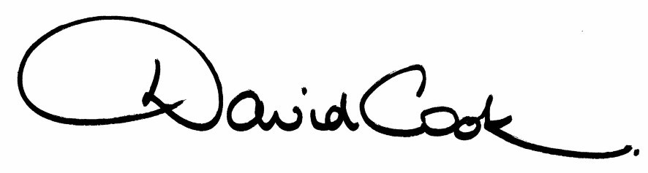

D Cook
Chief Executive

A G E N D A

1. Apologies.

2. Minutes of the meeting of the Council held on 10th May 2006 to be approved as a correct record and signed by the Mayor.

3. Declarations of Interest:
(a) Personal
(b) Prejudicial

4. To receive any announcements from the Mayor and/or the Leader of the Council.

5. Reports of the Chief Executive.

6. The Mayor to ask members of the public present if they want to speak on any item on the agenda.
7. To receive any public deputations and petitions.

Churches Together in Kettering and District:-
Mr David Chappell will address Council on the Motion at Item 8(i) on the agenda regarding Fairtrade

8. To receive reports from the Council's Executive and Committees, and receive questions and answers on any of those reports:-

(i) Fairtrade

recommendations from the Executive Committee:-

"(i) This Council implement a Fair Trade policy which can be used as a promotional tool for Fairtrade matters in the Borough; this to include the establishment of a section on the Council’s website that highlights outlets and organisations that support Fairtrade policies;

(iii) the Council acts as a catalyst for the establishment of a steering group consisting of local organisations and individuals within three months of this resolution being passed, and provides lead support for convening the first meeting of that steering group; and

(iv) the members, officers and those providing evidence to the Task and Finish Group be thanked for the work on this matter.

(ii) Corporate Improvement Plan 2005-2008 (report attached)

9. Statement of Accounts 2005/06 (report to follow)

10. Councillor Development Charter Working Group - Progress (report attached)

11. Local Government and Rating Act 1997 - Review of Boundary between Parished and Non-Parished Areas (report attached)

12. To consider any motions received in accordance with Council Procedure Rule 16:-

1. Councillor Philip Hollobone will propose and Councillor Terry Freer will second:

"that Kettering Borough Council opposes the merger or the Northamptonshire Police Force into an East Midlands Police Service".

2. Councillor Paul Corazzo will propose and Councillor Alex Gordon will second:

"that this Council calls upon Northamptonshire County Council to hold a public meeting in Kettering to consult on the proposed changes to the Eligibility Criteria for Community Care Services.

We note that all the other major Boroughs in the County are to have a public meeting and are dismayed that the people of the Borough of Kettering are to be ignored."

3. Councillor David Whyte will propose and Councillor Paul Corazzo will second:

"'We urge Kettering Borough Council to devise firm plans for it to adopt a green vehicle fleet and green corporate practices."

13. Any matters of urgency that the Mayor decides should be considered.

19.6.06
Fire Alarm

All meetings shall be adjourned immediately on the sounding of the fire alarm. The alarm is a continuous two-tone siren. On hearing the alarm please leave the building by the nearest emergency exit. There are emergency exits at both ends of the corridor outside the meeting rooms. On leaving the building please cross the car park and assemble on the grassed area by the church. Do not attempt to drive out of the car park as this may impede the arrival of emergency vehicles. Please do not return to the building until you are told it is safe to do so by a Council employee.

Toilets and Baby Changing Facilities

There are toilets and baby changing facilities in the corridor off the main entrance to the building you came through to get to the meeting room. The Council actively supports breastfeeding mothers. If you wish to use a private area please ask a member of staff.

Access for Disabled People

There are allocated parking bays outside the main entrance to the Municipal Offices for disabled people. The meeting rooms are located on the ground floor and access is gained for wheelchair users via the main entrance. If you require assistance, please ask the attendant on duty in the reception area.

No Smoking

Smoking is not permitted in the Municipal Offices.

