Direct Line: (01536) 534398
Email: anneireson@kettering.gov.uk
Our Ref: AI
Your Ref:
Date: 13th April 2006

Dear Councillor

You are summoned to a Meeting of Kettering Borough Council to be held at 7.00 pm in the Council Chamber, Municipal Offices, Bowling Green Road, Kettering on Wednesday, 26th April 2006.

Yours faithfully

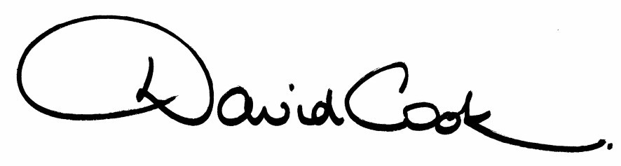

Chief Executive

A G E N D A

1. Apologies.

2. Minutes of the meeting of the Council held on 1st March 2006 to be approved as a correct record and signed by the Mayor

3. Declarations of Interest:
Personal
Prejudicial

4. To receive any announcements from the Mayor or the Leader of the Council.

5. Report of the Chief Executive.

6. The Mayor to ask members of the public present if they want to speak on any item on the agenda.

7. To receive questions from members of the public:

- Mawsley Allotments - question from the Chair of the Mawsley Allotment Association (attached).

8. To receive questions from members.

9. To receive reports from the Council's Executive and Committees, and receive questions and answers on any of those reports:

- Urgent Items Approved by the Executive - September 2005 to March 2006

10. Any matters of urgency that the Mayor decides should be considered.

13.4.06
Fire Alarm

All meetings shall be adjourned immediately on the sounding of the fare alarm. The alarm is a continuous two-tone siren. On hearing the alarm please leave the building by the nearest emergency exit. There are emergency exits at both ends of the corridor outside the meeting rooms. On leaving the building please cross the car park and assemble on the grassed area by the church. Do not attempt to drive out of the car park as this may impede the arrival of emergency vehicles. Please do not return to the building until you are told it is safe to do so by a Council employee.

Toilets and Baby Changing Facilities

There are toilets and baby changing facilities in the corridor off the main entrance to the building you came through to get to the meeting room. The Council actively supports breastfeeding mothers. If you wish to use a private area please ask a member of staff.

Access for Disabled People

There are allocated parking bays outside the main entrance to the Municipal Offices for disabled people. The meeting rooms are located on the ground floor and access is gained for wheelchair users via the main entrance. If you require assistance, please ask the attendant on duty in the reception area.

No Smoking

Smoking is not permitted in the Municipal Offices.

