TO ALL MEMBERS | Direct Line: (01536) 534200  Email: anneireson@kettering.gov.uk  Our Ref: AI  Your Ref:  Date: 5th December 2005

Dear Councillor

You are summoned to a Meeting of Kettering Borough Council to be held at 7.00 pm in the Council Chamber, Municipal Offices, Bowling Green Road, Kettering on Wednesday, 14th December 2005.

Yours faithfully

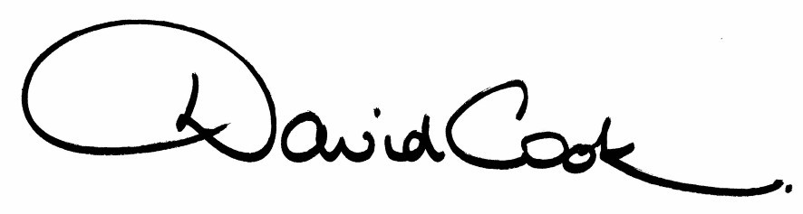

Chief Executive

NB: Following the meeting the Mayor invites all members to the Parlour for refreshments

A G E N D A

1. Apologies.

2. Minutes of the meeting held on 19th October 2005 to be approved as a correct record and signed by the Mayor.

3. Declarations of Interest.

4. To receive any announcements from the Mayor and/or the Leader of the Council.

5. Report of the Chief Executive.

6. The Mayor to ask members of the public present if they want to speak on any item on the agenda.

7. To deal with any business from the last Council meeting.

8. To receive any public deputations and petitions

9. To receive any questions from, and provide answers to the public in relation to matters which have been included on the Agenda.

10. To receive questions from members.

11. To receive reports from the Council's Executive and Committees, and receive questions and answers on any of those reports:

(i) Local Development Scheme

(ii) Councillor Development Charter

12. To consider any motions received in accordance with Council Procedure Rule 16:

(i) Proposed by Councillor Whyte and Seconded by Councillor Tod

"That this Council adopt:

- A 40% affordable housing target from all new developments of over 20 units in Kettering and the A6 Towns
- A 20% affordable housing target from all new developments of over 5 units in the villages"

(ii) Proposed by Councillor Adams and Seconded by Councillor Gordon

"At this late hour we urge the Conservative administration to:

- Avoid damaging the life chances of thousands of local people by its spiteful withdrawal of funding and its planned Christmas day eviction of KCU from Station Road
- and renew KCU lease and reinstate its funding"

(iii) Proposed by Councillor Scrimshaw and Seconded by Councillor King

"This Council asks Councillor Freer to apologise to the children of the Borough for depriving them of a Father Christmas and his Grotto in Kettering town centre this year"

13. To consider any items of urgent business accepted by the Mayor.
Fire Alarm

All meetings shall be adjourned immediately on the sounding of the fire alarm. The alarm is a continuous two-tone siren. On hearing the alarm please leave the building by the nearest emergency exit. There are emergency exits at both ends of the corridor outside the meeting rooms. On leaving the building please cross the car park and assemble on the grassed area by the church. Do not attempt to drive out of the car park as this may impede the arrival of emergency vehicles. Please do not return to the building until you are told it is safe to do so by a Council employee

Toilets and Baby Changing Facilities

There are toilets and baby changing facilities in the corridor off the main entrance to the building you came through to get to the meeting room. The Council actively supports breastfeeding mothers. If you wish to use a private area please ask a member of staff.

Access for Disabled People

There are allocated parking bays outside the main entrance to the Municipal Offices for disabled people. The meeting rooms are located on the ground floor and access is gained for wheelchair users via the main entrance. If you require assistance, please ask the attendant on duty in the reception area.

No Smoking

Smoking is not permitted in the Municipal Offices.

Private and Confidential Items

The press and members of the public can be excluded from business of the meeting on the grounds that it involves items of business which include the likely disclosure of exempt information as defined by Paragraphs 1-15 of Schedule 12A to the Local Government Act 1972.

