Direct Line: (01536) 534398
Email: anneireson@kettering.gov.uk
Our Ref: AI
Your Ref:
Date: 10th October 2005

Dear Councillor

You are summoned to a meeting of Kettering Borough Council to be held in the Council Chamber, Municipal Offices, Bowling Green Road, Kettering on Wednesday, 19th October 2005 at 7.00 pm.

Yours faithfully

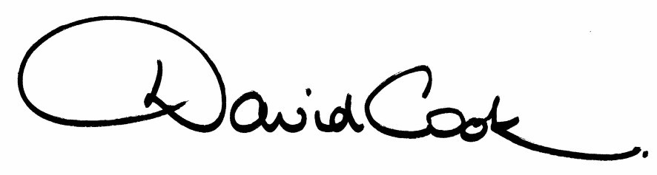

D Cook
Chief Executive

A G E N D A

1. Apologies.

2. Minutes of the meeting of the Council held on 27th July 2005 to be approved as a correct record and signed by the Mayor.

3. Declarations of Interest:
(a) Personal
(b) Prejudicial

4. To receive any announcements from the Mayor and/or the Leader of the Council.

5. Reports of the Chief Executive.

6. To receive questions from, and provide answers to, the public in relation to matters which have been included on the agenda

- Mr Gaziano (questions attached)

7. To receive questions from members

8. The Mayor to ask members of the public present if they want to speak on any item on the agenda.

9. Local Area Agreements (presentation jointly with the County Council on Local Area Agreements and their impact on the Borough)

10. To receive reports from the Council's Executive and Committees, and receive questions and answers on any of those reports:-

(i) Capital Strategy (report attached)

(ii) Asset Management Plan (report attached)
(Asset Management Plan to follow)

(iii) Statement of Accounts 2004/05 - Update/Amendments
(report to follow)

11. To consider any motions received in accordance with Council Procedure Rule 16:-

Motion No. 1

Councillor Whyte will propose and Councillor Corazzo will second:-

"That this Council give an assurance that it will seek, and consider seriously, a town-centre solution to its office problems, rather than committing itself to a move to an edge-of-town business park."

Motion No. 2

Councillor C Groome will propose and Councillor R Groome will second:-

"That mindful that many millions of Chinese, Koreans and other nationalities died at the hands of the Japanese in the Second World War and that many peoples have more recently been the victims of genocide, for example in the former Yugoslavia, Ruanda and Sudan, this Council resolves to celebrate a more inclusive Genocide Day in 2006 rather than the currently designated and more limited Holocaust Day."

12. Any matters of urgency that the Mayor decides should be considered.

Fire Alarm

All meetings shall be adjourned immediately on the sounding of the fire alarm. The alarm is a continuous two-tone siren. On hearing the alarm please leave the building by the nearest emergency exit. There are emergency exits at both ends of the corridor outside the meeting rooms. On leaving the building please cross the car park and assemble on the grassed area by the church. Do not attempt to drive out of the car park as this may impede the arrival of emergency vehicles. Please do not return to the building until you are told it is safe to do so by a Council employee.

Toilets and Baby Changing Facilities

There are toilets and baby changing facilities in the corridor off the main entrance to the building you came through to get to the meeting room. The Council actively supports breastfeeding mothers. If you wish to use a private area please ask a member of staff.

Access for Disabled People

There are allocated parking bays outside the main entrance to the Municipal Offices for disabled people. The meeting rooms are located on the ground floor and access is gained for wheelchair users via the main entrance. If you require assistance, please ask the attendant on duty in the reception area.

No Smoking

Smoking is not permitted in the Municipal Offices.

