Direct Line: (01536) 534398
Email: anneireson@kettering.gov.uk
Our Ref: AI
Your Ref:
Date: 19th July 2005

Dear Councillor

You are summoned to a meeting of Kettering Borough Council to be held in the Council Chamber, Municipal Offices, Bowling Green Road, Kettering on Wednesday, 27th July 2005 at 6.30 pm.

Yours faithfully

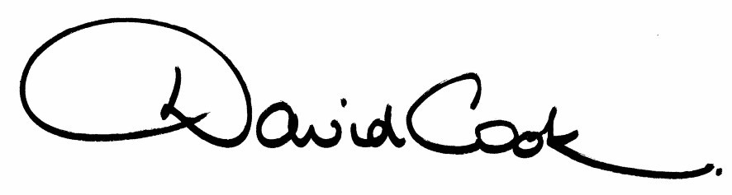

D Cook
Chief Executive

A G E N D A

1. Apologies.

2. Minutes of the meeting of the Council held on 29th June 2005 to be approved as a correct record and signed by the Mayor.

3. Declarations of Interest:
(a) Personal
(b) Prejudicial

4. To receive any announcements from the Mayor and/or the Leader of the Council.

5. Reports of the Chief Executive.

6. Declaration of Acceptance of Office - Deputy Mayor

7. To receive questions from, and provide answers to, the public in relation to matters which have been included on the agenda

8. To receive questions from members

9. The Mayor to ask members of the public present if they want to speak on any item on the agenda.

10. To receive reports from the Council's Executive and Committees, and receive questions and answers on any of those reports:-

(i) Further Electoral Review - Response to Boundary Committee for England Recommendations

(ii) Statement of Accounts

11. To consider any motions received in accordance with Council Procedure Rule 16:-

Councillor Linda Adams will propose and Councillor John Padwick will second:-

"In light of the recent success of Live 8 and the G8 decision on debt cancellation, aid and fair trade for many African countries, it is now time for this Council to implement a Fair Trade policy"

12. Any matters of urgency that the Mayor decides should be considered.

19.7.05
Fire Alarm

All meetings shall be adjourned immediately on the sounding of the fire alarm. The alarm is a continuous two-tone siren. On hearing the alarm please leave the building by the nearest emergency exit. There are emergency exits at both ends of the corridor outside the meeting rooms. On leaving the building please cross the car park and assemble on the grassed area by the church. Do not attempt to drive out of the car park as this may impede the arrival of emergency vehicles. Please do not return to the building until you are told it is safe to do so by a Council employee.

Toilets and Baby Changing Facilities

There are toilets and baby changing facilities in the corridor off the main entrance to the building you came through to get to the meeting room. The Council actively supports breastfeeding mothers. If you wish to use a private area please ask a member of staff.

Access for Disabled People

There are allocated parking bays outside the main entrance to the Municipal Offices for disabled people. The meeting rooms are located on the ground floor and access is gained for wheelchair users via the main entrance. If you require assistance, please ask the attendant on duty in the reception area.

No Smoking

Smoking is not permitted in the Municipal Offices.

