Direct Line: (01536) 534398
Email: anneireson@kettering.gov.uk
Our Ref: AI
Your Ref:
Date: 17th February 2005

Dear Councillor

You are summoned to a meeting of Kettering Borough Council to be held in the Council Chamber, Municipal Offices, Bowling Green Road, Kettering on Monday, 28th February 2005 at 7.00 pm.

Yours faithfully

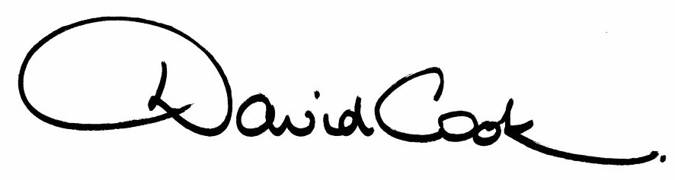

D Cook
Chief Executive

A G E N D A

1. Apologies.

2. Minutes of the meeting of the Council held on 15th December 2004 to be approved as a correct record and signed by the Mayor

3. Minutes of the Budget Consultation Meeting held on 20th January 2005 to be approved as a correct record.

4. Declarations of Interest.

5. To receive any announcements from the Mayor or the Leader of the Council.

6. Report of the Chief Executive.

7. The Mayor to ask members of the public present if they want to speak on any item on the agenda.

8. To receive any public deputations and petitions

9. To receive any questions from, and provide answers to, the public in relation to matters which have been included on the Agenda.

10. To receive questions from members

11. Nomination of Deputy Mayor

12. To receive reports from the Council's Executive and Committees, and receive questions and answers on any of those reports:

(i) Budget Proposals 2005/06 - General Fund, Capital Programme and Housing Revenue Account (report to follow)

(ii) Draft Local Development Scheme (report attached)

(iii) Office of the Deputy Prime Minister (ODPM) Growth Area Funding (report attached)

(iv) Work Programme for Scrutiny (report attached)

(v) Appointment of Independent Member to Standards Committee (report attached)

13. To consider any motions received in accordance with Council Procedure Rule 16.

Councillor C Groome will propose and Councillor R Groome will second:-

"that this Council hails the success of Mawsley as a new community and is delighted that it was nominated for a national award. It congratulates all those who have been involved in its development and notes the lessons for planning future sustainable communities"

14. Any matters of urgency that the Mayor decides should be considered.

17.02.05
Fire Alarm

All meetings shall be adjourned immediately on the sounding of the fare alarm. The alarm is a continuous two-tone siren. On hearing the alarm please leave the building by the nearest emergency exit. There are emergency exits at both ends of the corridor outside the meeting rooms. On leaving the building please cross the car park and assemble on the grassed area by the church. Do not attempt to drive out of the car park as this may impede the arrival of emergency vehicles. Please do not return to the building until you are told it is safe to do so by a Council employee.

Toilets and Baby Changing Facilities

There are toilets and baby changing facilities in the corridor off the main entrance to the building you came through to get to the meeting room. The Council actively supports breastfeeding mothers. If you wish to use a private area please ask a member of staff.

Access for Disabled People

There are allocated parking bays outside the main entrance to the Municipal Offices for disabled people. The meeting rooms are located on the ground floor and access is gained for wheelchair users via the main entrance. If you require assistance, please ask the attendant on duty in the reception area.

No Smoking

Smoking is not permitted in the Municipal Offices.

