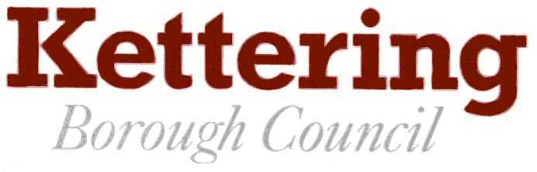

Programme of Meetings (Draft)

1st May 2016 to 31st May 2017

MEETING | VENUE | MAY | JUN | JUL | AUG | SEPT | OCT | NOV | DEC | JAN | FEB | MAR | APR | MAY
Annual Council | Offices | 18th |  |  |  |  |  |  |  |  |  |  |  | 17th
Council | Offices |  | 29th | 20th |  | 28th |  |  | 14th |  | 22nd | 1st | 26th
Budget Consultation | Offices |  |  |  |  |  |  |  |  | 26th
Executive | Offices | 25th | 15th | 13th |  | 21st | 19th | 16th | 7th | 18th | 15th | 15th | 12th | 24th
Standards Advisory | Offices |  |  | 5th |  |  |  |  |  |  | 27th
Monitoring & Audit | Offices |  | 14th |  |  | 22nd |  | 22nd |  |  | 8th |  | 6th
Research & Dev. | Offices |  | 7th |  |  | 27th |  |  | 6th |  | 7th |  | 4th
Planning Committee | Offices | 17th | 28th | 19th | 16th | 6th | 4th | 8th | 13th | 17th | 14th | 14th | 11th | 30th
Planning Policy Cttee | Offices |  | 8th 30th |  |  | 1st |  | 1st |  | 24th |  | 7th
Joint Planning Cttee | Various |  |  | 14th
Joint Delivery Cttee | Various |  |  |  |  |  | 20th |  |  | 31st |  |  | 13th
Employment Cttee | Offices |  |  | 28th |  |  | 13th |  |  | 26th |  |  | 13th
Joint Cons. Forum | Offices |  |  | 14th |  | 29th |  |  |  | 12th |  | 30th
A6 Towns Forum | Offices |  |  | 27th |  | 14th |  | 30th |  |  | 1st
Rural Forum | Various |  |  | 28th |  | 15th |  |  | 1st |  | 2nd
Kettering Town Forum | Offices |  |  | 25th |  | 12th |  | 28th |  | 30th
East Kettering Liaison | Offices |  |  | 12th |  |  | 6th |  |  | 19th |  | 30th
LSP Executive Board | Offices |  |  | 15th
Tenants’ Forum | Offices |  | 9th | 14th |  | 8th | 13th | 10th | 8th | 12th | 9th | 9th | 13th
Member Dev. Group | Offices |  |  | 6th | 31st |  | 19th |  | 7th |  | 8th | 29th
Members Info Session | Offices |  | 6th | 4th |  |  | 3rd | 7th |  | 23rd | 6th | 6th | 3rd
ELECTIONS/  REFERENDUM |  | 5th | 23rd |  |  |  |  |  |  |  |  |  |  | 4th

NB: Meetings of the Licensing Committee and Licensing Sub-Committee will be convened as required.

IF YOU REQUIRE A LARGE PRINT COPY OF THIS DOCUMENT PLEASE CONTACT
DEMOCRATIC SERVICES ON 534191

