- PURPOSE OF REPORT

- To inform the Committee of what to expect from Kettfest 2016
- To provide an update on the completion of junction improvement on Northampton Road
- To set out work underway to assist businesses in marketing the town centre

2 BACKGROUND INFORMATION

2.1 Kettering Borough lies within the South East Midlands, which is predominately a growth area, and is expected to facilitate growth of some 13,100 homes and 16,200 new jobs by 2021.

2.2 Members have made their priorities for infrastructure and jobs-led growth clear – these are the prerequisites of growth. Members have indicated they wish to use the growth agenda to leverage three key and interrelated ambitions for the borough; namely:-

- A better offer for our town centres
- A better education and training offer
- A better employment offer – high grade, higher density jobs

  - The mutually supportive role of these three aspirations cannot be over-stated. The town centres and the skills base will be persuasive to inward investors. Similarly, high grade employment supports vibrant town centres.

  - The Council has a vision to create town centres that are Characterful, Distinctive, and Fun. This vision has been externally validated by an independent planning inspector, and now sits firmly within our planning policy for Kettering Town Centre.

- KETTFEST 2016

  - Last year saw the inaugural Kettfest take place around Kettering- bringing a whole host of quirky, fun and local ideas together in a weekend of entertainment. This year will see the event return, over the weekend of 1st-3rd July, with a bumper pack of festivities.

  - The organisers of the event invite everyone to take part – and you can do so by visiting the website (www.kettfest.org) or via info@kettfest.org. Venues include Kino Lounge, the Prince of Wales, The yards, the Library, The peacock, Rocket Records, Keystone, Kettering Art’s Centre, Mangiamo’s Green Patch, Fuller Church and many more. Parking is free within Council Car Parks over the weekend – so please do venture into the town and find out what’s going on.

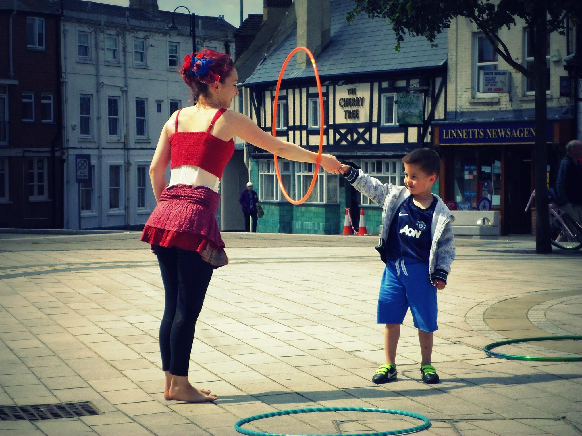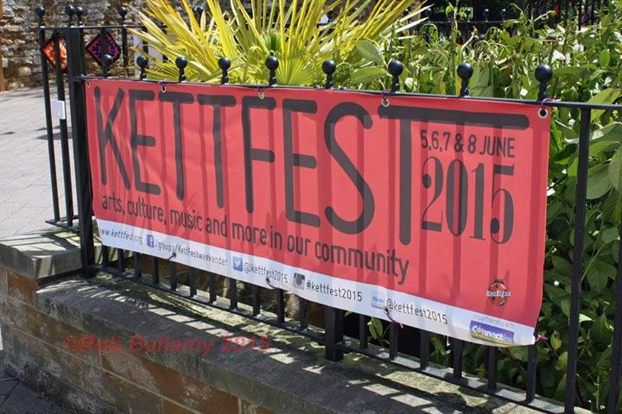
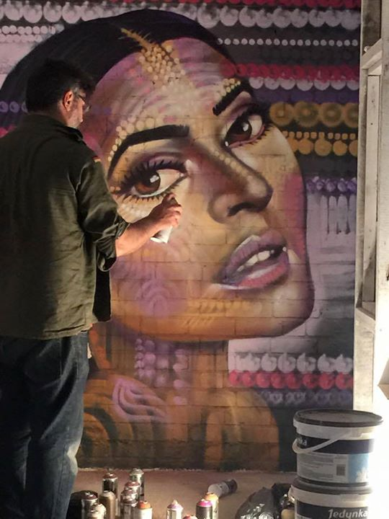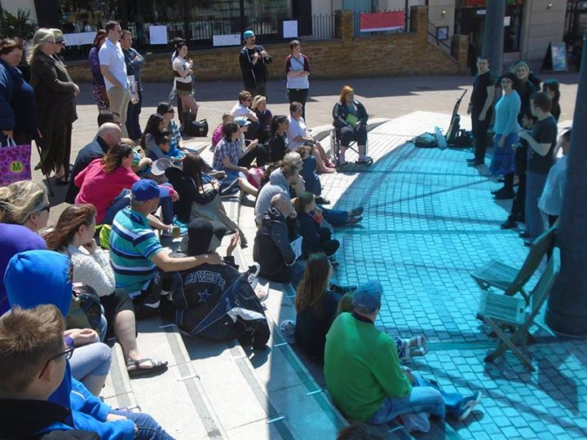

  - Last year was a fantastic example of the creativity, fun and character of Kettering – and a wonderful way to spend the weekend for all the family. I’m sure this year will prove to be even better. KBC has played a supportive role in the event, as we did last year – offering advice and guidance on a variety of issues faced by those organising it.

- JUNCTION IMPROVEMENTS

  - The works to improve the junction at Northampton Road/Sheep Street/Station Road/Bowling Green Road/Headlands have entered their final stage, with a review process now under way. We have an opportunity to feed into that with comments and suggestions – and will be doing so in relation to a few specific areas.

  - The project largely focussed on two things – improving traffic flow through the set of junctions and improving pedestrian access from the station area to the town centre. Initial feedback suggests that these aims have been met – particularly in relation to the improved traffic flow.

  - During the course of the works we have sought to assist businesses and the public to understand the delivery programme and its ramifications, and will continue to do so with regards to feeding back during the review process. Anyone with questions about the scheme can contact Northamptonshire Highways directly via their website, or come through to Kettering Borough Council.

  - As discussed at previous meetings of the Executive Committee, this project formed part of a wider Transport Strategy for Kettering Town Centre. The schemes within that strategy are largely paid for through contributions from developers – such as the recent works, the double roundabout at Northampton Road/Northfield Avenue, and the works to Rothwell Road roundabout. It is likely that this source of funding will remain key, though we are also working closely with Northamptonshire Highways to understand whether any additional sources of funding might be tapped into, so as to bring forward the delivery of other key projects.

  - In terms of what other key projects are being looked at: initial scoping work is underway on potential improvements to Eskdail Street.; and the London Road/St Marys Road/Bowling Green Road area is also under review – though this will work will begin in earnest once the full impact of the recent works further down Bowling Green Road have been mapped. Further updates on any of the schemes covered by the Strategy will be subject to future reports to the Executive Committee.

- KETTERING CULTURAL QUARTER

  - Last month’s report included a discussion on wayfinder signage proposed around the town centre – the sort of monolith signage that incorporates maps and walking routes; which would aid pedestrians to get to known destinations and uncover exciting unknown areas. As set out within that report we have begun to engage local businesses, and through this a proposal has emerged from the developer of The Yards to create a more defined sense of place in the area of the town centre centred on the Market Place.
  - The proposal would incorporate The Yards, Market Street, Market Place and Sheep Street (including the library, museum and gallery), and would be called Kettering’s Cultural Quarter.
  - The adopted Town Centre Area Action Plan sets out a number of quarters, which give us the ability to focus different types of development in different areas – recognising the different qualities they have. It is worth noting that the proposed Cultural Quarter overlaps a number of these – but would not impact upon how we use the AAP. Its purpose is largely focussed on promotional activity – securing increased visitor numbers by bringing together a selection of attractions into an easily defined locality – whereas the AAP gives colleagues in Development Services the ability to influence how the town centre develops over the years.
  - The proposals come from the private sector, but it is essential that there is widespread support for them from all those affected. As such we will be visiting businesses in the area to discuss how they feel it might impact upon them. Alongside this we have agreed to undertake some design work so as to be able to present some ideas of what the marketing material might look like. The businesses would then be able to use the material in their own marketing activity, thus spreading the word about Kettering town centre. Alongside this we continue to work with businesses within the rest of the town centre on ways to improve footfall and generate increased interest in the town centre. The Business in the Community Group, which has been the subject of previous updates to the Committee, meets regularly and we are able to feed into it with regards to planned events and other activity.
  - A future report to Executive will include the draft designs, as well as a commentary on the feedback received from key stakeholders.

- IMPACT ON POLICY

  - Members have made their priorities for infrastructure and jobs-led growth clear – these are the prerequisites of growth. Members have indicated they wish to use the growth agenda to leverage three key and interrelated ambitions for the borough; namely:-

- A better offer for our town centres
- A better education and training offer
- A better employment offer – high grade, higher density jobs

6 RECOMMENDATION

That the Executive Committee:

- Notes the update on Kettfest 2016 and looks forward to the event
- Welcomes the completion of junction improvement on Northampton Road and notes work underway on future projects
- To set out work underway to assist businesses in marketing the town centre

