Site Specific Part 2 Local Plan

Historically and Visually Important Local Green Space Background Paper
Summary of Landowner and Town/ Parish Council Consultation and Site Assessment Update
June 2016

SECTION 1: INTRODUCTION
The purpose of this paper is to provide an update to the Historically and Visually Important Open Space Background Paper (September 2015) following consultation with landowners and Parish Councils. This consultation took place between 30 October 2015 and 11 December 2015. The purpose of this consultation was to seek views of landowners and Town/ Parish Councils on the sites identified and on a draft Local Green Space policy. Through the consultation, comments were received to the designation of whole or part of sites; or supported designation of sites; or requested sites which had been discounted were designated as LGS. In addition to this a number of new sites were submitted.
River Nene Regional Park (RNRP) carried out an assessment of Visually Important Open Space which informed the 2015 Background Paper. Following the consultation RNRP carried out some additional work. This work included:
- Assessment of new sites
- Review of existing assessments
- Review of boundaries of existing sites

The assessments completed by RNRP have been used to inform conclusions on whether some sites should be progressed as Historically and Visually Important Local Green Space (LGS). In addition to this officer responses have been prepared to respond to comments made through the consultation.
Historically and Visually Important Local Green Space (LGS) will be designated in the Site Specific Part 2 Local Plan. These spaces are important because of the role they play in visual or historic terms in their location; these spaces could not be moved or provided elsewhere. These spaces do not need to be publicly accessible. This type of open space has previously been referred to as ‘Historically and Visually Important Open Space’. However, it is recommended that to ensure consistency with the NPPF, this type of open space is referred to in the plan as Historically and Visually Important Local Green Space (LGS).

The report begins by setting out the purpose of the designation; it then discusses general issues raised during the consultation in relation to the approach to designating LGS. It then summarises responses received for each site and additional assessment work and provides an officer response to the comments. A recommendation is included for each site. In some cases sites are recommended to be progressed as LGS, other sites are recommended to be amended and progressed as LGS and some sites are recommended to be discounted as LGS. Finally the report provides a summary of comments received on the draft policy and provides an officer response to the comments.

SECTION 2: PURPOSE OF THE DESIGNATION
The NPPF states that the Local Green Space designation will not be appropriate for most green areas or open space. The designation should only be uses:
- Where the green space is in reasonably close proximity to the community it serves;
- Where the green area is demonstrably special to a local community and holds a particular local significance, for example because of its beauty, historic significance, recreational value (including as a playing field), tranquillity or richness of its wildlife; and
- Where the green area concerned is local in character and is not an extensive tract of land.
The sites which are included in this report have been identified because of their beauty (visual) and/ or historic significance. Publicly accessible open space, which includes land with recreational value, has been identified through a separate open space assessment.
The purpose of Local Green Space is to provide special protection against development for green areas of particular importance to local communities (NPPG Paragraph 005, Ref Id 37-005-20140306).
Designation would give land protection consistent with that in respect of Green Belt, which is designed to keep land open and free from buildings, but otherwise there would be no new restrictions or obligations on landowners (NPPG Paragraph 020, Id 37-020-20140306).

SECTION 3: SUMMARY OF GENERAL COMMENTS
A number of responses for individual sites identified common issues which were also raised by other consultees in relation to other sites. These have been summarised below with an officer response setting out how these issues have been considered and addressed in relation to individual sites. These general issues are discussed below.
Land outside settlement boundaries
A number of comments have questioned the need for sites located outside the settlement boundary to be identified as Local Green Space, as these areas are already protected by open countryside policies.
Officer response: It is recognised that land outside settlement boundaries is protected by open countryside policies. However there are circumstances where development outside settlement boundaries could be considered for development. Policy 11 of the emerging Joint Core Strategy states that Part 2 Local Plans and Neighbourhood Plans may identify sites within or adjoining villages to help meet locally identified needs and to meet the rural housing requirements set out in table 5. In addition, Policy 13 in the emerging Joint Core Strategy sets out circumstances in which development adjoining the village boundary may be allowed for rural exceptions housing schemes, and Policy 25 sets out criteria for rural economic development and diversification. Therefore it is considered appropriate to designate Local Green Space adjacent to settlement boundaries to ensure that those areas which are demonstrably special are protected.
Land within Conservation Areas
A number of comments questioned the need for land which is within a Conservation Area, and therefore already protected, to be included. These respondents considered that the protection provided by Conservation Areas was adequate to protect these spaces.
The NPPG (Paragraph: 011 Reference ID: 37-011-20140306) provides guidance on whether it is appropriate to include land that is already protected. The NPPG states that if land is already protected by designation, then consideration should be given to whether any additional local benefit would be gained by designation as Local Green Space.
Officer response: The protection given through designation within a Conservation Area focuses on the impact development would have on the character and appearance of the Conservation Area, whereas the Local Green Space designation seeks to protect the open character of the area. It is considered that there may be circumstances where it would be beneficial for areas already within a Conservation Area to be provided with additional protection which focuses on maintaining the openness of the area. Sites will be considered on an individual basis, but the location of sites within a Conservation Area is not considered to be a reason for a site not to be identified as Local Green Space.
Land which is protected by Listing as a Listed Building or a Listed Building Curtilage
In some instances sites identified include Listed Buildings and Listed Building curtilages. Comments have questioned whether additional protection is required given the level of existing protection.
Officer response: The purpose of Local Green Space is to protect open space. Where Listed Buildings and associated private gardens have been included in the proposed sites these have been reviewed and where they are enclosed private gardens or grounds they have been removed from the proposed areas because existing designations are considered adequate to protect these areas.
Demonstrably special to the local community
A number of comments have referred to the need for sites to be identified because they are demonstrably special to the local community and that evidence has not been provided to support this.
Officer response: At this stage the sites have been assessed to determine whether they hold a particular local significance in terms of their visual (beauty) or historic impact. Some of these sites have been promoted through consultations or supported by communities through previous consultation responses. However the consultation on the draft Site Specific Part 2 Local Plan will be a further opportunity for comments to be received from the local community in relation to their local significance.
Garden Land
A number of comments highlighted that private gardens have been included in the area of Local Green Space and requested removal of these area from the designation.
Officer response: The Billesdon Neighbourhood Development Plan (2013-2028) Report by the Independent Examiner (May 2014). Considered the issue of a private garden which had been included as part of a Local Green Space. The Examiner considered that:
An area of land does not have to be in public ownership to be designated as a Local Green Space or have public access. Nevertheless, it does not appear to be the intention of the designation to allocate private gardens as a general rule as Local Green Space. If that were the intention, there would be many instances where there would be a case for designation of well-landscaped private gardens. Having viewed the Chapel site, I see little difference in terms of local significance between this site and other gardens in Brook Lane. Therefore, I do not consider that the Chapel site holds a particular local significance. In addition, the site has a level of protection already, as it lies within the Conservation Area,
Therefore gardens which have been included in the boundaries of proposed LGS’s have been reviewed and unless they are considered to hold a particular local significance then they have been recommended to be removed from the boundary.

SECTION 4: SUMMARY OF COMMENTS ON SITES AND ASSESSMENT OF SITES
KETTERING AND BARTON SEAGRAVE
Three sites were sites recommended to be designated as LGS in the Background Paper (2015). These were HVI053, HVI068 and HVI071.
HVI053/071
Response no 84 sought the removal of the cricket field from the designation as this area is within the Conservation Area and already protected.
Officer Response: As discussed in section 3 of this report, the location of a site within a Conservation Area provides different protection to Local Green Space; the open nature of this site is important to protect and therefore it is considered that the identification of this space as Local Green Space is appropriate.
Recommendation: It is recommended that this site is progressed as LGS.
HVI068
No comments were received through the consultation in relation to this site.
It is recommended that this site is progressed as LGS.
BURTON LATIMER
There were three sites recommended to be designated as LGS in the Background Paper (2015). These were HVI056, HVI057 and HVI058. Three sites were recommended to be discounted as LGS. These were HVI072, HVI073 and HVI074.
Burton Latimer Town Council questioned the need for the new level of control given existing legislation.
HVI056
Response 13 suggests the boundary should follow either the whole of the original field or be adjusted so the northern most part runs as a straight line from the field south of no 17 Wold Road.
Response 35 – seeks removal of land north of the cemetery from designation, the only historical fact is that one hundred years ago iron ore was excavated from the land and visually it overlooks the cemetery.
Response 68 seeks removal of land used as a builders store, workshop and general storage from the designation. There is no evidence the community has expressed an opinion on the importance of the space. Land is not undeveloped and is not accessible. Land is in the Conservation Area so already protected. Land is within the Conservation Area not important to its setting. Land is not identified as Important Open Space in the Conservation Area Appraisal.
Response 79 seeks removal of land in eastern section of the site which is remote from the church and peripheral to its setting. Land to the east of Wold Road is dominated by modern development. Land is in the Conservation Area so designation is unnecessary. Land is not identified in Conservation Area Appraisal as Important Open Space. Land to the north of the Cemetery is not of any special importance to the community, of no particular landscape beauty nor rich in wildlife.
Response 87 seeks removal of the L shaped parcel of land to the east of the site from designation because the site does not have any particular beauty, it is visually distinct from land to the north and the paddocks. It doesn’t contribute to the character of the Conservation Area or the setting of the cemetery. There are no attractive views across the land. It is not identified in the Conservation Area appraisal as Important Green Space. The site has no historic significance.
Response 90 seeks removal of the Manor House and Garden and wild garden area to the south from the designation because the Manor House and garden are not open space and are already protected by Listed Building and Conservation Area legislation. The wild garden is adequately protected through location within the Conservation Area.
Officer response: HVI056 was re-assessed by RNRP, taking into account comments received through the consultation. RNRP considered that there were 6 distinct areas within this site and assessed each of these against the criteria. This assessment concluded that areas C (Open Space along Wold Road) and E (Paddock at SW of site) shown on the plan meet the criteria for designation as LGS. Areas A (The Manor House and Gardens), B (Gardens of properties on Church Street), D (Open Space in the centre of the site) and F (Open Space at SE of site) did not meet the criteria to be designated as Visually Important Open Space.
Area A: RNRP concluded that the Manor House and Gardens are private and are not visible and views into the wooded area to the south are limited and therefore in visual terms it is recommended the area is removed from the designation.
Area B: RNRP concluded that the land is private gardens, visibility into some are limited and those which are more visible on the eastern site are manicured and do not offer much to the setting of the village or listed buildings to the north.
Area C: RNRP concluded this land provides views to the listed church and another listed building north of the site. The site is accessible with two footpaths running through it. The site meets the criteria as a Visually Important Open Space.
Site D: RNRP concluded that views into the site are limited due to land levels and hedgerows and there are no notable views from inside the site.
Site E: RNRP concluded that the site is visible from the cemetery and the view from the cemetery sets context for the village and creates a rural feel to an otherwise increasingly urban area. The site meets the criteria as Visually Important Open Space.
Site F: RNRP concluded that there are limited views into the site and views out to modern development and the A6 road. The views into and out of the site do not add to the character or setting of Burton Latimer, with the historic settlement being obscured by foliage to the north.
The updated RNRP assessment should be considered alongside the Historical assessment completed by MADE Environment. This assessment concluded that this is an intriguing, varied and valuable space located close to the centre of the town. It has a general amenity value for the local population as well as providing an important backdrop to the cemetery, the Church and Manor House. The space provides an important sense of openness at the back of the south side of Church Street and contributes positively to the setting of the Conservation Area. The space fully warrants designation as locally protected open space.
The Conservation Area Appraisal (paragraph 16.2) states that views from the cemetery towards the spire highlight how much open space is fundamental to the character of the historic centre of Burton Latimer. The Conservation Area Appraisal identifies the paddock to the south west of the Cemetery and the wooded area to the north west of this as Important Green Space.
It is recommended that the Manor House and Gardens and gardens to the rear of Church Street are removed from the designation as these are private gardens.
It is also recommended that areas D and F are removed from the designation because the role these spaces play visually, and in the setting of the historic core of the settlement is more limited.
It is recommended that areas C and E are progressed as LGS.
Recommendation: Amended site is progressed as LGS.
HVI057
Response 26 – support for the designation
Response 69 – Landowner concerned about implications of designation on future development aspirations.
Officer response: No evidence has been provided at this stage which alters the original assessment. Therefore it is recommended that this area is progressed as Local Green Space.
Recommendation: Site is progressed as LGS
HVI058
Response no 79 sought the removal of HVI058 because the Hall is protected by the Listing and the two fields are already in the Conservation Area.
Officer response: The Conservation Area appraisal (Paragraph 16.3) identifies Important Views across the two fields in the southern section of HVI058. These two fields are also identified in the Conservation Area appraisal as Important Green Space. It is important to protect the open character of these fields and therefore it is considered appropriate to for these fields to be identified as LGS.
The historical assessment of this site concludes that HVI058 is a varied and valuable space on the northern fringe of Burton Latimer. It provides important foreground setting for Burton Latimer Hall, one of the areas pre-eminent historic buildings, and the historic collection of buildings that stand around this part of Kettering Road. The site also contains locally significant landscape features and built curtilage structures some of which are listed in their own right. The historic assessment concludes that the site fully warrants designation as locally protected open space.
Burton Latimer Hall is a listed building and the grounds are Listed Building curtilage. The grounds are enclosed to the east by tree belt and to the west by a trees and a wall. The importance of Burton Latimer Hall and grounds are protected by the Listing. Given the existing protection and the enclosed and private nature of the site it is recommended that this area is excluded from the boundary of the Local Green Space.
Recommendation: Amended site is designated as LGS.
HVI072
No comments received.
Recommendation: Site is discounted as LGS
HVI073
Response no 13 questions why this is not included to provide a more visually coherent open area.
Officer response: RNRP’s original assessment concluded that this site did not meet the criteria for designation due to the limited role it plays in the setting of the settlement.
Recommendation: Site is discounted as LGS.
HVI074
No comments received.
Recommendation: Site is discounted as LGS
DESBOROUGH
There was one site recommended to be designated as LGS in the Background Paper (2015). This was HVI069. Three sites were recommended to be discounted as LGS. These were HVI055, HVI064 and HVI066.
HVI069
Response no 83 states there is no justification for designating this land as LGS and the ridge and furrow is not an unusual feature in the wider landscape.
Desborough Town Council (response no 49) supported the designation of this site.
Officer response: The area contains well preserved ridge and furrow, the impact of large scale development on this could not be mitigated and therefore it is appropriate for this area to be designated as important Local Green Space.
Recommendation: The site is progressed as LGS.
HVI055
A large number of comments were received seeking site HVI055 to be designated as LGS. This included response no’s 19, 23, 39, 40, 41, 42, 43, 44, 45, 46, 50, 51, 52, 53, 59, 60, 61, 62, 63, 64, 71, 72, 73, 74, 75, 77, 78, 80, 81, 91. The majority of these comments were received from residents. It should be noted that because this was not a public consultation, members of the public in other areas have not had the opportunity to comment at this stage. This opportunity will be provided through the consultation on the draft Site Specific Part 2 Local Plan.

Many of the comments highlight issues which are beyond the scope of this assessment, such as recreational uses of the land and wildlife. This assessment focuses on visual (beauty) and historic importance.
Desborough Town Council highlighted the importance of this land in providing a buffer between Desborough and Rothwell. It contains a Sub-regional GI corridor and unsympathetic treatment would cause disproportionate harm. Site should be retained as open space. It previously met the criteria and if considered with The Damms would meet the criteria.
Officer response: This site was reassessed by RNRP taking into account comments received. The assessment concluded that the site is not highly visible from outside of Desborough and is adjacent to modern development which reduces its impact as an important open space. The views into the site set little context for the settlement and views out highlight the modern development to the north and east and to the wind turbines. There are no listed buildings or conservation areas within sight.
Recommendation: Site is not designated as LGS.
The Damm’s
Response no’s 19, 21 (Civic Society) and 55 request The Damms is identified as LGS.
Desborough Town Council requested the inclusion of The Damms as LGS because this land is highly visible, is important to the setting of listed buildings and makes a high contribution to the setting from outside the settlement boundary.
Officer response: This site has been assessed by RNRP who concluded that part of the site meets the criteria to be designated as Visually Important Open Space. The assessment concluded that the Damms site is important for the setting of Desborough and for the listed church. The open space allows views of Desborough from Rothwell Road and views out from the church down to the Ise Valley. The assessment recommends part of the site is excluded from the designation. Due to the shape of the site, and location of modern development, the southern section does not offer views which enrich the character and setting of Desborough or the church to the North. The other two sections, the section north of the stream and the narrow strip which leads to it meet the criteria for designation as LGS.
Planning Application ref KET/2016/0044 an Outline Application for Residential Development of up to 304 dwellings was refused at Planning Committee on 17th May 2016. Therefore there is no planning permission on the site.
Recommendation: Amended site is progressed as LGS.
Wider Ise Valley
Consultation responses 91 23, 21 (Civic Society) sought the whole of the Ise Valley within the Desborough Parish to be designated as LGS.
Desborough Town Council suggested the area south of the town, and west of the B576 forms a rural edge, is within the Ise Valley Sub Regional corridor and is highly visible from public view points. It makes a high contribution to the setting of surrounding roads and properties. This area should be re-assessed.
Officer response: RNRP considered whether the whole of the Ise Valley, including the area north of HVI055, east of the Damms, should be designated as LGS. They concluded that the area north of HVI055, east of the Damms has no official access and would not meet the criteria for designation as Visually Important Open Space. They concluded that the wider Ise Valley would not meet the criteria set out in paragraph 77 of the NPPG as it is an extensive tract of land.
The NPPF states that the Local Green Space designation should not be used where the green area is an extensive tract of land. Designating the whole of the Ise Valley within Desborough Parish would be considered to be an extensive tract of land and therefore not in conformity with paragraph 77 of the NPPF. Therefore it would not be appropriate to designate this whole area as Local Green Space.
Recommendation: The Wider Ise Valley is not designated as LGS.
HVI066
No comments received.
Recommendation: Site is discounted as LGS.
HVI064
Recommendation: Site is discounted as LGS.
ROTHWELL
There was one site recommended to be designated as LGS in the Background Paper (2015). This was HVI054. One site was recommended to be discounted as LGS, this was HVI063.
No comments were received in relation to sites in Rothwell.
HVI054
Recommendation: Site HVI054 is designated as LGS.
HVI063
Recommendation: Site is discounted as LGS.
ASHLEY
Three sites were recommended to be designated as LGS in the Background Paper (2015). These were HVI001, HVI002 and HVI081. One site was recommended to be discounted as LGS, this was HVI082.
HVI001
Response no 18 highlights differences between the conservation area appraisal and the LGS assessment.
The Parish Council supports the designation of the site.
Officer response: Planning application KET/2016/0109 – Change of use of former paddock land to domestic garden was approved 7/4/16 on part of this site. It is recommended that this area remains part of the open space; conditions have been added to the planning permission to ensure the area retains its open character.
Recommendation: Site is designated as LGS.
HVI002 & HVI082
Response no 36 – HVI002 should not be designated as LGS as should the village need to expand this could be a suitable location.
Response no 37 (Ashley Parish Council) supports the identification of the site.
Response 38 objected to the designation of HVI002 as LGS and requests the deletion of the site as LGS.
Officer response: HVI002 and HVI082 are part of the same field. A comment was received from Ashley Parish Council seeking these sites to be considered as one. As these two sites are part of the same field it is logical for these to be considered together. Therefore these sites will be combined.
RNRP re-assessed site HVI002 to take into account comments received. RNRP concluded that the site sets the rural context for the village on the approach. It provides a setting for the listed buildings to the east of the site and also provides the context for the listed buildings and church to the north east. It recognises that even though views to the north east are limited, the listed buildings are visible enough from the site to allow the character of the village to be evident.
Recommendation: Site is designated as LGS.
HVI081
Response 036 questions the need for the designation given the site is outside the boundary.
Identification of the site is supported by the Parish Council.
Officer response: The reasons for including sites outside the boundary are set out in section 3 of this report.
Recommendation: Site is designated as LGS.
BRAYBROOKE
Two sites were recommended to be designated as LGS in the Background Paper (2015). These were HVI006 and HVI007. One site was recommended to be discounted as LGS. This was HVI083.
Response no’s 34, 48, 85 and the Parish Council supported the LGS identified in Braybrooke.
HVI006
Response no 2 supported the designation of HVI006
Anglian Water (Response no 7) requested the removal of land in Anglian Water’s ownership.
Response no 28 sought the removal of the garden for 21 School Lane from the designation.
Response no 10 highlights that the garden of 1 Newland Street has been a garden for over 30 years.
Response nos 008 and 009 requests the land at the corner of Griffin Road/ Newland Street is removed from the boundary.
Officer response: The garden of 21 School Lane was granted permission under application reference KE/85/676. This is a private garden and it is recommended this area is removed from the designation. It is also recommended that the boundary is altered to remove the gardens of 1 Newland Street and 2 Bridge House, Desborugh Road. In addition it is recommended that the boundary is amended to remove the land in Anglian Water’s ownership as this land is well screened. The area has also been amended to remove the road from the boundary of the designation. The area of land at the corner of Griffin Road/ Newland Street is part of the wider open space and is visible from Newland Street and Griffin Road. It is recommended this area remains part of the designation.
Recommendation: Amended site is progressed as LGS
HVI007
Recommendation: Site is progressed as LGS.
HVI083
Response no 85 questioned why HVI083 had been discounted and would favour the site being include to protect the open view of the countryside from Griffin Road and the frontage of The Old Rectory.
Officer response: HVI083 was discounted because RNRPs assessment concluded that visibility of the site is limited and it is only of medium importance to the setting of the village from within the village and from outside the village. Therefore it did not meet the criteria for designation.
Recommendation: Site is discounted as LGS.
BROUGHTON
Two sites were recommended to be designated as LGS in the Background Paper (2015). These were HVI011 and HVI012. Five sites were recommended to be discounted as LGS. These were HVI052, HVI075, HVI076, HVI077 and HVI078.
HVI011
Broughton Parish Council (response no 54) and response no 17 support the designation of HVI011.
Response no 67 objects to the designation of HVI011, the land has no inherent ‘special historic character’ and ‘lacks special interest’. The land is not publicly accessible. Broughton is a reasonably sustainable village and the site is close to services and facilities. Designation of the land will have a detrimental effect on future deliverability of sustainable development and housing growth within Broughton. The land is already covered by appropriate planning policies which are relevant to sites located in the open countryside and is within the Conservation Area Boundary.
Officer response: The assessments for this site recognise the important role the site plays in both historical and visual terms. The assessment by RNRP recognises the visual role the site plays in providing views and creating a rural feel in the village. The historical assessment recognises the fundamental role the site plays in establishing and perpetuating the genuine sense of a village set in a rural context. No changes are recommended.
Recommendation: Site is progressed as LGS.
HVI012
Broughton Parish Council suggested the pocket park should be included on historic grounds.
Response no 15 states there is no justification for designating this land. No evidence is provided to show that this land is 'demonstratably special' to the local community. This is of key importance to the designation of Local Green Spaces. It is not clear whether the site has been promoted for its beauty, historic significance, recreational value, tranquility or wildlife. It should be clear on what basis the site has been designated. Part of site not included within the Conservation Area so historic significance is questioned. Application KET/2013/0284 was not refused on grounds of local or historic character or the setting of heritage assets.
Response no 58 seeks the removal of the largest parcel of land within HVI012. The site should have been assessed separately. Historical analysis has not revealed any association with historic events, notable family, persons or movements. Site is on the boundary of the Conservation Area which is a material planning consideration. Site makes no contribution to the setting of listed buildings. Woodland screens the field from the church. No significant views. The use is farmland so not consistent with types of open space given as examples in the NPPF. Not shown to be demonstrably special to the local community.
Officer response: The pocket park is identified as publicly accessible open space through the Kettering Borough Open Space Assessment; therefore this site is already protected as open space. RNRP reassessed this site. To review the site it was split into three parcels. The assessment concluded that Parcel A (northern part of the site) is a small contained area with no public access and severely restricted views which does not provide much for the setting of the village. Parcel B (large agricultural field) Views to the open countryside are limited and the parcel does not add to the setting of the village. Parcel C has no public access and views are restricted by dense foliage. The site is only of medium importance to the setting of listed buildings and the conservation area.
Recommendation: Site is discounted as LGS.
HVI052
Broughton Parish Council suggested this should be re-assessed as a smaller site from the footpath leading to the churchyard up to The Gables. It is common land and never built on so should be regarded as historic and part of the village heritage.
Officer response: This area of land provides important views to the church and it is recommended that boundary of the site is amended and this area is designated as Local Green Space.
Recommendation: Amended site is progressed as LGS.
HVI075, HVI076, HVI078
Broughton Parish Council agree these sites should be discounted.
Recommendation: Sites are discounted as LGS.
HVI077
Broughton Parish Council requests this is included because there is a view from Mile End Lane to the east from HVI012.
Officer response: No change to the assessment. This site does not meet the criteria for designation as LGS.
Recommendation: Site is not progressed as LGS.
CRANFORD
Four sites were recommended to be designated as LGS in the Background Paper (2015). These were HVI013, HVI014, HVI015 and HVI080.
HVI013
No comments were received in relation to site HVI013.
Recommendation: It is recommended that site HVI013 is progressed as LGS.
HVI014
Response no 14 states that there is no justification for designating the site. No evidence is provided to show that this land is 'demonstrably special' to the local community. This is of key importance to the designation of Local Green Spaces. It is not clear whether the site has been promoted for its beauty, historic significance, recreational value, tranquility or wildlife. It should be clear on what basis the site has been designated. Site is protected by existing designation. Site did not meet the criteria applied by RNRP.
Officer response: The site has been promoted for its visual (beauty) and historic significance. While the historic assessment acknowledges that the site is not of the same level of significance as other open spaces within the village it recognises there are views across the site to points of interest and the site has merit through the provision of an open setting for these distinctive buildings. The settlement is notable for its open pastoral character and this space typifies this character. The assessment by RNRP recognised the site could not meet the criteria because it is not visible from outside the settlement and recommended that the site be progressed as LGS. The next stage of the process will be for the sites identified as Local Green Space to be included in the draft Site Specific Part 2 Local Plan. This will be subject to a public consultation where local communities will be able to comment of the site; this will enable further evidence to be gathered on the importance of sites identified to the local community.

Recommendation: It is recommended that site HVI014 is progressed as LGS.
HVI015
No comments were received in relation to site HVI015.
Recommendation: It is recommended that site HVI015 is progressed as LGS.
HVI080
Response no 20 requested that site HVI080 be amended to exclude the northern arable field. This field has no public access and the site has no recreational value, ecological value or any significant historic value. It has no particular landscape beauty and is not covered by a landscape designation.
Officer response: RNRP re-assessed this site to consider whether the northern arable field should be removed. RNRP concluded that the northern part of the site is as important to the context of the village as the southern half and should not be removed from the site boundary. The assessment recognises that this site is a fundamental part of the village. It provides a connection to the greenspace between Cranford St John and Cranford St Andrew and creates a setting for the village structure.
Recommendation: It is recommended that site HVI080 is progressed as LGS.
DINGLEY
Four new sites were put forward for consideration as LGS by Dingley Parish Council. These sites were all assessed by RNRP.
HVI086 – Dingley Race Course
RNRP concluded that while the site is highly visible on the approach to the village, the views do not provide character and setting for the village. However the report recognises the importance of the Racecourse to the village. The assessment concluded that the site does not meet the criteria as Visually Important Open Space but highlights that evidence should be sought in regard to the sites amenity value to the local community and also to the tourism/ economy of Dingley.
While the site does not meet the criteria of Visually Important Open Space
Recommendation: Site is not designated as LGS.
HVI087 – Kennels Field
RNRP concluded that views into the site are limited and that the site offers little to the setting of listed buildings. The assessment concludes that the site does offer some setting to the village as it is visible from Harborough Road, especially when approaching from the West. The assessment concluded that the site does not meet the criteria as a Visually Important Open Space.
Recommendation: Site is not designated as LGS.
HVI088 – Dingley Hall Gardens
RNRP concluded that views into and out of the site are limited as the site is surrounded by a dense treeline. The site included the church and Dingley Hall which are prominent features in the village. The site is not visible from outside of the village so can provide little contribution to the village’s character. The assessment concluded that the site does not meet the criteria as a Visually Important Open Space.
The Church and Dingley Hall are listed buildings and the curtilage of these buildings covers the whole of the space identified as HVI088. Therefore the land is already protected by these designations.
Recommendation: Site is not designated as LGS.
HVI089 – Dingley Park
RNRP concluded that views into the site are limited and the topography of the site further restricts visibility. Key views within the site are of Dingley Hall with a restricted view of the church. The site does set context for Dingley Hall as the views from the Hall and to the Hall highlight open space and the nature of the estate. The assessment concluded that the site does not meet the criteria as a Visually Important Open Space.
The site is 49ha and this is considered to be an extensive tract of land.
Recommendation: Site is not designated as LGS.
GEDDINGTON
Two sites were recommended to be designated as LGS in the Background Paper (2015). These were HVI016 and HVI079.
HVI016
Anglian Water (response no 7) requested the land in Anglian Waters ownership, which is in operational use, is excluded from the designation because the land does not contribute towards the assessment of the area as Historically and Visually Important Open Space.
Response no 25 – Seeks the removal of land to the west of New Road, north of the River Ise because the land is totally enclosed by tree lines and existing houses and is fenced and gates so not open space.
Response no 5 supported the inclusion of the strip of land to the rear of 28 Queens Street.
Officer response: RNRP reviewed the site in light of comments received. The original assessment of the site considered the whole area of land identified, whereas the review of the site considered whether there are parcels of land within the area which should or shouldn’t be included in the designation.
RNRP’s assessment identified areas, shown on the map, which meet the criteria as Visually Important Open Space. These spaces add to the setting of the village.
There are two areas which were included in the original LGS designation which RNRP identified did not meet the criteria for designation as Visually Important Open Space.
The parcel west of New Road, north of the river Ise was recommended to be removed from the designation because views into and out of the site are highly restricted and offers little setting to the village’s character.
The second area recommended to be removed from the designation straddles Bridge Street. The area to the east is inaccessible and blocked by dense trees and hedgerows. It offers little in the form of setting to the village. Land to the west is a manicured garden which also offers little in setting for the village.
Recommendation: Amended site is progressed as LGS.
HVI079
No comments were received in relation to site HVI079.
Recommendation: Site is progressed as LGS
GRAFTON UNDERWOOD
Two sites were recommended to be designated as LGS in the Background Paper (2015). These were HVI017 and HVI018.
HVI017
Response no 33 requested the removal of the garden of The Old Reading Rooms from the boundary and suggest the area in front of the church is added to the designation.
Grafton Underwood Parish Council (response no 88) suggested the area in from of the church be included in the designation.
Officer response: The garden of The Old Reading Rooms has a defined boundary and is visually separate from the open space. It is recommended this is removed from the designation. The area in front of the church is important to its setting and links the existing areas of HVI017. This area had previously been identified as part of the church yard in the open space assessment but is an open field; therefore it is recommended it is included as LGS. There are two residential buildings located within the current boundary. It is recommended that these are removed from the boundary as Local Green Space is not designed to include private residences or gardens.
Recommendation: Amended site is progressed as LGS.
HVI018
No comments were received in relation to HVI018.
Recommendation: Site is progressed as LGS.
GREAT CRANSLEY
No sites identified to be designated as LGS in the Background Paper (2015).
HARRINGTON
Two sites were recommended to be designated as LGS in the Background Paper (2015). These were HVI020 and HVI021. One site was recommended to be discounted as LGS. This was HVI051.
Harrington Parish Council commented that the garden of no 50 High Street has been extended and the footpath changed to allow the extension. To the west of HVI021 is The Park which is part of the Scheduled Ancient Monument and the remains of fishponds. The three fields to the south of HVI020 should be designated as LGS.
HVI020
Response no 24 – The designation is not necessary in light of existing designations and may weaken the argument against development of adjoining land which is equally important to the character of the village. HVI020 is already in the Conservation Area and HVI021 is a Scheduled Ancient Monument. The area of HVI020 includes garden land which is not visible from public vantage points. The Spinney area can also not be seen into, the trees are already protected by a blanket TPO. There is no objective appraisal of the historic importance of either site.
Response no 82 seeks removal of HVI020 from designation. The proposed designation HVI020 encompasses a large tract of land. The NPPF advised that LGS should not be used to designate large tracts of land. In addition the NPPG requires that consideration is given to whether additional benefit is gained from designation as LGS. HVI020 is already protected by inclusion in the Conservation Area; therefore it is not considered the additional designation is necessary. The designation would prevent any outward growth of Falls Farm, which is a working farm and key element of the local economy. The site is outside the settlement boundary so protected by open countryside policy. The land is no more special or of local significance than other land surrounding the village.
Officer response: RNRP re-assessed HVI020 in light of comments received. RNRP conclude that the site misses the criteria for designation as Visually Important Open Space because it makes a low contribution to the setting of the village when viewed from outside its boundaries.
Recommendation: Site is discounted as LGS.
HVI021
Harrington Parish Council suggested The Park and Ancient Fish ponds are added to the LGS.
Response no 24 questions the need for additional protection given the site is a Scheduled Ancient Monument,
Officer response: HVI021 is already a relatively large area and extending it further would not comply with the NPPF criteria which prevent designation of extensive tracts of land. These areas are adequately protected due to the distance from the village. No change to the original designation.
Recommendation: Site is progressed as LGS.
HVI084
Harrington Parish Council suggested the area to the south of HVI020 be classed as Historically and Visually Important Open Space.
Officer response: RNRP assessed the site and concluded that there are limited views into the site apart from the northern boundary and the SW entrance. Views out of the site are restricted by houses and trees. Site provides only moderate context to the village. The site doesn’t meet the criteria for designation as LGS.
Recommendation: Site is not progressed as LGS.
LITTLE OAKLEY
Five sites were recommended to be designated as LGS in the Background Paper (2015). These were HVI022, HVI023, HVI024, HVI025 and HVI026.
HVI022, HVI023, HVI024, HVI025 and HVI026
No comments were received in relation to these sites.
Recommendation: Sites are progressed as LGS.
LODDINGTON
Three sites were recommended to be designated as LGS in the Background Paper (2015). These were HVI027, HVI028 and HVI054A.
HVI027
Response no 016 - No evidence to show this land is 'demonstrably special' to the local community. It is not clear whether the site has been designated for its beauty, historic significance, recreational value, tranquillity or wildlife. It should be clear on what basis the site has been designated. The fact that the site makes a positive contribution to the setting of listed buildings and the Conservation Area does not demonstrate 'historic or visual significance' as required by para 77 of the NPPF. No need to duplicate protection provided by the Planning (Listed Buildings and Conservation Areas) Act 1990. Site is surrounded by build development, primarily post war. Protection of important views can be secured without blanket designation.
Officer response: RNRP reassessed this site. The assessment recognises the role the site plays in the character of the settlement and the role it plays in the setting of the conservation area and surrounding listed buildings. The assessment recommends that the site is progressed as Visually Important Open Space. The next stage of the process will be for the sites identified as LGS Local Green Space to be included in the draft Site Specific Part 2 Local Plan. This will be subject to a public consultation where local communities will be able to comment of the site; this will enable further evidence to be gathered on the important of sites identified to the local community.
Recommendation: Site is progressed as LGS.
HVI028
Response no 27 objects to the proposed designation of HVI028. The policy is not consistent or aligned with the NPPF policy on Green Space. The criteria are incompatible. LGS criteria focus on settlement which is a physical entity and the NPPF criteria focuses on the local community. There is no historic basis for the designation. LGS has no visually distinctive characteristics. There is no qualitative evidence to indicate that the site is demonstrably special to the local community. The selection of potential sites is inconsistent. The site is farmland so doesn’t conform to the criteria for designation.
Officer response: RNRP reassessed this site. The assessment concluded that the site is a key open space in the setting of the village and for numerous listed buildings. It provides views to the Grade II Listed Church and creates the rural character for the village.
Recommendation: Site is progressed as LGS.
HVI054A
No comments were received in relation to site HVI054A.
Recommendation: Site is progressed as LGS.
MAWSLEY
No sites identified to be designated as LGS in the Background Paper (2015).
NEWTON
One site was recommended to be discounted as LGS. This was HVI032.
Recommendation: Site is discounted as LGS.
PYTCHLEY
One site was recommended to be designated as LGS in the Background Paper (2015). This was HVI033.
HVI033
Pytchley Parish Council (response no 4) support the LGS identified for Pytchley.
Recommendation: Site is progressed as LGS.
RUSHTON
Two sites were recommended to be designated as LGS in the Background Paper (2015). These were HVI067 and HVI070.
HVI067
No comments were received.
Recommendation: Site is progressed as LGS.
HVI070 & HVI070a
Response no’s 1 and 11 suggest the area south of the brook should be included as LGS open space.
Officer response: RNRP concluded that this site does set the context for the listed buildings and the conservation area to the north and provides some setting to the village. The assessment recommends that this site is jointed to HVI070 and both sites are designated as Visually Important Open Space.
Recommendation: The Boundary of HVI070 is amended to include this site and designated as LGS Local Green Space.
STOKE ALBANY
One site was recommended to be designated as LGS in the Background Paper (2015). This was site HVI040.
HVI040
Stoke Albany Parish Council supported the designation of HVI040.
Response no 6 requests removal of the small square of land belonging to 2 Lower Road, Stoke Albany.
Officer response: It is recommended that the boundary is amended to exclude the small square of land as this is part of a separate land parcel and not part of the wider area of open space.
Recommendation: Amended plan is progressed as LGS.
SUTTON BASSETT
One site was recommended to be designated as LGS in the Background Paper (2015). This was site HVI042. One site was recommended to be discounted as LGS. This was site HVI041.
HVI042
No comments received.
Recommendation: Site is progressed as LGS.
HVI041
Recommendation: Site is discounted as LGS.
THORPE MALSOR
No sites identified to be designated as LGS in the Background Paper (2015).
WARKTON
Two sites were recommended to be designated as LGS in the Background Paper (2015). These were sites HVI043 and HVI044.
HVI043 and HVI044
No comments received.
Recommendation: Sites are progressed as LGS.
WEEKLEY
Three sites were recommended to be designated as LGS in the Background Paper (2016). These were sites HVI045, HVI046 and HVI047.
HVI045, HVI046 and HVI047
No comments received.
Recommendation: Sites are progresses as LGS.
WESTON-BY-WELLAND
One site was recommended to be designated as LGS in the Background Paper (2015). This was site HVI048. One site was recommended to be discounted as LGS. This was site HVI049.
HVI048
Response no 22 objects to the designation of HVI048. Just because land has always been open space that doesn’t make it unique or valuable in the setting of the village. Views to the church have been blocked by recent housing development. Primary views are of modern housing. Almost any field adjacent to the villages contributes to the rural feel of the village. The site is outside the settlement boundary so open countryside policies apply and within the Conservation Area.
Officer response: RNRP have re-assessed this site to take into account comments received. The assessment concludes that the site provides key views to listed buildings to the east and west and to open countryside to the north/ north east. The site creates the setting for the village. The assessment concludes that the site meets the criteria for designation as Visually Important Open Space.
Recommendation: Site is designated as LGS Local Green Space
HVI049
Recommendation: Site is discounted as LGS.
WILBARSTON
HVI085
Wilbarston Parish Council (response no 70) put forward a new site west of the church, known as Church Leys because the site offers views from the church yard across the Welland Valley and towards the church across fields which gives a true sense of Wilbarston in its setting above the valley as it was when the church was build.
Officer response: RNRP assessed this site and concluded that the site sets the character of the listed church and war memorial and sets further context for the Scheduled Ancient Monument to the west. It is Visually Important Open Space and as it is publicly accessible provides important views to Stoke Albany, the church and to the open countryside.
Recommendation: Site is progressed as LGS.

SECTION 5: SUMMARY OF COMMENTS RECEIVED ON DRAFT POLICY
Response no 7 requests clarification on what constitutes ‘very exceptional’ circumstances.
Response 90 objected to the wording of the policy because the presumption against approval of any development except in exceptional circumstances goes beyond the Green Belt legislation which the NPPF says Local Green Space should be equivalent to.
Response no 68 suggests wording is altered to state ‘The following sites, as defined on the Proposals Map are designated as Historically and Visually Important Open Space. Development which adversely affects the beauty, historic significance, recreational value (including playing fields), tranquillity or richness of wildlife of these sites will not be permitted, other than in very exceptional circumstances.’
Response no 46 suggests wording is added to ensure consultation takes place if assessments are revised.
Response no 18 supports the suggested wording of the draft policy.
Response no 16 states that the draft policy sets a ‘test’ higher than that when considering development in the green belt. The test proposes is very exceptional circumstances instead of very special circumstances. New wording is proposed.
Response no 13 seeks more detailed explanation of the term ‘exceptional circumstances’.
Officer response: Once sites are designated they would only be reviewed through a review of the Plan so the wording referring to revision of assessments is not necessary.
The NPPF states that Local Green Space should be consistent with policy for Green Belt.
Paragraph 88 of the NPPF states that: When considering any planning application, local planning authorities should ensure that substantial weight is given to any harm to the Green Belt. ‘Very special circumstances’ will not exist unless the potential harm to the Green Belt by reason of inappropriateness, and any other harm, is clearly outweighed by other considerations.
Paragraph 89 of the NPPF states that: A local planning authority should regard the construction of new buildings as inappropriate in Green Belt. Exceptions to this are:
- buildings for agriculture and forestry;
- provision of appropriate facilities for outdoor sport, outdoor recreation and for cemeteries, as long as it preserves the openness of the Green Belt and does not conflict with the purposes of including land within it;
- the extension or alteration of a building provided that it does not result in disproportionate additions over and above the size of the original building;
- the replacement of a building, provided the new building is in the same use and not materially larger than the one it replaces;
- limited infilling in villages, and limited affordable housing for local community needs under policies set out in the Local Plan; or
- limited infilling or the partial or complete redevelopment of previously developed sites (brownfield land), whether redundant or in continuing use (excluding temporary buildings), which would not have a greater impact on the openness of the Green Belt and the purpose of including land within it than the existing development.

It is recommended that the wording of the policy is altered to:
“Sites identified on the Proposals Map as Historically and Visually Important Local Green Space are recognised as being demonstrably special and hold a particular local significance. These Local Green Spaces must be preserved for their visual openness (beauty) or local historic significance. Development of these spaces will only be considered acceptable in very special circumstances, where development would clearly outweigh the harm caused to the space.”
Supporting text will provide further detail on what type of development may be considered appropriate within these areas.

SECTION 6: PLANS
Kettering & Barton Seagrave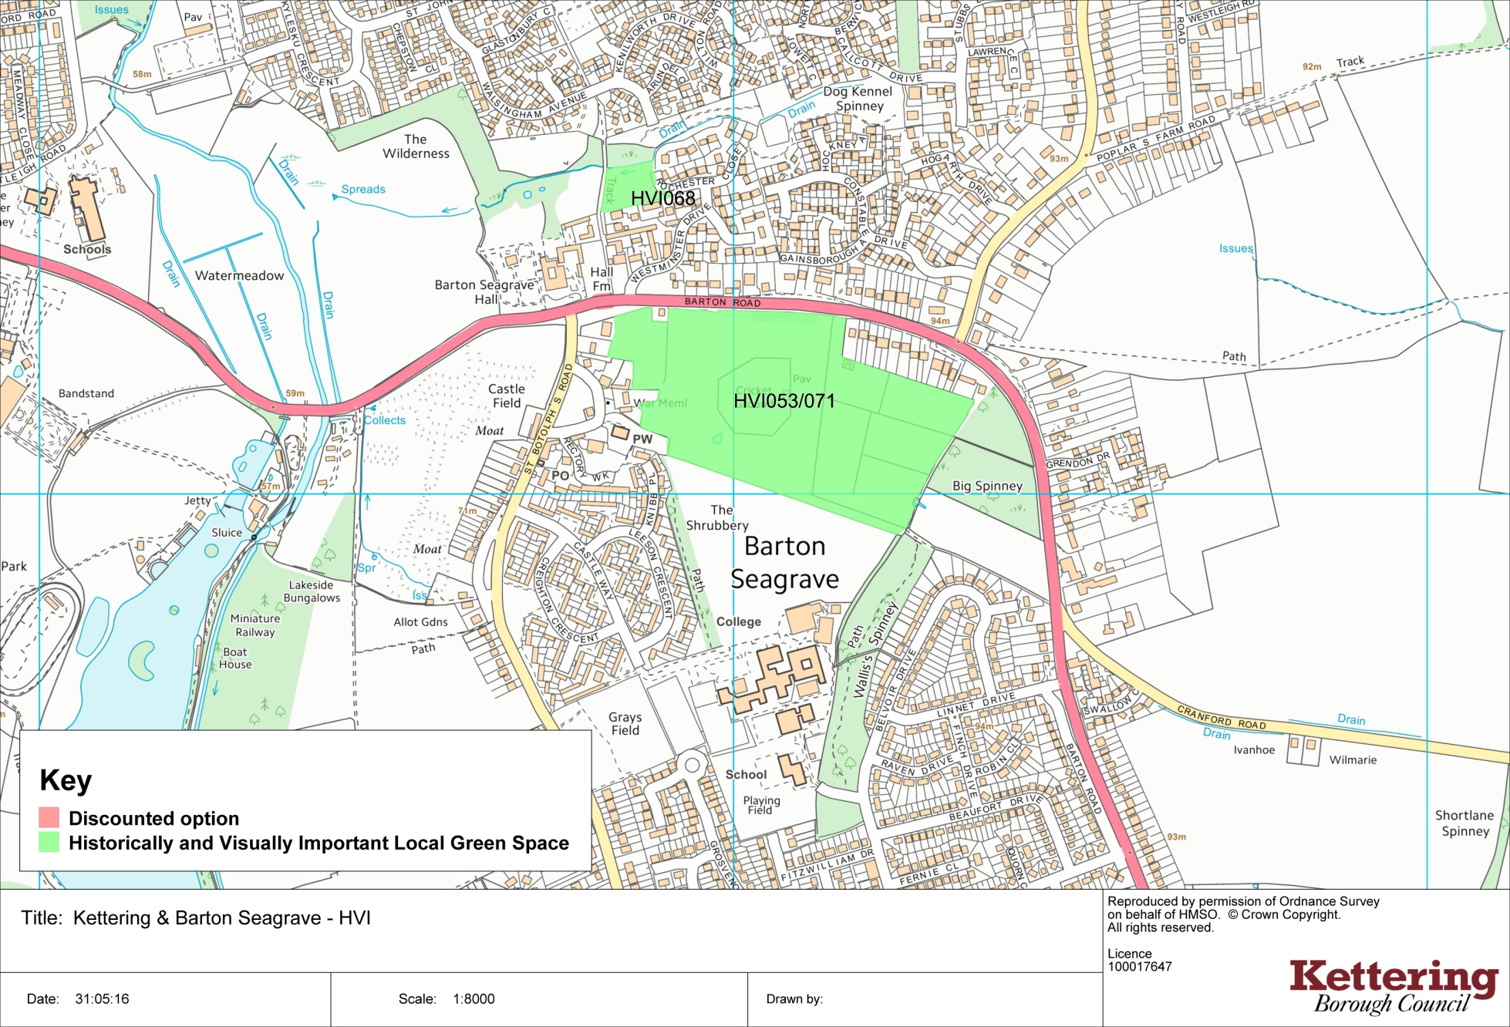
Burton Latimer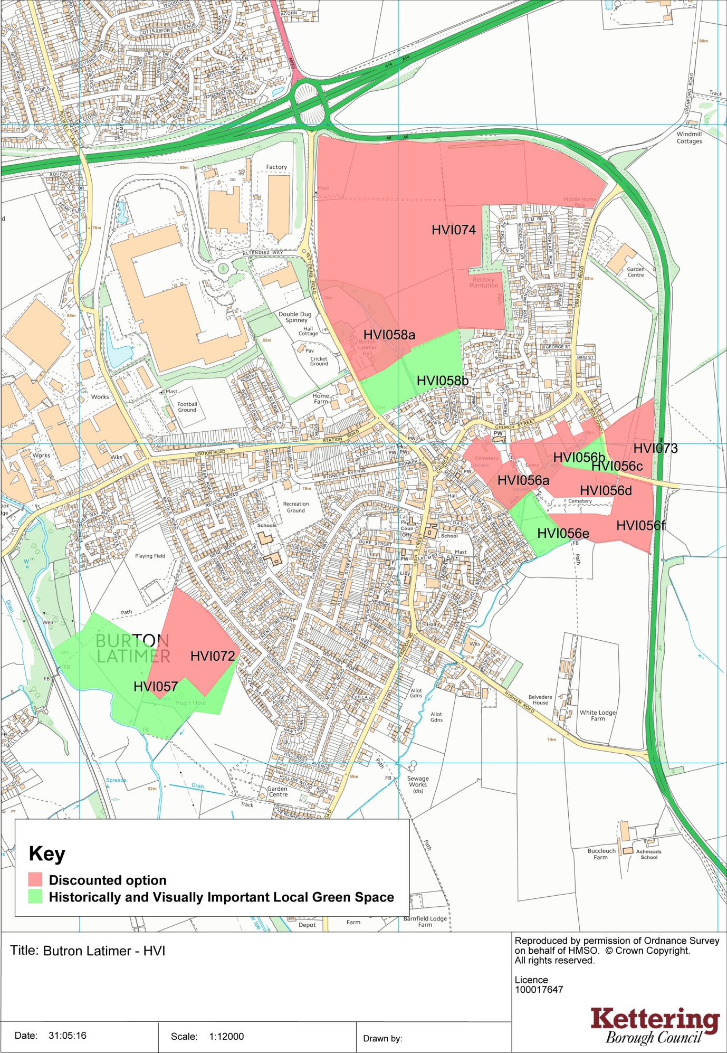
Desborough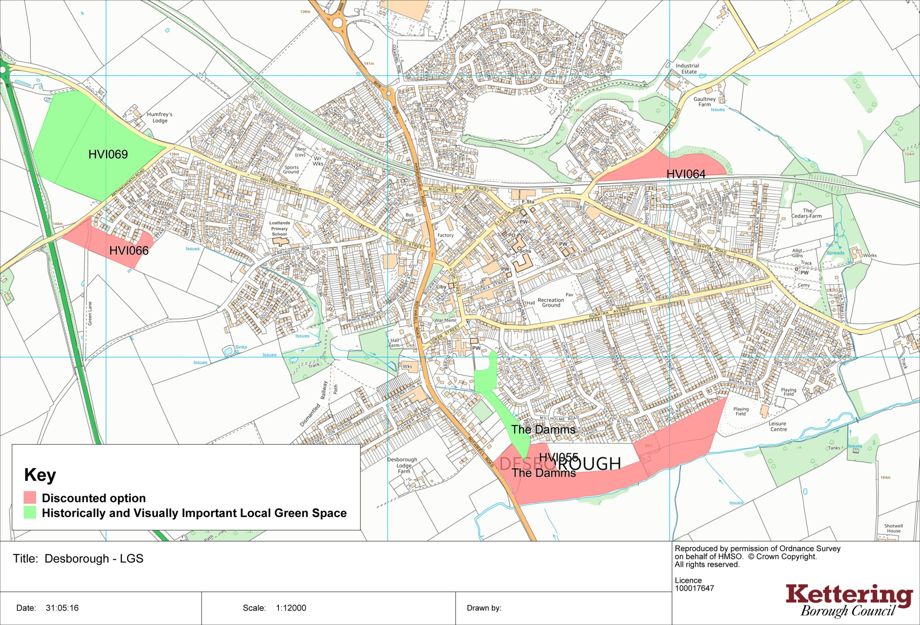
Rothwell
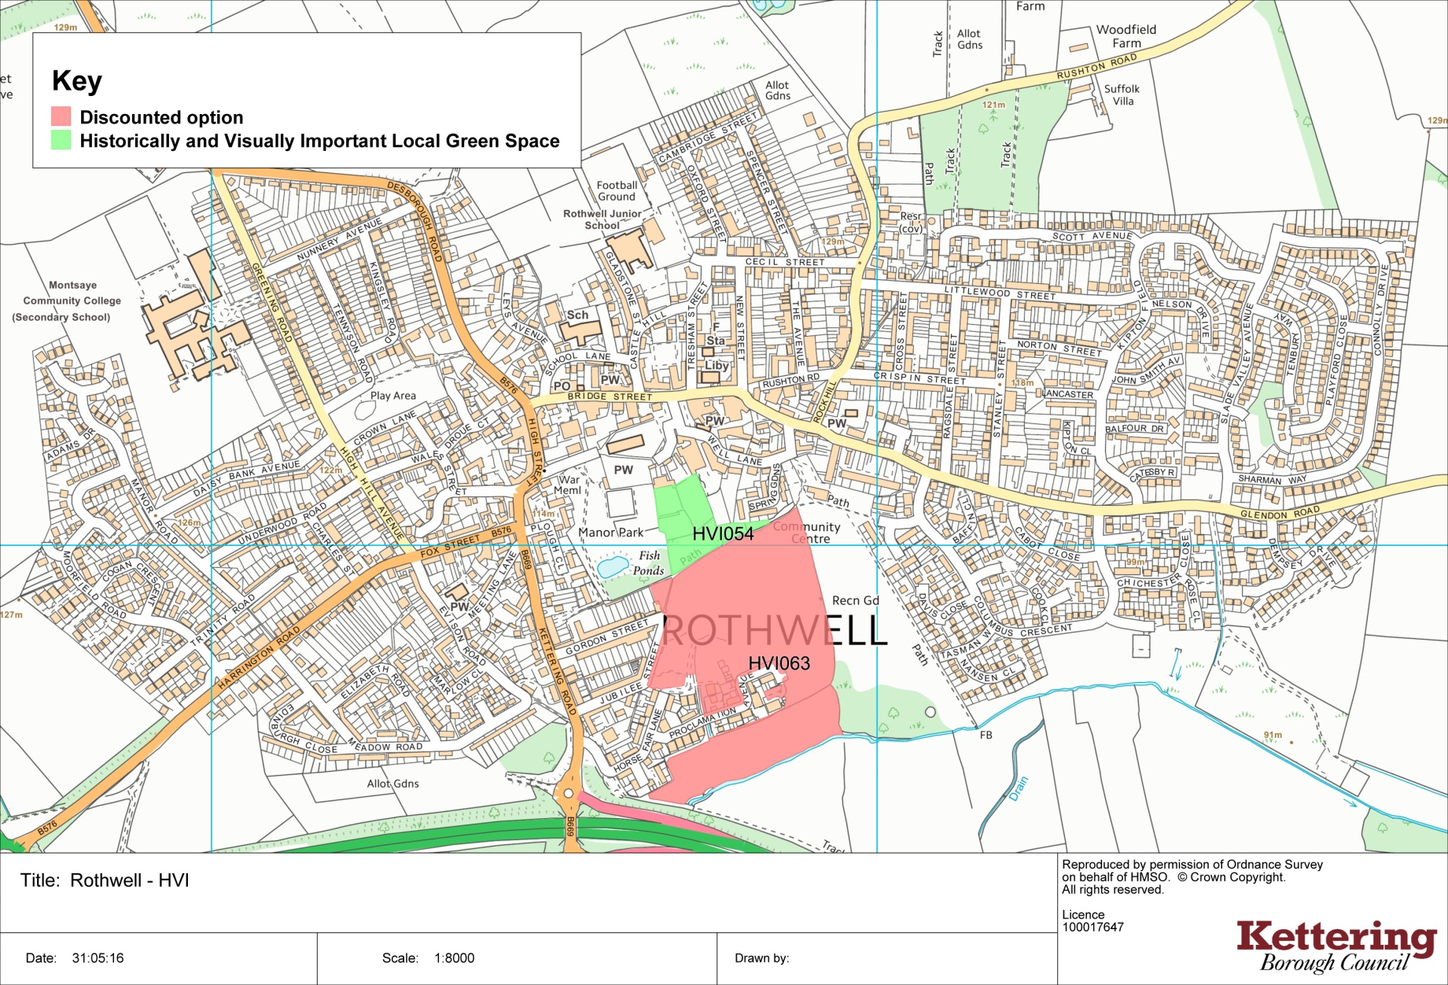
Ashley
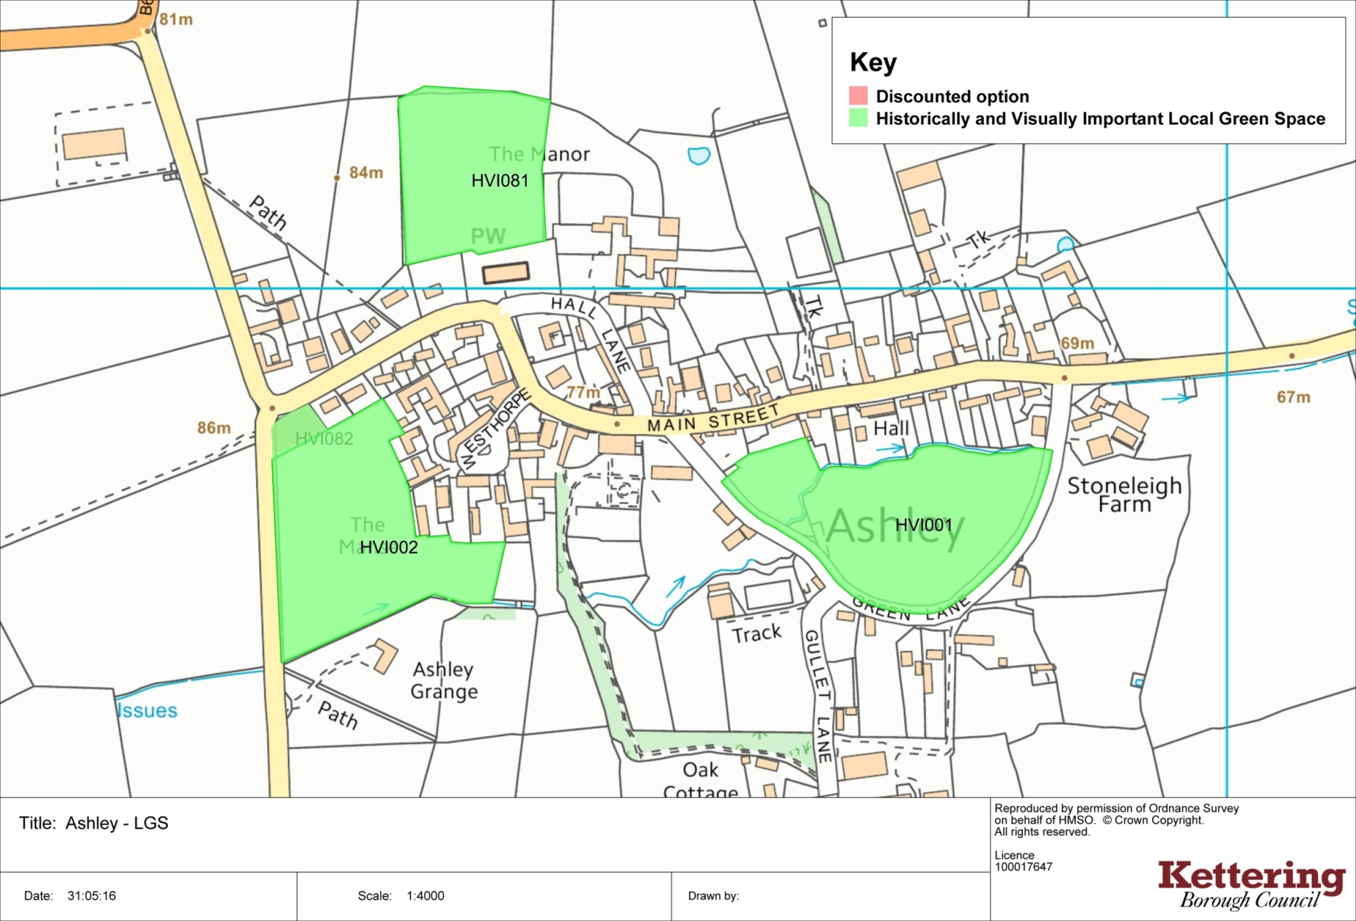
Braybrooke
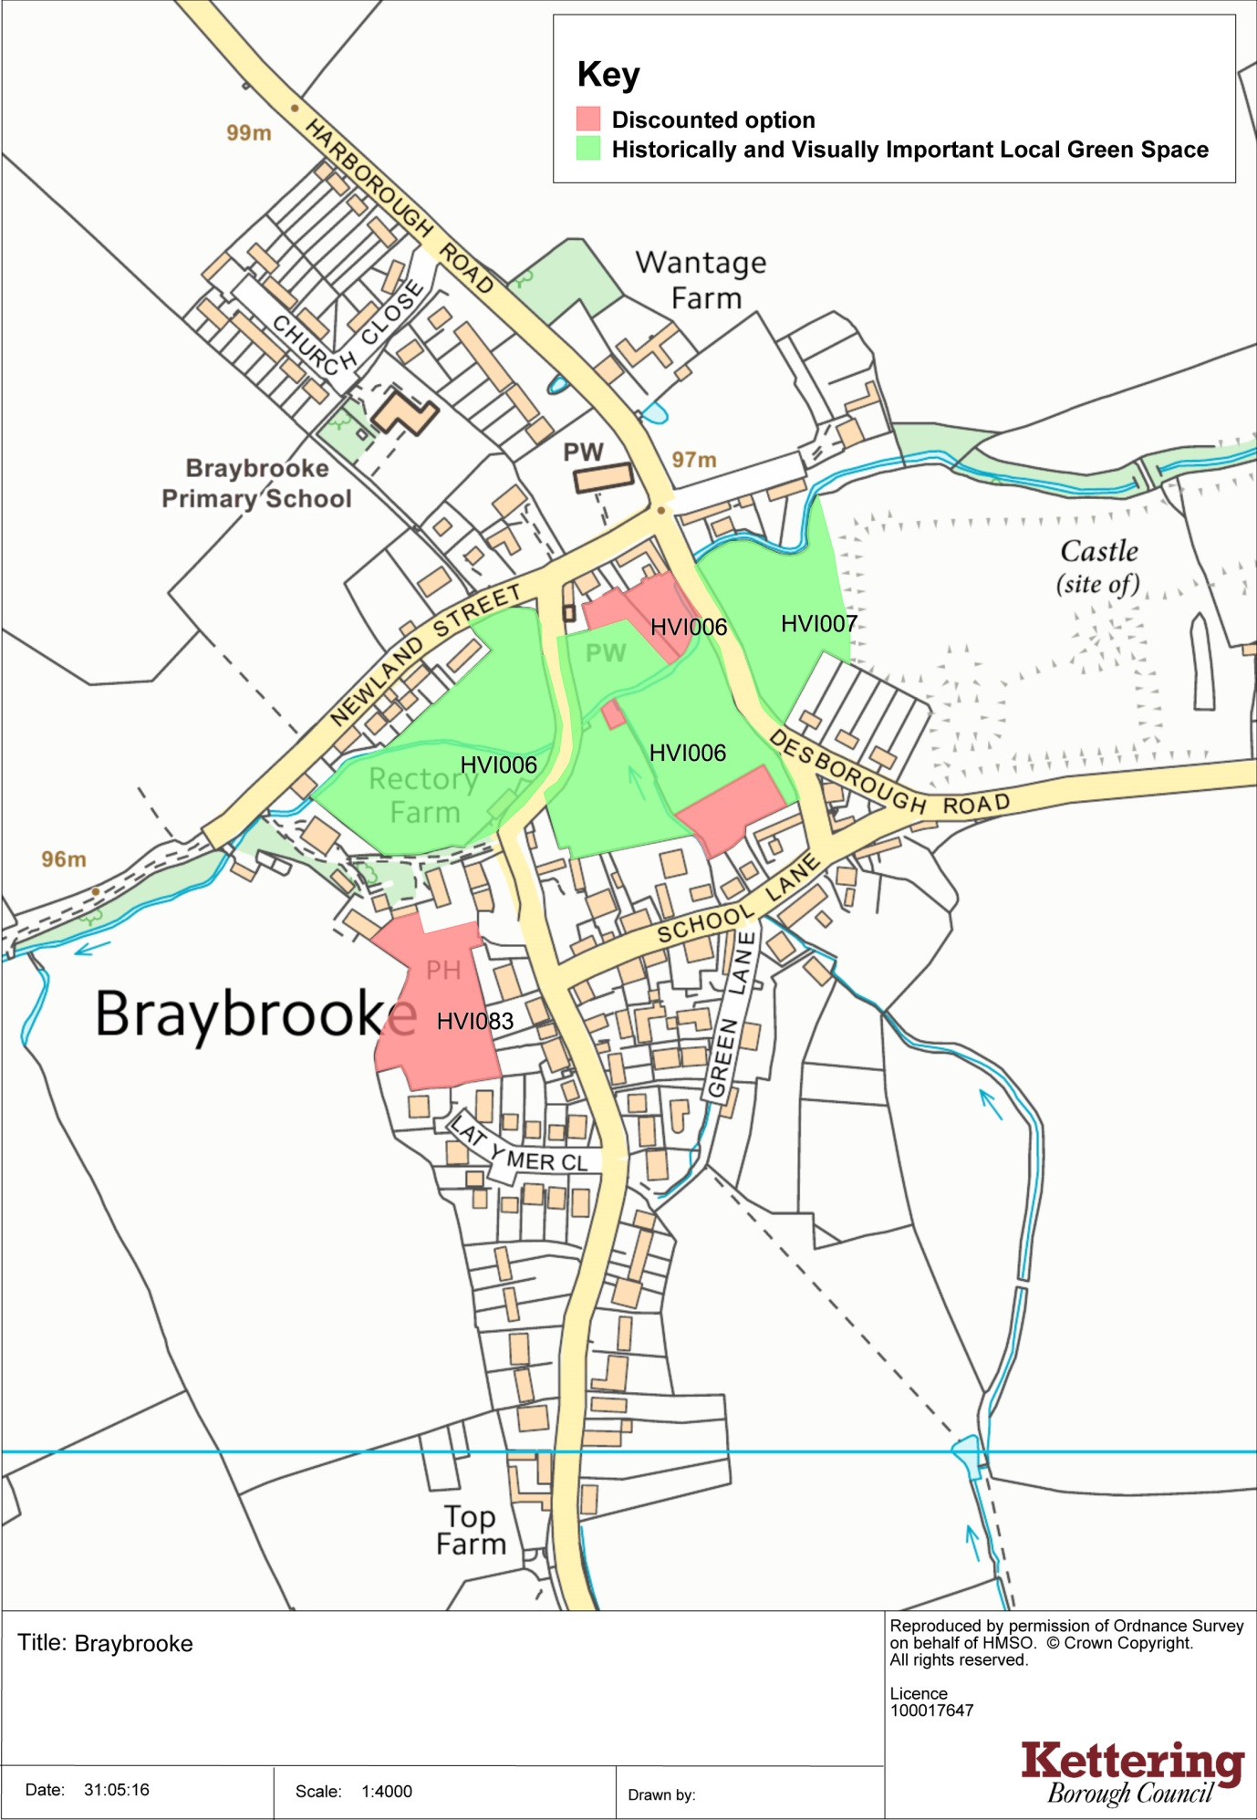
Broughton
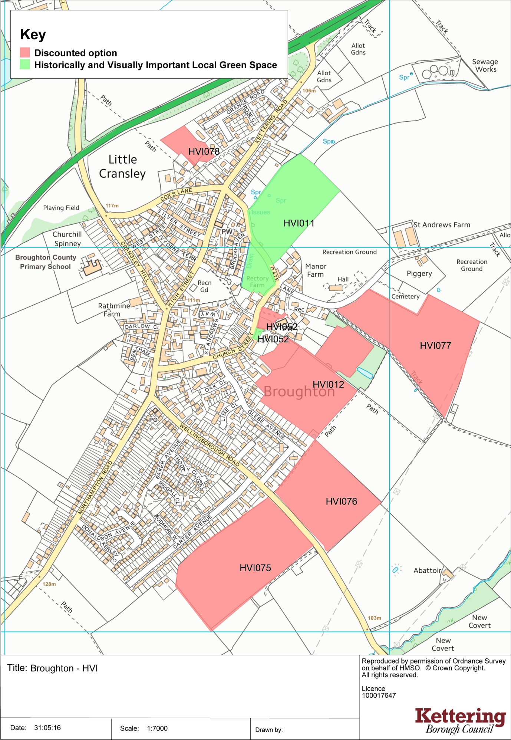
Cranford
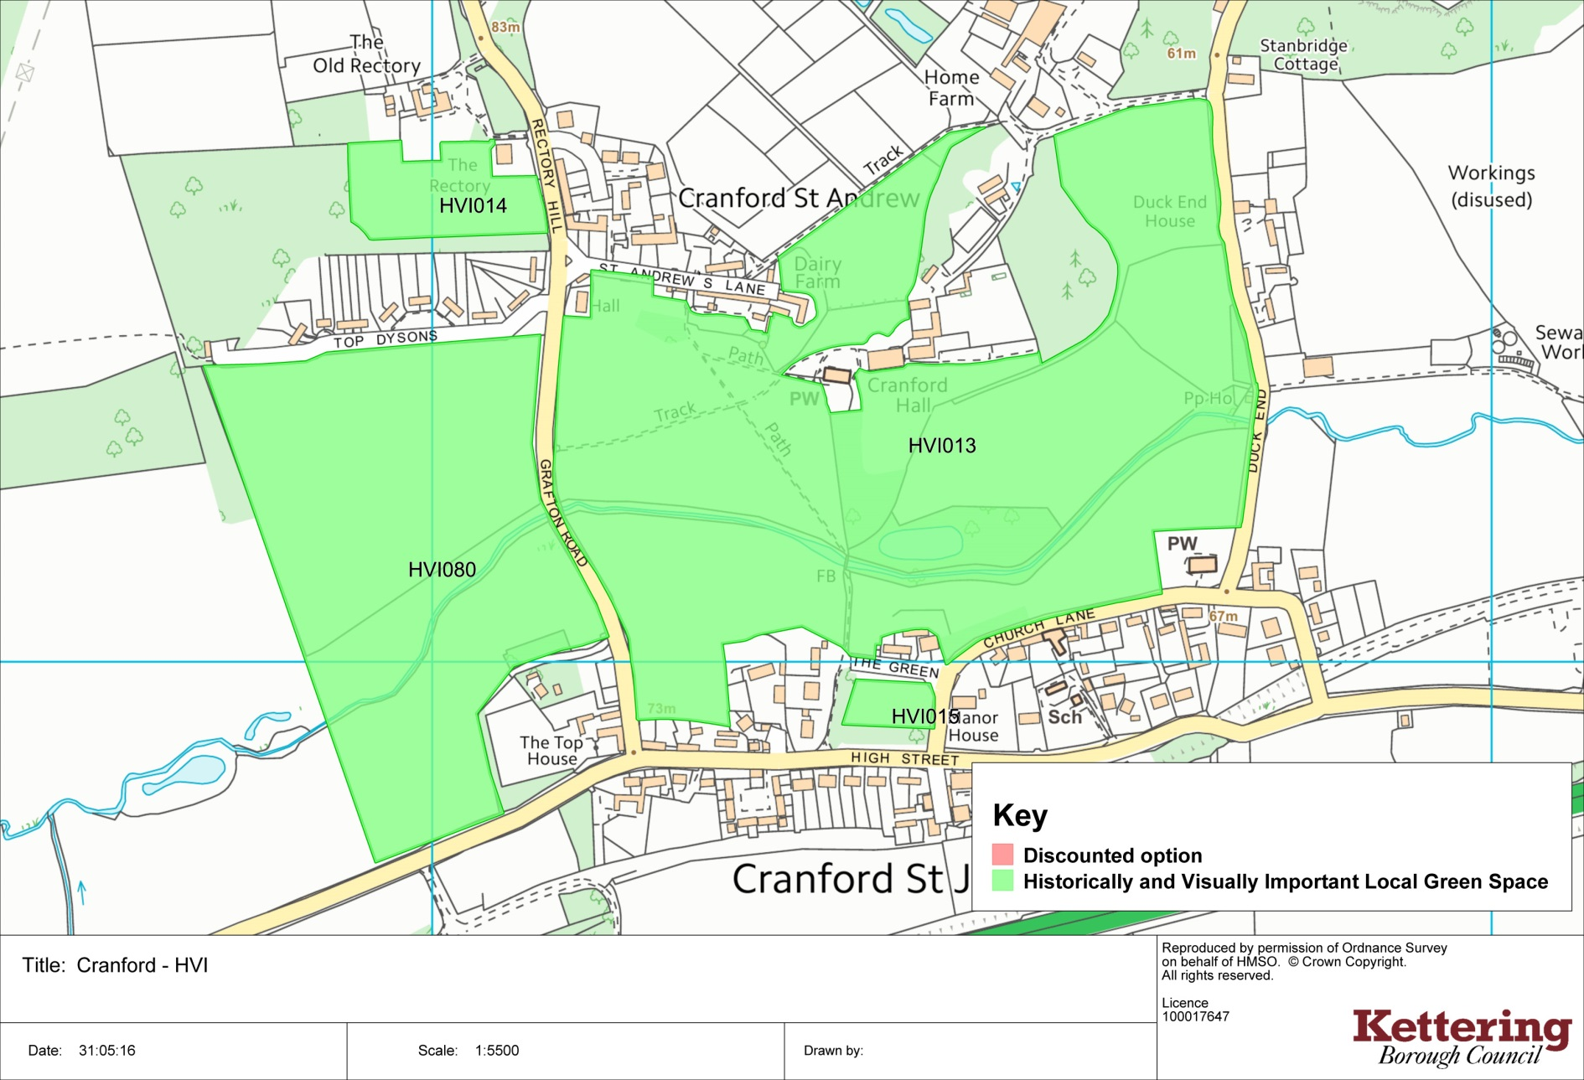
Dingley
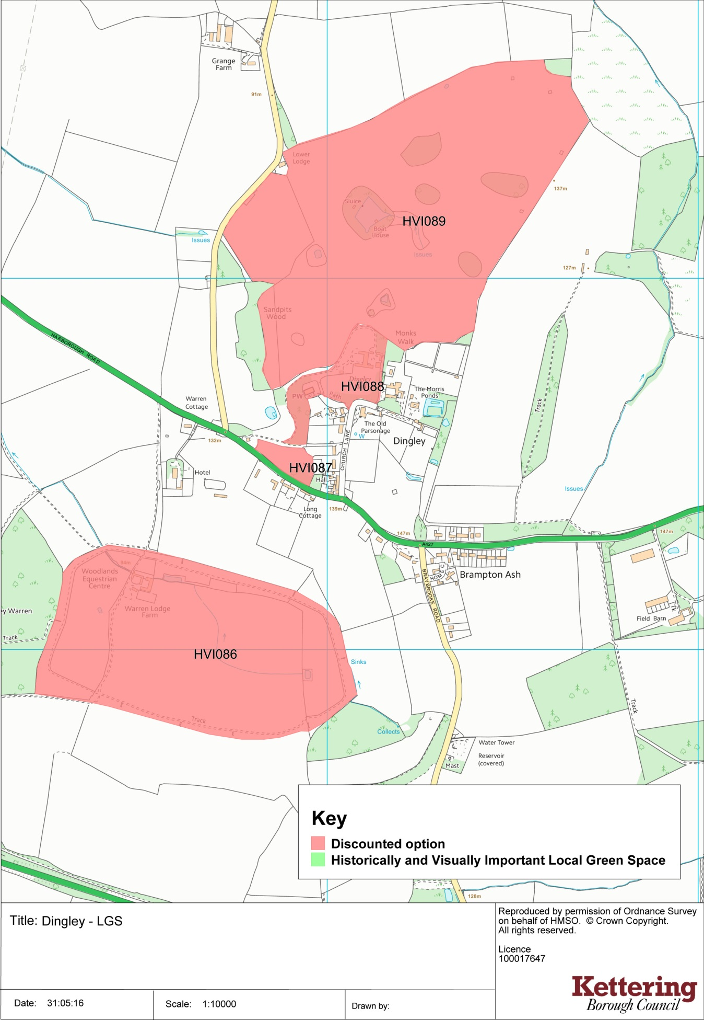
Geddington 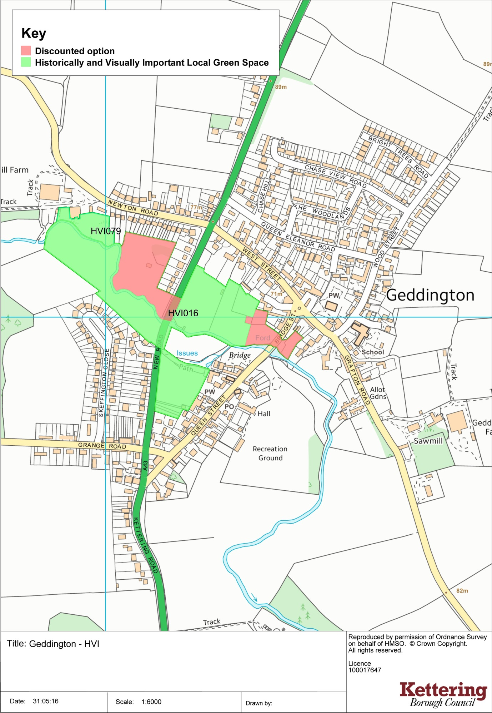
Grafton Underwood 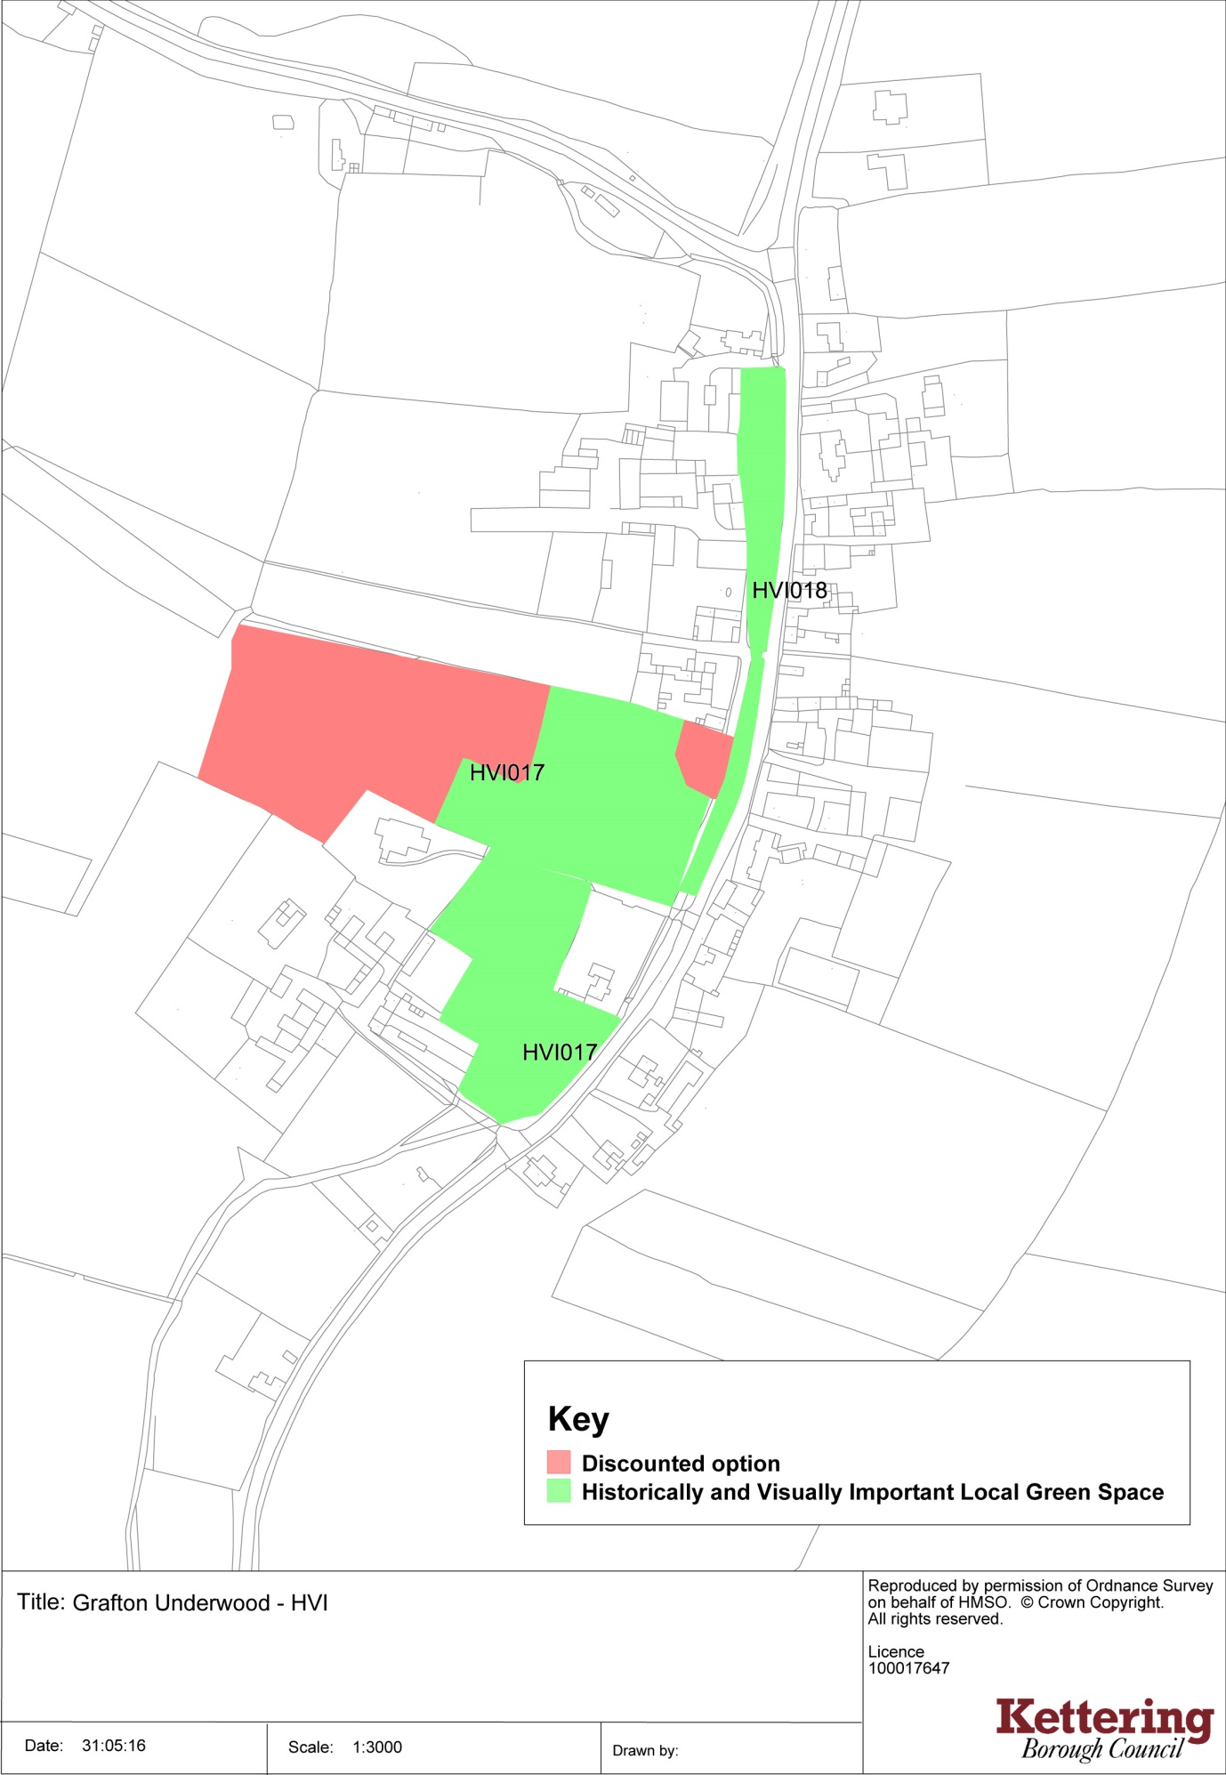
Harrington 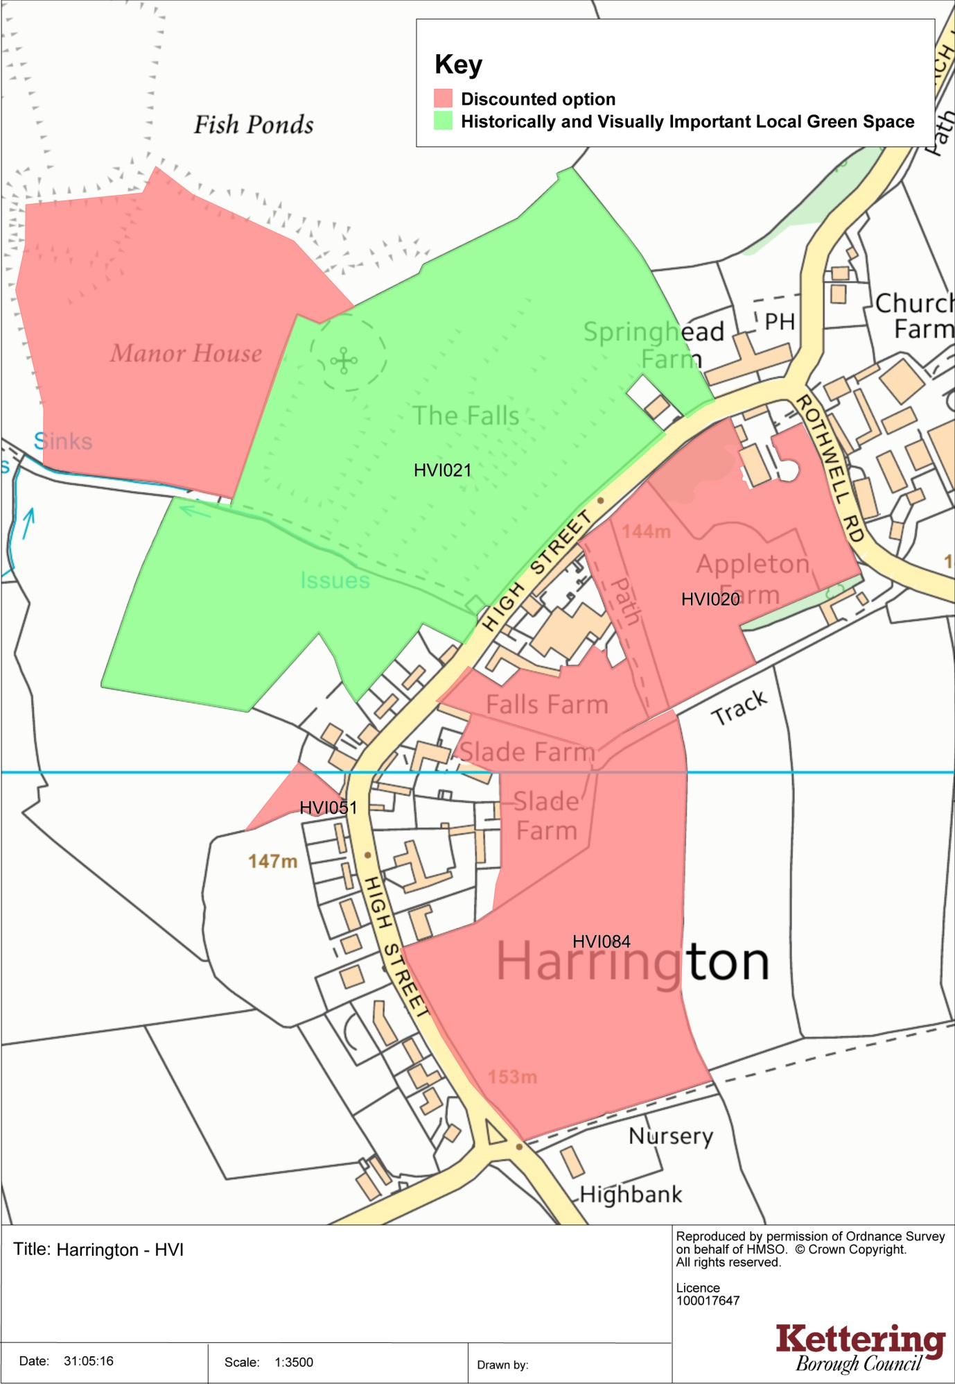
Little Oakley 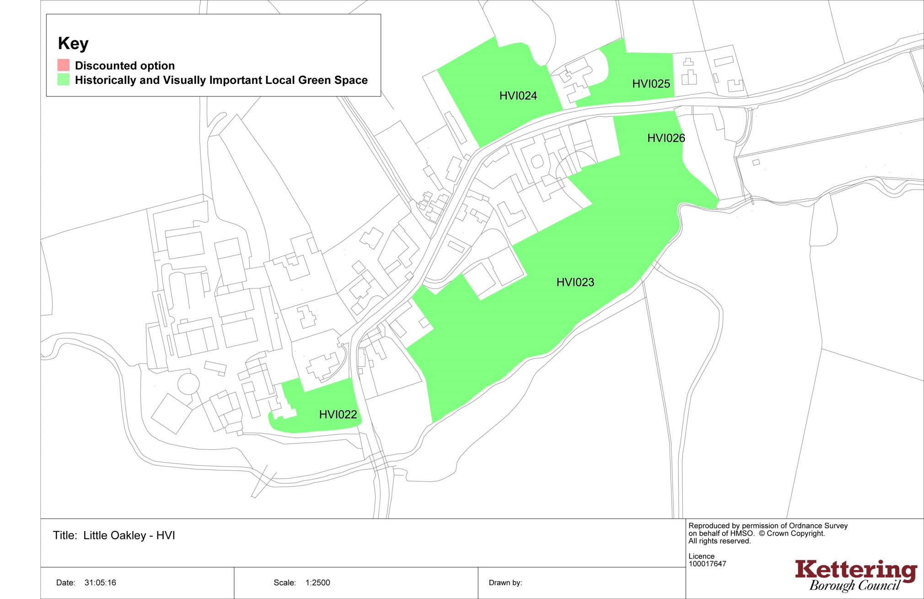
Loddington
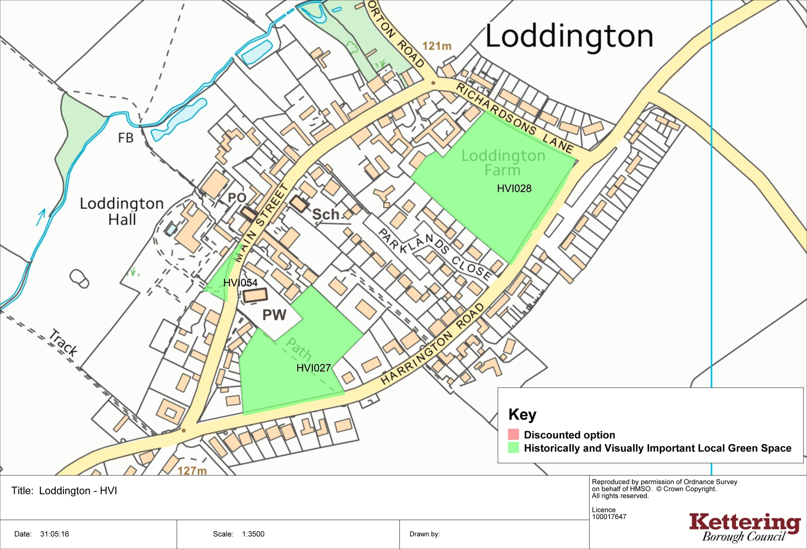
Newton
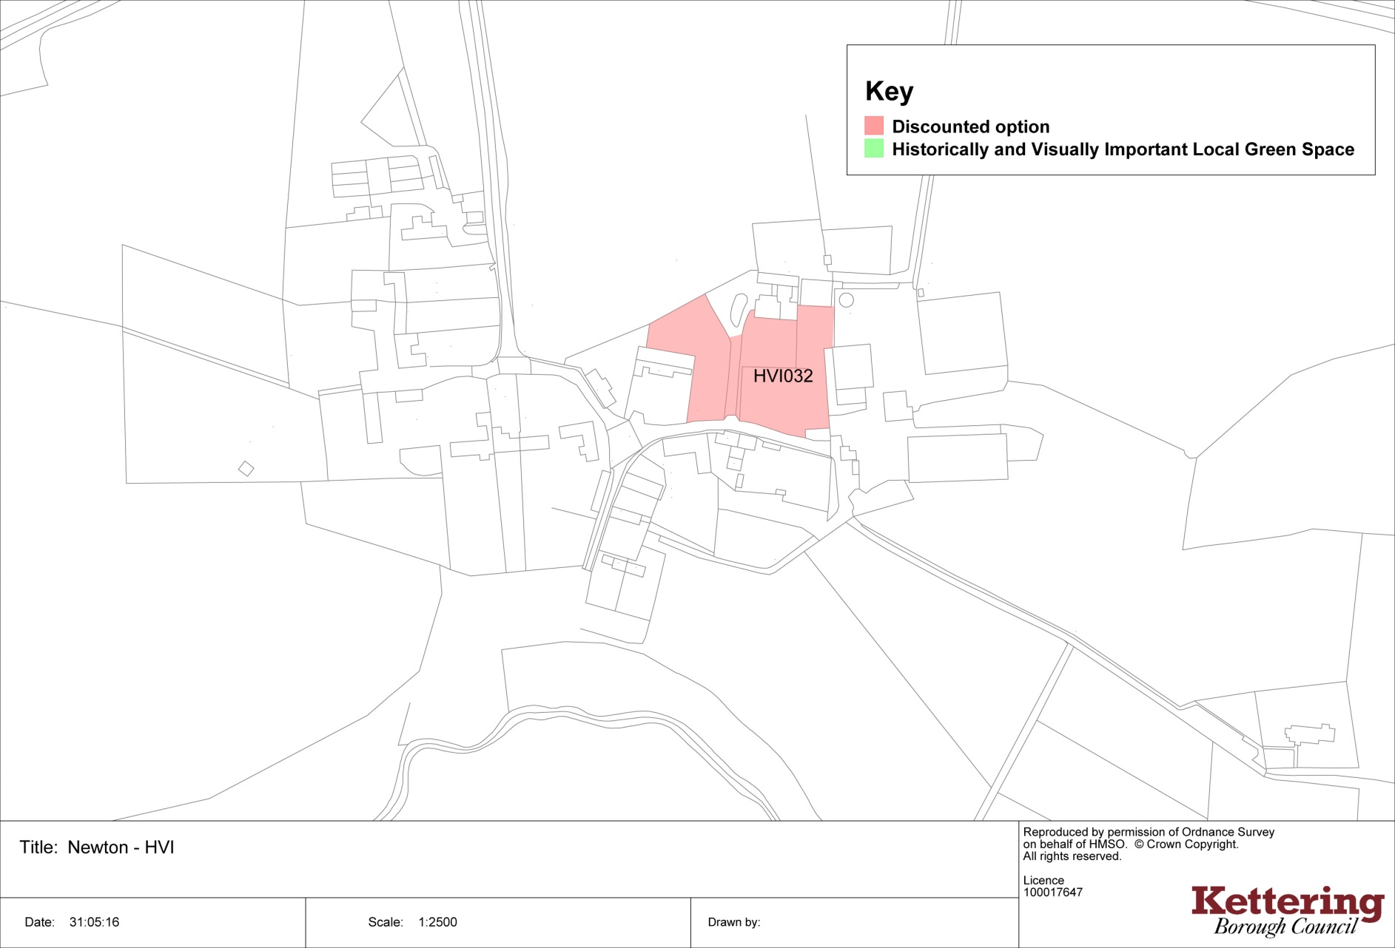
Pytchley
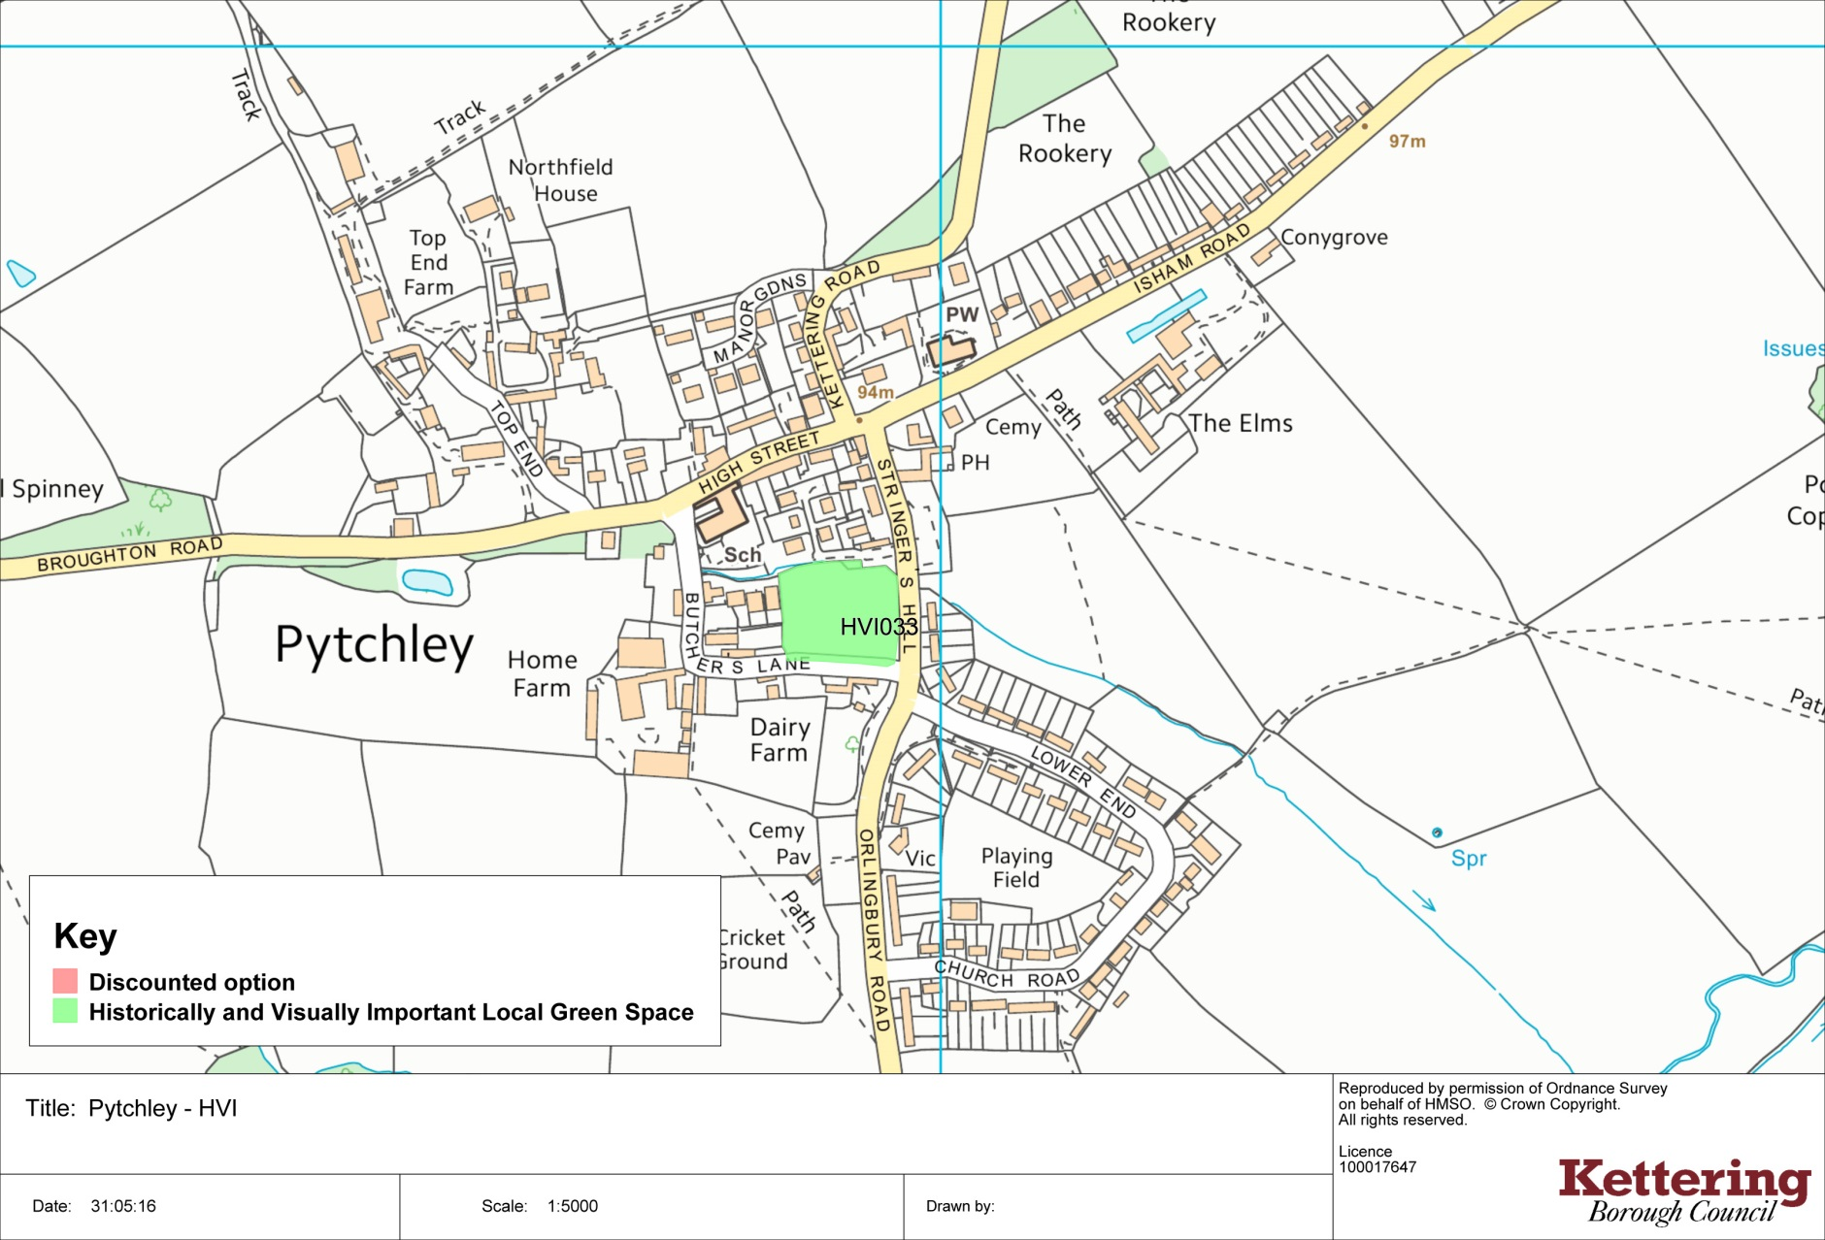
Rushton
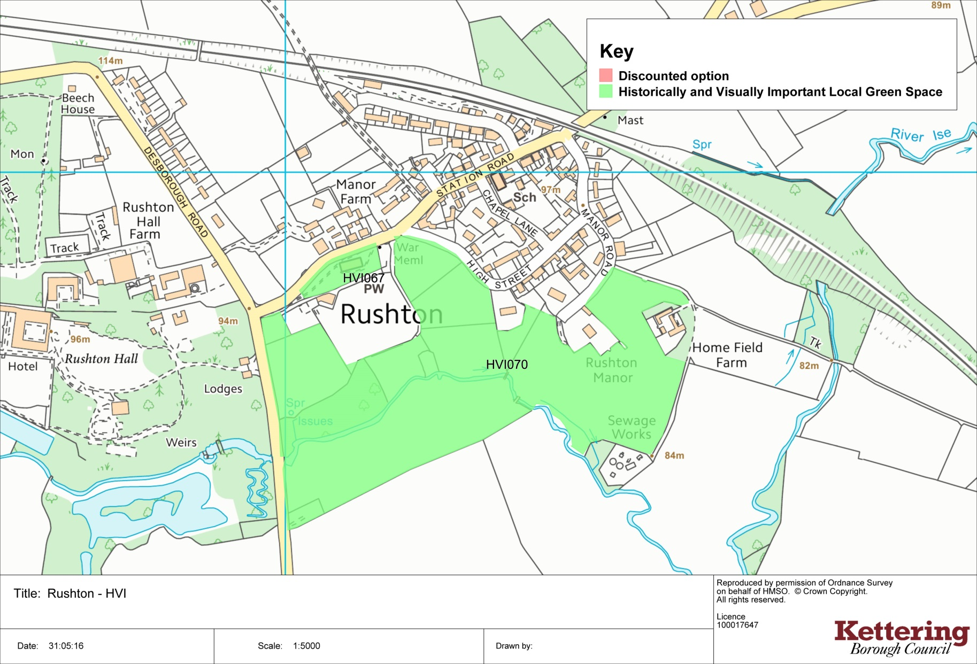
Stoke Albany
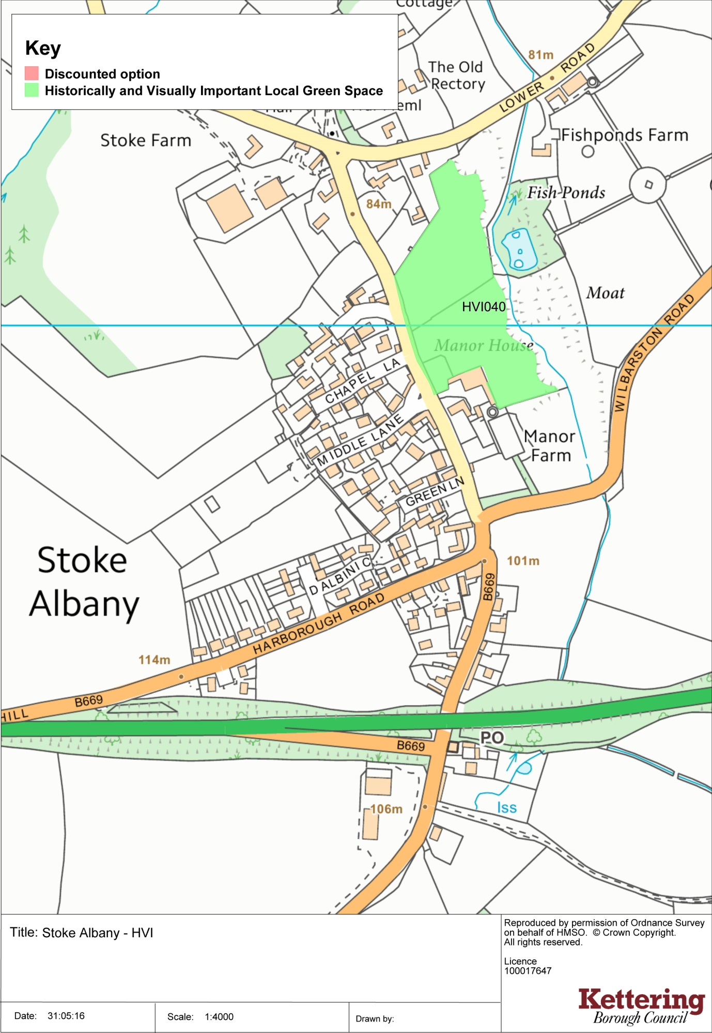
Sutton Bassett
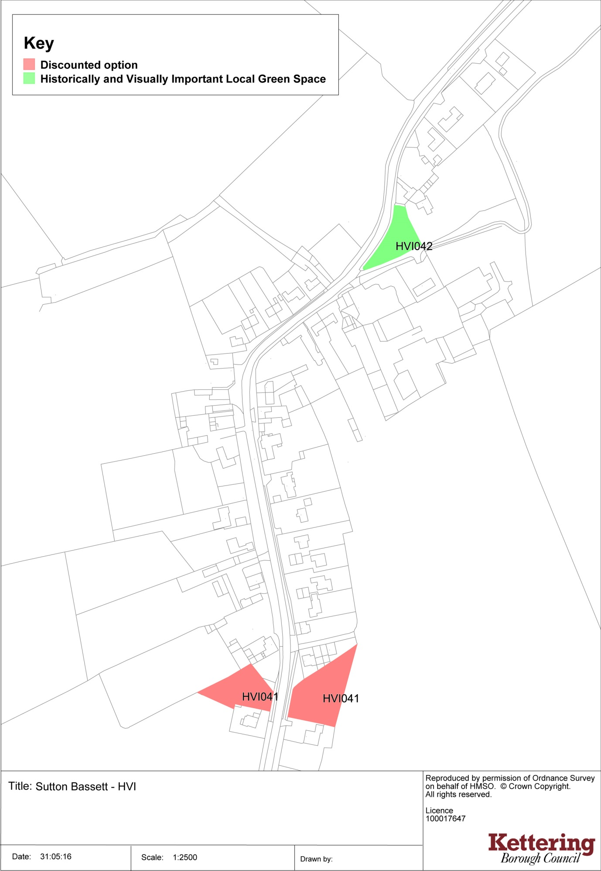
Warkton
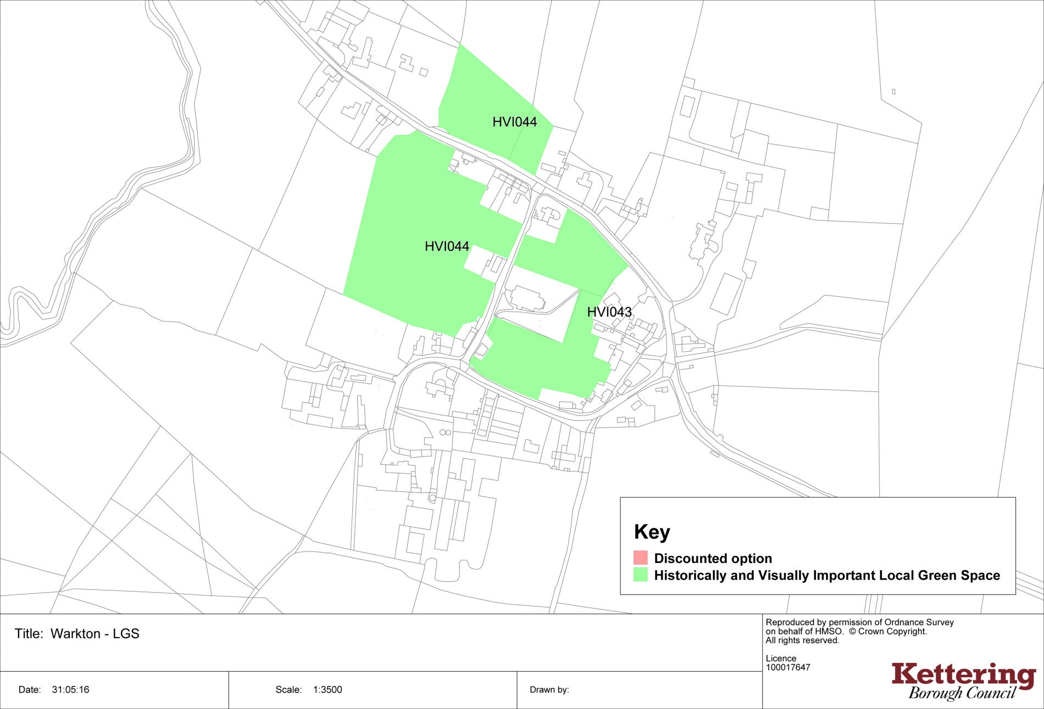
Weekley
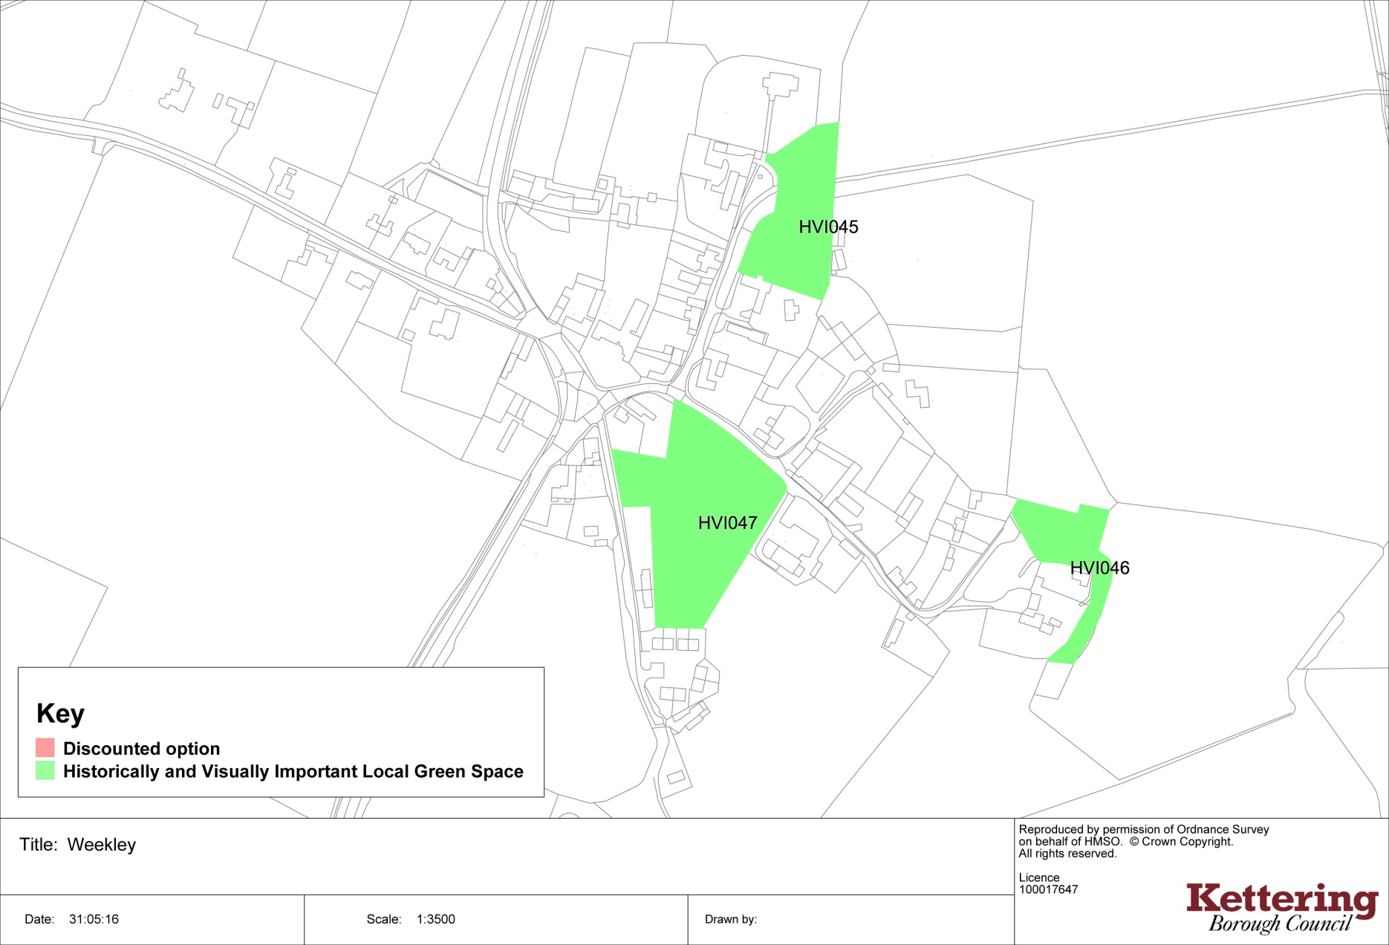
Weston by Welland
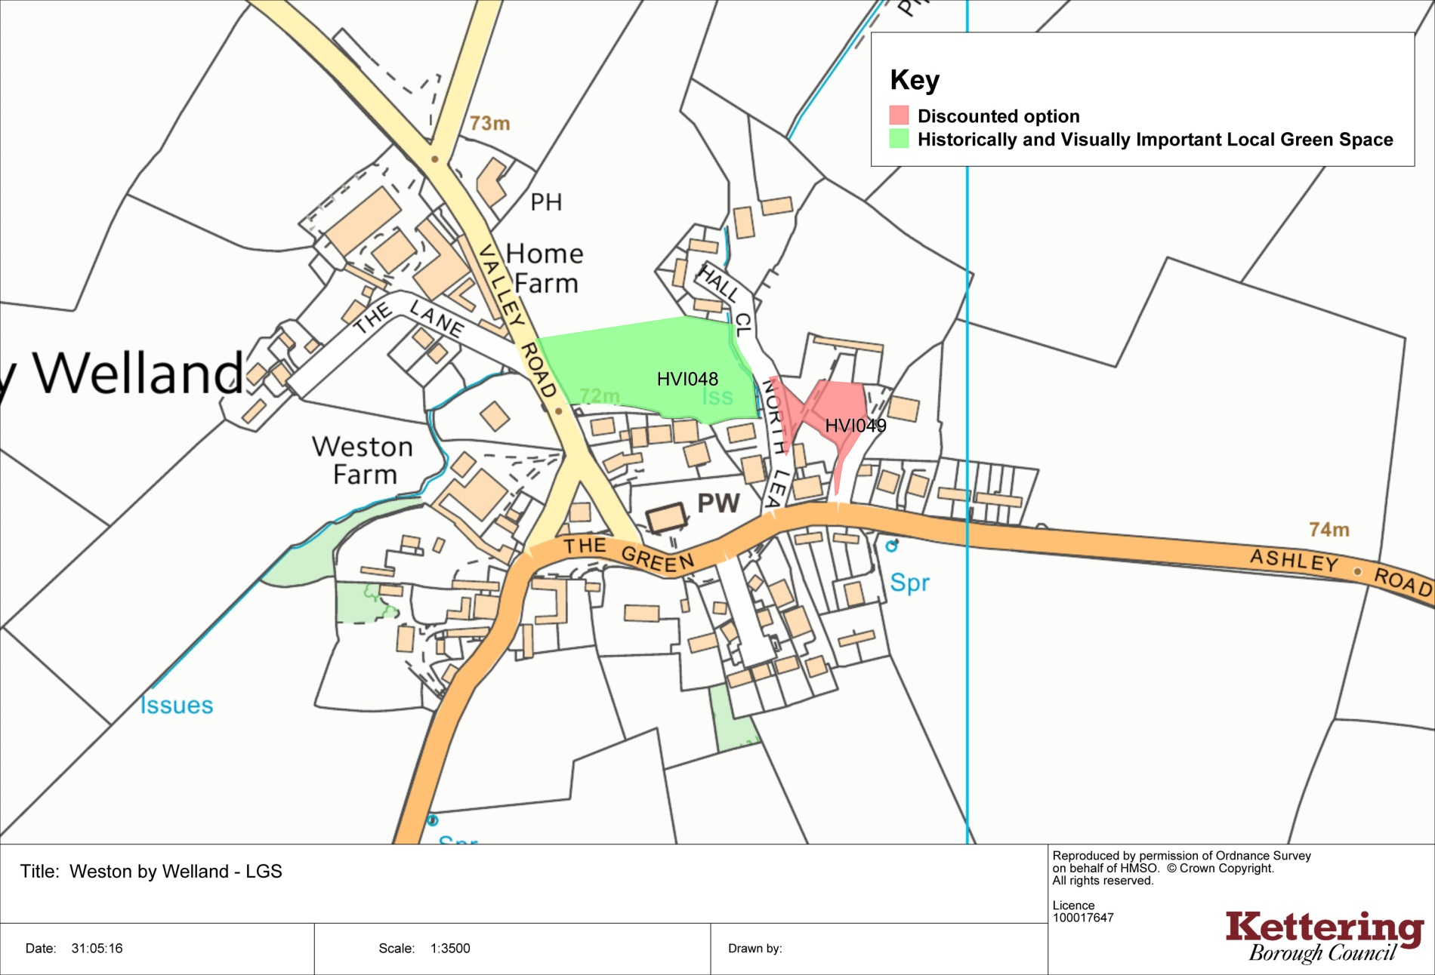
Wilbarston
