To all Members | Direct Line: (01536) 534398  Email: anneireson@kettering.gov.uk  Our Ref: AI  Your Ref:  Date: 10th May 2016

Dear Councillor

You are summoned to attend the ANNUAL MEETING of the BOROUGH COUNCIL, to be held in the Council Chamber, Municipal Offices, Kettering on Wednesday 18th May 2016 at 6.30 pm.

Yours faithfully

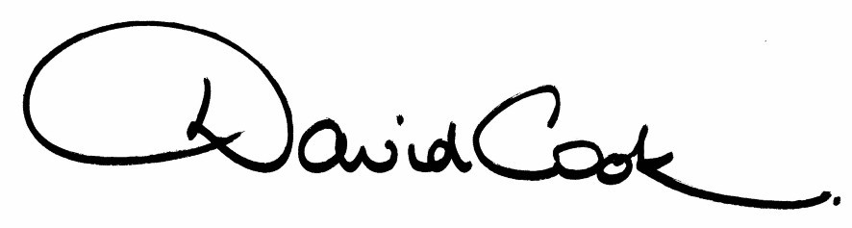

Chief Executive

A G E N D A

- Apologies

2. Election of Mayor

3. Nomination and Appointment of Deputy Mayor

4. Appointment of Mayor’s Chaplain

5. Presentation of Commemorative Mayoral Badge to the retiring Mayor.

6. The minutes of the meeting of the Council held on 20th April 2016 to be approved as a correct record and signed by the Mayor

7. Declarations of Interest
(a) Personal
(b) Prejudicial

8. To receive announcements from the Mayor.

9. To receive any report of the Chief Executive

10. To receive notification of the appointment of Leader of the Opposition.

11. To decide the allocation of seats (and substitutes) to Committees (to follow)

12. To approve a Programme of Ordinary Meetings for 2016/17 and to appoint members (including Chairs and Deputy Chairs) to committees, sub-committees (to follow)

13. To appoint councillors to serve on outside bodies (to follow).

14. Any other items of business the Mayor considers to be urgent.

10.5.16
Fire Alarm
All meetings shall be adjourned immediately on the sounding of the fire alarm. The alarm is a continuous two-tone siren. On hearing the alarm please leave the building by the nearest emergency exit. There are emergency exits at both ends of the corridor outside the meeting rooms. On leaving the building please cross the car park and assemble on the grassed area by the church. Do not attempt to drive out of the car park as this may impede the arrival of emergency vehicles. Please do not return to the building until you are told it is safe to do so by a Council employee.

Toilets
There are toilets in the corridor off the main entrance to the building you came through to get to the meeting room.

Facilities for Babies and Children
If you wish to use a private area to feed your baby please ask a member of staff. There are changing facilities in the corridor off the main entrance adjacent to the toilets.
Access for Disabled People
There are allocated parking bays outside the main entrance to the Municipal Offices for disabled people. The meeting rooms are located on the ground floor and access is gained for wheelchair users via the main entrance. If you require assistance, please ask the attendant on duty in the reception area.

No Smoking
Smoking is not permitted in the Municipal Offices.

Reporting on Meetings of the Council
Members of the press and public are entitled to report on meetings of the Council, Committees and the Executive, except in circumstances where they have been excluded in accordance with national rules.

If you wish to report on this meeting, please telephone 01536 534191 or email democracy@kettering.gov.uk at least two days before the meeting to enable the Council to provide reasonable facilities for you to do so. Failure to advise the Council of your intention may mean the necessary facilities will not be available.

If you are planning to attend, and do not wish to be recorded or photographed, please inform the Chair at the start of the meeting. The Protocol for members of the public wishing to film and report on meetings is available on Kettering Borough Council's website at:
http://www.kettering.gov.uk/recordingmeetings

