- PURPOSE OF THE REPORT

- Takes note of the Women’s Tour programme and supporting events;

- Recognises the importance of offering free business support events, like the Open for Business drop-in session; AND

- Notes the progress being made on improving part of the strategic transport network in Kettering town centre

2. BACKGROUND INFORMATION

2.1 Kettering Borough lies within the South East Midlands, which is predominately a growth area, and is expected to facilitate growth of some 13,100 homes and 16,200 new jobs by 2021.

2.2 Members have made their priorities for infrastructure and jobs-led growth clear – these are the prerequisites of growth. Members have indicated they wish to use the growth agenda to leverage three key and interrelated ambitions for the Borough; namely:-

- A better offer for our town centres
- A better education and training offer
- A better employment offer – high grade, higher density jobs

  - The mutually supportive role of these three aspirations cannot be over-stated. The town centres and the skills base will be persuasive to inward investors. Similarly, high grade employment supports vibrant town centres.

  - The Council has a vision to create town centres that are Characterful, Distinctive and Fun. This vision has been externally validated by an independent planning inspector, and now sits firmly within our planning policy for Kettering Town Centre.

- WOMEN’S TOUR

  - The final stage of the Women's Tour will take place on Sunday 19th June 2016, starting in Northampton town centre before taking a meandering path around the South, West and North of the county, finishing in Kettering. The distance for this stage is 70.4 miles – so it really is showcasing a large part of what Northamptonshire has to offer.

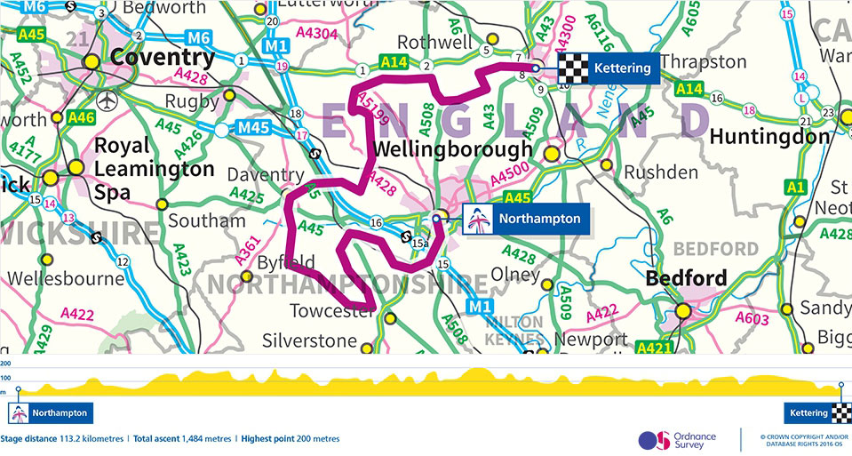

  - Preparations are underway to ensure that the day is even more successful than 2015 – which was an amazing success and brought thousands of people into Kettering town centre, as well as at various points along the route. This year will see the return of the Bike Village which will house a bike orientated market in the heart of the High Street. There will be a host of bike related activities, which include: crazy bikes, bike Scalextric, smoothie bikes and music bikes. As well as a bike themed competition that will involve members of the public and local shop owners. We are keen to engage with local businesses to see if there are ways of ensuring they are right at the centre of the action – and benefit from the increased activity and attention the event brings.
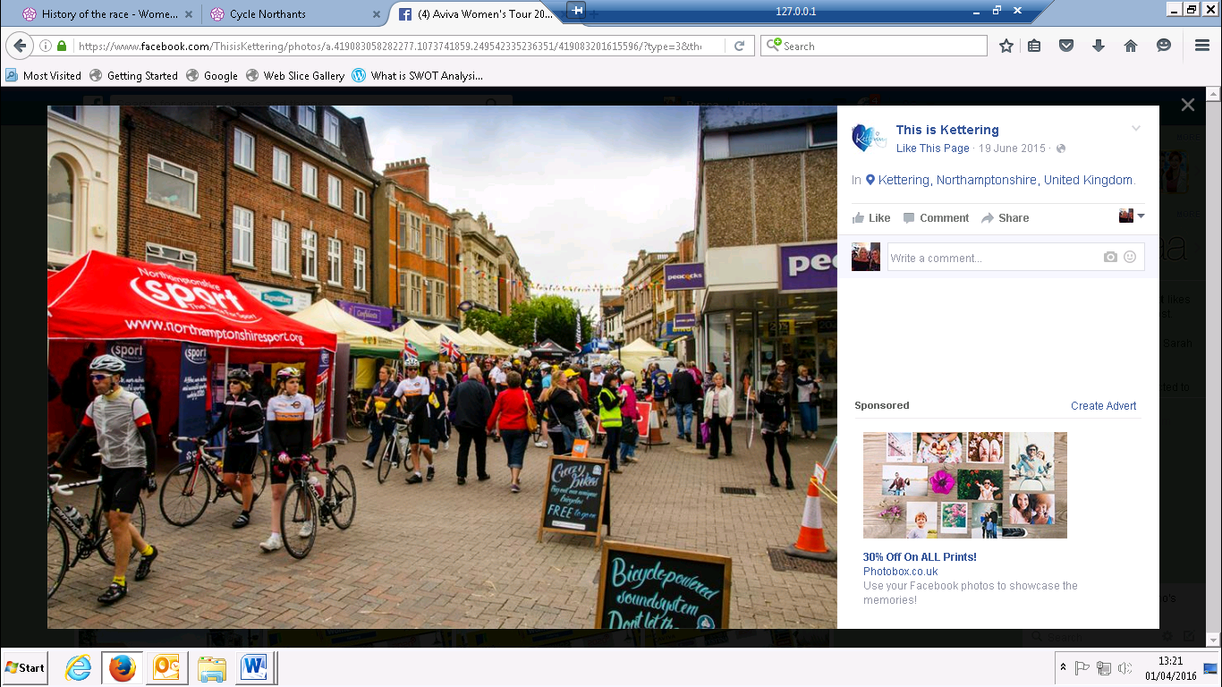
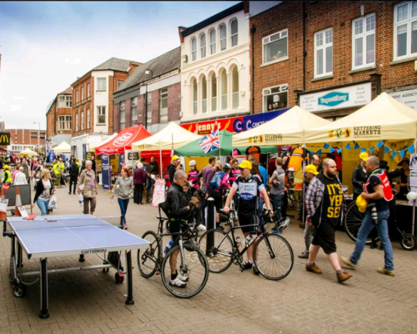

  - This year sees the race take some new routes and climbs within Northamptonshire. Details of the race are yet to be confirmed however, there is always a fantastic atmosphere at the start and finish of each race and crowds build quite quickly around these vantage points. Wherever you choose to watch the race you will appreciate what a spectacular event the Women's Tour is.

  - In 2015 Northamptonshire hosted stage three of the Women's Tour with the race starting in Oundle and finishing in Kettering. Approximately 67,500 people turned out across the UK to watch the Women's Tour in 2015 – 12,500 more than 2014. It is estimated that the event saw a £1million boost to the local economy, with spectators, cyclists and media personnel spending on accommodation, merchandise, food and drink. Kettering will play host to the final stage of the whole race – which means we should receive even more attention than we did in 2015.

4. NORTHAMPTON ROAD – SHEEP STREET – STATION ROAD – BOWLING GREEN ROAD

  - The improvement work on this junction is moving along at a steady pace – with no major issues having arisen in the first few weeks of the project. The traffic islands have been removed, a temporary traffic arrangement installed, and new pedestrian areas beginning to take shape.

  - The improvements will involve the removal of traffic lights at Sheep Street so that the traffic flows freely through from Bowling Green Road onto Northampton Road. Modelling suggests that this will help the increasingly common issue of traffic jams on Bowling Green Road and London Road. A pedestrian crossing point will be installed opposite the Alms Houses, with the existing crossing at the bottom of Bowling Green Road removed.

  - The proposed construction phase will run from March 2016 for a period of 8-10 weeks. The works will be complete well before the new surface is used to host part of the finishing stage for this year’s Women’s Tour.

  - Northamptonshire Highways continue to monitor the progress of works, as well as traffic flow through them – and are happy to answer any questions that might arise over the next few weeks.

5. OPEN FOR BUSINESS

  - On the 7th April Kettering Borough Council in partnership with SEMLEP will be running an ‘Open for Business’ Drop in Event. It will be held in the Council Chamber from 8.30am till midday. The morning will give businesses the opportunity to drop in and ask about the different ways we offer support and advice they require. There will be representatives from a number of departments and organisations; these range from Kettering Borough Training, Enterprise4Kettering, Velocity Growth Hub, Health & Wellbeing, Food Hygiene and Licencing and Economic Development.

  - We are hoping for a good turnout, and there has been a decent level of interest so far. If the event proves useful to businesses, we will look to roll the event out on a regular basis.

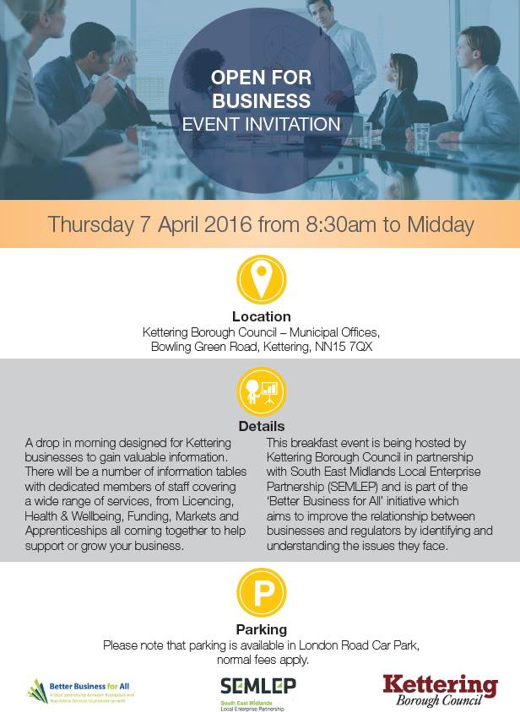

- IMPACT ON POLICY

  - Members have made their priorities for infrastructure and jobs-led growth clear – these are the prerequisites of growth. Members have indicated they wish to use the growth agenda to leverage three key and interrelated ambitions for the Borough; namely:-

- A better offer for our town centres
- A better education and training offer
- A better employment offer – high grade, higher density jobs

7. RECOMMENDATION

That the Executive Committee:

- Takes note of the Women’s Tour programme and supporting events;

- Recognises the importance of offering free business support events, like the Open for Business drop-in session; and

- Notes the progress being made on improving part of the strategic transport network in Kettering town centre

