Site Specific Proposals Local Development Document
Background Paper: Settlement Boundaries (Update) September 2015 - Addendum

  - Purpose of this Addendum
This document is provided as an update to the above background paper and information presented within it, ahead of its presentation to Planning Policy Committee on Wednesday 2nd September 2015. This document should not be considered separately, but together with the original document as a whole. A final copy of the above background paper will be prepared incorporating changes included within this addendum.

1.2 Revised Key (page 23)
The original key is amended to include:
- Amendment to ‘Potential Employment Option’ label to include ‘Further assessment required’, and colour change of the key image.

- A revised image for ‘Proposed Housing Allocation – Recommended for Progression’ and ‘Proposed Housing Allocation – Recommended for Further Assessment’ to show the chequered infill, consistent with the plans.
The revised key is set out below.

 | Proposed Strategic Employment Allocation (Joint Core Strategy)
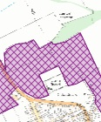 | Proposed Sustainable Urban Extension (Joint Core Strategy)
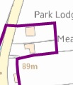 | Existing Settlement Boundary
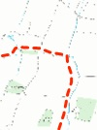 | Proposed Settlement Boundary
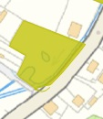 | Historic and Visually Important Open Space
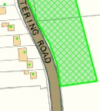 | Proposed Housing Allocation – Recommended for Progression
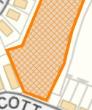 | Proposed Housing Allocation – Recommended for Further Assessment
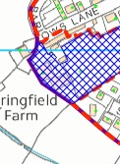 | Potential Employment Option – Further assessment required.

1.3 Changes to Historic and Visually Important Open Space (HVI)
The following changes have been made to accurately reflect the latest HVI areas contained within the SSPLDD Background Paper dated September 2015.
1.3.1 Kettering (page 24)
Minor amendment to enlarge boundary of HVI located south of Barton Road.

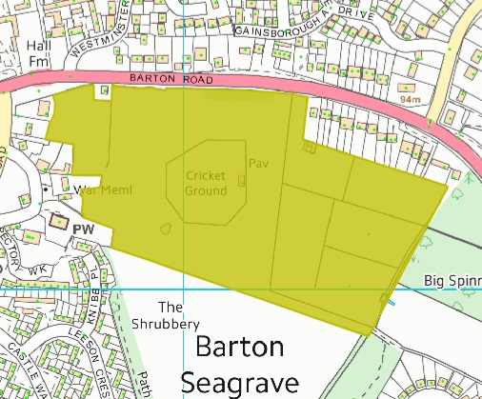

    - Desborough (page 32)
Removed HVI south of Desborough, Millholme Road and Valley Rise.

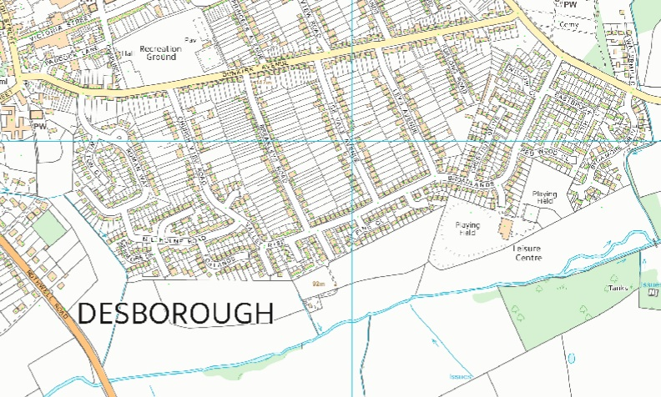

    - Burton Latimer (page 41)
Removed HVI south of Station Road.

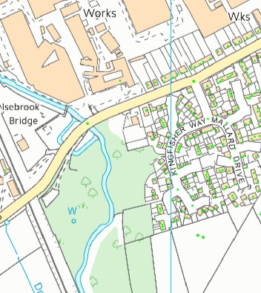

    - Loddington (page 66)
Enlarged HVI southeast of the St Leonards Church, off Main Street.
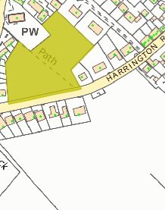

    - Geddington (page 121)
Minor amendment to reduce the boundary of HVI open space adjacent to the River Ise and dwellings on Chapel Lane.

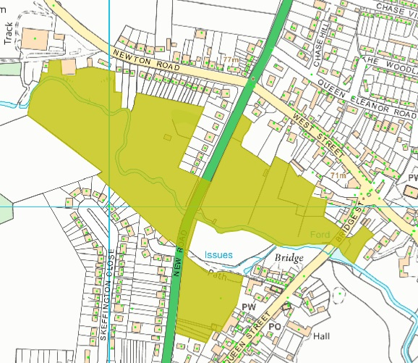

  - Amendment to the strategic employment site allocation at Kettering South (page 24)

The extent of the boundary of the proposed strategic employment allocation of Land at Kettering South, has been recently amended through the latest Focused Changes consultation to the Pre-submission North Northamptonshire Joint Core Strategy. The following plan shows the amended site boundary which extends slightly further south.
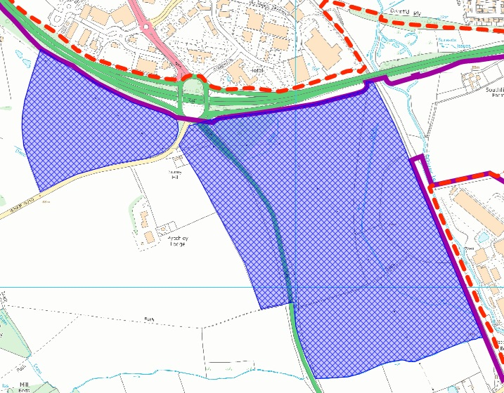

  - Inclusion of proposed employment allocations
The 2015 version background paper excludes the majority of potential employment allocations which are to be made through the Part 2 Local Plan. Some of these sites were submitted through the SSP LDD Options Consultation and at this stage have not been fully assessed. As a result, no decisions to progress these sites have been made. However, it is considered that these should be shown on plans contained within the Background Paper to provide context to the information presented within the paper. These sites are identified and shown with a blue check notation.
Once these sites have been fully assessed, a separate recommendation shall be made to Committee seeking endorsement to progress any favourable sites as part of further work to progress Part 2 Local Plan.

1.5.1 Desborough (page 32)
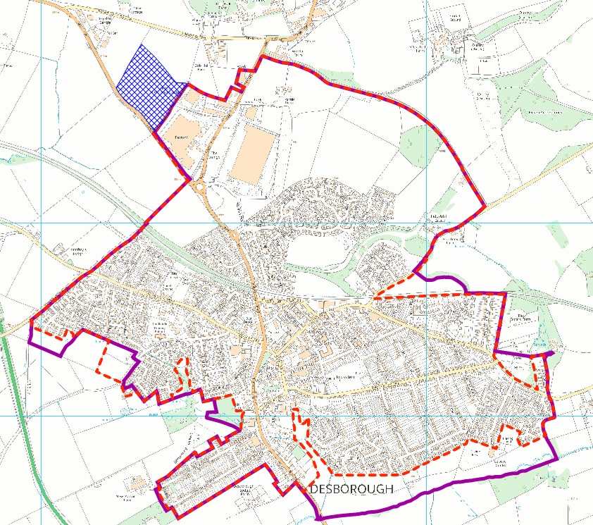
1.5.2 Rothwell (page 38)
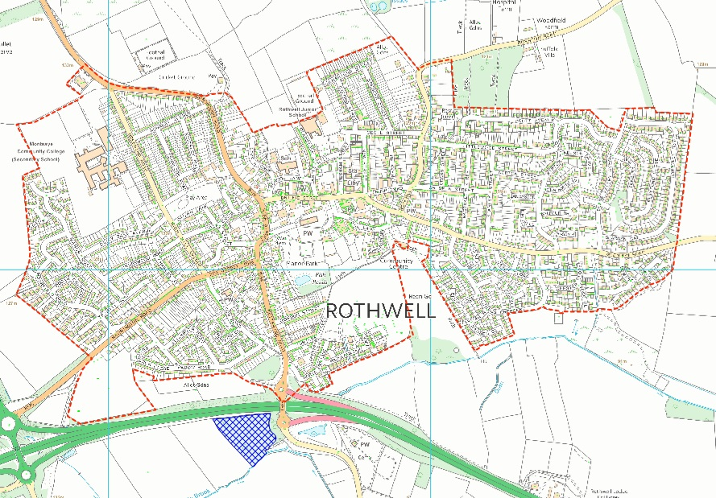

1.5.3 Broughton (page 54)
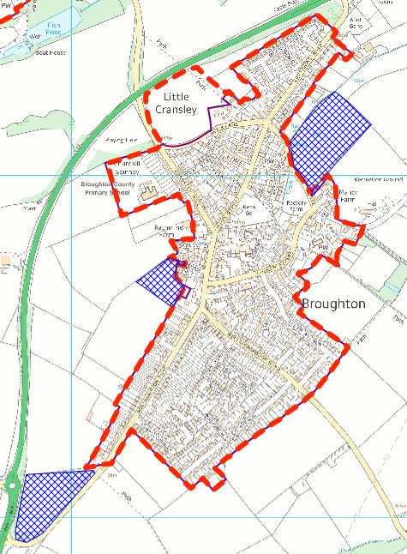

1.5.4 Wilbarston (page 89)
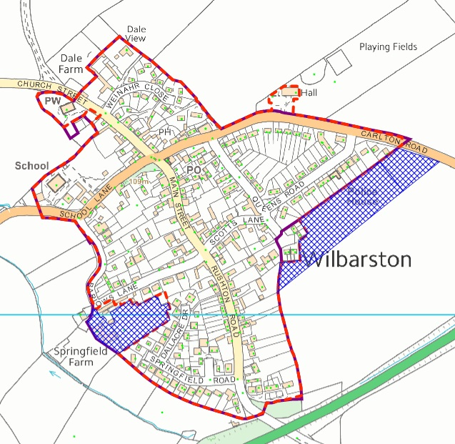
1.5.5 Geddington (page 121)
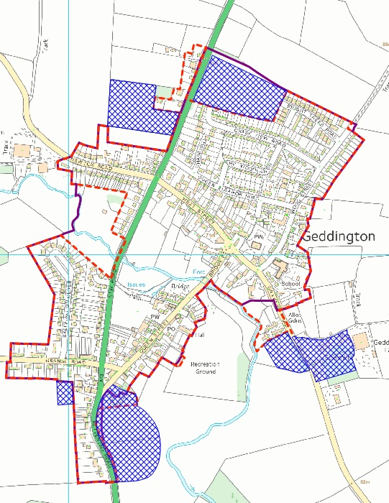

1.6 Changes to Settlement Boundaries
Two errors have been identified within the background paper relating to the settlements of Broughton and Geddington and their proposed boundaries. A revised map and corresponding text are provided below showing these corrections.
1.6.1 Broughton (pages 54 – 55)
New Site Ref. D
Land north and east of Crane Close (east of the Redrow site KET/2012/0709) is open land in use as a meadow/paddock and should be excluded from the settlement boundary in accordance with defining principles 1, and 3(d).
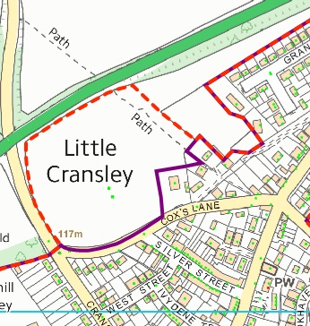
1.6.2 Geddington (pages 121 and 122)
Site Ref. B
Land at 41 – 33 Stamford Road was referred to as site ref B. Reference was made to a response given through the SSP LDD Options paper. It has been noted that this comment related to a gap site and not the group of existing properties. This gap site now benefits from extant outline permission for a new dwelling. As a correction to the original Background Paper, considered together with the existing dwellings, the gap site and row of dwellings should be included within the settlement boundary in accordance with defining principles 1 and 2(a), and 2(c). The stables, serving Redhouse Farm, Stamford Road (granted by planning permission KET/2008/0823) is included within the settlement boundary as it is co-joined with the permitted garage. However, land to the north of the stables is visually open and relates to the open countryside beyond. If developed, this may harm the character and structure of the settlement. As a result, this land is excluded from the settlement boundary in accordance with defining principles 1 and 3(c).
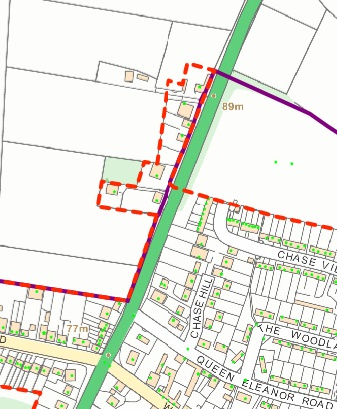
1.7 Changes to the Rothwell Sustainable Urban Extension (pages 38-39)
New Site Ref. G
Land north and east of Rothwell Cricket Ground (off Desborough Road) previously formed part of the Rothwell Sustainable Urban Extension (SUE) which is now identified as a strategic housing allocation within the emerging Joint Core Strategy. This site was omitted from the final SUE, but remains a potential housing site requiring further assessment – shown below as an orange hatched area.
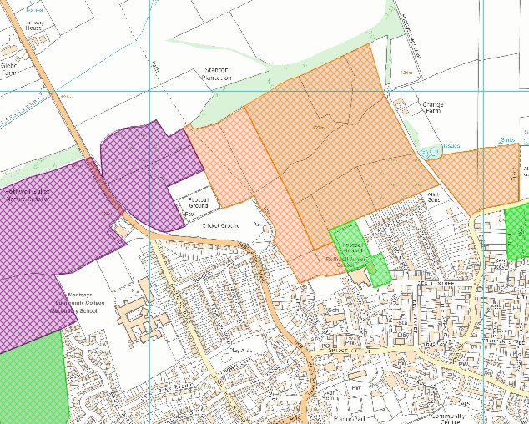

1.8 Overview of settlements within Kettering Borough
A short description of the type and size (including population numbers) of each settlement is included in the 2012 Background Paper – refer to pages 1 to 3. Details of whether a settlement boundary already exists for each settlement are also specified. An update will be included in the 2015 Background Paper prior to consultation in order to provide context to the information presented.
1.9 Desborough Greenspace
Criteria 3a states that boundaries will exclude playing fields or open space at the edge of settlements (existing or proposed). The settlement boundary for Desborough currently includes Desborough Greenspace.
This area of open space was not included in the Kettering Borough Open Space Needs Assessment (2007) as it was prepared prior to its development. This assessment work, however, is currently being updated and once completed the settlement boundary will be amended to exclude this area of open space.

- END -

