Appendix 2 - Kettering Borough Council

Draft Consultation Response

Introduction

The Council appreciates the opportunity to comment on proposals to close the County Court and Magistrates’ Court in Kettering. In 2010 this Council responded to the consultation proposal to close Kettering Magistrates’ courts. The reasons and rationale for retaining a court presence then still apply now and, due to the growth of North Northamptonshire over those five years and the anticipated future growth, that argument is strengthened. We wish to oppose the closure on the grounds that these proposals would
- harm access to, and the effectiveness of, justice in the area
- put intolerable burdens on courts elsewhere in the county
- put additional strains on other public and voluntary services
- damage the vitality of Kettering town centre
- run counter to the need to develop sustainable communities in growth areas such as this one, at a time of significant population and business growth
- reduce the numbers of local people able and willing to become magistrates in the future.

At the same time the Council recognises the key principles outlined in the consultation document around the Ministry of Justices (MOJ) key objectives of
- Ensuring access to Justice
- Delivering Value for Money and
- Enabling efficiency in the longer term

We believe we can help you to fulfil these objectives by working in partnership with Kettering Borough Council to utilise our estate to provide, at the very least, some of these essential local services. Our offer is outlined in section 7 of this response.
Some of these points you may recognise from our submission in 2010. We make no apology for that, they were important then and they are even more important now.

Kettering - Central Location & Growth

North Northamptonshire is a single functional area comprising individual yet interdependent towns, villages and rural areas set close together in a shared green infrastructure including the Nene Valley and Rockingham Forest. The three main towns of Corby, Kettering and Wellingborough are closely related (just 8 miles between adjacent town centres) with good transport links Kettering is the largest town in North Northamptonshire and additionally is in the geographic middle of all the towns the magistrates and County Court will serve. Thus public transport and access issues are best met in Kettering. .

This is illustrated in the diagram below

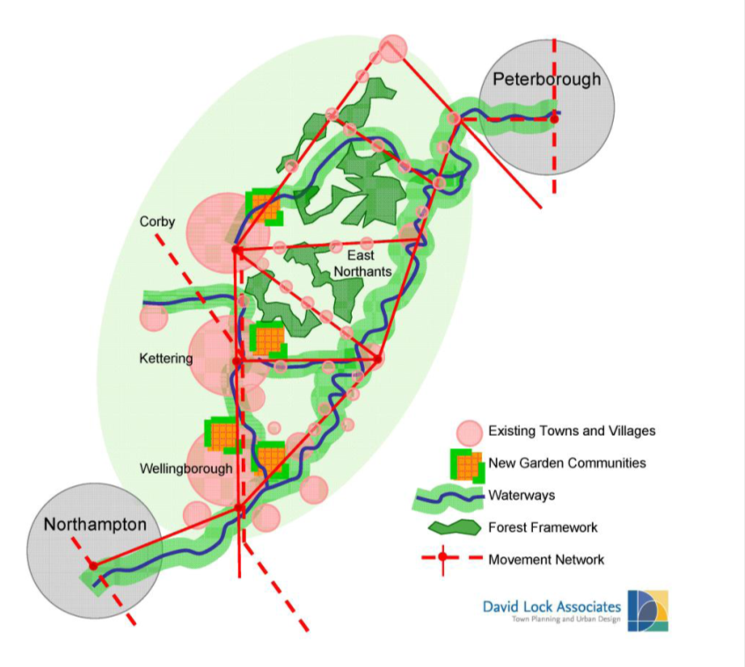

Kettering, and all of North Northamptonshire, was identified in 2001 as part of a growth area, and as a consequence of that, there has already been significant growth across the area, both in terms of housing and jobs. Kettering has been particularly successful in attracting new business to the area, in securing additional infrastructure commitment and in building new homes. Whilst it does not follow that there is a proportionate increase in the number of cases coming to court, it is inevitably the case that more people makes more work for public services of whatever kind. Similarly a more pro-active approach by public agencies to dealing with crime and anti-social behaviour generates a continued demand for court services Also, the magistrates’ court deals with a wide range of civil matters, with council tax, rent and business rate debts, with planning and environmental health enforcement, and parking and littering offences, all of which are functions of economic growth. Even allowing for more disposal of cases through on the spot fines, we cannot see that an 18% increase in population within the borough of Kettering and a 22% increase across North Northamptonshire justifies a reduction in court capacity of the kind proposed.
Attached as an annex are figures showing the actual rate of growth across North Northamptonshire in the last decade, and the projected rate of growth up to 2022. From this, it can be seen that Kettering has had the largest increase in absolute numbers of new homes, the largest increase in population and is set to maintain that level of growth.

Kettering Town Centre

Kettering town centre is the largest town centre in the county outside Northampton, and benefits from its central location in the centre of the area, drawing in shoppers from the surrounding towns.

The same pattern is true, on a larger scale, for the night time economy, and indeed, the night time economy inevitably gives rise to a significant number and type of offences which find their way to court.

The Council’s redevelopment and revitalisation of the town centre are well developed, with the new market place and restaurant quarter, town centre events calendar, additional retail offer and the development of a new office hub based around the nearby railway station. Combine this with an additional 1,000 new homes, all within the town centre and it is clear that it will be harmful to the centre, as well as unhelpful for local people and the legal profession for a growing town to be deprived of one of its principal public services.

Kettering’s Multi-Agency Hub

As you know we have most public services operating out of our Bowling Green Road /London Road building, Health CAB, etc. In this context, the two key partners are the Police and the Probation Service. The former are already based here, the latter will relocate their operations here very shortly. In additions we are currently working with JobCentre Plus on plans to relocate there services to our site.

The multi-agency hub provides a range of linked services in one place that “wrap around” the customer. For the court customer this could provide on-site and joined up debt, housing, job and benefit advice.

This is not just a council vision. It is a reality that is already operating in our building.

Kettering - New Criminal Justice Centre

The Police are locating their new Criminal Justice Centre in Kettering therefore a Kettering base would provide:-
i. A more accessible and convenient location for attendees of the court.
ii. A venue where the key supporting public services – Police and Probation – are already on site facilitating maximum efficiency and co-ordination.
Kettering –and the Future Supply of Magistrates

Losing the Corby and Kettering benches will reduce the number of people willing and able to become magistrates and reduce the attractiveness of being a magistrate. Magistrates will incur additional time off work for travelling to and from other locations and additional costs. The principle of magistrates courts, that justice should be rendered locally by local people, will be undermined if a town of 60,000 people, and a catchment area of well over 100,000 cannot be seen to support its own magistrates bench.

Delivering Value for Money and efficiencies in the longer term

The consultation paper estimates the total annual revenue costs of both the Kettering County and Magistrates’ Courts at a total of £186,000.

The relocation of the magistrates’ and County Court to the Borough Council offices would not only reduce these annual revenue costs considerably, whilst still providing a local service, but in addition would have the added longer term benefit of releasing two buildings from the MOJ estate in prime town centre locations.

Kettering – Our Offer to HM Courts & Tribunal Service

As stated earlier in this document this Council recognises that the Courts Service needs to realise its three key objectives

- Ensuring access to Justice
- Delivering Value for Money and
- Enabling efficiency in the longer term

but believes this can be done by means other than losing a vital public service in a growing town and district and we believe that we can assist in keeping a court presence in Kettering.

Both the Magistrates Court and the County Court are centrally located in town; so are the Borough Council’s offices. The Borough council has a well-regarded, award winning, and well advanced programme of combining multiple public services in shared locations, around a customer service offer which embraces local authority, policing, probation, health, tax and voluntary sector advice services.

We would like to propose to the courts service that we could facilitate the continued provision of a court presence in Kettering by joint use of the Council’s estate for this purpose.

The Council Chamber is capable of being used in the daytime by the court service, just as it is currently at weekends by the registrar’s service for weddings, and by the Council for evening meetings and events.

We have the ability in the space available in the Municipal offices to replicate facilities that Kettering magistrates court has now, at less revenue cost than currently incurred by the HM Courts and Tribunal Service. We believe we can benefit both our organisations, and the wider community, by relocating the magistrates’ court, and the county court. This will release two buildings in the HMCS estate for sale, which in turn will assist the Council’s own redevelopment plans for key sites in town.

