Site Specific Proposals
Local Development Document

Background Paper: Settlement Boundaries (Update)

September 2015

CONTENTS PAGE NO

- INTRODUCTION 1

- BACKGROUND 2 – 4

- METHODOLOGY FOR DRAWING SETTLEMENT 4 - 7
BOUNDARIES

- REVIEW OF SETTLEMENT BOUNDARIES 7 – 152

- INTRODUCTION

1.1 The purpose of this background paper is to provide an update to the Site Specific Proposals Local Development Document (SSPLDD) Background Paper: Settlement Boundaries published in February 2012. Together with other updated technical reports, this document will form an up-to-date evidence base to support the progress of the Site Specific Local Development Documents and adoption of part 2 of the Local Plan.
  - As proposed housing and employment site allocations will affect the extent of proposed settlement boundaries, once confirmed these additional allocations will be incorporated into the final version of this paper. Inclusion of these sites will be undertaken in accordance with principles 2(d) and 3(b) of the existing criteria set out in the Site Specific Local Development Document (SSPLDD) Background Paper: Settlement Boundaries (February 2012).

  - The rest of this Background Paper is set out three further sections. Section 2 of this Paper explains the historic work undertaken so far in terms of defining boundaries for the majority of settlements within the Borough of Kettering, as well as identifying those settlements which do not have defined boundaries. An explanation of the work carried out so far which has contributed towards this update is also set out.

  - Section 3 of this Paper sets out the methodology used for defining settlement boundaries within the Borough of Kettering, as well as the process and principles applied when making changes to them.

  - Section 4 of this Paper covers the current review of settlements located within the Borough, taking into account consultation feedback received through the SSP LDD – Options Paper consultation, and current assessment work. Section 4 includes maps of each settlement which have a settlement boundary, together with all proposed changes. A table accompanies each map to provide further explanation to the proposed changes.

- BACKGROUND

2.1 On 30th January 1995 the Local Plan for Kettering Borough was adopted, which included proposals maps for each settlement to define their boundaries. These were underpinned by a number of Local Plan policies which provided detail on types of development suitable within and outside of these boundaries. Relevant Local Plan policies have now been saved and are used together with other Development Plan policies to inform planning decisions with respect of the location of new development.

  - In 2005, work commenced on the review of these settlement boundaries and a set of principles were created to define the extent of the settlements. Preparation of the SSPLDD – Issues Paper took this work forward and developed a draft list of defining principles used to define the extent of settlement boundaries.

  - Consultation on the SSPLDD Issues Paper was carried out between 9th March and 20th April 2009, and gave rise to strong support on the use of settlement boundaries and retention of existing settlement boundaries. Support was also given to the use of settlement boundaries for the following settlements:

- Thorpe Malsor
- Harrington
- Sutton Bassett
- Ashley
- Pytchley
- Little Oakley

  - At the same time, the creation of a settlement boundary for the new village of Mawsley was supported, leaving the following settlements within open countryside and without settlement boundaries:

- Brampton Ash
- Dingley
- Orton
- Pipewell

  - Findings of this consultation exercise were reported to Planning Policy Committee on 1st September 2009.

  - The SSPLDD Background Paper: Settlement Boundaries (February 2012) takes forward this earlier work, and incorporates additional town and parish council comments which were previously sought.

  - In summary, the SSPLDD Background Paper: Settlement Boundaries (February 2012) sought to assess the most suitable approach for dealing with new development in the countryside, looking at the use of either settlement boundaries or criteria based policies. The SSPLDD Background Paper: Settlement Boundaries (February 2012) also updated the ‘settlement boundary defining principles’ and pre-existing settlement boundaries taking into account the SPPLDD Issues Paper consultation feedback.

  - Specifically, minor changes to the wording of ‘Settlement Boundary Defining Principle’ 2 (c) and 3(c) were made, and principle 3(b) was updated to relate solely to exclusion of affordable housing from the settlement boundary. Principles relating to the inclusion within boundaries for ‘new allocations’, and the exclusion from boundaries of large gardens/visually open areas (3d) and similar areas which if developed or included within the settlement would harm the structure, form and character of the settlement (3e). A list of current Settlement Boundary Defining Principles is provided at paragraph 3.2 of this paper.

  - The paper also sets out a methodology for reviewing settlement boundaries, based on an iterative desktop analysis and site visit approach, with additional consultation with parish councils where appropriate.

  - Following this work, the revised settlement boundaries have been subject to further consultation through the SSPLDD – Options Paper which took place between 12th March – 23rd April 2012; comments received were reported to Members of Planning Policy Committee on 4th September 2012, but no further work has been carried out to feed in the latest consultation comments into the settlement boundary review.

  - Due to a delay in the submission and adoption of the emerging Joint Core Strategy (Part 1 of the Local Plan), progress on Part 2 of the Local Plan (Site Specific Plan Local Development Documents) has also been delayed, affecting the currency of this earlier background study work which will be relied upon as an evidence base when submitting part 2 of the Local Plan for examination.

  - In addition to this, site allocations for new housing and employment for the plan period remain outstanding and will affect the extent of the final settlement boundaries. As a result, a review of the last Site Specific Proposals Local Development Document (SSPLDD) Background Paper: Settlement Boundaries (February 2012) is now required, in order to progress the Site Specific Plan Local Development Documents (Part 2 of the Local Plan) to submission stage and provide an up-to-date evidence base.

- METHODOLOGY FOR DRAWING SETTLEMENT BOUNDARIES

  - The SSPLDD - Issues Paper set out a draft list of principles which could be applied either when defining settlement boundaries or in preparing a criteria based policy. These principles were based on previous work commenced in 2005, and were updated through the SSPLDD – Background Paper: Settlement Boundaries (February 2012) taking into account consultation responses to the SSPLDD - Issues Paper Consultation. These provide the current criteria for assessing the current settlement boundaries and are set out below in paragraph 3.2.

  - Settlement Boundary Defining Principles
Principle 1:

The boundary will be defined tightly around the built up framework and where
possible will follow defined features such as walls, hedgerows and roads.

Principle 2:

Boundaries will include:

a) Existing commitments for built development i.e. unimplemented
planning permissions;

b) Buildings on the edge of settlements which relate closely to the
economic or social function of the settlement e.g. churches,
community halls;

c) Curtilages which are contained and visually separated from the
open countryside;

d) New allocations.

Principle 3:

Boundaries will exclude:

a) Playing fields or open space at the edge of settlements (existing or
proposed);

b) New allocations for affordable housing;

c) Isolated development which is physically or visually detached from
the settlement (including farm buildings or agricultural buildings on
the edge of the settlement which relate more to the countryside
than the settlement);

d) Large gardens and other open areas which are visually open and
relate to the open countryside rather than the settlement;

e) Large gardens or other area whose inclusion or possible
development would harm the structure, form and character of the
settlement.

Principle 4:

Settlement boundaries do not need to be continuous. It may be appropriate
given the nature and form of a settlement to define two or more separate
elements.

3.3 As part of the work to update the existing settlement boundary background paper the following work is required to ensure that it is up-to-date and provides a robust evidence base to support adoption of Part 2 of the Local Plan.

3.4 Desk Top Study - Initially a desk top review of the local plan boundaries will take place. This review will apply the principles set out above using aerial photography and GIS maps. This will allow an initial view to be taken as to where the boundary should be drawn. Where it is considered that the boundary may need to be amended this will be recorded. The desk top review will result in a set of draft boundaries. In summary, the desktop review will consider the following matters:

- Review of Comments received through the SSPLDD – Options Paper Consultation;

- Review of Extant Consents and Lawful Development;

- Review of any other changes to pre-existing land uses to address errors/inconsistences;

- Review site allocations coming forward through work on the SSPLDD – Pre-Submission Paper.

3.5 Site Visits - Following the desk top review site visits will take place to assess the draft boundaries. It is not possible to assess the boundaries purely using GIS mapping as this does not allow consideration of the form and character of the settlement. Decisions made on the site visits will be noted and where
appropriate photos will be taken to illustrate why a decision was made.

- REVIEW OF SETTLEMENT BOUNDARIES

  - This section of the paper reviews the settlement boundaries, using the methodology above, on a settlement by settlement basis. For each settlement there is a map showing the existing boundary which is annotated to show where changes are proposed and where they have been considered. These maps are accompanied by a table which provides detail on how and why decisions relating to the boundaries were made and how they accord with the relevant settlement boundary defining principles.

  - The boundaries do not currently include all new housing or employment allocations as not all sites promoted for allocation have been assessed for development and will be consulted on during the options paper consultation. Sites considered suitable for allocation will be added to the boundaries prior to consultation on the proposed submission plan. This may also include strategic employment or housing sites which come forwards through adoption of the North Northamptonshire Joint Core Strategy.

  - Table 1 below shows comments received during the Options Paper consultation relating to specific alterations to settlement boundaries. These have been taken into account when assessing the individual boundaries.

Table 1: Summary of comments to the SSPLDD – Options Paper Consultation
Options Paper summary of comments (numbers in brackets are the number of respondents) |  | Proposed Amendments
Ashley  Question - Do you agree with the proposed settlement boundary, subject to the inclusion of new allocations? | - Disagree with enlargement to include site RA/162. (22)  - Agree / Strongly Agree (19)  - Disagree with enlargement to include site RA/137. (2)  - Disagree/Strongly Disagree (21)  - Sites RA/162 and/or RA/137 should be included within the development boundary (3). | 1. Site discounted as potential housing option and not included.  2. No additional changes required.  3. Site discounted as potential housing option and not included.  4. None additional changes required  5. No changes have been made. Site RA/137 has significant constraints (e.g. impact on linear character of the village, setting of listed buildings and Conservation Areas). The site has been discounted. RA/162 has received significant objection has been discounted.
Brampton Ash  Question - Do you think Brampton Ash should continue to be considered as scattered development in the open countryside? If not, should a village boundary be drawn? | - No comments received regarding creation of a settlement boundary. | 1. No change. Settlement to remain in open countryside.
Braybrooke  Question - Do you agree with the proposed settlement boundary, subject to the inclusion of new allocations? | - Disagree/Strongly Disagree (94)  - Site RA/128 should be excluded (87)  - Site RA/128 should be included (1)  - Site RA/143 should be excluded (1)  - Agree/Strongly agree (1) | - A review of HVI’s has determined (Planning Policy Meeting on 31.07.14) that HVI007 should remain designated. As open space on the edge of the settlement it should be excluded from the settlement boundary in accordance with Principle 3(a) of the assessment criteria.  - Part of site RA/128 remains a potential housing option. If this site is progressed as an allocation it will be added to the boundary prior to consultation on the proposed submission plan.  - Part of site RA/128 remains a potential housing option. If this site is progressed as an allocation it will be added to the boundary prior to consultation on the proposed submission plan.  - Site RA/143 has been discounted as a potential housing option due to constraints with access and delivery services and will be excluded from the proposed settlement boundary.  5. Noted.
Broughton  Question - Do you agree with the proposed settlement boundary, subject to the inclusion of new allocations? | - Disagree/Strongly Disagree (29).  - Site RA/127 should be excluded (1).  - Site RA/15 employment allocation should be included (1).  - Generous Settlement boundaries sought to increase land availability (1).  - Site RA/098 housing allocation should be excluded (1).  - Agree/Strongly Agree (8).  - Site RA/098; RA/127; RA/096; RA/101; and RA/094 should be excluded. (1)  - No new allocations should be made (4) | - Noted.  - Site RA/127 remains included as a potential housing option subject to access through RA/098. If the site is progressed through the SSPLDD the boundary will be amended.  - Employment site RA/15 remains a potential employment option and will be included within the settlement boundary if it remains so.  - Current principles guiding settlement boundaries seek a tight boundary. The provision of a 5 year housing land supply will address these concerns.  - This site is retained as a proposed housing – focused option and benefits from extant planning consent (KET/2012/0709; 2013/0773) which is currently being implemented.  - Noted  - As per points 2 and 5 re RA/098 and RA/127. Site RA/096 has been discounted and will not be included within the settlement boundary. RA/101a is to be retained as a potential housing allocation subject to no more than 12 dwellings being delivered. RA/094 also remains a potential housing allocation and is split between 2 sites.  - See above comments.
Cranford  Question - Do you agree with the proposed settlement boundary, subject to the inclusion of new allocations? | - Agree (1) | - No additional action required.
Dingley  Question - Do you think Dingley should continue to be considered as scattered development in the open countryside? If not should a village boundary be drawn? | - Agree/Strongly Agree (12)  - Disagree/Strongly Disagree (1)  - The village is in two parts and could have two settlement boundaries (1) | - No additional action required.  - Noted.  - It is considered that the village remains a scattered settlement largely focusing around Dingley Hall with scattered dwellings. Although the village benefits from a church (community building) the settlement is severed by the busy A427 Harborough Road affecting its character and structure.
Geddington  Question - Do you agree with the proposed settlement boundary, subject to the inclusion of new allocations? | - Agree with the inclusion of sites RA/107, RA109, and RA110 (2)  - Disagree with inclusion of RA/108 as a potential employment site (2)  - Disagree / Strongly Disagree (3)  - Site RA/102 should be included within the settlement boundary (2)  - 39 Stamford Road should be included within the settlement boundary.  - Agree / Strongly Agree (2) | - These sites remain potential housing allocations and may be incorporated into the final settlement boundary.  - This site remains a proposed employment option which if taken forwards through the SSPLDD will be incorporated into the settlement boundary.  - This site was discounted through the options paper, but development of the site of this scale would not be consistent with the growth strategy set out in the CSS or emerging JCS which maintains a primary focus on growth towns.  - Site RA/102 has been discounted as a housing allocated option and will be excluded from the settlement boundary.  - The properties on this side of the settlement are stated in response to the Options Paper consultation to have an open appearance which relates better to the open countryside and maintains a rural feel. It should therefore be excluded from the settlement boundary. However, it is considered that they do have a social relationship with the village and are part of it. As a result, the site should be included within the settlement boundary.  - No additional action required.
Glendon  Question - Do you think Glendon should continue to be considered as scattered development in the open countryside? If not, should a village boundary be drawn? | - No comments received. | - No action to take.
Grafton Underwood  Question - Do you agree with the proposed settlement boundary, subject to the inclusion of new allocations? | - Disagree / Strongly Disagree (2)  - Agree to inclusion of RA/114 (1)  - Disagree with the exclusion of RA/113 (1) | - Noted.  - Site RA/114 has been discounted due to a large number of objections received through the SSPLDD – Options Paper consultation, limited services and facilities within the village and limited local need for new development.  - Site RA/113 has been discounted due to a large number of objections received through the SSPLDD – Options Paper consultation, limited services and facilities within the village and limited local need for new development.
Great Cransley  Question - Do you agree with the proposed settlement boundary, subject to the inclusion of new allocations? | - Agree / Strongly Agree (2)  - Disagree / Strongly Disagree (2)  - Site RA/112 should be included within the settlement boundary (2) | - No additional action required.  - Noted  - Site RA/112 is stated in the Options paper response to have been discounted due to impacts on Cransley Hall. However, the SSPLDD – Housing Allocations Update (Oct 2013) confirms it benefits from extant consent KET/2013/0306 for a dwelling which has been implemented. The site will therefore be included within the settlement boundary.
Harrington  Question - Do you agree with the proposed settlement boundary, subject to the inclusion of new allocations? | - Disagree / Strongly Disagree (1)  - Agree / Strongly Agree (1) | - Noted  - No additional action required.
Little Oakley  Question - Do you agree with the proposed settlement boundary, subject to the inclusion of new allocations? | - No comments received. | - No action to take.
Loddington  Question - Do you agree with the proposed settlement boundary, subject to the inclusion of new allocations? | - Disagree / Strongly Disagree (22)  - Exclude changes near 97 Harrington Road and the back of Hall Close.  - Garden serving No 4 Sterling Court has been omitted from the boundary changes.  - Include land to the rear of 77 Harrington Road within the settlement boundary (5)  - Extend boundary to include potential garden extensions serving 85a – 99 Harrington Road (1) | - Noted  - The settlement boundary includes existing garden land and accords with the approved principles for defining the settlement boundary.  - Part of the garden has now been included, but part has been excluded on the basis of defining Principle 3(d) and 3(e).  - Planning permission KET/2015/0477 was permitted on 14.08.15 which includes the land referred to. As an extant consent, defining Principle 2(a) supports its inclusion within the settlement boundary.  - Site does not benefit from planning. Land is currently open and in use as agriculture. As a result, inclusion within the settlement boundary would conflict with defining Principle 3(d).
Mawsley  Question - Do you agree with the proposed settlement boundary, subject to the inclusion of new allocations? | - Agree / Strongly Agree (2)  - Inclusion of RA/115 supported (1)  - Disagree / Strongly Disagree (7)  - Boundary should not include site RA/115 | - Noted  - Site RA/115 has been discounted as a housing option due to significant amount of objections, and potential access to the site.  - Noted.  - As per point 2.
Newton  Question - Do you agree with the proposed settlement boundary, subject to the inclusion of new allocations? | - Agree / Strongly Agree (1)  - Inclusion of site RA/130 (1) | - Noted  - Site RA/130 is a potential housing option and will be included if the site is progressed through the SSPLDD.
Orton  Question - Do you think Orton should continue to be considered as scattered development in the open countryside? | - No comments | - No action to take.
Pipewell  Question - Do you think Pipewell should continue to be considered as scattered development in the open countryside? | - Agree / Strongly Agree (1)  - Disagree / Strongly Disagree (1) | - Noted.  - Noted.  Conclusion  There is both support and objection to the creation of a settlement boundary. Previous decision has been to treat Pipewell as a scattered settlement which most closely represents its character.
Pytchley  Question - Do you agree with the proposed settlement boundary, subject to the inclusion of new allocations? | - Disagree / Strongly Disagree (1)  - Agree / Strongly Agree (2) | - Noted  - Noted
Rushton  Question - Do you agree with the proposed settlement boundary, subject to the inclusion of new allocations? | - Disagree / Strongly Disagree (1)  - Proposed settlement boundary excludes garages on Manor Road which should be included (1) | - Noted  - Site identified as RA/190 discounted as a potential housing option as it has a negative impact and is constrained.
Stoke Albany  Question - Do you agree with the proposed settlement boundary, subject to the inclusion of new allocations? | - Disagree / Strongly Disagree (1)  - Allocate new sites for housing (e.g. RA/193, RA/160) (2)  - Agree / Strongly Agree (3)  - Boundary should not include RA/120 (2)  - Village boundaries should be co-joined | - Noted  - All identified sites (RA/120/RA160/ RA/147, RA/193) have been discounted as housing options sites, due to impacts on the countryside and character of the village, or significant site constraints.  - Noted  - See response 2.  - It is stated within Background Paper: Rural Masterplanning that the gap between the two elements of the village boundary is an important aspect of the village’s unique character. Defining Principle 4 also states that ‘settlement boundaries do not need to be continuous’.
Sutton Bassett  Question - Do you agree with the proposed settlement boundary, subject to the inclusion of new allocations? | - Agree / Strongly Agree (3)  - Disagree / Strongly Disagree (2)  - Area in green (site 41) either side of the road should be included within the settlement boundary (2)  - Development south of the village, opposite the church and north of the village to the west should be considered (1) | - Noted  - Noted  - These sites are identified as Historically and Visually Important Open Space. They were identified as housing option sites RA/196 and RA/197 and discounted due to significant constraints (i.e. the HVI)  - Sites RA/198 and RA/199 (south of the village have been discounted as housing options sites, as have RA194 (opposite the church) and RA/195 (north of the village). No other sites have been identified or come forwards. As a result, the village boundary will not be altered as a result of new housing sites.
Thorpe Malsor  Question - Do you agree with the proposed settlement boundary, subject to the inclusion of new allocations? | - Disagree / Strongly Disagree (1)  - Village boundary should be extended northwards (1) | - Noted  - The Background Paper: Settlement Boundaries looked at extending the village boundary further north of the village to include Farm Buildings, the paper concluded that the buildings are agricultural in nature and relates better to the open countryside and therefore should remain outside of the village boundary for this reason.
Thorpe Underwood  Question - Do you think Thorpe Underwood should continue to be considered as scattered development in the open countryside? If not, should a village boundary be drawn? | - No comments received. | - No action to take.
Warkton  Question - Do you agree with the proposed settlement boundary, subject to the inclusion of new allocations? | - Disagree / Strongly Disagree (1).  - Supported that Moorfield Farm (including its entrance) is designated as an employment site and included within the settlement boundary (1).  - Land east of Warkton should be included within the settlement boundary (1).  - Land south west of Warkton (west of Is brook farmhouse) in use as 6 commercial units and should be included within the settlement boundary.  - Agree / Strongly Agree (1). | - Noted  - Units identified as being in use for agriculture have been excluded from the settlement boundary as they relate to open countryside. Other units now in use for commercial use remain included within the settlement boundary.  - This land has been granted planning permission KET/2014/0262 for a single dwelling. As the permission is extant, the site has been included within the settlement boundary.  - Buildings are agricultural in character and have been excluded from the settlement boundary in accordance with defining Principle 3(c).  - Noted
Weekley  Question - Do you agree with the proposed settlement boundary, subject to the inclusion of new allocations? | - Disagree / Strongly Disagree (1).  - Wash Well Lane site should be assessed to be included as a housing allocation site (2). | - Noted  - The Wash Well Lane land will be assessed against the housing allocations background paper (February 2012).
Weston by Welland  Question - Do you agree with the proposed settlement boundary, subject to the inclusion of new allocations? | - Agree / Strongly Agree (3).  - Car parking area, garden lawn and vegetable patch immediately to the rear of the residence No 6 the Green should be included within the settlement boundary. (1)  - Proposed housing option site RA/136 is supported for inclusion within the settlement boundary. | - Noted  - Part of this land is now incorporated into the land as it directly serves the property. However, in accordance with Principle 1 and Principal 3(e) not all of the land has been included as the development of the site would harm the character and structure of the settlement.  - Site RA/136 remains a potential housing site within the SSPLDD. If the site is progressed through the SSPLDD it will be included in the boundary.
Wilbarston  Question - Do you agree with the proposed settlement boundary, subject to the inclusion of new allocations? | - Disagree / Strongly Disagree (1).  - Agree / Strongly Agree (1).  - Support the inclusion of RA/200 and RA/201.  - Support the inclusion of RA/172 | - Noted  - Noted  - Both RA/200 and RA/201 which were promoted as mixed and affordable housing have been discounted due to their adverse impact on the landscape and drainage constraints. They will not be included within the settlement boundary.  - Site RA/172 remains a potential housing option, but for affordable housing. Defining Principle 3(b) states that allocations for affordable housing should be excluded from the settlement boundary.

4.4. The following plans set out recommended changes to the settlement boundaries for each settlement within the borough of Kettering, with the exception of Brampton Ash, Dingley, Orton and Pipewell which shall remain as scattered settlements within open countryside. These changes are made in accordance with the settlement boundary defining principles.
4.5 The key below explains the markings on each map and what they represent, in order to aid the reader’s interpretation of the changes which are now recommended.

Key
 | Proposed Strategic Employment Allocation (Joint Core Strategy)
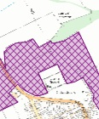 | Proposed Sustainable Urban Extension (Joint Core Strategy)
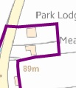 | Existing Settlement Boundary
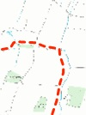 | Proposed Settlement Boundary
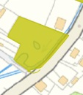 | Historic and Visually Important Open Space
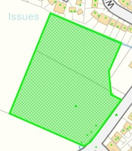 | Proposed Housing Allocation – Recommended for Progression
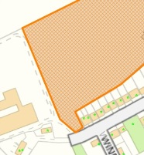 | Proposed Housing Allocation – Recommended for Further Assessment
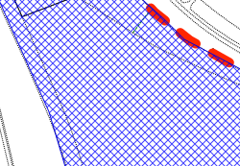 | Potential Employment Option

4.6 KETTERING
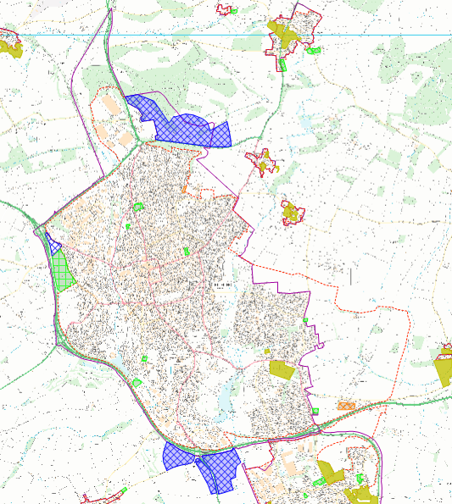
G
H
D
E
B
F
K
L
J
I
M
AAAAA
C
A
N

Map Reference | Site Ref | Issue | Relevant Criteria | Further Investigation Required | Findings/ Conclusions
Rothwell Road adjacent Brewsters to the Crematorium. | A | Land south of Rothwell Road is agricultural and not developed. This is currently included within the settlement boundary. This section of Rothwell Road can be removed from the settlement boundary. | Principle 1. | 1) Review planning history. | No relevant planning history on adjacent land.  Conclusion  Exclude highway from settlement boundary.  Site K2 which is a potential employment option is located west of this area. If this site is progressed the boundary will be amended.
A14 and landscape buffer from junction 7 – 9 and up to East Midlands Mainline. | B | Parts of A14 (J7-9) and up to east midlands mainline, located within settlement boundary. North side of A14 should form the boundary to provide a tight settlement boundary. | Principle 1. | - Review aerial map. | 1) A14 demarcates the town boundary for Kettering which is located north of the trunk road. As a result, a tight boundary would follow the northern side of the trunk road. The A14 itself should therefore be excluded from the settlement boundary.
Land west of Gipsy Lane (no’s 5 Langsett Close - 96 Gipsy Lane). | C | Land subject of pending housing application KET/2015/0551 for 350 dwellings. | Principle 1, 2(a). | 1) Review planning history. | 1) Outline planning permission is currently being considered, and determination of KET/2015/0551 is pending. The site is also identified as a housing allocation to be taken forwards for consideration and public consultation.  Conclusion  Inclusion of the site within the settlement boundary is premature at this stage, and should be excluded in accordance with Principle 1.
Linear Park Land north of A14 and south of Wicksteed Park. | D | Park is open space located on the edge of the settlement and should be excluded from the settlement boundary. | Principle 1, 3(a). | 1) Review planning history. | 1) No relevant planning history.  Conclusion  Exclude site from settlement boundary as located on edge of settlement. This will achieve a tighter boundary Principle 1 and accord with Principle 3(a).
A14 east of East Midlands Mainline to j10. | E | Parts of A14 (East Midlands Mainline – j10) located within settlement boundary. North side of A14 should form the boundary to provide a tight settlement boundary. | Principle 1 | - Review aerial map | - A14 demarcates the town boundary for Kettering which is located north of the trunk road. As a result, a tight boundary would follow the northern side of the trunk road. The A14 itself should therefore be excluded from the settlement boundary.
Land east of Kettering. | F | KET/2013 /0514 and KET/2008/0274 grants planning permission for 5500 dwellings. | Principle 1, 2(a) | 1) Review planning history. | 1) There is extensive planning history for the site which is being brought forwards to delivery stage. As a committed site for residential development, it should be included within the settlement boundary in accordance with Principles 1 and Principle 2(a).
Margaret Road Allotments. | G | Allotments are an open space, which in this instance is located on the edge of the settlement boundary. | Principle 1, 3(a). | 1) Review aerial photography. | 1) Existing use pre-existed in 2000. Epoch layer also shows allotments in 1945.
Charlotte Place Play Area and Open Space. | H | Open Space and Play Area located on the edge of the settlement. | Principle 1, 3(a). | 1) Review aerial photography. | 1) Existing use pre-existed in 2000. Epoch layer also shows allotments in 1945.
Playing fields north of 41 Scott Road – 18 Weekley Glebe Road. | I | Site is open space located on the edge of the settlement. | Principle 1, 3(a). | 1) Review planning history. | 1) Permissions KET/2010/0043; KET/2013/0243 give consent for a new school with play area and playing fields surrounding. Open space located on the edge of the settlement should be excluded in accordance with Principle 3(a); this also provides a tighter settlement boundary in accordance with Principle 1.
Woodland adjacent 9 Milton Courts – 31 Long Fellow Drive – 22 Malvern Close and adjacent allotments. | J | Woodland is landscape buffer to residential development and allotments are open space which should be excluded from the settlement. | Principle 1, 3(a). | 1) Review aerial photography. | Conclusion.  Exclude woodland and allotment open space.
43 – 44 Weekley Wood and Weekley Hall Farm. | K | Isolated dwellings. | Principle 1, 3(c). | 1) Review planning history.  2) Review aerial photography. | 1) Site identified as a strategic employment site.  2) Weekley Hall Farm has roofs missing in 2014. 43-44 Weekley Wood appear in use as dwellings.  Conclusion  Buildings are located in an isolated position, but within a strategic employment site being taken forward to examination through the emerging JCS. As part of a strategic employment site, they should be included within the settlement boundary.
Weekley Wood. | L | Weekly Wood includes woodland which is both within and outside of a strategic employment site included in the JCS. Some of the land currently within the settlement boundary includes high levels of heritage sensitivity. | Principle 1. | 1) Review planning history. | 1) Site identified for strategic employment and being taken forward through the emerging JCS under policy 36, which seeks to protect heritage assets and wildlife sites.  Conclusion  It is premature to include the Strategic Employment site until the JCS has undergone examination and adoption. The site and other parts should be excluded from the settlement boundary at this stage.
Land north and west of North Kettering Business Park and John Lowther Training and Activity Centre. | M | Land is has a rural appearance and currently located within the settlement boundary. | Principle 1, 3(d). | 1) Review planning history.  2) Review aerial photography. | 1) KET/2006/0157 grants permission for a linear park. As open space on the western edge of the business park, it should be excluded from the settlement boundary in accordance with Principle 3(d). There is no relevant planning permission for land north of the business park; its exclusion from the settlement boundary would accord with Principle 1.
A43 from North Kettering Business Park to Junction 7 of A14. | N | No development located north of the highway and discounted as a potential employment site. | Principle 1. | 1) Review planning history. | 1) Land north of A43 does not benefit from extant consent, and has been discounted as a strategic employment site. The land is currently  Conclusion.  Exclude site from settlement boundary

4.7 DESBOROUGH
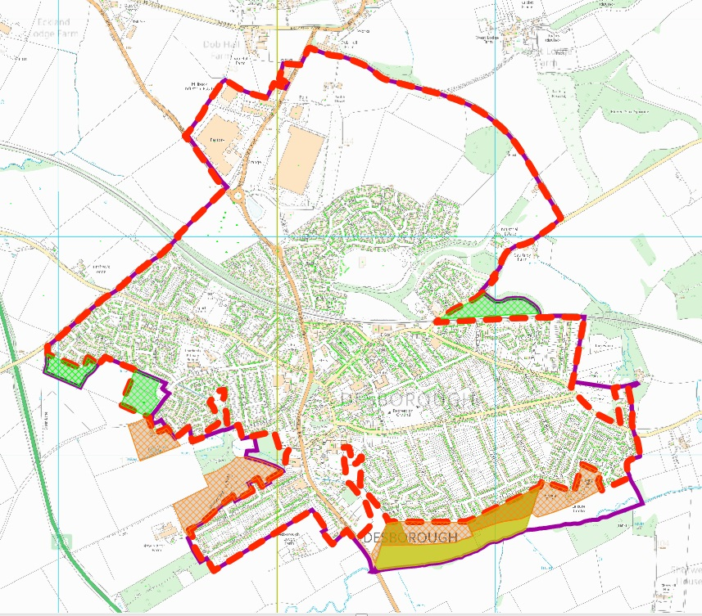
G
F
E
D
C
H
A
B
Map Reference | Site Ref. | Issue | Relevant Criteria | Further Investigation Required | Findings/ Conclusions
Agricultural land and Public Open Space located between Rothwell Road to the west and Sycamore Drive to the East. | A | Land is in use as agriculture or public open space and located on the edge of the settlement, but currently included within the settlement boundary. | Principle 1. | 1) Review planning history. | 1) Part of open space, agricultural land, and old leisure centre site are identified as a potential housing allocation site requiring further assessment and public consultation. If progressed though the SSPLDD boundary will be amended.  Conclusion  It is premature to include this site within the settlement boundary and it should be excluded to form a tight boundary in accordance with principle.
Rushton Road Cemetery. | B | Cemetery is located on the edge of the settlement and is defined as open space. Principle 3(a) states it should be excluded from the settlement boundary. | Principle 1, 3(a). | 1) Review aerial photography. | 1) Land north of cemetery is allotments which are also Public open space, beyond which there is a paddock and isolated rural dwelling.  Conclusion  Exclude site from settlement boundary and create a tight settlement boundary in accordance with Principle 1 and Principle 3(a).
Land south west of Bleaklow Close to 8 Eyam Close. | C | Land identified as site DE/188 for potential housing allocation, which is recommended to be progressed, and currently included within settlement boundary. | Principle 1. | - Review planning history  - Review aerial photography. | 1) Site is recommended for progression through the SSPLDD to pre-submission stage as a new site with few constraints. If the site is progressed through the SSPLDD the boundary will be amended.  2) Site is in use as agriculture.  Conclusion  Until public consultation is carried out and site adopted as a housing allocation, it is premature to include the site within the settlement boundary. As an agricultural use, it should be excluded from the settlement boundary at this time, in order to achieve a tight boundary in accordance with Principle 1.
Land adjacent 15 Upper Dane – The Orchard, Harrington Road. | D | Site benefits from planning permission (KET/2012/0780; KET/2014/0688) for residential housing subject to S106. | Principle 1, 2(a). | - Review planning history. | Planning history reveals an extant consent on the site for 75 dwellings. As a result, the site should be included within the settlement boundary as residential development is acceptable in principle.
3 – 7, 6 – 10 Orchard Close. | E | Dwellings excluded from settlement boundary, but form part of an existing residential development. | Principle 1, 2(a). | 1) Review planning history.  2) Review aerial photography. | 1) KET/2003/1054 grants planning permission for 10 dwellings.  2) Dwellings present in 2005 aerial photography.  Conclusion  Include dwellings within settlement boundary in accordance with Principle 1 and Principle 2(a).
Amenity land to the west of Neuville Way. | F | Open space located on the edge of the settlement and currently included within the settlement boundary. | Principle 1, 3(a). | 1) Review planning history.  2) Review aerial photography. | 1) No relevant planning history.  2) Land has been amenity land associated with the adjacent residential estate since before 2000.  Conclusion  Exclude site from settlement boundary to achieve a tighter boundary and ensure public open space remains outside of the settlement.
Pocket Park off Pioneer Avenue. | G | Pocket park located on the edge of the settlement and currently included within the settlement boundary. | Principle 1, 3(a). | 1) Review planning history.  2) Review aerial photography. | 1) Site identified as a strategic site which has been discounted through the SSPLDD.  2) Site has been a pocket park since at least 2000.  Conclusion  Due to its edge of settlement location, in accordance with Principle 1 and Principle 3(a), the pocket park should be excluded from the settlement boundary.
Land west of 124 Federation Avenue to 1 Windsor Avenue. | H | Land in use as allotment and scrub outside of defined garden areas, but currently included within settlement boundary. | Principle 1, 3(d). | 1) Review planning history.  2) Review aerial photography. | 1) No relevant planning history.  2) Scrub land pre-existed in 2000, whilst allotment land appears separated from gardens serving 1 and 3 Windsor Avenue at the same time.  Conclusion  Exclude site from settlement boundary

4.8 ROTHWELL
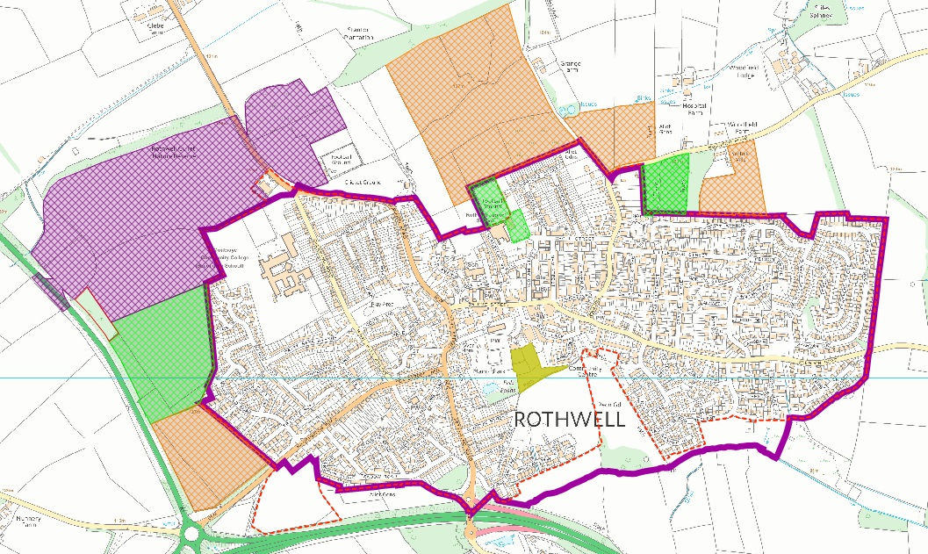
D
E
C
A
F
B

Map Reference | Site Ref. | Issue | Relevant Criteria | Further Investigation Required | Findings/ Conclusions
Land south of 7 Cockayne Close – 1 King Johns Walk. | A | Agricultural land within settlement boundary. | Principle 1, 3(d). | 1) Review planning history. | 1) No relevant planning history.  Conclusion  Exclude site from settlement boundarysettlement boundary.
Open Space south of Well Lane. | B | Open space currently included within settlement boundary. | Principle 1, 3(a). | 1) Review planning history. | No relevant planning history.  Exclude site from settlement boundary.
Open Space south of 1 Cook Close – 35 Rose Close, and 19 – 11 Nansen Close. | C | Open space currently included within settlement boundary. | Principle 1, 3(a) | 1) Review planning history. | No relevant planning history.  Exclude site from settlement boundary.
Football Ground (west of Cambridge Street). | D | Land used as playing fields and included within settlement boundary. | Principle 1, 3(a). | 1) Review planning history. | 1) No extant consents. Site identified as a potential housing site allocation, recommended to be progressed.  Conclusion  It is premature to include the site within the settlement boundary at this stage on the basis of a potential housing allocation. As the site is in use as playing fields, it should be excluded from the settlement boundary in accordance with Principle 1 and Principle 3(a).
Rothwell Medical Centre, Desborough Road. | E | Medical Centre outside of the settlement boundary. | Principle 1, 2(b). | - Review planning history. | - Medical Centre granted planning permission under KET/2008/1010.  Conclusion  As a medical centre it is a community facility built with planning permission. Inclusion within the settlement boundary accords with principles 1, 2(a) and 2(b).
Morris Homes site, land south of Harrington Road. | F | Land currently excluded from settlement, but benefits from extant consent for residential development which has been implemented. | Principle 1, 2(a). | 1) Review planning history. | 1) KET/2009/0474; KET/2014/0688 grants outline planning permission for residential development which has been implemented.  Conclusion  Include within settlement boundary in accordance with Principle 2(a) as housing development now delivered.

4.9 BURTON LATIMER
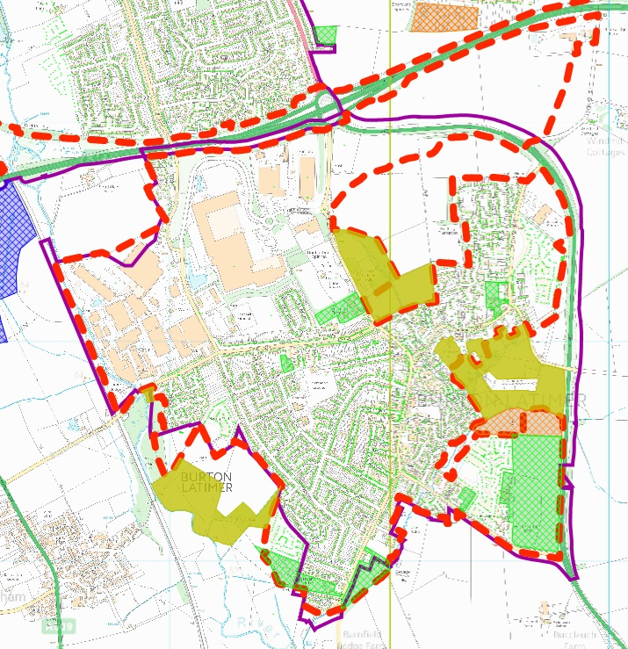
A sF
S sF
R sF
Q sF
P sF
O sF
N
L & M
K sF
J sF
H sF
I sF
G sF
F
E sF
sF
C sF
D sF
B sF
U
T

Map Reference | Site Ref | Issue | Relevant Criteria | Further Investigation Required | Findings/ Conclusions
East Midlands Railway Line adjacent Weetabix. | A | Railway line located within settlement boundary. | Principle 1. |  | Eastern edge of Railway line provides a built boundary .
Land south of Weetabix abutting railway bridge (northside). | B | Land excluded from settlement boundary. | Principle 1. |  | Land currently excluded from settlement boundary. Minor change will incorporate this land into settlement boundary and follow the existing railway bridge in accordance with Principle 1.
Land west of Kingfisher Way. | C | Land is meadow/grass land and currently included within the settlement boundary. | Principle 1, 3(d). | - Review aerial photography. | 1) Land in use as meadow/grassland since before 2000.  Conclusion.  Land has an open character relating to open countryside, and should be excluded from the settlement boundary in accordance with Principle 1 and Principle 3(d).
Land south of Teal Close. | D | Land has extant consent (KET/2012/0732) for residential development. | Principle 1, 2(a). | No. | Inclusion of site within settlement accords with identified principles
Land west of 175 – 183 Queensway. | E | Parts of gardens serving these properties are excluded from settlement boundary. | Principle 1. | 1) Review aerial photography. | Garden areas excluded from settlement boundary are relatively small, and existing gardens are not overlarge. They are visually separate from open countryside, and should be included within the settlement boundary.
Land west of 165 – 109 Queensway. | F | Boundary needs shifting northwards slightly, to exclude agricultural land. | Principle 1. | No. | Amend boundary to exclude fields in accordance with Principle 1.
Hogs Hollow Site. | G | Site benefits from extant consent (KET/2012/0228) and developed for housing. | Principle 1, 2(a). | No | Amend settlement boundary to include extent of built site, but exclude open space located on edge of settlement.
Land west of Bosworths. | H | Site benefits from extant consent (KET/2013/0750) for residential development and is excluded from the settlement boundary. | Principle 1, 2(a). | No. | Amend settlement boundary to include site.
Land west of ‘The Rushes’. | H | Land comprises an access track to a field, and is currently included within the settlement boundary. | Principle 1, 3(d). | 1) Review planning history. | - No relevant planning permissions and site in agricultural use visually related to open countryside beyond. Include site within settlement boundary.
Land south of Riverview.. | I | Site is agricultural land or open space and is included within the settlement boundary. | Principle 1, 3(a)(d). |  | Conclusion  Land visually related to open countryside beyond and should be excluded from settlement boundary.
Land adjacent Finedon Road. | J | Land benefitting from extant consent for residential development (KET/2015/0021) included within the settlement boundary. | Principle 1, 2(a). | 1) Review planning history. | 1) KET/2015/0021 grants planning permission for residential development of the land.  Conclusion  As a site with extant consent, it should be included within the settlement boundary in accordance with Principle 1 and Principle 2(a).
Land east of 51 Finedon Road and Westley Close. | K | Minor amendment to boundary | Principle 1 | 1) Review aerial photography | 1) The current settlement boundary does not follow the River Ise and includes some agricultural land and allotments. This should be amended to exclude the site.
2 – 3 Westley Close. | L | Land excluded from settlement boundary. | Principle 1, 2(b)(c). | 1) Review aerial photography. | 1) Properties present since at least 2005.  Conclusion  Inclusion of dwellings within the settlement boundary accords with principles 1, 2(b) (c).
Land southeast of 43 – 17 Finedon Road and south of 8 – 11 Ensleigh Close, Ashby Close, Jacques Close, and Addis Close. | M | Settlement boundary includes allotment land and agricultural land adjacent properties. | Principle 1, 3(a). | 1) Review aerial photography. | 1) Allotment land is a form of open space, which in this instance is located adjacent to the settlement boundary. Agricultural land is visually open and relates to the open countryside. It should therefore be excluded from it in this instance, in accordance with principle 1 and 3(a) and 3(d).
The Medical Centre, Higham Road. | N | Development is excluded from the settlement boundary, but has a direct social role with the settlement. | Principle 1, 2(b). | 1) Review aerial photography.  2) Review planning history. | 1) Medical centre and car park present since at least 2005.  2) KE/02/0503 grants planning permission for the facility.  Conclusion  Site should be included within settlement boundary in accordance with Principle 1 and Principle 2(b).
A6 bypass. | O | Bypass is currently included within the settlement boundary | Principle 1 | 1) Review planning history | 1) There is no relevant planning history.  Conclusion  The bypass should be excluded and the settlement boundary should run along the western boundary of the bypass in accordance with Principle 1.
Cemetery and land north of Silverstone Road, Wheatfield Drive, south of Church Street and Wold Road. | P | A cemetery is an open space which if located on the edge of a settlement should be excluded from the settlement boundary. Other land has an open appearance, either forming fields or parts of existing large gardens. | Principle 1, 3(a), 3(d) | 1) Review planning history  2) Review aerial photography | 1) No relevant planning history.  2) Gardens serving properties on Church Street (e.g. Manor House, Fernbank) are overly large and open in appearance, have a strong visual relationship with the adjoining field parcels, some of which are currently included within the settlement boundary.  Conclusion  The aforementioned gardens all have a visual relationship with the adjacent open countryside and should be excluded from the settlement boundary (Principle 3d). This in turn places the cemetery on the edge of the settlement, which, as open space, should also be excluded from the settlement boundary in accordance with Principle 3(a).
Land north of Wold Road (southeast of 16 – 24). | Q | Paddocks are included within the existing settlement boundary | Principle 1, 3(d) | 1) Review aerial photography | 1) Land has been used as paddock/meadow since at least 2000. The sites have an open appearance which visually relates to open countryside beyond and should be excluded from the settlement boundary in accordance with Principle 1 and Principle 3 (d).
Land east of Slipton Road, and west of A6 bypass. | R | Land currently within settlement boundary, but open in character and appearance, and more appropriately associated with the open countryside beyond the A6. | Principle 1, 3(d). | 1) Review planning history  2) Review aerial photography | 1) No relevant planning history  2) Aerial photography does not show land being historically used for any purpose other than scrub/woodland.  Conclusion  Exclude site from settlement boundary in accordance with Principle 1 and Principle 3(d).
Agricultural land east of Kettering Road, north of St Crispin Close, Heath Way, The Crescent and Elm Road. | S | Land is currently located within the settlement boundary and should be excluded. | Principle 1, 3(d)(e) | 1) Review planning history  2) Review aerial photography | 1) Some of the land falls under KET/2013/0661 which grants permission for employment including b1, b2, and b8; this should be included within the settlement boundary as employment land directly linked to Burton Latimer. Other than the permitted employment site, the majority of the land does not have any relevant planning history.  2) The land has been arable since at least 2000. Epoch layers show it as agricultural land back in 1843.  Conclusion  Arable fields have an open appearance related to open countryside and should be excluded from the existing settlement boundary. The approved employment site should be included within the settlement boundary.
Land (highway and verge) north of Altendiez Way. | T | Part of A14 trunk road and verge are located within the settlement boundary and should be excluded to provide a tighter settlement boundary | Principle 1 | - Review aerial photography | Conclusion  - Exclude A14 and Verge.
Land north of Weetabix. | U | Part of the site is excluded from the settlement boundary | Principle 1, 2(b)(c) | 1) Review planning history  2) Review aerial photography. | 1) KE/98/0621 grants permission for a food production unit and warehousing on the site.  2) The aforementioned has been present since at least 2000 and continued to form part of the curtilage of Weetabix.  Conclusion  Include site within the settlement boundary in accordance with principles 1, 2(b) and 2(c).

4.10 PYTCHLEY
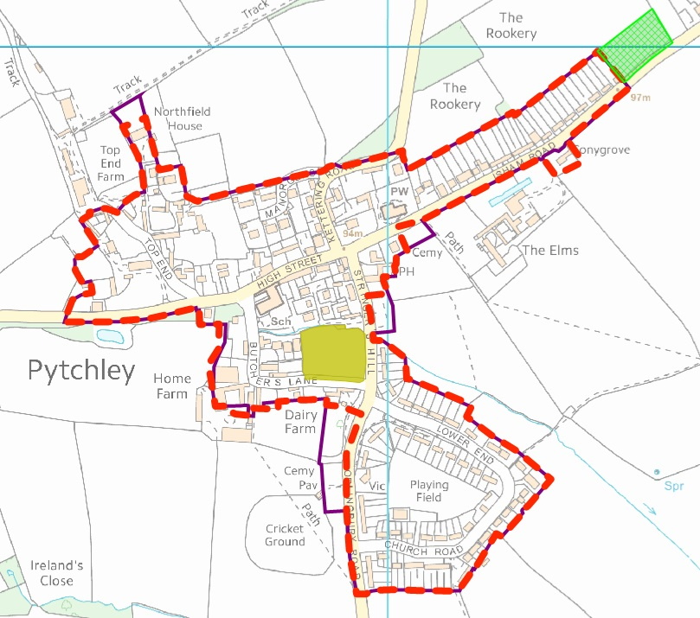
B
G sF
F
E
D
C
A
Map Reference | Site Ref | Issue | Relevant Criteria | Further Investigation Required | Findings/ Conclusions
Conygrove, Isham Road. | A | Dwelling is excluded from the settlement boundary | Principle 1, 2(c) | 1) Review aerial photography  2) Review planning history | 1) House been present since before 1945 according to EPOCH layer.  2) No relevant planning history  Conclusion  Although the dwelling is located on the south side of Isham Road which is largely open fields on this section of highway, the dwelling sits closely to the highway and adjacent dwellings on the north side of the road. As a result, the dwelling relates more to the existing adjacent dwellings than open countryside which abuts it, and is clearly defined. Inclusion of the site within the settlement therefore accords with Principle 1 and Principle 2(c).
Cemetery, Isham Road. | B | Cemetery is currently included within the settlement | Principle 1, 3(a) |  | Cemeteries are a type of open space. AS this cemetery is located on the edge of the settlement, it should be excluded from the settlement boundary in accordance with Principle 1 and Principle 3(a).
Car Park of Overstone Arms, Stringers Hill. | C | Car park within settlement boundary. | Principle 1, 3(d) and 3(e). |  | Car park provides a visually open break through this part of the village, which will be lost if developed.= by buildings and could harm the open character in this part of the village, The site should be excluded in accordance with principles 1, 3(d) and 3(e).
Cemetery, Orlingbury Road. | D | Cemetery is currently included within the settlement. | Principle 1, 3(a). |  | Cemeteries are a type of open space. AS this cemetery is located on the edge of the settlement, it should be excluded from the settlement boundary in accordance with Principle 1 and Principle 3(a).
Land south of Jasmine Cottage, Butchers Lane. | E | Garden excluded from settlement boundary. | Principle 1, 2(c). | - Review aerial photography. | Site included as garden since before 2000.  Conclusion  The site is visually separated from open countryside, and clearly related to the dwelling. Inclusion of the site accords with Principle 1 and Principle 2(c).
Land south and west of 2 Home Farm Cottage, Butchers Lane. | F | Land excluded from settlement boundary which has recently been granted planning permission. | Principle 1, 2(a). | - Review planning history. | - KET/2013/0006 grants planning permission for 9 dwellings approved on 26.02.13.  Conclusion  The site benefits from extant consent for 9 dwellings and the extent of the site should be included within the settlement boundary.
Land to north of Northfield House, Top End. | G | All of garden to west excluded from settlement, whilst additional land to the north is included. | Principle 1, 2(a), 3(d), 3(e). | - Review aerial photography. | 1) Land north is agricultural land and not part of the residential curtilage.  Conclusion  Exclusion of the land would accord with the relevant principles. The land relates more to open countryside and is visually separate from the settlement boundary.

4.11 BROUGHTON
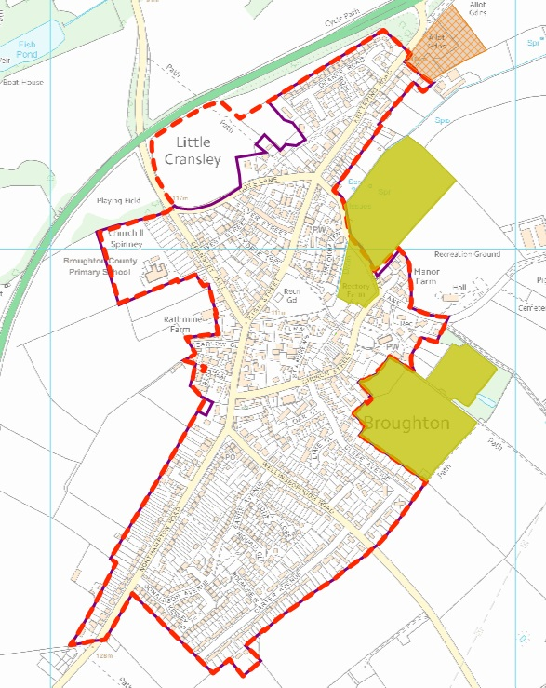
C
B sF
A

Map Reference | Site Ref | Issue | Relevant Criteria | Further Investigation Required | Findings/ Conclusions
Land adjacent Silver Street, Cransley Hill, 3 Crane Close and Meadow Grange. | A | Agricultural field benefiting from planning permission KET/2013/0773 is not included in the existing boundary. | Principle 1, 2(a). | 1) Review planning history. | 1) Permission KET/2013/0773 is an extant consent which is currently being implemented.  Conclusion  As an extant consent, the site should be included within the settlement boundary in accordance with Principle 2(a).
Garden serving Manor Farm House and 1 – 3 Manor Farm Close. | B | Parts of the gardens serving the properties are excluded from the settlement boundary. The gardens are not large. | Principle 1, 2(c). | 1) Review aerial photography.  2) Review planning history. | 1) Gardens present in 2005. Dwellings and gardens not present in 2000.  2) KET/2002/0647 granted planning permission for change of use to garden for all properties which were permitted separately.  Conclusion  The gardens are visual separated from the adjacent open countryside and clearly linked to the dwellings they serve, and permitted. The gardens are modest in size, and their inclusion accords with Principle 1 and Principle 2(c).
Land west of 10 High Street, Broughton. | C | Land forms part of garden serving 10 High Street, and is excluded from the settlement boundary. | Principle 1, 2(c). | - Review aerial photography. | - Site has formed part of the garden to 10 High Street, since before 2000.  Conclusion  Site is visually detached from the adjacent open countryside, being enclosed by planting. The site is contained and visually associated with 10 High Street. As a result, it should be included within the settlement boundary in accordance with Principle 1 and Principle 2(c).

4.12 GREAT CRANSLEY

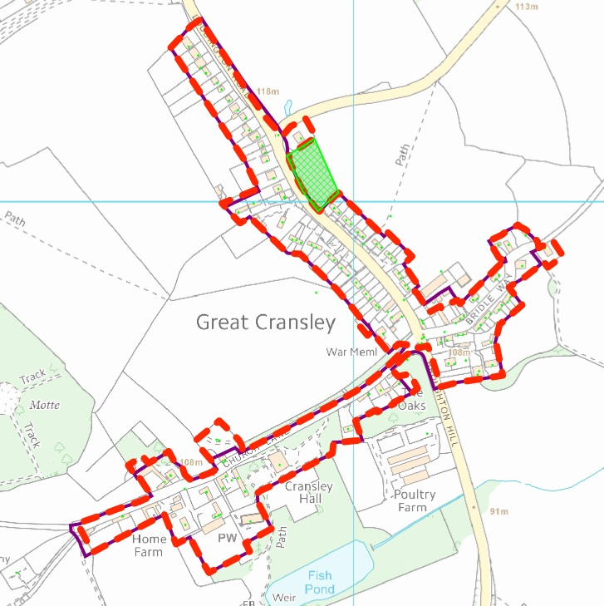
A sF
B sF
C sF
D sF
E sF
F sF
G sF
H sF

sF
sF
F
Map Reference | Site Ref | Issue | Relevant Criteria | Further Investigation Required | Findings/ Conclusions
Land west and north of 35 Church Lane. | A | land included within settlement boundary which includes highway with no additional development beyond to the north. | Principle 1, 3(d) . | 1) Review aerial photography.  2) Review planning history. | 1) Land appears visually open and associated with the rural agricultural use beyond.  2) No relevant planning history.  Conclusion  Exclusion of part of the farm access and highway will provide a tighter settlement boundary and exclude areas which are visually open and relate to the countryside in accordance with Principle 1 and Principle 3(d).
Land North of 12 Church Lane. | B | Domestic buildings located outside of settlement boundary. | Principle 1, 2(c). | 2) Review aerial photography. | 1) Garage building present between 2005 and 2009.  2) No planning history for garage building, but KET/2007/1126 grants planning permission for pool house (not yet implemented).  Conclusion  Enlarge settlement boundary slightly to the north to incorporate additional building. Exclude wider garden area which appears open in appearance, and could harm the structure of the settlement if developed.
Land at 2A Church Lane. | C | New dwellinghouse permitted under KET/2013/0306 and implemented. | Principle 1, 2(a). | 1) Review planning history. | Conclusion  As a new consent, the site should be incorporated into the settlement boundary.
The Oaks, Church Lane. | D | Part of garden not included within settlement boundary. | Principle 1, 2(c) | 1) Review aerial photography.  2) Review planning history. | 1) Aerial photography shows a larger garden area than present on epoch layers. The enlargement however is not significant in size.  2) No relevant planning history.  Conclusion  Enlarge settlement boundary to include enlarged garden which remains modest in size and clearly delineated from surrounding open countryside, without harming the character and form of the settlement, in accordance with Principle 1 and 2(a).
Highway at Broughton Hill (adjacent 1 Holly Lane). | E | Highway included in settlement but sits adjacent land to west located outside of the settlement boundary. | Principle 1. | 1) Review aerial photography. | Conclusion  Exclude highway from settlement in order to maintain a tight settlement boundary in accordance with Principle 1.
Haydrag Cottage, Bridle Way. | F | Property excluded from settlement boundary. | Principle 1, 2(c). | 1) Review aerial photography.  2) Review planning history. | 1) Aerial maps show property has been enlarged between 2000 and 2005 and appears in use as a dwellinghouse with curtilage.  2) KET/1992/0004 granted permission for conversion of barn to dwelling.  Conclusion  Dwelling present for approximately 10 years of more and should be incorporated into the settlement boundary as it currently sits on the edge of the settlement, and is clearly defined from open countryside by boundary treatment.
Land to rear of 3 – 7 Bridle Way. | G | Agricultural buildings and land located within the settlement boundary. | Principle 1, 3(c). | 1) Review aerial photography.  2) Review planning history. | 1) Aerial photography shows agricultural buildings set back from the street which have a close relationship with open countryside as a result of their functional relationship and location.  2) KET/2013/0351 grants planning permission for one of the old dairy buildings to be used as a microbrewery. This is not directly related to the economic or social function of the settlement.  Conclusion  Exclude agricultural buildings from the settlement boundary in accordance with Principle 1 and Principle 3(c).
48 Loddington Road. | H | Dwelling currently located outside of the settlement boundary. | Principle 1, 2(a). | - Review historic maps. | - Dwelling shown as present in 1945 – 1970 Epoch Maps.  Conclusion  Dwelling has been present for a significant period. It sits opposite (east) a row of existing dwellings and (north) of dwellings of the same side of the road, in a central village position. The dwelling should be included within the settlement boundary in accordance with principles 1 and 2(a).

4.13 MAWSLEY – No change made to the settlement boundary.
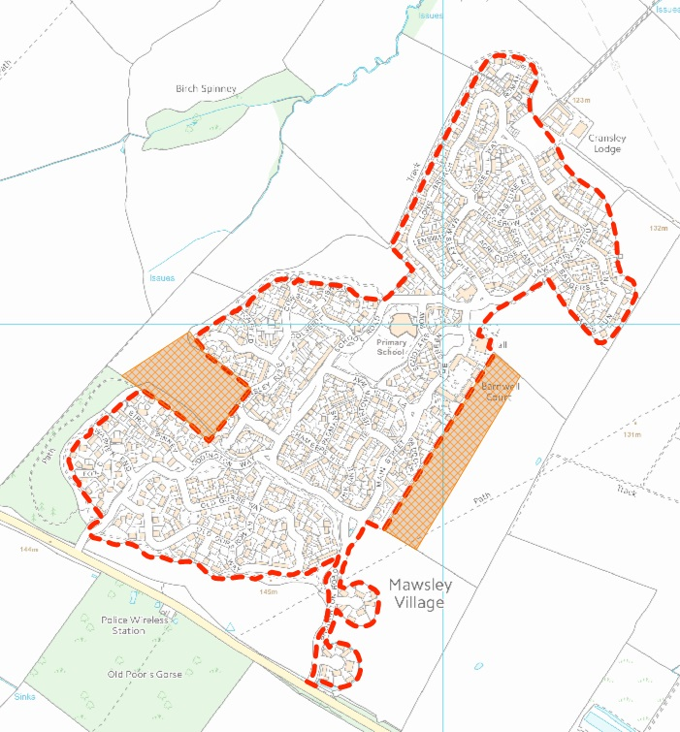

  - LODDINGTON
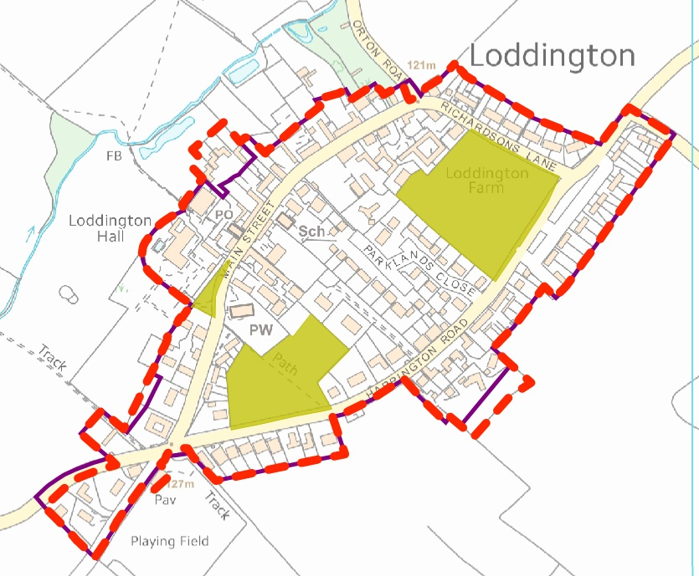
B sF
A sF
E
D sF
F
C
sF
Map Reference | Site Ref | Issue | Relevant Criteria | Further Investigation Required | Findings/ Conclusions
Highway of Harrington Road adjacent Langham House – Medley, Mawsley Lane. | A | Highway currently included within settlement boundary. | Principle 1. |  | Land north of highway is undeveloped. In order to achieve a tightly defined boundary in accordance with Principle 1, the land should be excluded from the settlement boundary.
Loddington Cricket Pavilion. | B | Building excluded from settlement boundary. | Principle 1, 2(b). |  | The building provides a social function to the village and in accordance with Principle 1 and Principle 2(b), should be included within the settlement boundary.
Highway adjacent 2 Main Street. | C | Highway currently included within settlement boundary. | Principle 1. |  | Land east of highway is undeveloped. In order to achieve a tightly defined boundary in accordance with Principle 1, the land should be excluded from the settlement boundary.
Land south of 4 – 7 Sterling Court. | D | Gardens and buildings outside of settlement boundary. | Principle 1, 2(a). | 1) Review aerial photography  2) Review planning history. | 1) Aerial photography indicates that large areas of well-kept land may coalesce with authorised gardens, which if developed would have a harmful impact on the character and form of the settlement.  2) KET/1994/0067 grants permission for dwellings.  Conclusion  Inclusion of the dwellings and some of the garden areas within the settlement boundary would accord with Principle 1 and Principle 2(a).
Land northwest of Ashley House and Hall Close. | E | Garden serving properties not included within existing settlement boundary. | Principle 1, 2(c). | 1) Review aerial photography. | 1) Existing garden curtilages have remained unchanged since before 2000.  Conclusion  Inclusion of the land within the settlement boundary would accord with Principle 1 and Principle 2(c) and should be included.
Land to rear of 77 Harrington Road. | F | Existing garden excluded from settlement boundary. | Principle 1, 2(a), 2(c), 3(d), 3(e). | - Review planning history. | - Planning permission KET/2015/0447 granted planning permission for a new dwelling with enlarged garden to incorporate the existing garden serving 77 Harrington Road, part of which was previously excluded from the settlement boundary.  Conclusion  The grant of KET/2015/0477 creates an extant permission for a garden. Given the position of the new building within the site, the garden size is modest. The existing landscaping is to be retained and enhanced, to secure a natural edge. Enlargement of the settlement boundary to include this site and adjacent land associated with 77 Harrington Road therefore accords with Principle 1 and Principle 2(a).

  - THORPE MALSOR
A
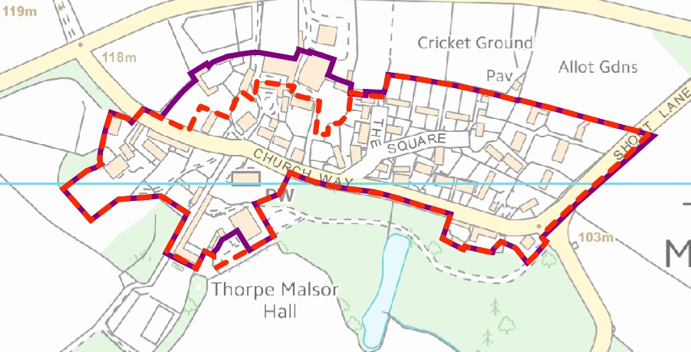
B
C
sF
sF
Map Reference | Site Ref. | Issue | Relevant Criteria | Further Investigation Required | Findings/ Conclusions
Agricultural buildings north of Home Farm. | A | Farm buildings relate to open countryside and are isolated from the settlement and do not offer a social /economic function. | Principle 1, 3(c). | 1) Review aerial photograph.  2) Review planning history. | 1) Majority of buildings present since before 2000.  2) No relevant planning history.  Conclusion  Exclude buildings from settlement boundary in accordance with Principle 1 and Principle 3(c).
Garden serving Thorpe Malsor Hall. | B | Part of the garden serving the hall (driveway) is excluded from the settlement boundary | Principle 1, 2(c) | - Review aerial photograph  - Review planning history | 1) Site clearly of a different character to adjacent open countryside.  2) No planning history relevant to the settlement boundary. However, KET/2002/0092 sets a site plan which the amended boundary partially follows.  Conclusion  Include additional
Land north of 4A The Square. | C | Boundary to 4A the Square is regular. Current boundary is irregular. Regularise the boundary to follow the land form. | Principle 1 | - Review Arial Photography | Conclusion

  - HARRINGTON
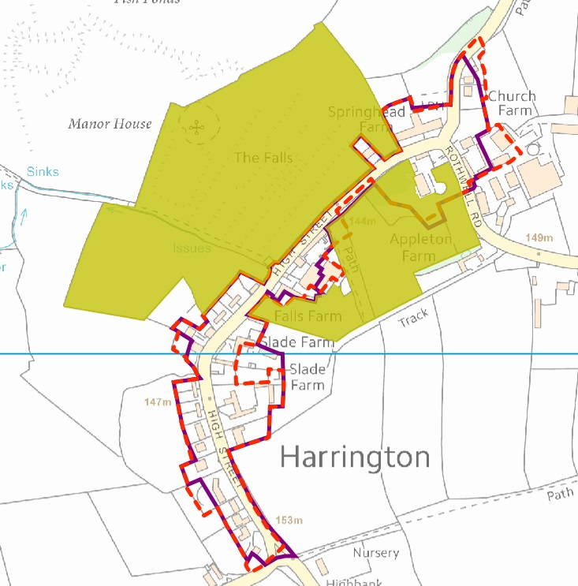
C
B
A
I
D
E
J
F
G
H
L

Map Reference | Site ref | Issue | Relevant Criteria | Further Investigation Required | Findings/ Conclusions
1 High Street (Rydewell House). | A | Part of the front/side garden is located outside of the settlement boundary | Principle 1, 2(C), 3(d), 3(e) | 1) Review aerial photography  2) Review planning history | 1) Photographic aerial maps show that the curtilage has been extended since before 2000. Epoch layers show the extent of the enlargement, which follows the original settlement boundary.  2) No relevant planning permission.  Conclusion  Enlargement of the settlement boundary to include the additional curtilage will accord with Principle 1 and Principle 2(c) as the boundary will follow the property boundary which separates it from open countryside. It is considered that the curtilage boundary is not so large it would harm the form and structure of the settlement as its linear form is maintained.
Kelton House, 7 High Street. | B | Part of rear garden excluded from settlement boundary | Principles 1, 2(c), 3(d), 3(e). | 1)Review aerial photography  2) Review planning history. | 1) Garden appears to have been enlarged pre-2000.  2) KE/1994/0194 grants planning permission for MCOU from farmland to garden land.  Conclusion  The LPA has granted to consent for the land to be used as garden. The land is enclosed and visually separate from the surrounding open countryside. Inclusion of the land within the settlement boundary accords with Principle 1, and Principle 2(c).
Land west of Harrington House, 25 High Street. | C | Part of garden excluded from settlement boundary | Principles 1, 2(c), 3(d), 3(e). | 1)Review aerial photography  2) Review planning history. | 1) Enlarged garden not present in 2000 (2005 layer not working).  2) No planning permission permitted.  Conclusion  The new garden area is proportionate with other o properties on High Street. As a result it is considered that its inclusion within the settlement boundary would not adversely affect the structure of the village and would accord with Principles 1 and Principal 2(c).
Land east of 24 High Street and Slade Farm, High Street. | D | Agricultural land included within settlement boundary | Principles 1, and 3(c). | 1) Review aerial photography  2) Review planning history. | 1) The land appears to be in use as agricultural land since before 2000 and is currently in use as a meadow.  2) There is no relevant planning permission to indicate that its use should be included within the settlement boundary.  Conclusion  Exclusion of the land from the site boundary would accord with Principle 1 by tightly defining the built up framework as the isolate buildings are agricultural buildings.
Land southeast and east of Falls Farm. | E | Part of garden excluded from the site boundary | Principles 1, 2(c). | 1) Review aerial photography  2) Review planning history. | 1) Land appears to have been incorporated into garden since approximately 2005.  2) No relevant planning history applies.  Conclusion  The site is clearly defined and separated from the adjacent open countryside. Although there is no planning permission for change of use, the use has been established for approximately 10 years +. Inclusion of the site within the settlement boundary would accord with Principle 1 and Principle 2(c).
50 High Street. | F | Garden east of the property excluded from the settlement boundary. | Principles 1, 2(c). | 1) Review aerial photography  2) Review planning history. | - Land in use as garden since at least 2005.  - Planning permission KET/2001/0575 granted consent for an extension which falls within the site.  Conclusion  Incorporation of the site within the settlement boundary would accord with policy 1 and 2(c) and not harm the linear structure of the village.
Land south of Rectory Cottage (58a High Street), Appleton Farm house, and Close House, Church Farm. | G | Tennis court of Rectory Cottage and other properties are excluded from the settlement boundary. | Ps 1, 2(c), 3(d) and 3(e). | 1) Review aerial photography  2) Review planning history. | - Tennis court been present on Rectory Cottage since pre-2000. Appleton Farmhouse is listed and has a large listed building curtilage. Epoch layers confirm the extent of the LB curtilage and indicate that the tennis court fell outside of the defined curtilage of Rectory Cottage,  - KE/93/0092 granted planning permission for the tennis court.  Conclusion  Rectory Cottage has a large curtilage which follows the route of the highway to the edge of the settlement towards Appleton Farmhouse and Close House. Inclusion with the settlement boundary extends the linear layout of the settlement. Much of the garden serving Rectory Cottage remains outside of the settlement boundary and inclusion of the entire curtilage could harm the form and structure of the settlement if developed as it would deviate from the traditional linear plan form. It is considered that inclusion of the garden north of the tennis court and exclusion of garden south of the tennis and the tennis court itself would accord with Principle 1, and Principle 2(c). The boundary should remain terminated at the boundary brick wall as this marks the start of the built form of the village. Properties including Appleton Farmhouse and Close House, Church Farm further south remain visually disconnected from the village and have a stronger relationship with the open countryside beyond.
Church Farm and Buildings. | H | Buildings excluded from settlement boundary | Principles 1, 2(b), and 3(c). | 1) Review aerial photography  2) Review planning history. | - Aerial photographs show that an agricultural building has been demolished and new buildings erected in accordance with KET/2008/0093.  - KET/2008/0093 grants planning permission.  Conclusion  Some historic farm buildings and new buildings have been permitted as part of the bed and breakfast business which provides an economic function of the settlement. Extending the settlement boundary to incorporate these buildings would accord with Principle 1 and Principle 2(b). Those which remain in agricultural use should be excluded in accordance with Principle 3(c) as their economic function relates to open countryside.
Highway adjacent Rydewell House, 1 High Street. | I | Highway, verge and hedgerow included within settlement boundary | Principle 1 | - Review aerial photography | - Open fields lay beyond the highway, verge and hedgerow to the east, and have an open appearance visually linked to open countryside.  Conclusion  Although a minor amendment, exclusion of this part of the highway from the settlement boundary will tighten the boundary and accord with Principle 1.
Buildings to the rear of 36 High Street to 44 High Street. | J | Building located within settlement boundary, but not linked to economic or social function of the settlement | Principle 1. | - Review aerial photography; | - Buildings either have an agricultural or commercial use (brewery) and are all co-joined and situated tightly to the main farm house within the farmstead.  Conclusion  The buildings should be included within the settlement boundary in this instance, as they are not scattered. Despite having a function associated with open countryside, they are located within a central position within the village and tightly grouped. A recommendation to include the buildings within the settlement boundary accords with Principle 1.
Land east of Lairdmannoch to 25 Church Lane. | K | Driveway serving properties is excluded from the settlement boundary | Principle 1, 2(c) | 1) Review aerial photography | - Driveway physically separated from adjacent open countryside to the east and physically linked to the associated properties.  Conclusion  Include site within settlement in accordance with Principle 1 and Principle 2(c).

  - BRAYBROOKE

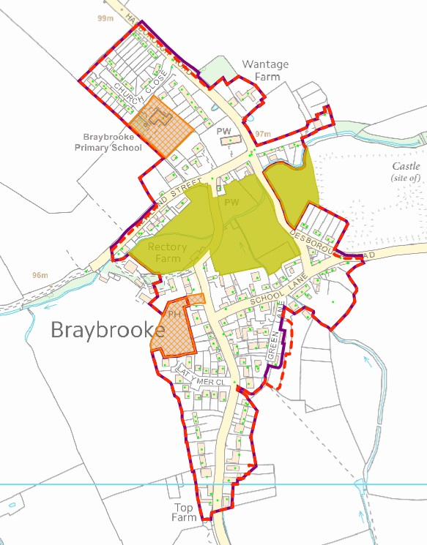
E
A
C
D
B

Map Reference | Site Ref | Issue |  | Relevant Criteria | Further Investigation Required | Findings/ Conclusions
Land at 9 Green Lane and Millennium House. | A | Site excluded from settlement boundary |  | Principles 1, 2(c). | 1) Review aerial photography  2) Review planning history | 1) Aerial photography shows that Millennium house was completed after the 2000 photographic layer was created, but that 9 The Green was present prior to this date, together with its garden.  2) No relevant planning history which shows the extent of the curtilage. Millennium House was granted under KE/98/0336.  Conclusion  Including the site within the settlement boundary will maintain a tightly defined boundary which follows existing hedgerows which follow the boundaries of the properties in accordance with Principle 1. The curtilages serving the properties are not expansive and are visually separated from open countryside to the west in accordance with Principle 2(c).
Highway Land northeast of 33 to 15 Harborough Road. | B | Highway included within settlement boundary, but no development located northeast |  | Principles 1, 3(d) | 1) Review aerial photography. | 1) Land northeast of properties on Harborough Road is verge, hedgerow and arable fields and has an open, character more closely associated with open countryside. To provide a tighter settlement boundary in accordance with Principle 1 and Principle 3(d), this land should be excluded.
Highway land adjacent 24 School Lane. | C |  | Highway land, hedge and verge included within settlement boundary | Principle 1 | 1) Review of aerial photography | 1) North of the highway there is a hedge and rural open fields and depressions of Braybrooke Castle which is a SAM. This land has a strong relationship with the open countryside and can be excluded in order to form a tighter boundary, in accordance with Principle 1.
Land adjacent 7 – 31 Newland Street. | D |  | Highway land, hedge and verge included within settlement boundary | Principle 1 | 1) Review of aerial photography | 1) North of the highway there is a hedge and rural open fields. This land has a strong relationship with the open countryside and can be excluded in order to form a tighter boundary, in accordance with Principle 1.
Land east of 55 – 65 Griffin Road. | E |  | Full extent of gardens excluded from the site boundary. | Principles 1, 2(c), 3(d) and 3(e) | 1)Review aerial photography  2) Review planning history | 1) 63 Griffin Road was the only dwelling present on the site in 2000, with plots 55 and 65 forming the curtilage to 63 Griffin Road. No. 55 and 65 Griffin Road were built between 2005 and 2009.  2) KET/2004/0474 granted permission for 55 Griffin Road with a smaller curtilage than is present now. KET/2008/0562 granted planning permission for an extension to the garage serving the existing dwelling. KET/2005/0540 granted planning permission for the erection of 65 Griffin Road.  Conclusion  KBC granted permission to build 55 and 65 Griffin Road and enlarge the existing garage to 63 Griffin Road; the principle of residential development on land specified within those applications were therefore accepted in principle. Including an enlarged curtilage within the settlement boundary beyond what was permitted will have a harmful impact on the form and structure of village settlement if developed. A minor adjustment has been made to the settlement boundary however, taking into account the extant permissions which have been implemented.

  - STOKE ALBANY
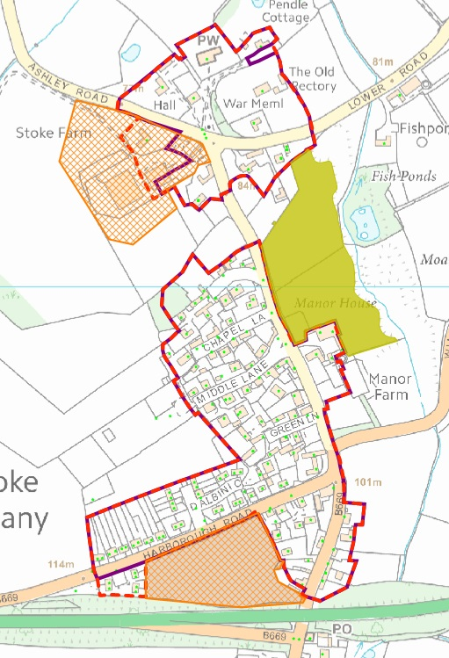
A
F
D

Map Reference | Site Ref | Issue | Relevant Criteria | Further Investigation Required | Findings/ Conclusions
Denman Close. | A | Properties on close excluded from settlement boundary | Principle 1, 2(c) | 1) Review of aerial photography  2) Review of planning history | 1) Close and properties present since before 2000.  2) Properties granted permission under KET/1993/0750.  Conclusion  Dwellings have clearly defined public access and curtilages. Include site within settlement boundary in accordance with Principle 1 and Principle 2(c).
Land south of Pendle Cottage, Ashley Road. | D | Slither of land excluded from settlement boundary | Principle 1, 3(d), 3(e) | 1) Site visit | Land is coalesced with the front/side garden of the property and an adjoining paddock area which wraps around the property and the defined garden. As a result, the site is not visually separated from open countryside, but is viewed in relation to the dwelling. Inclusion of the land within the settlement boundary would not harm the character or structure of the settlement, although inclusion of the adjoining paddock land would.  Conclusion  Include site within the settlement boundary in accordance with Principle 1.
Stoke Farmhouse and land south. | F | Excluded from settlement boundary | Principle 1, 2(a) | 1) Review aerial photography  1) Review aerial photography | 1) Dwelling present before 1970 based on EPOCH 6.  2) Land south of Stoke Farmhouse granted permission (KET/2012/0715) for 2 dwellings.  Conclusion  Enlarge settlement boundary to include dwelling and land further south.

  - WILBARSTON

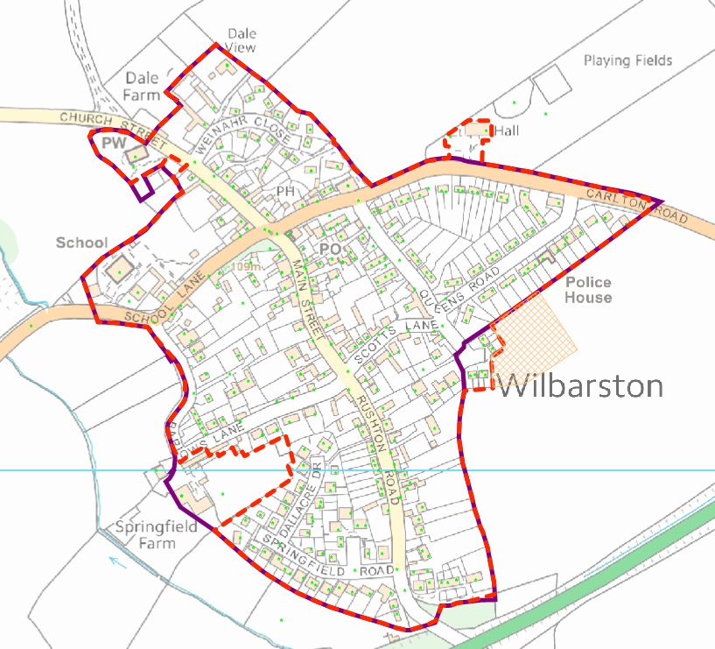
B
E
C
D
A

Map Reference | Site Ref | Issue | Relevant Criteria | Further Investigation Required | Findings/ Conclusions
11 Barlows Lane, farm buildings and land. | A | Dwelling not included in settlement boundary. Buildings and land | Principles 1, 3(c) | - Review aerial photography  - Review planning history | 1) Dwelling has been present since before 2000.  2) Planning Permission KET/1986/0466 granted permission for the dwelling for agricultural occupation. The land south of Barlows lane did benefit from planning permission for residential development, but this has since lapsed. The site is a discounted employment site (SSPLDD – Options Paper Consultation March 2012).  Conclusion  Inclusion of dwelling accords with Principle 1, whilst exclusion of the scattered agricultural buildings accords with Principle 3(c). The field no longer benefits from extant permission and should be removed from the settlement boundary in accordance with Principle 1.
1-8 Kendalls Close. | B | Dwellings located outside of the settlement boundary | Principle 1, 2(a) | - Review planning history | - Application KET/1994/0704 grants planning permission for the 7 affordable houses.  Conclusion  As the planning permission has been implemented and the houses have now been built, they should be included within the settlement boundary in accordance with Principle 1 and Principle 2(a).
Village Hall and car park. | C | Village hall and car park is excluded from the settlement boundary. | Principle 1, 2(b) |  | Conclusion  Village hall provides a social function to the village. Together with its car park, the village hall is included within the settlement boundary.
All Saints Church, Church Street. | D | Graveyard is a public open space on the edge of the settlement and is currently included within the settlement boundary | Principle 3 (a) | 1) Review GIS | Conclusion  Excluding the southern and part of the eastern side of the graveyard from the settlement boundary where the stone boundary wall is not present accords with Principle 3(a).
Highway adjacent 44 Carlton Road. | E | Highway separates dwellings from open countryside to the north. This should be excluded to achieve a tighter settlement boundary | Principle 1. | 1) Review aerial photography. | Conclusion  Minor adjustment involving the exclusion of the highway will achieve a tighter settlement boundary in accordance with Principle 1.

  - SUTTON BASSETT
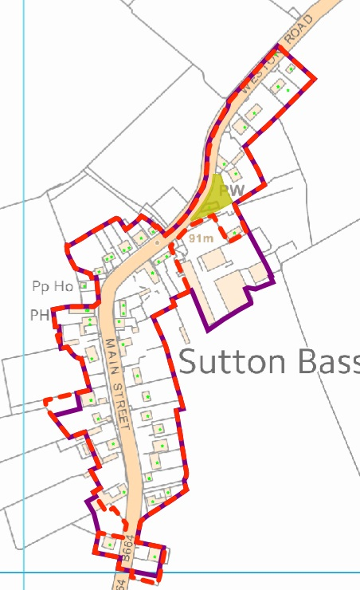
A
B
C
D

Map Reference | Site Ref | Issue | Relevant Criteria | Further Investigation Required | Findings/ Conclusions
2 Main Street. | A | Full extent of garden is excluded from the settlement boundary. | Principles 1, 2(c). | - Review aerial photography.  - Review planning history. | - Garden extended sometime between 2000 and 2005.  - KET/2011/0299 removes agricultural tie and includes entire site; KET/2012/0593 granted a CLUED confirming part of garden was now in lawful use as a garden and not agricultural land.  Conclusion  The garden is not excessive in size and is well defined by a boundary treatment which clearly separates it from open countryside beyond. The planning history indicates that the LPA accepted the principle of releasing the agricultural tie from the dwelling. Its inclusion within the site boundary accords with Principle 1 and Principle 2(c).
5 Main Street. | B | Part of land to the south of the property is included within the settlement boundary, and is a discounted housing option site. | Principles 1, 3(d). | 1) Review aerial photography  2) Review planning history | 1) 2014 layer shows site as agriculture (small meadow).  2) KET/2010/0833 granted planning permission for the adjacent property which included MCOU from land to residential from agriculture. The permission does not extend to the site; a previous housing allocation option for the site has now been discounted and is not being progressed.  Conclusion  The site has a rural and open character which visually relates to the surrounding open countryside. As a result, its exclusion from the settlement boundary would accord with Principle 1 and Principle 3(d).
13 Main Street (Claddagh House). | C | Part of garden is not included within the settlement boundary. | Principle 1, 2(c), 3(d) and 3(e). | 1) Review aerial photography.  2) Review planning history. | 1) Part of the garden has formed the curtilage to the dwelling since before 2000, whilst a small slither of land further west has been added since.  2) KE/88/0732 and KE/87/0461 granted planning permission for one dwelling, the red line of which extended to the site (excluding the additional slither).  Conclusion  Inclusion of the additional garden (minus western slither) accords with Principle 1 and Principle 2(c) and is appropriate given that the garden has served the property for a significant period of time.
38 Main Street and Farm Buildings. | D | Dwelling and associated farm buildings. | Principle 1, 3(c). | - Review aerial photography.  - Review planning history. | - Buildings present since before 2000. Epoch layer shows buildings as present in 1970.  - No relevant planning history.  Conclusion  Exclude scattered farm buildings as they relate to the agricultural function of the surrounding open countryside.

  - WESTON BY WELLAND
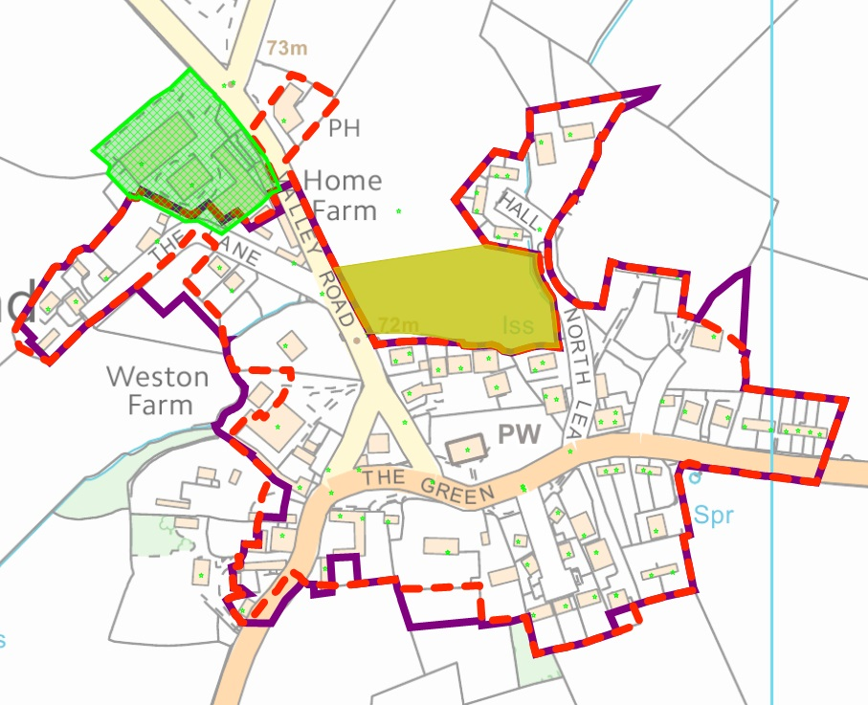
I
B
H
K
J
C
E
D
F
G
A
Map Reference | Site Ref |  | Issue | Relevant Criteria | Further Investigation Required | Findings/ Conclusions
Wheel and Compass on Valley Road. | A |  | This property (and car park) is excluded from the settlement boundary. | Principle 1, 2(b). | - Aerial photograph review | 1) Pub is located on the edge of the village, but provides a key social function to the village. It has been present pre 1970’s and is therefore established.  Conclusion  Inclusion of the pub, recent extension, and part of the car park (to the front/southwest of the pub) within the settlement boundary accords with Principle 1 and Principle 2(b).
Weston Farm, The Green. | B |  | Farm buildings included within the settlement boundary. | Principle 1, 3(c). | - Review aerial photography. | - All but one of the farm buildings are co-joined to the farmhouse through a series of buildings. One building is set further back (west) and stands as a detached building.  Conclusion  The majority of farm buildings should be retained within the settlement boundary, given the central village position of the farm stead. One building stands physically detached to the rear (west of the site). Exclusion of the detached building from settlement boundary accords with Principle 1 and Principle 3(c). Inclusion of the remaining farm buildings within the settlement boundary is considered appropriate and in accordance with Principle 1.
9 The Green. | C | Garden land excluded from settlement boundary. |  | Principles 1, 2(c). | - Aerial photography review.  - Planning history review. | - Curtilage appears to have existed prior to 2000, but is not present on the 1970-1996 epoch layer.  - Property is Grade II listed. Listed Curtilage extends to include the majority of the garden; variation may be due to scale of plans.  Conclusion  Inclusion of the site within the settlement boundary accords with Principle 1 and Principle 2(c).
2 School Farmyard, Ashley Road (land south of). | D |  |  | Principles 1, 2(c). | - Review aerial photography.  - Review planning history. | - Site has formed a garden to 2 School Farmyard since before 2000.  - KET/1995/0698 grants outline permission for 2 dwellings, but the boundary does not extend as far as the existing curtilage.  Conclusion  Site forms a small principle garden area to the existing property. Planning history indicates that the property does not have full planning permission, but its existence for more than 10 years (including the garden) means that it is now lawful. Enlargement of the settlement boundary to include the garden would follow the line of existing boundary treatments to adjoining properties which is contained and visually separated from open countryside. This would accord with the Principle 1 and Principle 2(c).
Land south of Welland House, The Green. | E | Agricultural land located within settlement boundary. |  | Principle 1, 3(c). | - Review aerial photography.  - Site visit. | - Land in use as paddock/meadow and visually separated from dwellinghouse.  - Site visit outstanding.  Conclusion  Settlement boundary revised to exclude land in accordance with Principle 1 and Principle 3(c).
Land to north of no. 3 Northlea. | F | Garden to north of property. |  | Principle 1, 3(e). | 1) Review of aerial photography. | 1). Property has a garden to the south and east which offers amenity space and is more physically and visually linked to the settlement. Land to the north of the dwelling is more visually linked with open countryside development of which would have a harmful impact on the settlement structure. The land is therefore excluded in accordance with Principle 1 and Principle 3 (e).
Land east of 8 Hall Close. | G | Irregularity to garden boundary needs correcting. |  | Principle 1, 2(c). | 1) Review aerial photography. | Separation between garden and adjacent field which is currently included within the settlement boundary is clearly defined. Exclude field from settlement boundary to regularise this error.
Land south of The Old Farmhouse, 12 The Lane. | H | Part of the garden is not included within the existing settlement boundary . |  | Principle 1, 2(c). | 1) Review aerial photography. | Site has formed part of the garden since before 2000. The garden is visually defined and separated from open countryside beyond.
Weston Farm Buildings and agricultural land southwest of dwellings on The Lane. | I | Agricultural buildings currently included within the settlement, but functionally linked to the se of open countryside. Agricultural land also visually open and functionally related to open countryside. |  | Principle 1, 3(c), 3(d). | 1) Review aerial photography  2) Review planning history. | 1) No significant change to the current situation since 2000.  2) No relevant planning history.  Conclusion  Agricultural buildings and land have an economic relationship with the open countryside. The latter also has a visual link with open countryside. In accordance with principles 1, 3(c) and 3(d), the site should be excluded from the settlement boundary.
Highway Adjacent 10 The Green. | J | Land east of highway is open countryside. |  | Principle 1. | 1) Review aerial photography. | 1) Exclude highway from settlement boundary in order to achieve a tighter settlement.
Land west of 6 The Green. | K | The driveway, garden, vegetable patch is not included within the settlement boundary (taken from SSP LDD – Options Consultation). |  | Principle 1, 3(e). | - Review aerial photography. | - Observations made.  Conclusion  1. Site/Garden is extensive, and inclusion of entire site would risk development which could harm the structure and character of the settlement as previously stated through the Options Consultation. As a result, a tight boundary should be retained which includes the driveway and part of the site, however, there is scope to enlarge the boundary slightly in order to incorporate a small area of driveway and garden without harm to the structure of the settlement.

4.22 ASHLEY
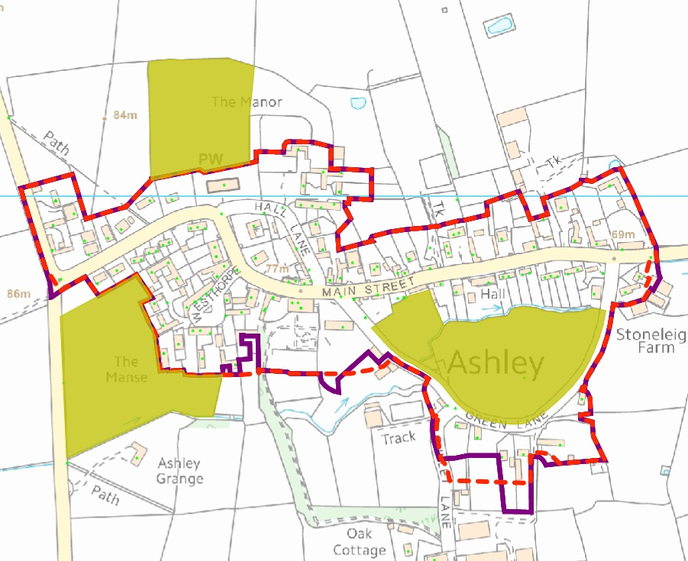
F
E
D
H
I
G
C
AS
B

Map Reference | Site Ref | Issue | Relevant Criteria | Further Investigation Required | Findings/ Conclusions
Welland Bank, Medbourne Road. | A | Part of garden excluded from settlement and no physical link with the countryside. | Principle 1, 3 (e). | 1) Review Historic photographic aerial maps.  2) Review planning history. | 1) Incorporated into garden approx. 10 years.  2) No planning permission granted to extend the site for residential.  Conclusion  Inclusion of land within settlement boundary will further extend the settlement beyond the central figure 8 layout. This will be harmful to the structure, form and character of the settlement. The site should be excluded in accordance with Principle 1 and Principle 3(e).
Medbourne Road Highway. | B | Highway included. | Principle 1. | 1) Review historic photographic ariel maps. | Conclusion  Extent of highway at the village entrance from Stoke Albany does not need to be included in the settlement boundary as there is no residential development facing on to it at this point. Exclusion of the highway at this point will more tightly define the settlement in accordance with Principle 1.
Land south of 5 The Maltings, Hall Lane. | C | Land which could be incorporated into residential curtilage. | Principle 1, 2(c), 3 (d) and (e). | 1) Review Historic photographic aerial maps.  2) Review planning history. | 1) Site physically separated from dwelling by hedge/fence.  2) Planning Application KE/91/0151 to use land as garden refused as it would intrude into open countryside.  Conclusion  Inclusion of the site within the settlement boundary conflicts with Principle 2c and Principle 3d; it is therefore excluded.
Land south of Casebrook and 4 Stone Cottage Green Lane and access lane serving Oak Cottage and the Dales. | D | Land used as garden not included within settlement boundary. | Principle 1, 2(c), 3(d) and (e). | 1) Review Historic photographic aerial maps;  2) Review planning history. | - 1) Land at both properties appears to have been used for garden since at least  - 2) KET/2005/0341 granted for stable blocks. No other relevant Planning History.  - 3) Topographical variation between Stone Cottage and access serving Oak Cottage and the Dales is significant, with Stone Cottage being banked 1.5-2m higher. Caserbrook has a wider frontage which could be  Conclusion  Inclusion of the site would accord with the existing settlement boundary with respect of gardens serving Saddlestones and Orchard House. Inclusion would accord with Principle 1 and Principle 2(c) with respect of following hedgerows which separate the site from open countryside to the south. Epoch 2 (1891 – 1912 shows a much smaller curtilage which has already been built on. In accordance with Principle 3(e) it is recommended that tighter boundary is drawn which takes into account the epoch boundary maps and existing built development. As a result, the boundary should be reduced for Saddlestones and Orchard House, but enlarged for Caserbrook and Stone Cottage.
The Garden House, Green Lane. | E | Whether to exclude Stable / coach house buildings and access point from settlement boundary. | Principle 1, 2(c), 3(d) and (e). | 1) Review Historic photographic aerial maps.  2) Review planning history. | - Building present pre 2000.  - KET/1988/1237 granted PP for Extension of existing stables, 5 Loose boxes and barn.  Conclusion  The buildings abut Green Lane with the coach house building located behind a stone boundary wall. The vehicular access is shared with the dwelling and stables and sub-divides the garden area. The stables are clearly unrelated to the dwelling, which the coach house building sits behind a stone boundary wall which encloses The Garden House providing a physical link to the property. As a result, the access should be included within the settlement boundary with the coach house and the stables excluded. Inclusion of the entire garden would conflict with Principle 3(e). As a result, part of it should be excluded.
Land south of Westhorpe Grange and Orchard House. | F | Potential garden land excluded from the settlement boundary. | Principles 1, 2 (c), 3 (d) and (e). | 1) Review Historic photographic aerial maps.  2) Review planning history. | - Westhorpe Grange land appears to be used as garden since 2005, and Orchard House land since 2009.  - No relevant Planning Permissions to support extension of settlement boundary.  Conclusion  Inclusion of part of the garden would accord with Principle 1 and Principle 3 (e) as long as not all of the garden is included. Although the gardens/curtilages are visually separate from open countryside, the aforementioned considerations are given greater weight.
Land southeast of 40 Green Lane and Stoneleigh farm. | G | Agricultural buildings (except one) excluded from settlement boundary. | Principles 1, 2 (b), 3(c). | - Review historic photographic aerial maps.  - Review planning history. | - The buildings have been present pre 2000 and also showing on the 1970’s epoch layer. Some land (northeast of Stoneleigh Farm) is included within the boundary does not appear to be garden but agricultural land.  - No relevant planning permissions dating back to 1974 onwards.  Conclusion  The agricultural function of the buildings relates directly to open countryside where farming practices are undertaken. Inclusion of the buildings within the settlement would extend the settlement further southeast. It is considered that agricultural land already included in the settlement boundary should also be removed in accordance with Principle 1 and Principle 2(c).
Land south of Orchard House and Saddlestones, Green Lane. | H | Gardens are large and currently included within the settlement boundary. | Principle 1, 3(d). | 1) Review aerial photography.  2) Review planning history. | 1) Site formed part of garden since before 2000. Epoch layer 6 shows site as garden in 1970’s.  2) No relevant planning history.  Conclusion  Farm yard land is located to the rear of the site. Reducing the area of the settlement will result in part of the garden being located outside of the settlement boundary, which will protect this part of the settlement from unplanned development which could harm the structure and form of the settlement. This approach accords with Principle 1 and Principle 3(d).
Yeomans, 10 Green Lane. | I | Part of a paddock is located within the settlement boundary. | Principle 1, 3(d). | - Review aerial photography. | 1) Land used as meadow and physically disconnected from the curtilage of Yeomans.  Conclusion  Land is agricultural in character and appearance and visually associated with open countryside. As a result, it should be excluded from the settlement boundary in accordance with Principle 1 and Principle 3(d).

4.23 RUSHTON

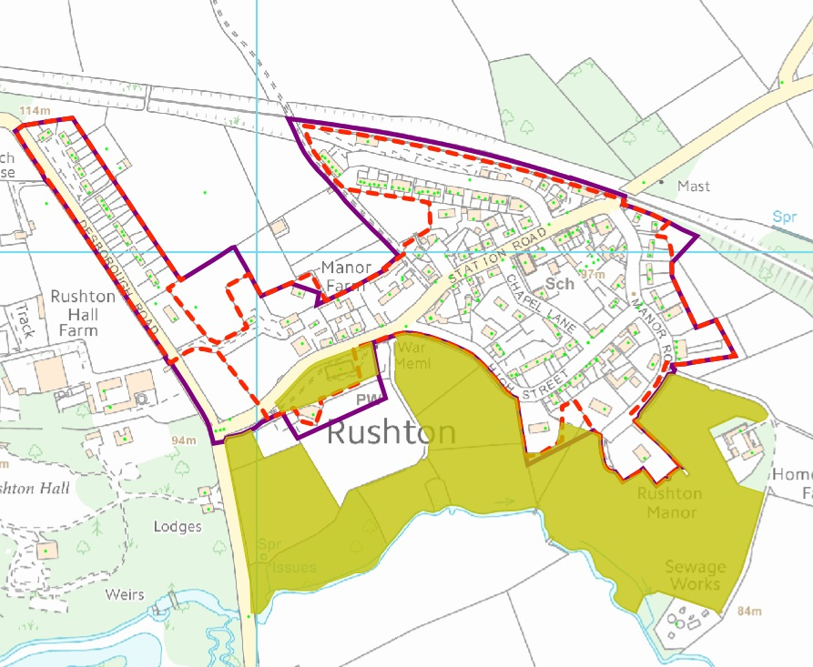
J
I
C
D
B
A
H
G
E
F

Map Reference | Site Ref: | Issue | Relevant Criteria | Further Investigation Required | Findings/ Conclusions
Meadow Land on the corner of Desborough Road / Station Road. | A | Meadow is visually open and within the current settlement boundary. | Principle 1, 3(d). | - Review aerial photography and site visit. | - The land is separated from the highway by low agricultural fencing and open in appearance. It is separated from the Old Rectory (west) by a high brick wall.  Conclusion  The site is located on the edge of the settlement, and is visually open and has a use relating to open countryside. In accordance with Principle 1 and Principle 3(d) it is recommended to be excluded from the settlement boundary.
Part of cricket ground and church yard. | B | Both are included within the settlement boundary. | Principle 1, 3(a). | 1) Review aerial photography. | Both sites are open space located on the edge of the settlement which should be excluded based on Principle 3(a). The resultant tight boundary accords with Principle 1.
Land south of Brook Paddock. | C | Existing boundary does not follow property boundary. | Principle 1. | 1) Review aerial photography. | Adjust settlement boundary inwards to follow property boundary.
Land south of 2 – 8 High Street. | D | Open land included within settlement boundary. | Principle 1, 3(d). | 1) Review aerial photography. | Land coalesced with open countryside and visually relates to it, Adjusting the settlement boundary to exclude the land accords with Principle 1 and Principle 3(d).
Land east of 1b to 3 Manor Road. | E | Land included within settlement boundary. | Principle 1, 3(e). | 1) Review aerial photography.  2) Review planning history. | 1) Land appears visually separate from residential curtilage.  2) Site is identified as RA/190 which is a discounted potential housing site. The site has negative impacts (landscape, facilities, settlement character) and has poor highway access.  Conclusion  Exclusion of land from the settlement boundary will protect the character and form of the settlement from back land development, follow existing defined curtilages, and tighten the settlement boundary in accordance with the identified principles.
East Midlands Railway Line. | F | Existing boundary includes part of the railway line. | Principle 1. | 1) Review aerial photography. | Current boundary includes railway line and should be excluded.
Highway adjacent 1 – 6 Midlands Cottages. | G | Land west of highway is open countryside. Highway could be excluded to achieve a tighter settlement boundary. | Principle 1. | 1) Review aerial photography. | Highway abuts open meadows to the west which is undeveloped. To maintain a tight boundary, the settlement boundary should be adjusted to follow the highway along the east side.
Open space south of 7 – 19 Midland Cottages. | H | Open space included within settlement boundary although located on the edge of the settlement. | Principle 1, 3(a). | 1) Review aerial photography. | As site is located on the edge of the settlement, it should be excluded in order to accord with Principle 1 and Principle 3(a).
Rear garden of Tresham House. | I | Garden currently excluded from the settlement boundary. | Principle 1, 2(c). | - Review aerial photography. | 1) Garden larger since before 2000, although epoch layer shows it was splayed between 1970 and 1996.  Conclusion  Inclusion of the land within the settlement boundary will not harm the character or form of the settlement and follow the existing curtilage which is visually contained and separated from the settlement boundary.
Play area, Desborough Road. | J | Area currently located within the settlement boundary, although on the edge. | Principle 1, 3(a). | - Review aerial photography. | The play area is Public Open Space located on the edge of the settlement. Criteria 3(a) states this should be located outside of the settlement boundary, which will also reduce tighten the settlement boundary.

  - NEWTON
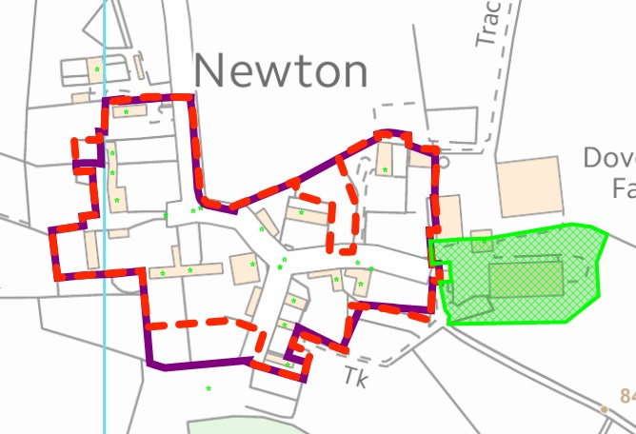
C
B
A
E
D

Map Reference | Site Ref: | Issue | Relevant Criteria | Further Investigation Required | Findings/ Conclusions
Land south of The Red Barn and The Stables. | A | Large gardens serving properties have open appearance and may harm structure of settlement if developed. | Principle 1, 3(d), 3(e). | 1) Review aerial photography  2) Review planning history. | 1) Garden appears extended since before 1970, based on Epoch layer 6.  2) No relevant planning history.  Conclusion  The existing garden is large and generally open in appearance. It is recommended to exclude the site from the settlement boundary in order to protect the structure of the village from inappropriate development in accordance with Principle 1 and Principle 3(e).
Newton House (No. 8). | B | Part of garden excluded from the settlement boundary. | Principle 1, 3(e) | 1) Review aerial photography  2) Review planning history. | 1) Site forms part of a modest garden since 2000.  2) No relevant planning history.  Conclusion  The combined garden is modest in size, and whilst the land has been used as a garden for a significant period of time and is enclosed by low level fencing, in accordance with Principle 1 and Principle 3(e), it is recommended to exclude the site from the settlement boundary in order to protect the settlement structure from development which may otherwise give rise to harm.
The Old Dairy (land south and east). | C | Current settlement boundary does not follow the curtilage boundary to this property. | Principle 1. | 1) Review aerial photography. | 1) The current settlement boundary deviates from the existing property curtilage.  Conclusion.  Adjust the settlement boundary to follow the defined curtilage in accordance with Principle 1.
Land north and west of The Willows. | D | Grassed area co-joined with adjacent meadow and agricultural land is currently included within the settlement boundary. | Principle 1, 3(d). | - Review aerial photography. | 1) Land is co-joined to adjacent agricultural land and open in appearance.  Conclusion  Site should be excluded from the settlement boundary in accordance with Principle 1 and Principle 3(d).
Land west of Chestnut Cottage, Oakley Road. | E | Garden land excluded from settlement boundary. | Principle 1, 2(c). | 1) Review aerial photography. | 1) Site forms part of a modest private rear garden serving Chestnut Cottage, and is physically separate from the adjacent open countryside.  Conclusion  It is recommended that the site be included within the settlement boundary in accordance with Principle 1 and Principle 2(c).

  - GEDDINGTON
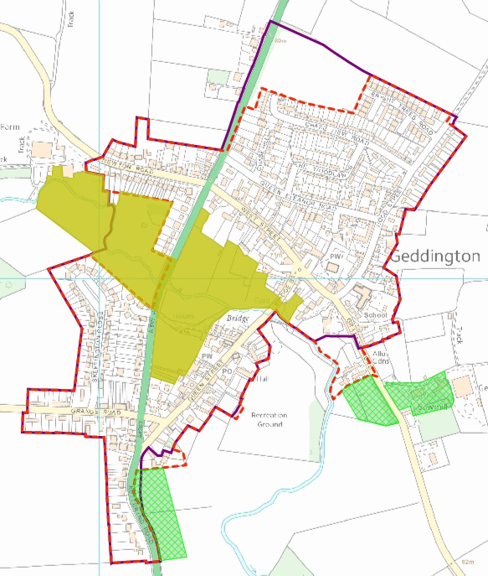
C
D
E
F
B
A

Map Reference | Site Ref | Issue | Relevant Criteria | Further Investigation Required | Findings/ Conclusions
Land north of Chase View (identified as discounted housing allocation RA/102). | A | Land discounted as a housing option site but currently including within settlement boundary. | Principle 1, 3(d). | 1) Review planning history. | 1) KET/2007/1077 for 46 dwellings and 6 apartments was refused; KE/02/0814 for 79 dwellings dismissed at appeal. Site discounted as a housing options site.  Conclusion  The site is visually open in appearance (currently used as paddocks). Exclude site from settlement boundary in accordance with Principle 1 and Principle 3(d).
41 – 33 Stamford Road. | B | Dwellings excluded from settlement boundary. | Principle 1, 3(c). | 1) Review planning history. | 1) KET/2013/0787 granted for a dwelling at land north of no 37 Stamford Road. Other dwellings historically present or recently permitted. These properties are visually detached from the village but are functionally related to the village. Response to the SSPLDD – Options Paper stated that dwellings relate to open countryside and should be excluded from the defined settlement boundary.  Conclusion  There is no change to the circumstances of the site since the SSP LDD – Options Consultation. The site is physically/visually separate from the settlement and should be excluded from the settlement boundary in accordance with Principle 1 and Principle 3(c).
Land east of 3-4 Steele Way. | C | Garden land currently excluded from settlement boundary. | Principle 1, 2(c). | 1) Review aerial photography;  2) Review planning history. | 1) Garden extended since before mid-2009.  2) KET/2010/0328 grants a CLUED for a garden extension.  Conclusion  Include garden within settlement boundary as this is clearly defined, formally recognised by the LPA. This would be in accordance with Principle 1 and Principle 2(c).
Bowling Club building, Queen Street. | D | Club building located outside of settlement boundary. | Principle 1, 2(b). |  | Conclusion  The club building performs a local social function and is directly related to the use of the bowls lawn which is currently located within the settlement boundary. The building should be included within the settlement boundary in accordance with Principle 1 and Principle 2(b).
Land south of The Priory and Properties and Orchard Close. | E | Land excluded from the site boundary. | Principle 1, 2(a) and (c) | 1) Review planning history.  2) Review aerial photography. | 1) 5 dwellings on Orchard close built after 2005 through KET/2003/1089 and KET/2005/0824. Part of land south of The Priory is listed building curtilage.  2) Land historically undeveloped prior to Orchard Close being built.  Conclusion  Orchard Close as a recent residential development should be included within the settlement boundary. Land south of The Priory abuts Orchard Close. Its inclusion within the settlement boundary would not harm the structure or character of the development given the restrictions in place by the listed building curtilage and extent of the Conservation Area and existing presence of Orchard Close. Inclusion of the land within the settlement boundary accords with principles 1, 2(a) and 2(c).
Highway adjacent 49 and 51 Wood Street. | F | Highway currently included within settlement boundary. | Principle 1. |  | Conclusion  Land east of highway is undeveloped. In order to achieve a tightly defined boundary in accordance with principle 1, the land should be excluded from the settlement boundary.

  - WEEKLEY

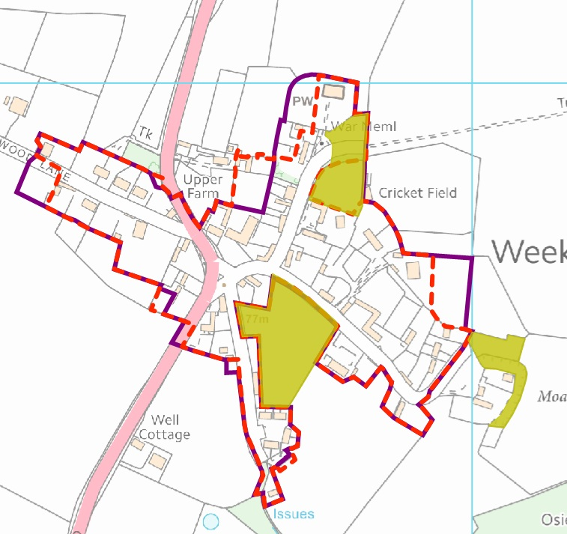
G
H
F
E
D
C
B
AD
I

Map Reference | Site Ref | Issue | Relevant Criteria | Further Investigation Required | Findings/ Conclusions
Small area of field south of 39 The Lane. | A | The site is currently included within the settlement boundary. | Principle 1, 3(d). | - Review aerial photograph. | - The site is in use for agricultural purposes (meadow) and is visually open in appearance.  Conclusion  Exclude site from settlement boundary in accordance with Principle 1 and Principle 3(d).
Highway land west of the Montagu Club. | B | The site is currently included within the settlement boundary. | Principle 1. |  | Land west of highway is open countryside and not developed.  Conclusion  Exclude highway from settlement boundary in accordance with Principle 1.
Rear garden of 1 Stamford Road. | C | Part of garden excluded from the settlement boundary. | Principle 1, 2(c). | 1) Review aerial photography. | 1) Site formed part of garden to property since 1970 based on EPOCH 6.  Conclusion  The curtilage boundary is clearly defined and visually associated with the dwelling house.
Land west of 4 Weekley Wood Lane. | D | Side garden included within the settlement boundary. | Principle 1, 3(e). | 1) Review aerial photography.  2) Review planning history. | 1) Epoch layers show that the garden enlargement occurred sometime between 1996 and 2000.  2) No relevant recent planning permission.  Conclusion  Exclude the side garden from the settlement boundary to achieve a tighter boundary and protect the structure and form of the village from further development in accordance with Principle 1 and Principle 3(e).
2 Woodstock, Weekley Wood Lane. | E | Part of garden excluded from settlement boundary. | Principle 1, 2(c). | - Review aerial photograph. | - Site has been included within the garden since before 2000.  Conclusion  Site is clearly defined by boundary features and visually separated from open countryside to the north. Inclusion of the site within the settlement boundary accords with Principle 1 and Principle 2(c).
Red Barn Cottage and garden serving The Old Vicarage Residential Nursing Home. | F | Site currently excluded from the settlement boundary. | Principle 1, 2(c). | - Review aerial photograph. | 1) Red Barn Cottage in use since before 2000 and garden serving Old Vicarage present for a similar time.  Conclusion  Position of site in relation to other dwellings within the settlement closely related, and have a clearly defined curtilage which visually separates them from open countryside. Inclusion of the site within the settlement boundary accords with Principle 1 and Principle 2(c).
Part of garden serving 15 Church Lane and part of cemetery at St Marys Church. | G | Large garden within settlement and cemetery is Public Open Space on edge of settlement. | Principle 1, 3(a) (e). | - Review aerial photograph. | - Epoch 4 layer shows the extent of the original garden was significantly smaller. The cemetery is open space and is located on the edge of the settlement.  Conclusion  Reduction of settlement boundary to exclude the west side of the cemetery and part of the existing garden will accord with Principle 1 and protect the structure of the existing village from inappropriate development in accordance with Principle 3(e). Exclusion of the cemetery will also accord with Principle 3(a).
Cedar Lodge, 46 Main Street. | H | Large garden visually open and relates to open countryside and could harm the open character of the area. | Principle 1, 3(e). | 1) Review aerial photography.  2) Review planning history. | 1) Land in use as garden since before 2000. Epoch 2 shows the garden has been this size since 1891.  2) No relevant planning permissions.  Conclusion  Garden is very large and although enclosed by hedge, it appears visually open and relates to open countryside. Exclude site from settlement boundary in accordance with Principle 1 and Principle 3(e).
35A Pernak Cottage. | I | Dwelling excluded from settlement boundary. | Principle 1, 2(a). | - Review planning history. | Dwelling approved under KET/2013/0614.  Conclusion  Extant permission exists for dwelling. In accordance with Principle 1 and Principle 2(a), the dwelling should be included within the settlement boundary.

4.27 WARKTON
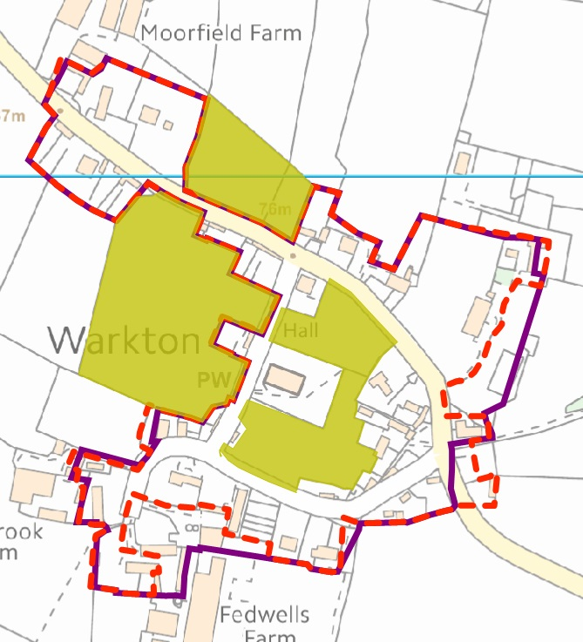
H
F
G
AD
BD
CD
DD
ED

Map Reference | Site Ref | Issue | Relevant Criteria | Further Investigation Required | Findings/ Conclusions
Land south of 19 – 25 Warkton. | A | Agricultural buildings located within the settlement boundary. | Principle 1, 3(c). | - Review settlement boundary.  - Review planning history. | 1) Buildings are agricultural and have been present since before 2000.  2)No relevant planning history.  Conclusion  Exclude farm buildings from settlement boundary in accordance with Principle 1 and Principle 3(c).
Land east of 36 Warkton. | B | Non-residential land included within the settlement boundary. | Principle 1. | 1) Review settlement. boundary  2) Review planning history. | 1) Site does not form part of curtilage to 36 Warkton. Land is in use as an informal driveway/parking area.  2) No relevant planning history.  Conclusion  Exclude site from settlement boundary in order to achieve a tight settlement boundary in accordance with Principle 1.
Land south of 41 Warkton. | C | Site benefits from planning permission for residential development and is currently outside of the settlement. | Principle 1, 2(a). | 1) Review planning history. | 1) KET/2014/0262 grants planning permission for reuse of a redundant rural building as a dwellinghouse.  Conclusion  Include site within settlement boundary.
Land east of the Old Rectory. | D | Property has a large garden which if developed would have an adverse impact on the open character and structure of the settlement. | Principle 1, 3(e). | 1) Review aerial photography.  2) Review planning history. | 1) Site been used as garden and tennis court since at least 2000.  2) No relevant planning history.  Conclusion  Development of the site would harm the open character of this part of the village. Exclusion of the site will prevent this and achieve a tighter settlement boundary in accordance with Principle 1 and Principle 3(e).
Land northeast of the Old Rectory. | E | Large area of garden serving property is excluded from the settlement boundary leaving a very small amenity area. | Principle 1, 3(d). | 1) Review aerial photography. | 1) Land served as garden since at before 2000. Land is open and co-joined with open countryside to the east. Garden within settlement boundary is very small and cuts across part of the building/dwelling.  Conclusion  Minor enlargement of the settlement boundary to the east will provide a courtyard area of amenity space within the settlement boundary to serve the existing properties and include all of the existing building, without harming the character or structure of the settlement, in accordance with Principle 1 and Principle 3(d).
Land west of 16 – 17 Warkton. | F | Part of garden excluded from settlement boundary. | Principle 1, 2(c). | 1) Review aerial photography.  2) Review planning history. | 1) Site formed part of garden to 16-17 Warkton since before 2000. Garden land is physically and visually separated from the adjacent field to the west.  2) No recent relevant planning history.  Conclusion  Include site within settlement boundary in accordance with Principle 1 and Principle 2(c).
Land at 18 Isebrook Farmhouse, Warkton. | G | Dwelling excluded from settlement boundary. | Principle 1, 2(c). | 1) Review aerial photography. | 1) Building currently outside of settlement boundary and been present since 1843 according to Epoch layer.  Conclusion  Include site within settlement boundary.
Moorfield Farm Workshops. | H | One of the workshop units is located outside of the settlement boundary | Principle 1 | - Review aerial photography | - Existing boundary line cuts through the workshop building.  Conclusion  Minor amendment to settlement boundary required so that it follows the western boundary of the existing building, in accordance with Principle 1.

4.28 GRAFTON UNDERWOOD
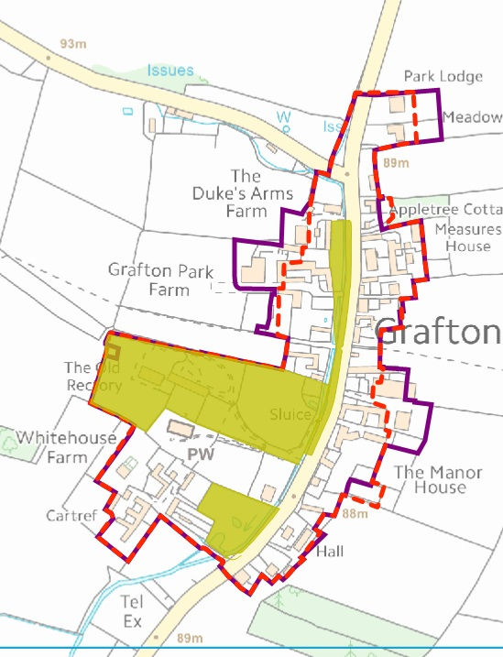
H
F
G
I
A
BD
CD
D
E

Map Reference | Site Ref: | Issue | Relevant Criteria | Further Investigation Required | Findings/ Conclusions
Land east of Village Hall. | A | Part of agricultural land located within settlement boundary. | Principle 1, 3(d). | - Review aerial photography.  - Review planning history. | 1) The site is laid to grass and coalesced with the adjacent field.  2) No relevant planning history.  Conclusion  Adjust boundary to exclude site in accordance with Principle 1 and Principle 3(d).
Tennis court and Manor House. | B | Tennis Court is excluded from settlement boundary. | Principle 1, 3 (d), 3(e). | 1) Review aerial photography.  2) Review planning history. | 1) The tennis court has been present on site since before 2000.  2) KET/2014/0472 granted a CLUED for garden land which included the site.  Conclusion  Include tennis court within site as it has been part of the curtilage for a significant period time and considered lawful. Exclude the rest of the garden included within the CLUED as development of the site would have a harmful impact on the character and structure of the settlement boundary.
Agricultural buildings east of the Byre. | C | Agricultural buildings are located within the settlement boundary. | Principle 1, 3(c). | - Review aerial photography.  - Review planning history. | 1) Agricultural buildings present before 2000.  2) No relevant planning history.  Conclusion  Exclude site from settlement boundary.
Land east of 24a and 25 Cranford Road. | D | Existing garden excluded from settlement boundary. | Principle 1, 3(c). | 1) Review aerial photography. | - Site has formed garden to properties since before 2000.  Conclusion  Site is clearly separate from open countryside to the east and forms part of a modest garden area. Include site within settlement boundary in accordance with Principle 1 and Principle 3(c).
Garden serving Meadowside and Park Lodge. | E | Large garden s serving properties currently within settlement boundary. Development of gardens would harm the open character of the area. | Principle 1, 3(e). | 1) Review aerial photography.  2) Review planning history. | 1) Site included as garden land since 2000.  - No relevant planning history.  Conclusion  Development of the site is possible by access between the dwellings; this would harm the character and structure of the settlement. The gardens are large. Exclusion of part of the gardens accords with Principle 1 and Principle 3(e).
Dukes Mill Cottage, Cranford Road. | F | Building is agricultural and included within the settlement boundary. | Principle 1, 3(c). | 1) Review aerial photography.  2) Review planning history. | 1) Building present since before 2000, with a larger attached building previously present.  2) No relevant planning permission.  Conclusion  Exclude building from settlement boundary as their function relates to open countryside in accordance with Principle 1 and Principle 3(c).
Agricultural buildings west of 1 and 2 Grafton Park Farm. | G | Agricultural building included within the settlement building. | Principle 1, 3(c). | 1) Review aerial photography.  2) Review planning history. | 1) Agricultural buildings present since before 2000.  2) No relevant planning history.  Conclusion  Buildings and associated land have a use associated with the open countryside and should be excluded from settlement boundary in accordance with Principle 1 and Principle 3(c).
Land west of Grafton Park Farm. | H | Land has an agricultural use and is included within the settlement boundary. | Principle 1, 3(d). | 1) Review aerial photography.  2) Review planning history. | 1) Aerial photography shows agricultural equipment on part of the land.  2) No relevant planning history.  Conclusion  The land which is under agricultural use should be removed from the settlement boundary, leaving a smaller area of curtilage associated with the farm house in accordance with Principle 1 and Principle 3(d).
Land west of the Old Rectory. | I | Small area of garden excluded from the settlement boundary. | Principle 1, 2(c). | - Review aerial photography. | 1) Site is included within the listed building curtilage. Aerial photography does not show a previous use of the land.  Conclusion  Include site within the settlement boundary in accordance with Principle 1 and Principle 2(c).

4.29 CRANFORD ST ANDREW AND ST JOHN
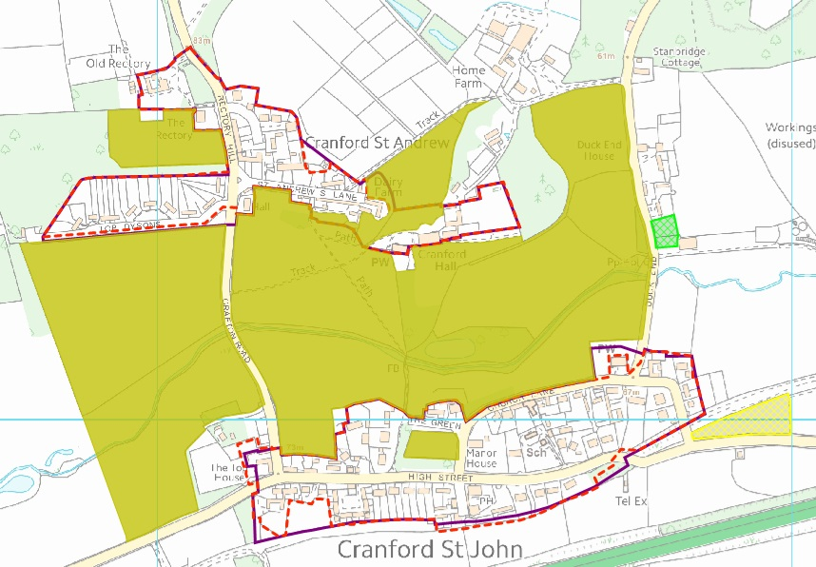
D
E
F
G
H
I
A
C
B
Map Reference | Site Ref: | Issue | Relevant Criteria | Further Investigation Required | Findings/ Conclusions
Highway verge and part of adjacent Top Dysons and part of Grafton Road included within settlement boundary. | A | Verge and highway included within settlement boundary. | Principle 1. | 1) Review aerial photography. | 1) Land south of verge and highway is rural in character and undeveloped; as a result, the boundary can be drawn to the north of the highway to maintain a tighter settlement boundary in accordance with Principle 1.
Land north of 21 St Andrews Lane. | B | Large area of garden located within settlement boundary. | Principle 1, 3(d) and (e). | 1) Review aerial photography.  2) Review planning history. | 1) Large area of garden has a visual relationship with open countryside to the north, and inclusion within the settlement boundary could lead to development which harms the linear layout of the settlement.  2) No extant planning permission for the site exists.  Conclusion  Exclude land from settlement boundary to provide a tighter boundary which protects the character of the settlement and its visual appearance in accordance with principles 1, 3(d) and 3(e).
Land north of 12 St Andrews Lane and east of 31 St Andrews Lane. | C | Large area of garden located within settlement boundary. |  | - Review aerial photography.  - Review planning history. | 1) Large area of garden has a visual relationship with open countryside to the north and east, and inclusion within the settlement boundary could lead to development which harms the linear layout of the settlement.  2) Land is designated as LB curtilage serving 12 St Andrews Lane.  Conclusion  Exclude land from settlement boundary to provide a tighter boundary which protects the character of the settlement and its visual appearance in accordance with principles 1, 3(d) and 3(e).
The Top House,  Grafton Road. | D | Large garden area outside of settlement boundary. This land is also curtilage listed. | Principle 1, 2 (c), 3(d), 3(e). | 1) Review aerial photography.  2) Review planning history | 1) Property has significant sized garden which includes a swimming pool which has been present or more than 10 years.  2) Land identified as curtilage listed, associated with The Old Granary.  Conclusion  Part of the garden area closely associated with the dwellings The Old Granary, The Top House, and the swimming pool can be included within the settlement boundary, excluding larger areas of the garden which could harm the character and structure of the settlement if included within the boundary. This would accord with principles 1, 2(c), 3(d) and 3(e).
Land south and east of Mill Barn, and 2 – 10 High Street. | E | Land included within the settlement boundary currently forms part of a paddock/meadow; part of the garden serving Mill Barn should be excluded as it is visually open in appearance and consent KET/2012/0271 for a new dwelling has now expired. | Principle 1, 3(d) and 3(e). | 1) Review aerial photography.  2) Review planning history. | 1) Aerial photography shows land as part of a wider curtilage and separate field parcel.  2) KET/2015/0215 provides extant consent for new dwelling, but does not include woodland wedge currently located within the settlement boundary.  Conclusion  Woodland wedge relates to open countryside located to the south, as does the small field parcel, which left undeveloped would protect the linear character of the settlement. These two areas of land should be excluded from the settlement boundary for this reason in accordance with principles 1 and 3(d) and 3(e).
Garden land serving 38 – 34a High Street, 40 Hill Rise, through to 50 High Street. | F | Part of garden land not located within settlement boundary. | Principle 1, 2(c). | 1) Review aerial photography.  2) Review planning history. | 1) The gardens are not excessive in size (particularly 38 – 34A High Street) and the existing boundary only excludes a small area of garden to each property on High Street. Their inclusion within the settlement boundary is not considered to harm the structure of the settlement, and follows existing boundary features which delineate at from the surrounding open countryside.  2) Historic planning permissions for new dwellings along High Street (e.g. KET/2001/0196) extend to the revised settlement boundary.  Conclusion  It is recommended to extend the existing settlement boundary slightly to incorporate established garden areas serving existing properties, some of which have very small garden areas. This will not harm the linear character of the settlement and accords with Principle 1 and Principle 2(c).
Land east of 54 High Street. | G | Land is woodland and falls outside of permitted curtilage and relates to open countryside to the south. | Principle 1, 3(d). | 1) Review aerial photography.  2) Review planning history. | 1) Site continuously been used for woodland.  2) No permission granted for residential use.  Conclusion  Exclude land from settlement boundary as relates to open countryside, in accordance with
Land East and West of Teal House. | H | Part of field within settlement boundary. | Principle 1. | 1) Review aerial photography.  2) Review planning history. | 1) Part of settlement boundary is not drawn tightly to curtilage boundary, and also cuts in to land west of Teal House.  2) No planning history for land east of Teal House. Extant consent granted for residential dwelling on land west (KET/2012/0810) expires 11th April 2016.  Conclusion  Amend settlement boundary to include approved residential site to west and exclude agricultural land to east.
Cemetery land surrounding St Johns Church, Church Lane. | I | Cemetery is a public open space on the edge of the settlement and is currently included within the settlement boundary. | Principle 1, 3(a). | 1) Review aerial photography. | Conclusion  Exclude cemetery in accordance with Principle 1 and Principle 3(a).

- END -

