To all Members | Direct Line: (01536) 534398  Email: anneireson@kettering.gov.uk  Our Ref: AI  Your Ref:  Date: 7th July 2015

Dear Councillor

You are summoned to a meeting of Kettering Borough Council to be held in the Council Chamber, Municipal Offices, Bowling Green Road, Kettering on Wednesday, 15th July 2015 at 7.00 pm.

Yours faithfully

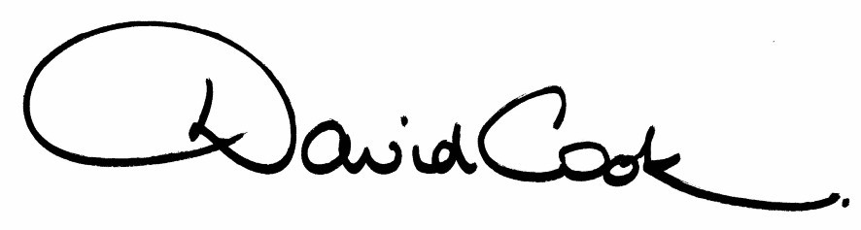

D Cook
Chief Executive

A G E N D A

1. Apologies.

2. Minutes of the Annual Meeting of the Council held on 20th May 2015 to be approved as a correct record and signed by the Mayor.

3. Declarations of Interest:-

- Disclosable Pecuniary Interests
- Personal Interests

4. To receive any announcements from the Mayor and/or the Leader of the Council.

5. Report of the Chief Executive:

6. The Mayor to ask members of the public present if they want to speak on any item on the agenda.

7. Presentation of Petition – Public Spaces Protection Order

8. Request from Cransley Parish Council – Change of Name (report attached)

9. The Local Authorities (Standing Orders) (England) (Amendment) Regulations 2015 (report to follow)

10. Appointments to Outside Bodies (list attached)

11. Appointments to Committees (2015-16) (list attached)

12. To consider motions received in accordance with Council Procedure Rule 16 as follows:-

(i) To be proposed by Councillor Clark Mitchell and seconded by Councillor Anne Lee that:-

"In relation to the issue of Child Poverty raised by the Evening Telegraph and the fact that Kettering Borough Council already supports various charities and food banks, the Council undertakes to facilitate a conference within 2015 with relevant charities and organisations whose aim is to help the affected families.”

(ii) To be proposed by Councillor Jan Smith and seconded by Councillor Mike Brown that:-

"This motion recognises the enormous contribution local sporting
organisations make to our Borough. An active society is a healthy
society, thus this motion wishes to endorse the majority group’s Manifesto commitment to the Borough. In particular we aim to regenerate some of our older leisure facilities and also
to work more closely with our local sporting teams, to help them
realise their own aspirations and future success within their home
towns/villages.”

(iii) To be proposed by Councillor Scrimshaw and seconded by Councillor West that:-

“Kettering Borough Council congratulates the organisers and participants of Kettfest. The recent festival was a fantastic boost to the town and was a great example of a community event. We hope that this will become an annual event and look forward to working with them to make next year’s event even bigger and better.”

13. To receive questions from members.

14. Any matters of urgency that the Mayor decides should be considered.

7.7.15
Fire Alarm
All meetings shall be adjourned immediately on the sounding of the fire alarm. The alarm is a continuous two-tone siren. On hearing the alarm please leave the building by the nearest emergency exit. There are emergency exits at both ends of the corridor outside the meeting rooms. On leaving the building please cross the car park and assemble on the grassed area by the church. Do not attempt to drive out of the car park as this may impede the arrival of emergency vehicles. Please do not return to the building until you are told it is safe to do so by a Council employee.

Toilets
There are toilets in the corridor off the main entrance to the building you came through to get to the meeting room.

Facilities for Babies and Children
If you wish to use a private area to feed your baby please ask a member of staff. There are changing facilities in the corridor off the main entrance adjacent to the toilets.
Access for Disabled People
There are allocated parking bays outside the main entrance to the Municipal Offices for disabled people. The meeting rooms are located on the ground floor and access is gained for wheelchair users via the main entrance. If you require assistance, please ask the attendant on duty in the reception area.

No Smoking
Smoking is not permitted in the Municipal Offices.

Reporting on Meetings of the Council
Members of the press and public are entitled to report on meetings of the Council, Committees and the Executive, except in circumstances where they have been excluded in accordance with national rules.

If you wish to report on this meeting, please telephone 01536 534191 or email democracy@kettering.gov.uk at least two days before the meeting to enable the Council to provide reasonable facilities for you to do so. Failure to advise the Council of your intention may mean the necessary facilities will not be available.

If you are planning to attend, and do not wish to be recorded or photographed, please inform the Chair at the start of the meeting. The Protocol for members of the public wishing to film and report on meetings is available on Kettering Borough Council's website at:
http://www.kettering.gov.uk/recordingmeetings

