B O R O U G H O F K E T T E R I N G

Committee | A6 TOWNS FORUM | Item | Page 1
 |  | 10
Report |  | Fwd Plan Ref No:
Originator | Head of Community Services |  | -
Wards | All | 24th June 2015
Affected
Title | OUTDOOR GYMS

1. | PURPOSE OF REPORT
 | To provide general information in respect of outdoor gym provision in the
 | Borough

2. INFORMATION

- Outdoor gyms are a continuing phenomenon within the United Kingdom. Over the last ten years there has been a growing movement for outdoor spaces for adults, not just for children and young people. Trim trails were probably the forerunner of outdoor gyms and a small number could be found dotted about the UK. A good example of a trim trail can be found in a Victorian park near

Skegness seafront. Smaller versions of trim trails were developed locally for children, for example at Broughton Village Hall, Charlotte Place Park and Hall Meadow Park in Kettering.

2.2 The first outdoor gym equipment was installed in Charlotte Place Park many years ago, the two items provided were prototypes and were supplied free of charge by Wicksteed Playscapes. The next provision was unplanned, but was an offer that could not be refused. Again, the equipment was provided free of charge with Kettering Borough Council (KBC) funding its installation. The timescale for installation was very short and the equipment was installed at Hall Meadow Park, adjacent to Kettering Conference Centre. This installation has worked well and has complemented the existing play provision that now caters for all ages, toddlers to senior residents.

2.3 The next outdoor gym provision was led by Mawsley Parish Council and was part of their plan for play facilities for older children and adults. Mawsley carried out their own consultation, submitted funding applications, secured funding and delivered the whole project 2013. Two other schemes were installed in 2014 in Kettering, one at Rockingham Road Pleasure Park led by The Friends of Rockingham Road Pleasure Park and the other at Millennium Park, Brambleside led by the Brambleside Community Association (Photo 1).

2.4 Kettering Borough Council supported Desborough Town Council to secure funding for an outdoor gym within Dunkirk Avenue Recreation Ground. This was installed in the early part of 2015. The Town Council will be officially opening the gym at Desborough Carnival on the 27the June.

B O R O U G H O F K E T T E R I N G

Committee | A6 Towns Forum | Item | Page 2
 |  | 10

2.5 There continues to be a lot of interest from other parish and town councils. We are keen to continue to work with groups to consult, secure and deliver similar areas in appropriate locations.

2.6 Outdoor Gyms are only one aspect of free or very affordable play/sport provision that has been provided within the Borough, directly by KBC or by other organisations. Some examples are:-

- Healthy Happy Families – Delivered at Primary Schools

- Wicksteed Park

- Kettering by the Sea (KBC)

- Museum and Art Gallery Children’s Activities

- Summer Play Schemes

- Summer Sports Schemes

- Equipped Play Areas

- Multi Wheeled Sports Facilities

- Tennis Courts

- Multi Use Games Areas

- Bowls Greens

- BMX tracks

- Grassed football pitches
- Artificial Sports pitches
- Athletics Track
- Allotment Sites
- ‘Walking for Health’ Health Walks

B O R O U G H O F K E T T E R I N G

Committee | A6 TOWNS FORUM | Item | Page 3
 |  | 10

2.7 There are a number of potential health benefits from having outdoor gym provision in the Borough. Sefton Council have produced an evaluation of the use of their outdoor gym provision and its impacts on the health of their residents. They reported that residents had found that access to this equipment had increased their levels of physical activity and also reduced barriers to being active such as cost and transport. Research has also shown that contact with green spaces and the natural environment promotes better physical and mental health, and also improves self-esteem and confidence.

- CONSULTATION AND CUSTOMER IMPACT

- Any enhanced or new play provision should always consider the impact on residents living on the boundary of public open spaces. The normal sequence of events for such provision is as follows:

  - Consultation with residents on boundaries

  - Review

  - Consultation with users

  - Review

  - Provide feedback to all and finally agree scheme

  - Seek and secure funding

  - Procure and deliver scheme

  - Celebration event

- POLICY IMPLICATIONS

- The PPG17 Assessment provided KBC with the information to develop and adopt the ‘Open Space Supplementary Planning Document’ (SPD) in 2008. The SPD provides standards for quality, quantity and accessibility standards for different types of open space. This includes ‘provision for children’ and provision for young people. These standards are used by KBC when responding to planning applications of ten or more dwellings. As a result of new housing developments, additional play provision may be provided. The full SPD may be found on KBC’s website but for ease of reference the standards have been replicated at Appendix 1.

4.2 If there is no on site requirement, an off site contribution is sought if there are existing play sites within the accessibility standard. The SPD does not consider equipped sites for older adults but outdoor gyms are suitable for young people and could be considered by developers as part of on site provision under the typology of ‘provision for young people’.

B O R O U G H O F K E T T E R I N G

Committee | A6 TOWNS FORUM | Item | Page 3
 |  | 10

5. FINANCIAL/ RESOURCE IMPLICATIONS

5.1 There are additional resource implications, and installations have required successful external funding applications. The additional equipment will be included in existing Royal Society for the Prevention of Accidents (RoSPA) inspections that are carried out twice per annum.

6. HUMAN RESOURCE IMPLICATIONS

6.1 There are no additional human resource implications in respect of this report.

7. LEGAL IMPLICATIONS

There ae no additional legal implications in respect of this report.
8. RECOMMENDATION
To note the resource implications and the active role of community groups to consult, secure funding and deliver outdoor gymns and new or enhanced equipped play areas.

7. | 7. | LEGAL IMPLICATIONS

Contact Officer : Pia Bellamy (piabellamy@kettering.gov.uk)

Background Papers:

Title
Date
Contact Officer

Previous Minutes/Reports:

Ref:
Date:

B O R O U G H O F K E T T E R I N G

Committee | A6 Towns Forum | Item | Page 5
 |  | A3 | of 5

Photo 1 : Rockingham Road Pleasure Park.

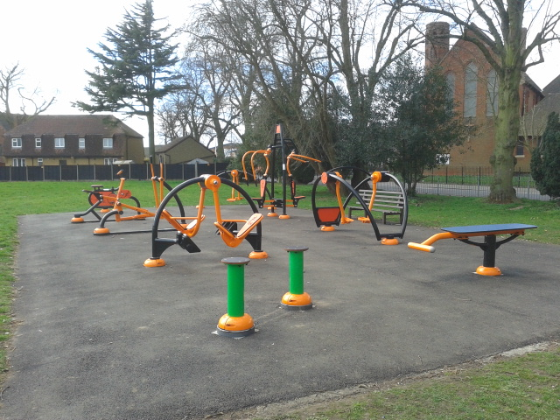

Photo 2: Brambleside Scheme
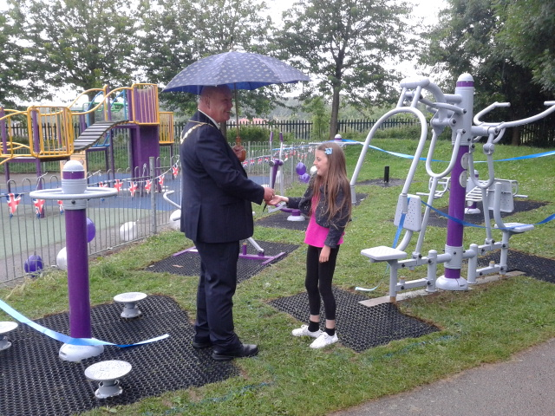

Photos 3 and 4 Dunkirk Ave Recreation Ground

