To all Members | Direct Line: (01536) 534398  Email: anneireson@kettering.gov.uk  Our Ref: AI  Your Ref:  Date: 14th April 2015

Dear Councillor

You are summoned to a meeting of Kettering Borough Council to be held in the Regency Room at the Naseby Hotel, Sheep Street, Kettering on Wednesday, 22nd April 2015 at 7.00 pm.

Yours faithfully

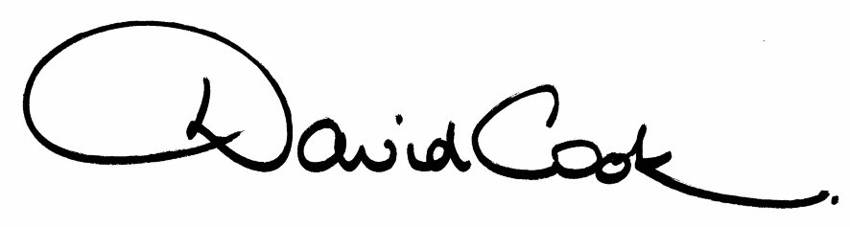

D Cook
Chief Executive

A G E N D A

1. Apologies.

2. Minutes of the meeting of the Council held on 25th February 2014 to be approved as a correct record and signed by the Mayor

3. Declarations of Interest:-

- Disclosable Pecuniary Interests
- Personal Interests

4. To receive any announcements from the Mayor and/or the Leader of the Council.

5. Report of the Chief Executive:

6. The Mayor to ask members of the public present if they want to speak on any item on the agenda.

7. Nomination of Deputy Mayor 2015/16

8. Changing the Constitution – Amendment to the Scheme of Delegation

9. To receive questions from members.

10. Any matters of urgency that the Mayor decides should be considered.

11. Report of the Appointments Committee (to follow)
(This report, or part of this report, may be considered in private and confidential because it contains information relating to an individual or likely to reveal the identity of an individual.)

14.4.15
Fire Alarm
All meetings shall be adjourned immediately on the sounding of the fire alarm. The alarm is a continuous two-tone siren. On hearing the alarm please leave the building by the nearest emergency exit. There are emergency exits at both ends of the corridor outside the meeting rooms. On leaving the building please cross the car park and assemble on the grassed area by the church. Do not attempt to drive out of the car park as this may impede the arrival of emergency vehicles. Please do not return to the building until you are told it is safe to do so by a Council employee.

Toilets
There are toilets in the corridor off the main entrance to the building you came through to get to the meeting room.

Facilities for Babies and Children
If you wish to use a private area to feed your baby please ask a member of staff. There are changing facilities in the corridor off the main entrance adjacent to the toilets.
Access for Disabled People
There are allocated parking bays outside the main entrance to the Municipal Offices for disabled people. The meeting rooms are located on the ground floor and access is gained for wheelchair users via the main entrance. If you require assistance, please ask the attendant on duty in the reception area.

No Smoking
Smoking is not permitted in the Municipal Offices.

Reporting on Meetings of the Council
Members of the press and public are entitled to report on meetings of the Council, Committees and the Executive, except in circumstances where they have been excluded in accordance with national rules.

If you wish to report on this meeting, please telephone 01536 534191 or email democracy@kettering.gov.uk at least two days before the meeting to enable the Council to provide reasonable facilities for you to do so. Failure to advise the Council of your intention may mean the necessary facilities will not be available.

If you are planning to attend, and do not wish to be recorded or photographed, please inform the Chair at the start of the meeting. The Protocol for members of the public wishing to film and report on meetings is available on Kettering Borough Council's website at:
http://www.kettering.gov.uk/recordingmeetings

