1. PURPOSE OF REPORT

- To announce the commencement of works on Public Realm Phase 4 – the installation of new rising bollards in Kettering town centre

- To highlight the progress made on the Soan’s Yard development

- To inform Members about changes to the way Chesham House is being managed

2. BACKGROUND INFORMATION

2.1 Kettering Borough lies within the South East Midlands, which is predominantly a growth area, and is expected to facilitate growth of some 13,100 homes and 16,200 new jobs by 2021.

2.2 Members have made their priorities for infrastructure and jobs-led growth clear – these are the prerequisites of growth. Members have indicated they wish to use the growth agenda to leverage three key and interrelated ambitions for the borough; namely:-

- A better offer for our town centres
- A better education and training offer
- A better employment offer – high grade, higher density jobs

  - The mutually supportive role of these three aspirations cannot be over-stated. The town centres and the skills base will be persuasive to inward investors. Similarly, high grade employment supports vibrant town centres.

  - The Council has a vision to create town centres that are Characterful, Distinctive, and Fun. This vision has been externally validated by an independent planning inspector, and now sits firmly within our planning policy for Kettering Town Centre.

3. PUBLIC REALM PHASE 4

  - Last week saw the commencement of the construction phase for the rising bollards scheme – part of the Public Realm Phase 4 project – for Kettering town centre. Previous reports have gone into detail about the project, but it is worth reminding ourselves of the core objectives. There were:

- Reduce traffic in the High Street and Gold Street area
- Improve the pedestrian and shopping environments
- Allow more events and markets to take place on the street
- Encourage more on-street dining (a café culture)
- Drive further private investment

  - The new arrangements, as set out within the Traffic Regulation Order, are as follows:

- 20mph speed limit throughout the zone
- Four rising bollards – one at each gateway (access via swipe cards)
- Collapsible bollard at Meeting Lane
- Blue Badge parking is to be provided at Lower Street and Gold Street (as well as existing parking spaces)
- Loading/Deliveries are prohibited between 9am-5pm (Sun-Thurs) and 8am-5pm (Fri-Sat)
- Cycling is prohibited within the town centre

  - The zone covered by the project is an extensive one – such that the project will play a key role in the future of Kettering town centre. The wider project will see new public realm throughout the main shopping area of the town, with a re-imagined public square at the bottom of Gold Street. The following image indicates how that might look:

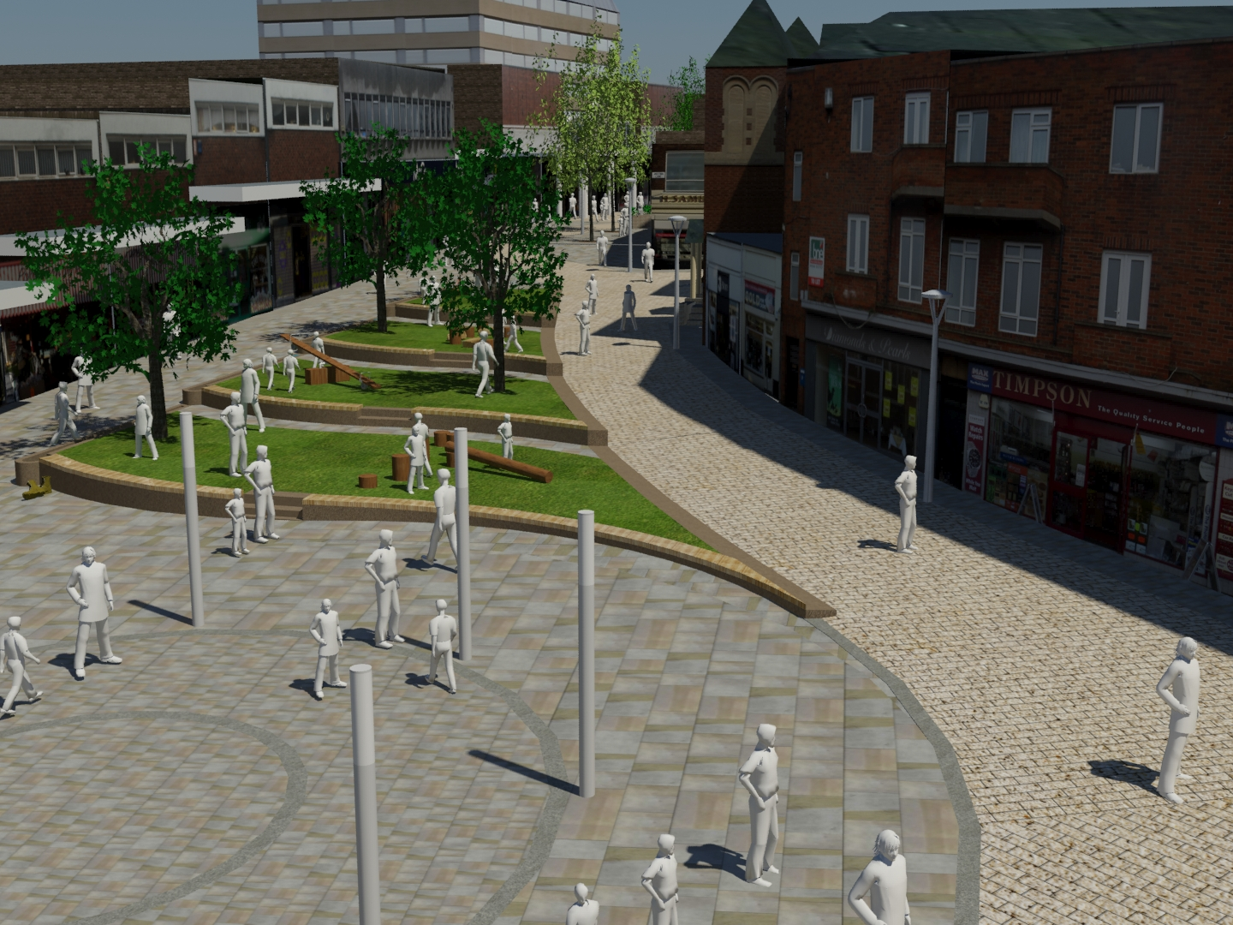

  - The purpose of this report is to outline precisely where the new bollards are to be located. The best way of doing this is via the designs:

High Street
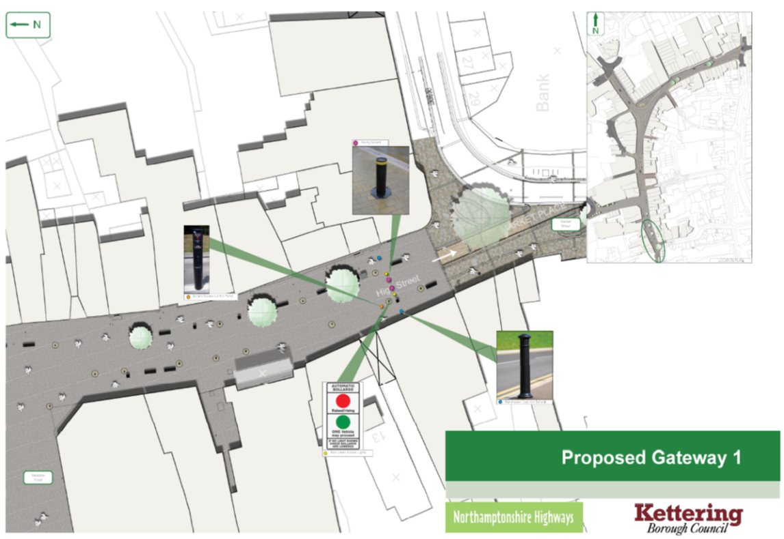

Meadow Road

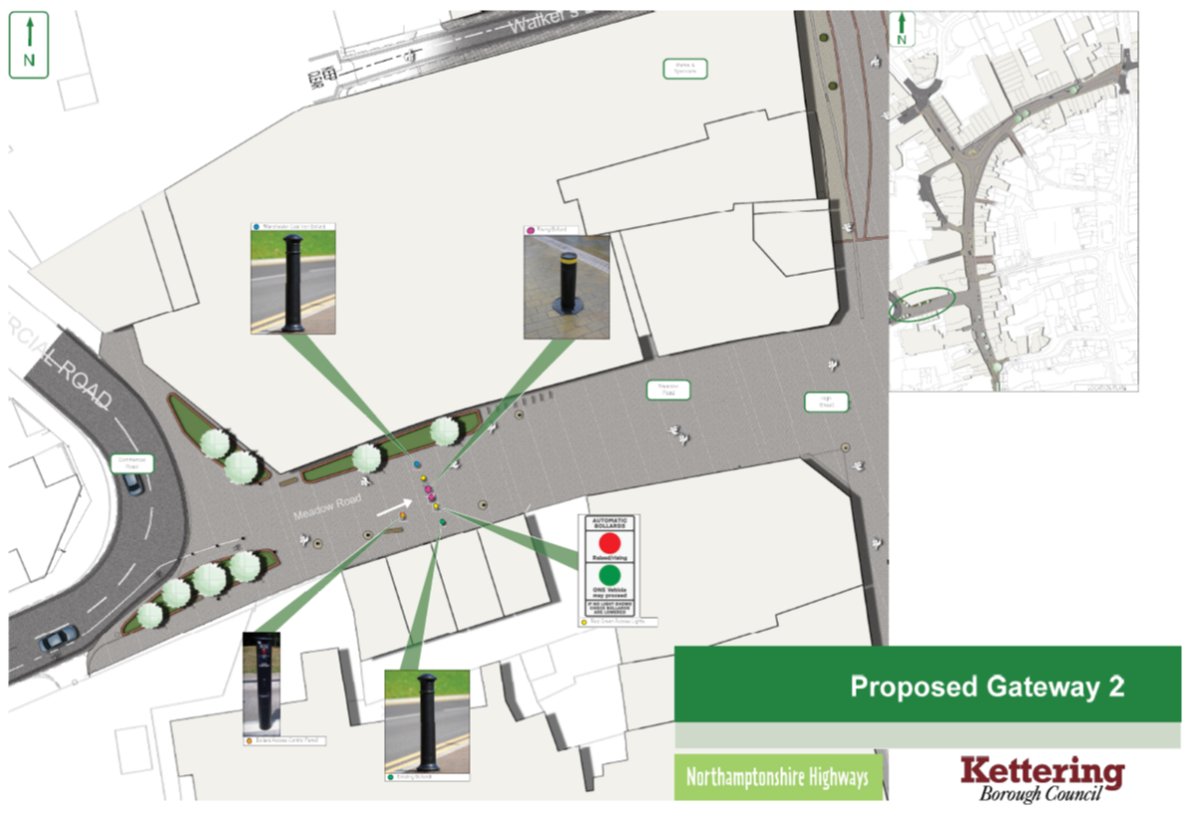
Lower Street
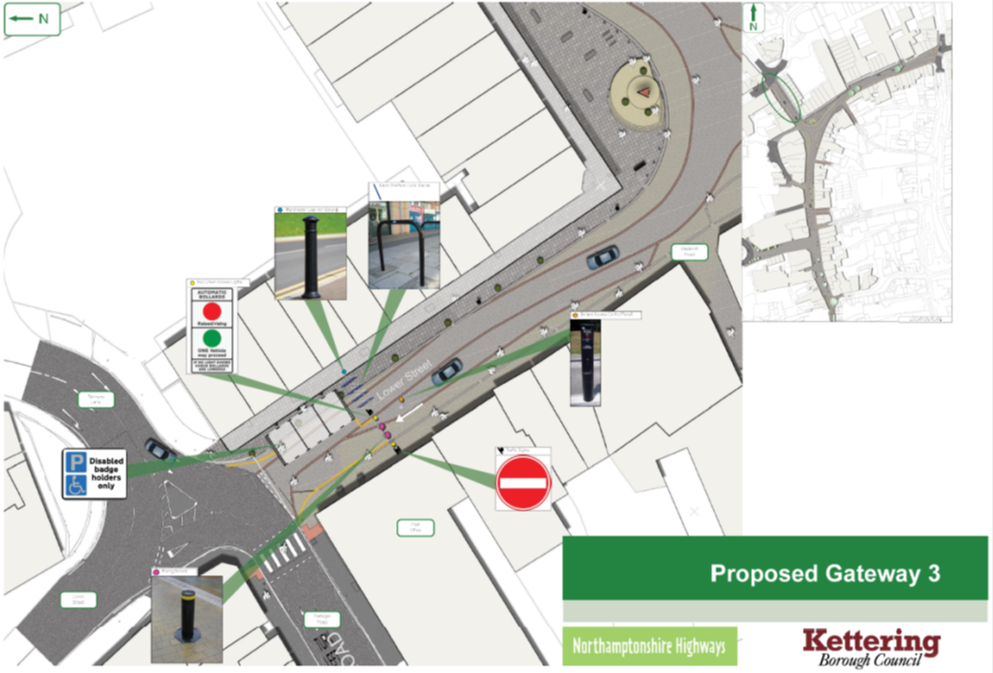

Gold Street
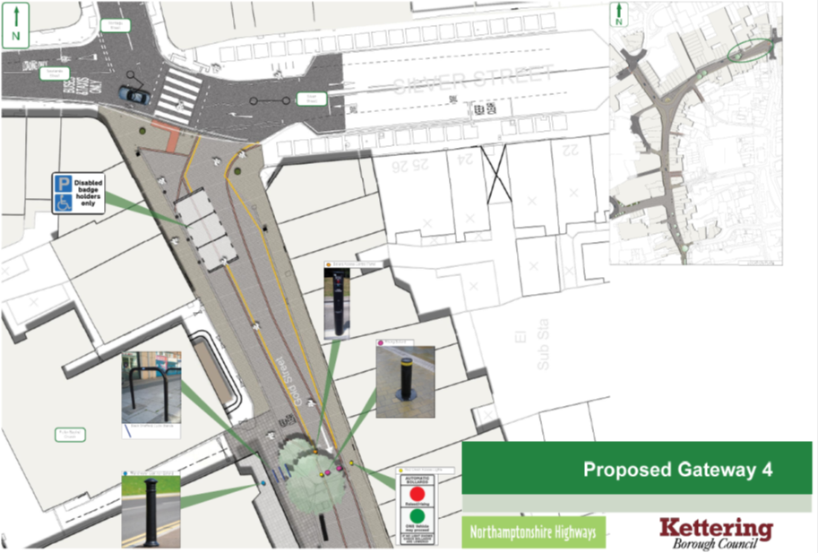

Meeting Lane
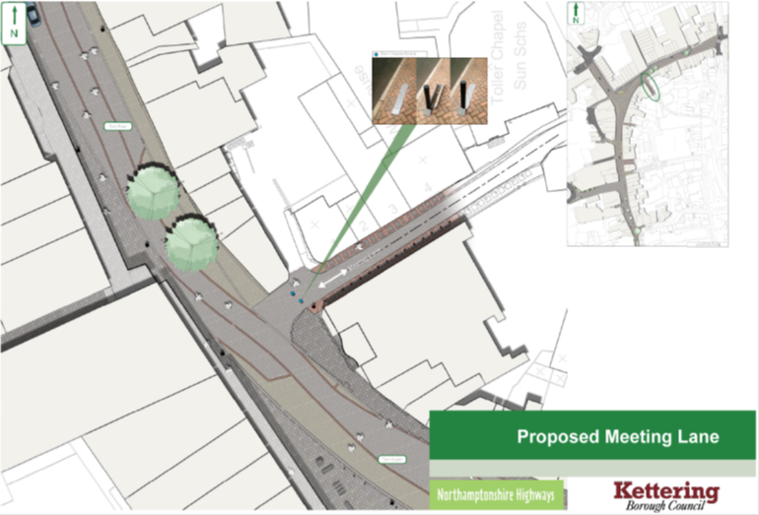

Wadcroft
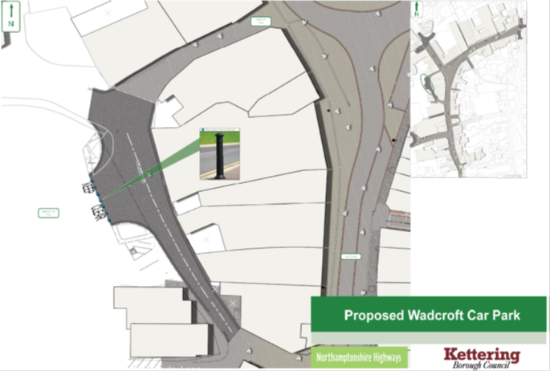

  - As these images show – new rising bollards to be installed at High Street, Meadow Road, Lower Street and Gold Street. Meanwhile manual bollards will be installed at the bottom of Meeting Lane and fixed bollards at Wadcroft. This will secure the pedestrianized part of the town centre as just that – pedestrian.

  - It is anticipated that the construction phase should take between 6-8 weeks to complete. We will keep people informed of progress and key dates so that as minimal an amount of disruption is caused as possible. Alongside the communication that Northamptonshire Highways are seeking to have with businesses and the public, KBC will be having discussions about the swipe cards businesses will need to access the zone outside of the core hours for deliveries.

- SOAN’S YARD UPDATE

  - Our vision for The Yards is to establish a recognisable hub for niche and independent retailers that will act as a destination in its own right. It will form the link between the restaurant quarter centred on the award winning Market Place development, and the more main stream national retailers of the northern part of the town centre.

  - The Executive Committee in January 2012 endorsed the marketing of the Yards in line with the proposed method of disposal. In January 2013 the Executive Committee agreed to let the Yards development site to Kevin Jones for retail, restaurant and office use – which would involve refurbishing and redeveloping the majority of the existing buildings. In October 2013 the Planning Committee approved a planning application for the change of use of the site.

  - Works have been underway on site now for approximately 6 months – initially to demolish some 1920s extensions to the old Kettering Ambulance Station. Those works are progressing well, and it is intended to have the first units let this summer.

5. CHESHAM HOUSE

5.1 Chesham House provides office space and meeting rooms for small and medium-sized enterprises as well as a being the home of Enterprise4Kettering, which offers business support. The University of Northampton has worked in partnership with Kettering Borough Council to provide a management role at Chesham House Enterprise Centre for a number of years, as well as delivering the business support offer – these have been managed through independent Service Level Agreements.

5.2 With respect to the management SLA; it was based on the University providing a staff resource and KBC providing £30,000 towards the costs of running the building (utilities, etc).

5.3 We have been in discussion with the University over the last few months, and it is now clear that they wish to cancel the arrangement; focusing instead on delivering their new campus in Northampton.

5.4 Having assessed the options available to us, it has been decided to locate the Economic Development team within Chesham House to fulfil the management function alongside their existing work. This will enable KBC to fully understand the Centre’s requirements, so that a long term solution can be decided upon at a later date.

5.5 We are in the process of making the final arrangements at the moment, with a view to being installed there before the end of April – which is when the University will cease their management function.

5.6 Tenants have been notified of the changes and reassured that there will be no drop in the high level of service they currently benefit from. There is now an opportunity for them to make recommendations about the ongoing management processes, etc.

5.7 Chesham House has been fully let for almost a year now, and there are regular enquiries about office and meeting room space. We’d like to thank the University for their hard work over the last few years, and wish the team well in their latest endeavours. We are determined to ensure that there is no slip in tenancy numbers, and are looking at ways we can make improvements where possible.

6. POLICY IMPLICATIONS AND USE OF RESOURCES

Members have made their priorities for infrastructure and jobs-led growth clear – these are the prerequisites of growth. Members have indicated they wish to use the growth agenda to leverage three key and interrelated ambitions for the borough; namely:-

- A better offer for our town centres
- A better education and training offer
- A better employment offer – high grade, higher density jobs

7. RECOMMENDATION

That the Executive Committee:

- Welcomes the commencement of work on the Public Realm Phase 4 project
- Notes the progress made to date on the Soan’s Yard development
- Recognises the hard work done to establish Chesham House as an Enterprise Centre, and supports the approach taken to secure its ongoing success

