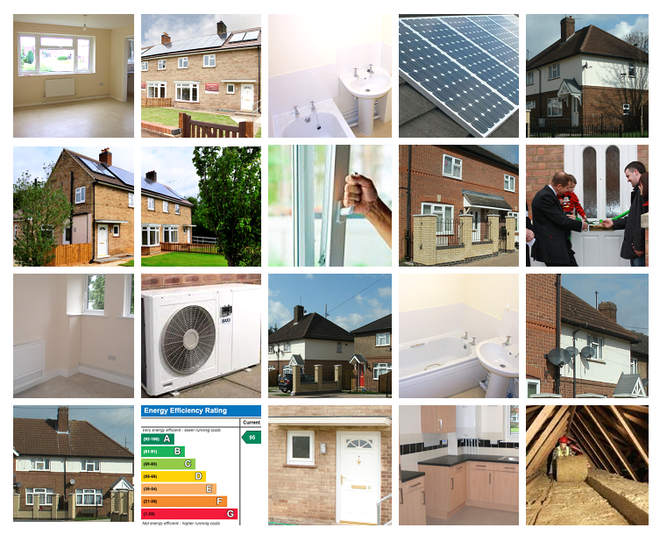

Asset Management Report

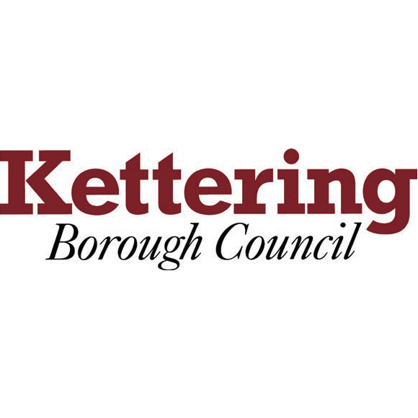
Update for Tenants Forum

March 2015


Contents

- Introduction

- Financial Update

- Programme Update

1. Introduction

A bit of a brief report this month!! With the 2014-15 Housing Capital programme drawing to a conclusion, and surveyors working through their 2015-16 schedules, there is a limited amount of information to report back this month. Most schemes have been concluded on site, and the team are now taking the opportunity to “get ahead of the curve” by finalising their property programme lists for next year, with the majority of expressions of interest notifications having now gone out earlier this month.

There is a brief financial summary and 2014-15 programme update for information / discussion, however April’s edition will see far more detail on the up and coming 2015-16 schedule, with details on regions that have been identified for investment through the stock condition database, and the level of investment that has been allocated the various work types. This should spark significant interest and I hope discussion, and further demonstrate that Kettering Borough Council is progressing at a good rate in respect of ongoing investment in its housing stock.

Thanks for your continued support,

Darren
darrenibell@kettering.gov.uk

- Financial Update

- Current 2014-15 budget has been adjusted following a number of agreed internal virements. The adjusted annual budget is now £4m across both Housing and Environmental Care.

- 84% of the adjusted budget has been either expended or committed as of 1st March 2015. This equates to a remaining budget of circa £650k.

- Majority of projects have now been completed and are undergoing final account processes, however Homes For The Future Desborough, Fire Precaution, Structural Balcony & Walkway programmes, amounting to a total cost allocation of circa £400k remain on site, and are expected to be completed by the end of March 2015.

- It is forecast that capital void costs will overspend by around £100k by the end of March 2015.

- The Council forecasts that the current capital programme will come in on budget at the end of March, and that any underspend will be carried forward to 2015-16. There will be no detrimental impact to the 2015-16 budget in respect of overspends.

3. Programme Update

Final scheme feasibility planning for Homes For The Future at Hampden Crescent completed and due for submission to SMT at the end of March 2015.

Site office at Alexandra Road, Desborough now fully operational.

GRP door upgrade programme at Weekley Glebe has been completed, other than a handful of no access cases.

Works to improve walkways and balconies at Dahlia Road, Marion Square and Scott Road is on site and progressing.

Full passenger lift upgrades at Madams Gardens and the Lawns has been delayed to allow for consultation with customers in respect of interim access arrangements, however works are planned to start on site mid March 2015.

Communal door entry upgrades at Whiteford Drive have been completed.

Fire Risk Assessment reviews completed and works awarded. Project now on site.

Further three buy back properties now purchased an in works on site.

2015-16 Property schedules have been issued to all responsible surveyors, driven via Estate Pro.

