**1 PURPOSE OF REPORT**

The purpose of this report is to:

1. outline the draft budget figures for the Council’s three main accounts for 2015/16 (to start the formal budget consultation process);
2. consider the main issues that are likely to impact on the Council's budgets in the medium term;
3. provide an illustration of the Council’s medium term financial projections.

**2 CONTENTS**

* 1. To help Members navigate this report, it contains five sections:

**Section A** **‘Budget Strategy’ (pages 3 to 10)** – Provides specific reference to the Council’s:

|  |  |
| --- | --- |
| Context  Policy Position  Guiding Principles | Page 3  Page 7  Page 8 |
|  |  |

**Section B** **‘The current year’s Budget Position (2014/15)’ (pages 11 to 17)** – Provides the detail to the current year’s budget position.

|  |  |  |  |
| --- | --- | --- | --- |
|  | |  | |
| **Section C ‘Next year’s draft Budget Position (2015/16)’ (pages 18 to 27) –** Provides the detail to the 2015/16 draft budget  **Section D ‘Medium Term Financial Landscape’ (pages 28 to 32) –** Provides details to the following technical aspects of the budget process:   |  |  | | --- | --- | | National Financial Landscape | Page 28 | | Local Government Grant Settlement | Page 30 | | |  | |
|  | |  | |
|  | |  | |
|  | |  | |

**Section E ‘The Medium Term Prospects’ (pages 33 to 34) –** Provides an update on the Council's Medium Term Financial Strategy

These five sections are then followed by a **Summary and Recommendations.**

The report contains the following appendices

A – Draft Budget Booklet

B – Budget Consultation Timetable

**Section A: Budget Strategy**

**3 CONTEXT / BACKGROUND**

* 1. The Council’s budget strategy is well known to members through the monthly ‘maintaining a durable budget’ reports to the Executive Committee.
  2. Each and every month the Executive Committee receives a detailed report on the Council’s budget position. This particular report brings together all the key messages and figures so that the Council can fulfil its statutory responsibilities to construct and formally consider (and ultimately approve) a number of budgets.
  3. The Council operates three main accounts; each requires an annual budget to be considered and approved by members in accordance with statutory requirements. Table 1 outlines what each account is used for.

|  |  |
| --- | --- |
| **Table 1 – The Council’s Three Accounts** | |
| **Account** | **Description** |
| **General Fund Revenue Account** | All revenue expenditure and income (i.e. day to day running costs), financed from Council Tax, Government Grants and Fees and Charges (excluding those related to the provision of Council Housing). |
| **Capital** | All capital expenditure and income (i.e. acquisition, replacement and enhancement of assets) financed from Government Grants, external contributions, revenue contributions, capital receipts and borrowing. |
| **Housing Revenue Account** | All revenue expenditure and income on activities related to being a housing landlord. |

* 1. The Council has an established policy position from which it considers its budget – this includes a number of guiding principles / rules which ensure that the Council has a robust medium term financial strategy. A reminder of the policy position is provided later in this section, before we do that, below is a reminder of the key messages from **last year’s budget process** (as a reference point).

**Messages from the last budget process – a reminder**

* 1. When the Council set its budget for 2014/15 in February 2014, the following points were outlined at that time:-
* *Council Tax remains below the national average (around £3 per week for the average household);*
* *The Council has maintained a balanced budget without cutting front line services or using one-off reserves;*
* *The Council has maintained its overall support for the voluntary sector;*
* ***The changes to the national landscape continue to bring greater uncertainty and volatility to future projections****.*
* *The Council needs to continue its* ***excellent track record of delivering budget savings*** *to balance the budget for 2014/15.*
* *Prior to the consideration of any council tax increase, it is estimated that* ***£1,429,000 of savings will be required.*** *We will start 2014/15 in a similar position to 2013/14 because of the continued use of the Council’s successful budget delivery framework which has resulted in the Council already having secured some of the on-going savings required for 2014/15. The remaining savings with the exception of £100,000 have also been identified and the Council is confident that these will be delivered during 2014/15.*
* *The Council’s strong and controlled budgetary position is a direct result of the adherence to the guiding principles that have been diligently followed over recent years. The challenges faced for 2014/15 mean that it is even more important that the guiding principles are followed if the council is to remain in a relatively good financial position.*
* ***A capital programme of around £5.5m*** *is not inconsiderable for a District Council of Kettering’s size and no doubt a welcome boost to the local economy.*
* *The budget is of course, only a paper exercise and the challenge of delivering the £1,429,000 of savings during 2014/15 must not be underestimated. The Council’s focus will remain on maintaining the delivery of high quality front-line services. However, with the level of changes necessary some transition turbulence is inevitable.*
* *A further £1,464,000 of savings is estimated to be needed to balance the budget for 2015/16. Work on the budget delivery framework will continue to ensure savings are identified.*
* *Assumptions have been made for future levels of government grant (and other funding changes) and* ***a decrease of 16% has been applied for 2015/16*** *following the provisional settlement and* ***further annual decreases in overall funding of 10% for 2016/17 and beyond.***
* *Based upon the assumptions applied, the future years’ budgets would require ongoing year on year savings of:*

***2015/16 £1,464,000***

***2016/17 £1,293,000***

***2017/18 £1,054,000***

***2018/19 £1,018,000***

* ***The system for government funding which was introduced in April 2013 effectively transfers significant risks from central to local government.*** *Such risks include;*
* ***Business Rate Volatility***

*Future changes in business rates yield will have a direct impact on a significant proportion of the grant received by the council in the future. The Council has most of the risk of any downward movement whilst it can retain a small element of any increased yield. This element of risk continues to be monitored very closely.*

*Business rate appeals will also impact on the councils future funding.* ***The Government have announced that there will be a consultation on reforms to business rate appeals with a commitment to clear 95% of the September 2013 backlog of appeals before July 2015. This is an area that will need to be closely monitored.***

* ***Council Tax Benefits Volatility***

*As widely expected and as reported to the Executive as part of the 2013/14 budget process* ***future levels of council tax support funding will be reduced in line with the reductions in central government core grant.*** *It is also likely that* ***the council will have to bear the cost of increased caseload*** *over the medium term – given the current economic outlook this continues to be a real and present risk.*

***Other Considerations***

* *The projections in all years rest on the Executive’s adherence to the “Guiding Principles” the “Modelling for Recovery Principles” and the Budget Containment Strategies (para 4.4).*
* *Depending on the decisions taken in relation to Council Tax, year on year savings of these magnitudes have and will continue to take capacity out of the organisation. The priority has been front line delivery and accordingly members may notice a reduction in some areas of internal delivery, as well as our* ***capacity to influence longer term strategic issues.***
* *Many of the changes to be implemented are untested and it is inevitable some transition turbulence may be experienced even with the focus on protecting front line service delivery.*
* ***All the council’s partners, elected councillors and staff should feel proud of reaching this point. However we must maintain this extraordinary effort if we are to continue to achieve our ambitious objectives.***
  1. The relatively recent recession in the national economy coupled with the national debt reduction policy caused significant economic and fiscal pressures on businesses and local councils. Councils had to respond quickly to the challenges faced and some found that they hadn’t anticipated the changes and subsequently could not act quick enough to deal with them. In Kettering, our approach ensured that the Council was able to pro-actively deal with the challenges faced through;
* Having high level strategic financial capability (in addition to the council’s operational resources);
* Anticipating and influencing major ‘Big Ticket’ items;
* Having a well-motivated and flexible workforce that is pro-actively delivering change.   
  1. These have allowed us to develop and deliver the strategies necessary to deal with changing financial circumstances including such things as
* establishing (and sticking to) budget guiding principles;
* developing a budget delivery solution that suited KBC;
* finding innovative methods of service delivery.

1. **POLICY POSITION**
   1. Members are reminded that during 2010 the Council agreed a unique budget delivery framework from which to help deliver its ambitious financial strategy. The framework consisted of eight workstreams – this is illustrated below for ease of reference;



**Capital   
Review**

**Service Plans**

**Fees and   
Charges   
Review**

**Prioritisation**

**Innovation   
Group**

**Staff   
Suggestions**

**Partnership**

**Working**



**Lobbying**

***Budget***

***Delivery***

***Framework***

* 1. As previously reported to this committee, the strategy has to date proved extremely successful and helped provide additional flexibilities from which to address the national funding challenges that face all local authorities.
  2. This overall strategy provides the cornerstone on which the Council's long-standing success in both setting a ‘balanced budget’ and delivering within budget are founded. The Council's established policy position has been key in providing a stable point of reference – this was recognised at the meeting of the Executive Committee on 16 April 2014 when the following resolution was approved in relation to the budget setting process for 2015/16:

*“the same methodology be applied to the formulation of the 2015/16 budget as it applied to the 2014/15 budget, with particular reliance on:-*

*- the existing guiding principles*

*- the existing modelling for recovery principles*

*- the existing budget containment strategy*

*- the existing eight workstreams”*

* 1. The foundations of the Medium Term Financial strategy are the *'guiding principles*,' *'modelling for recovery’* principles, ‘*budget containment strategy,’* ’and the ‘*prioritisation golden rules’* These have served the Council well and remain the Council's approved policy position going into the budget process for 2015/16. For ease of reference, these are reproduced here:-

**Financial Strategy Guiding principles:**

1. *Revenue balances should not fall below £1m and overall revenue reserves should not fall below 10% of net revenue expenditure;*
2. *In setting the Council Tax, members should consider the medium term to ensure that a sustainable budgetary position is preserved (with due regard being given to any penalties that might apply);*
3. *The level of household Council Tax to increase each year in line with inflation at least, where the budget is in deficit, to ensure resources remain consistent with budgeted costs;*
4. *When setting the Capital Programme, consideration is given to allocating capital resources to schemes that are beneficial to the Council’s overall revenue budget position;*
5. *To maximise the resources available to the Authority, the Council will actively lobby the Government on relevant issues (e.g. grant distribution/ planning fees).*

**Modelling for Recovery principles:**

1. *Wherever possible, continue with all planned investments and programmes, to protect the local economy and lever in other investments;*
2. *Given the strength of our Treasury position we should consider debt funding as a means of programme delivery or stimulus – if this can be shown to be sustainable and have a wider economic benefit;*
3. *Organise our fiscal structures and business models to attract and retain the maximum amount of revenue within the local economy;*
4. *To ensure all possible avenues are used within procurement rules to source locally;*
5. *Protect the performance of Council services which come under particular strain;*
6. *Work closely with partners in the voluntary, public and private sectors, to ensure optimum efficiency.*

**Budget Containment Strategy:**

1. *Where a specific grant which funds a specific service is withdrawn, the service stops;*
2. *Where grant funding reduces, which Kettering Borough Council passports through to another organisation, the reduced sum continues to be passported, providing the end recipient organisation feels it can still provide a value-added service at that funding point.*
3. *Where a function is transferred to another provider, the Council leaves all service-provision discussions, including any top-up funding, with the new provider;*
4. *The Council would ordinarily neither seek to buffer nor profit from tax changes.*
5. *The Council should not substitute itself as a provider / funder of services when another public provider cuts such a service.*

**Prioritisation ‘Golden Rules’:**

1. *Revenue Impact – The item should have a positive* ***material and causal*** *impact on the Council’s revenue budget over the medium term. The impact should be material in nature.*
2. *Fit with Key Priorities - There should be a direct and causal impact upon the achievement of the Council key priorities of;*

* *Better Town Centres*
* *Better Jobs*
* *Better Educational Offer*

1. *Risk and Return Profile - The item / project should fit the Council’s risk and return appetite and also complement the overall portfolio of investment / assets.*
2. *Investment Leverage - The item / project should ideally act as either an ‘invest to save’ type project or one that ‘pump primes’ other significant investment into the borough.*
3. *Self Sufficiency - Given the continuing trend of reduction in central government grants, priority will be given to projects that assist in the Council moving further towards financial self-sufficiency.*
4. *Strategic Partnerships - The item should generally have a positive impact on the Council’s strategic partnerships and the Council’s long term strategic ambitions for the borough – eg, town centre development. In particular – items that support and help develop ‘scope’ rather than ‘scale’ will be prioritised.*

4.5 Whilst these principles provide a robust framework to work within, the Council’s success comes from an ability to deliver. The Budget Delivery Framework has provided the operational mechanism for delivering the savings required to balance the budget for the past five years. This will continue for maintaining a durable budget into the medium term.

**Section B: The Current Year’s Budget Position (2014/15)**

**5 CURRENT YEAR’S BUDGET (2014/15) – LATEST ESTIMATE**

* 1. The following section outlines the latest budget estimates for each of the three accounts:

**GENERAL FUND REVENUE ACCOUNT – Latest Estimate**

* 1. The projected outturn for the General Fund is shown in Table 2: -



* 1. From the most recent budget process, Members will recall that additional ongoing savings of £1,429,000 were required for this year (2014/15).
  2. As previously reported to this Committee, the Council has identified ongoing budget savings of £1,329,000 and further in year savings of £100,000 were required. The budget delivery framework has continued to be used in order to identify where the £1,329,000 will be delivered from, the identified savings of £1,329,000 are summarised in Chart 1:

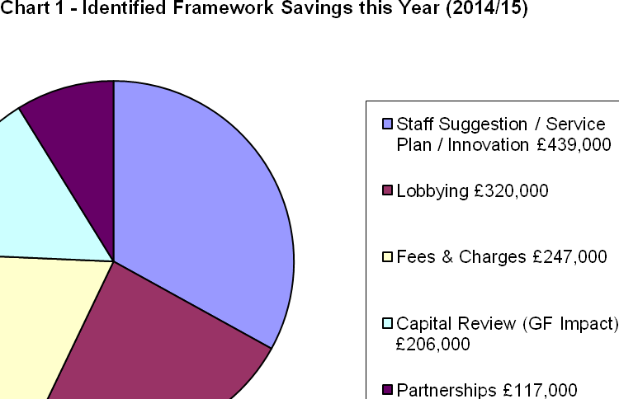

* 1. During the budget process, members were informed of a number of ‘big ticket’ items. These are typically items of large value that could have a disproportionate impact on the Council's budget if they moved in an adverse fashion. Consequently these are monitored very closely and members and officers may occasionally try to influence (through lobbying) any changes that may take place especially when such changes are triggered through changes in national policy.
  2. A direct consequence of the early delivery of savings for 2015/16 and a number of one-off items is that the Council has some flexibility to help deal with specific risks that are identified in the medium term. The Executive have previously approved that further budget savings (either of a one off nature or from the early delivery of framework savings) be used to increase earmarked reserves to help provide additional flexibility and protection against business risks / threats. This approach has previously been endorsed by the Council’s external auditors, KPMG. Accordingly, the smoothing reserves do help provide some protection against key business risks, including business rates income / welfare reform and providing continued opportunity for ‘invest to save’ type schemes.
  3. The search for savings is a continuous process, as is their implementation. They are implemented once resilience tested and the trend over the past number of years is that the Council has been successful in delivering savings early.
  4. The General Fund working balance is estimated to be £1.5m at 31st March 2015. This is in line with best practice and in line with the current policy position.
  5. Through its proactive approach, the Council is delivering a balanced budget and is also able to have a resilient reserve position. Many local authorities are using their reserves to help set a balanced budget, something which is unsustainable in the medium term. This is not the case at Kettering Borough Council where budget savings are identified in full. The Council does however use any in-year flexibility to supplement its earmarked reserves when specific risks are identified – to this end the council’s reserves will be supplemented to deal with the specific current risks of (a) Business Rates Appeals, and (b) possible future national changes in New Homes Bonus funding – both these are discussed later in the report.
  6. Whilst the principles and strategies continue to provide a robust framework to work within the success comes from an ability to deliver. The Council has an excellent track record of driving efficiency savings, successfully lobbying on national policies and attracting external funding. These have been key in the Council achieving the financial standing it currently enjoys. However, it is important the Council continues with the same level of commitment and momentum as there is much uncertainty and significant challenges facing local government in the years ahead.
  7. The Council’s impressive record in identifying and delivering efficiency savings over the past six years, including the year under consideration (2015/16), are around **£8.360m** - as illustrated in Table 3;

|  |  |
| --- | --- |
| **Table 3 – Efficiency Savings** | **£000** |
| 2010/11 | 1,260 |
| 2011/12 | 1,910 |
| 2012/13 | 1,330 |
| *2013/14* | *950* |
| 2014/15 | 1,330 |
| **Total** | **6,780** |
| *2015/16* | *1.580* |
| ***Total***  ***% Cash Savings (Net Budget)*** | ***8,360***  ***82%*** |

* 1. The scale and delivery of this level of **efficiency savings is particularly impressive given that there has been no detrimental impact on the delivery of front line services** and when considering the increased costs of utilities and inflation levels. Over the six year period (as detailed in Table 3) the efficiency savings will be equivalent to approximately **82%** of the Council’s draft net budget (which stands at £10.1m for 2015/16).
  2. Members are reminded that **before the efficiency programme** commenced a number of years ago, the Council was charging a level of **Council tax below the national average yet delivering a level of performance that was above the national average.** Despite having to deliver efficiency savings of £8.360m in the past six years, the Council’s level of council tax charged remains below the national average and performance remains above average.
  3. Members will recall the following illustration that summarises the Council’s overall position as being a ‘high performing / low cost’ local authority.



* 1. The above position was achieved before the Council decided to have no increase in Council Tax in 2011/12 (and before any aspirations for subsequent Council Tax freezes). Members are reminded that despite having no increase in Council Tax in 2011/12 and despite having to deliver the level of efficiency savings (as outlined in Table 3), the Council’s performance in key priority areas remains ‘above average’. Given this context, to maintain the Council’s position as a high performing whilst being a low cost local authority has been a significant achievement and has not happened by accident.
  2. **To achieve this position with no reduction in front line services is an extraordinary effort - one of which both officers and members should be extremely proud.**

**CAPITAL PROGRAMME – Latest Estimate**

* 1. The updated projected outturn for the Capital Programme is shown in Table 4;



* 1. The detailed composition of the capital programme can be seen by reference to Appendix A – Section 2.
  2. As previously reported, the HRA variance results from the average property price for the Empty Homes project being less than anticipated and the main General Fund variances relate to the timing for the delivery of the Fleet maintenance facility being later than anticipated.
  3. In line with the Council’s prioritisation guiding principles, a global capital budget sum of £1,000,000 has been included in the Capital Programme – this will provide a source of funding for the Council to use when pursuing commercial property deals or investments that yield a positive revenue return. Individual project approvals will of course be subject to the normal approval process.
  4. Table 4 illustrates that based upon the latest estimates for 2014/15; borrowing of £1,404,000 will be required to finance the programme. This is in accordance with the Council’s guiding principles and Members are reminded that although in the past the Council has not had to borrow from external sources for this funding, it has in effect borrowed the money ‘from itself’ from other cash holdings that the Council has. The borrowing that the Council undertakes to finance its capital programme is required to deliver the Council’s three key objectives and results not only in improvements being made to the locality but also increases the asset valuations that the Council holds on its balance sheet that is published annually in the Statement of Accounts.

**Housing Revenue Account – Latest Estimate**

* 1. The updated projected outturn for the Housing Revenue Account is shown in Table 5. The Housing Revenue Account is currently projected to come in on budget.



* 1. The detailed composition of the Housing Revenue Account can be seen by reference to Appendix A – Section 3.
  2. Members are reminded that in 2012/13 the housing subsidy system was replaced with a new ‘self-financing’ system of housing finance that was introduced across the Country. The Executive Committee at its meeting of 15th February 2012 approved the strategy for financing the housing debt;

|  |  |
| --- | --- |
| The amount to borrow | £72.9m |
| Who to borrow from | Public Works Loan Board (preferential rates) |
| A fixed or variable rate loan | Fixed rates |
| What type of loan(s) | Maturity loans |
| What period of loan(s) | A number of fixed term loans at different maturity dates (to provide the Council with the flexibility required) |

* 1. It was previously reported to Members that by using ‘maturity loans’, the Council has retained the maximum flexibility that it can. In essence, maturity loans are serviced annually (throughout the duration of the loan) by paying interest to the Public Works Loan Board (PWLB). No principal repayment of the loan takes place throughout the duration of the loan. The Council will however each year make a provision for principal repayment and can then decide at the maturity of each loan whether it wishes to fully repay the outstanding principle or re-finance the loan.
  2. The Council has a well-balanced borrowing portfolio and was able to take advantage of both the preferential short and long term rates that were made available from the PWLB to finance the self-financing transaction.

**Section C: Next Year’s Budget Position (2015/16)**

1. **DRAFT BUDGET – 2015/16**
   1. The consideration of the draft budgets for 2015/16 is the statutory responsibility that Members will start to discharge when considering this report.
   2. The detailed draft budget figures are contained in the budget booklet at Appendix A. The booklet contains:

* Section 1 - General Fund
* Section 2 - Capital Programme
* Section 3 - Housing Revenue Account

**DRAFT** **GENERAL FUND BUDGET 2015/16**

* 1. As well as monitoring framework savings identified for 2014/15 work has continued throughout the year on identifying savings for the following year – 2015/16. The detailed work on the budget has now been completed and the total savings required to deliver a balanced budget has increased slightly from £1,564,000 to £1,579,000. The savings target incorporates the additional £100,000 of savings required following the Executives decision late in the 2014/15 budget process to implement a revised car parking strategy.
  2. The previous budget report to this Committee in December outlined that savings of £1,314,000 had already been identified – at the time this meant that additional on-going savings of £250,000 were required to ‘balance the budget’. Following the completion of the detailed draft budget process this was further increased by £15,000. It is pleasing to report that additional on-going savings of £265,000 have been identified - meaning that the Council will be able to have a balanced draft budget for 2015/16, **(subject to successfully delivering those savings).**
  3. Following on from the successful delivery of the required framework savings for 2014/15, and the early delivery of some additional savings during the year – Table 6 summarises the estimated financial position for the period to the end of March 2016.



* 1. The Council has a statutory duty to consider the medium term financial projections when setting its budget for 2015/16.
  2. From Table 6 it can be seen that the Council’s budget delivery framework will need to deliver £1,579,000 of savings in 2015/16 to maintain a balanced budget. The assumptions will need to be kept under close review during 2015/16. The identified savings are summarised in Chart 2:

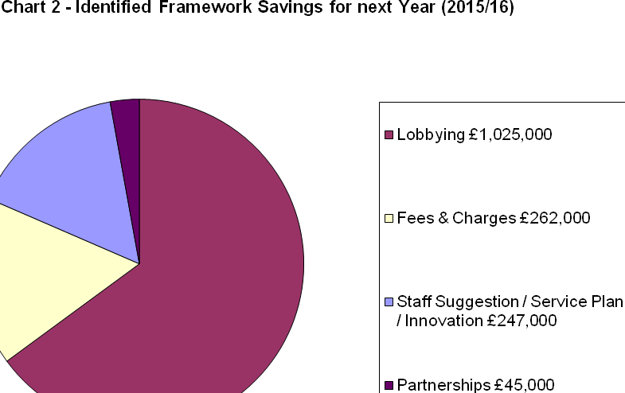

* 1. The Council’s success in delivering a balanced budget over the past five years has come from the Budget Delivery Framework (as outlined in Section 4) and particularly from the Staff Suggestions and Innovation Framework which prior to 2015/16 annually contributed to around 40% of the total savings target. Looking forward, it is important to note that the biggest contributing workstream becomes Lobbying – this includes income that is generated as a direct result of nudges and changes to national policy (such as New Homes Bonus and Business Rates) which is harvested as new homes and businesses are delivered on the ground.
  2. Table 7 summarises how the £1,579,000 for 2015/16 is anticipated to be found and compares this to the savings of £1,329,000 identified for 2014/15. Work continues on resilience testing the ideas and assumptions, and the delivery of the savings is dependent upon the Council adhering to its suite of budget principles and golden rules (previously outlined in Section A).

|  |  |  |  |  |
| --- | --- | --- | --- | --- |
| **Table 7 – Identified Framework Savings** | **2014/15** | | **2015/16** | |
|  | **£’000** | **%** | **£’000** | **%** |
| Staff Suggestions / Service Plan / Innovation | (439) | 33 | (247) | 15 |
| Fees and Charges | (247) | 19 | (262) | 17 |
| Partnerships | (117) | 9 | (45) | 3 |
| Capital Review | (206) | 15 | (0) | 0 |
| Lobbying | (320) | 24 | (1,025) | 65 |
| **Total Identified Framework Savings** | **(1,329)** | **100** | **(1,579)** | **100** |

* 1. It was reported to the November Executive that savings of this magnitude are becoming increasingly difficult to maintain. Around 65% of the savings identified for 2015/16 have been generated through the lobbying framework. It is going to become increasingly important to consider further frameworks in future years as the reality of being able to deliver a balanced budget in the Medium Term (2016/17 – 2019/20) is looking increasingly fragile – the consideration of commercial investment opportunities will become a key element.
  2. Chart 3 details where the total framework savings have been identified since the frameworks were implemented back in 2010.

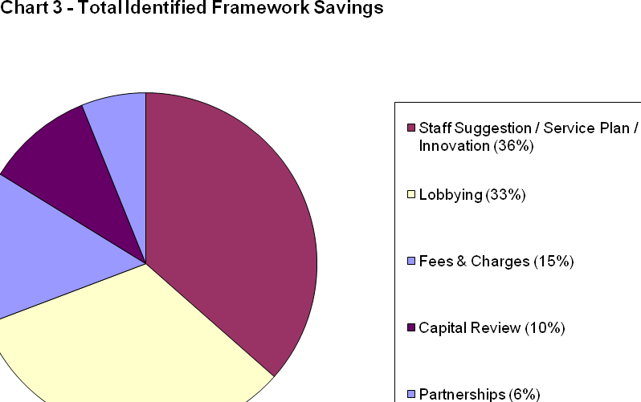

* 1. Prior to the provisional grant settlement the Council had been modelling a reduction in government grant of £739,000 (15.8%) for 2015/16. The Council’s provisional grant settlement for 2015/16 is £3,980,000; this represents a cash reduction in grant of £682,000. The latest provisional figure is broadly in line with previous indications, although it does represent a 14.6% reduction on the previous year. Further details regarding the provisional grant settlement are provided in Section D.
  2. The Council will need to continue to keep its key budget assumptions under review throughout 2015/16. These are unprecedented times and the assumptions used are again likely to require amendment through the year to respond to changes in national policy post General Election 2015, in particular;
* Inflation
* Growth
* Local economic impact
* National economic impact
  1. If the Council is to continue to set a balanced budget it is becoming increasingly clear that the success it has achieved from existing frameworks will need to have a revised emphasis, including more attention being given to possible commercial investment opportunities if the Council is to reduce reliance on central government funding and to become more self-sufficient.
  2. Some of the major service risks and pressures the Council face in 2015/16 and the years thereafter are highlighted in the following paragraphs.

**Service Pressures**

**Other Public Sector Providers**

* 1. The Council is seeing a number of public sector providers facing significant financial challenges, it is important the Council continues to adhere to the principles which it has set and does not deviate from these, particularly with regard to the Budget Containment Strategy principles and in particular point 6 which is reproduced below:

1. *The Council should not substitute itself as a provider / funder of services when another public provider cuts such a service.*

**New Homes Bonus**

* 1. Members will recall that in July 2013 a consultation was undertaken with a view to £400m (of the £1,140m set aside nationally) being ‘top sliced’ from the national pot for New Homes Bonus – the intention being to pay the money directly to LEPS rather than local authorities. This Council worked closely with CLG officials and has consistently and persistently said that the funding should come from anywhere other than New Homes Bonus. This was recognised and the Government announced in the 2013 Autumn Statement that it has decided not to ‘top slice’ the New Homes Bonus for those authorities outside of London.
  2. A further review evaluating New Homes Bonus was undertaken by the Government during 2014 and key findings include that the policy was delivering to the key principles of being “powerful” “simple” “transparent” and “flexible”. Despite this, the national funding totals for New Homes Bonus have still not been confirmed as a permanent feature of local authority funding.
  3. It is fair to say that the outcome of the General Election 2015 will have a major bearing on how the scheme will operate in the future (or indeed whether the scheme will continue).
  4. Table 8 reminds members of the strategy that was approved last year in relation to the use of new homes bonus funding to support the Council’s base budget.



* 1. Although the Council has not brought 100% of the new homes bonus funding into the base budget, the cash totals that are being applied are now very significant in terms of their absolute value. The Council may wish to revise the above strategy as more information becomes available, at the very least it would be prudent to ensure that there is a specific reserve available to help ‘smooth’ the impact of any funding reductions in the future (should that occur). The comments earlier in the report about supplementing reserves for this purpose are important to note.
  2. In addition to the above issues there are a number of other pressures the Council will face in both the short and the medium term these are summarised in Table 9.

|  |  |  |
| --- | --- | --- |
| **Table 9** | | |
| **Business Risk** | **Issue** | **Possible Financial Range** |
| Business Rate Appeals | The authority continues to carefully monitor the financial implications of the growing number of business rate appeals nationally. This is especially so given the announcement in the 2013 Autumn Statement of the intention to clear 95% of the national backlog of appeals by July 2015 and the information in the Local Government Settlement about liability for pre April 2013 appeal costs – an issue that could have significant financial implications to local authorities. | + £500,000 |
| Homelessness | The Council has for a number of years successfully managed the level of homelessness during a long period of pressure through innovative measures to prevent the use of bed and breakfast expenditure. The service however is demand led and currently continues to experience pressures. | + £200,000 |
| Council Tax Support | Members will be aware of this issue from the report considered by Full Council in December 2014. It continues to be an area that requires careful budget monitoring. | + £100,000 |
| Recycling Commodities | The market price for the various commodities that the Council recycles is becoming more volatile and has resulted in a reduced income stream. This is an area that the Council will continue to monitor closely. | + £100,000 |
| Utilities Cost | The assumptions used will need close monitoring during the year in case of further changes. Over the past year the price of utilities particularly gas and electricity has risen sharply, although the cost of fuel and associated items has fallen. The budget for 2015/16 takes account of these increases however if the trend continues this could place considerable pressure on the Council’s budgets. A 1% change in these costs is around £10,000. | +/- £50,000 |

**DRAFT CAPITAL PROGRAMME (2015/16 – 2019/20)**

* 1. As part of the budget process members are required to consider the Council’s capital programme, and available funding, so that a programme can be agreed for 2015/16 together with indicative funding for the following four years.
  2. Members are required to approve the capital programme for 2015/16 and approve a five-year rolling capital programme with commitment given for schemes in years 2 to 5 to assist with scheduling and achieving the programme.
  3. The draft capital programme for 2015/16 – 2019/20 is detailed in Appendix A – Section 2. The high level summary is reproduced in Table 10.



* 1. From reference to Table 10 it can be seen that:
* The programme for 2015/16 is £5.902m
* The programme from 2016/17 – 2019/20 is approximately £5.3m per annum.
  1. **Capital Receipts** – Under the previous housing finance rules, when a house was sold under the right to buy legislation – the Council could retain 25% of the proceeds with 75% being paid to the Government. Prior to the introduction of the new housing finance system it was suggested that local authorities should retain 100% of the receipts – this made sense given that they have 100% of the debt. By the time the new system came into being, the position had changed significantly and had reverted back to local authorities retaining 25% of the proceeds with 75% being paid to Government. The Government on 2 April 2012 announced that the maximum Right to Buy discount in Kettering would increase from £24,000 to £75,000 per property (a three-fold increase!). Ministers also confirmed their intention that the proceeds from any additional sales (sales over and above that assumed in the self-financing settlement) would be used to fund replacement homes on a one-for-one basis across the country as a whole. The capital programme for 2014/15 to 2019/20 assumes funding from Right to Buy receipts of £100,000 per annum.
  2. **Borrowing –** the estimate for borrowing for 2015/16 is £1.418m. The revenue impact of borrowing (be it external or internal) in 2015/16 is included in the revenue budgets. Members are reminded of the earlier comments made in paragraph 5.21.

**DRAFT HOUSING REVENUE ACCOUNT (HRA) 2015/16**

* 1. A summary of the draft HRA budget for 2015/16 is included at Appendix A - Section 3 of the budget booklet. The high level summary is reproduced in Table 11:



* 1. The Housing Revenue Account (HRA) includes all the income and expenditure items associated with maintaining a landlord account for the Council’s housing stock. The Council has a statutory obligation to produce a balanced “ring-fenced” HRA. The account must operate in a surplus position and this is achieved by adopting the principle that an agreed minimum balance of £300,000 should be the HRA’s primary strategic aim over the medium to long term. The level of the minimum balance is risk assessed and takes account of the limited nature of the service, the fact that budgets are less volatile than in the General Fund and transactions tend to be high in number but low in value.
  2. The Government announced in summer 2013 that from 2015/16 social rents will rise by CPI plus 1% each year for ten years, previously social rents were rising by RPI plus 0.5% plus £2. This will result in lower increases in social rents. Whilst authorities can charge more or less than the guidelines issued by central government they will nonetheless be constrained by the limit rent – which is the maximum that can be charged based on the formula prescribed by central government.
  3. The Council has applied the government guideline to calculate the rent increase for 2015/16 this results in an increase of 2.20%. (this is the income assumed in the income figure in Appendix A Section 3).
  4. The draft budget will be discussed by the Tenants’ Forum at its meeting of 12th February 2015 along with the proposal for rent setting. This will be reported back to the Executive meeting on 18th February 2015 for approval.
  5. Sections 5.24 – 5.26 referred to the new ‘self-financing’ system of housing finance and the borrowing strategy undertaken to finance this transaction. This is the fourth year of the new housing finance system and enables the Council to benefit from the greater certainty the new system provides from a budgeting perspective.
  6. Prior to the new system the Council would have received an annual subsidy determination usually in December notifying the Council of the amount of subsidy payable in the following financial year. The Council was paying in the region of 34% of the rent it collects from its tenants over to the Government (approximately £4.5m for 2011/12).
  7. The subsidy payments have now been replaced with principal repayments and interest payments which are a direct result of the borrowing of £72.9m undertaken to finance the ‘self-financing’ payment. The housing debt at 31st March 2014 was £68.9m. The 2014/15 budget provides for a further debt repayment of £3m which would reduce the debt to £65.9m at 31st March 2015.
  8. The other key elements of the budget are;

1. Rents – income expected from tenants.
2. Repairs & Maintenance – The costs for response and planned maintenance.
3. General Management – The costs of managing the Council’s housing stock.
4. Special Services – Income / expenditure relating to flats & sheltered housing.
   1. Appendix A – Section 3 shows the composition of the draft budget for 2015/16.

**Section D – Medium Term Financial Landscape**

* 1. This section makes the link between the national financial landscape and the Council’s resultant medium term financial position.

**National Financial Landscape**

* 1. There continues to be much uncertainty about local government funding in the medium term. This section looks at two key national economic indicators (Public Sector Net Borrowing and Gross Domestic Product).
  2. The following chart summarises the changes in Public Sector Net Borrowing between the 2010 and 2014 Autumn Statement. This illustrates that the rate of reduction in borrowing has not been as great as predicted at the beginning of the parliamentary term reductions are however being made and these are significant in cash terms.

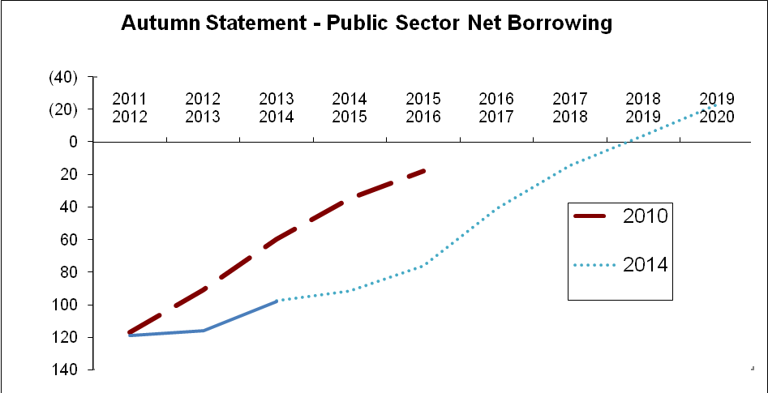

£ Billion

* 1. The outlook for GDP growth is also summarised in the following graph:

**%**

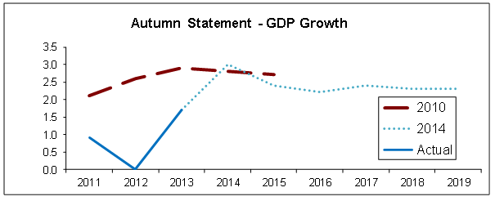

* 1. The following graph is interesting context in that it analyses the gap between income and expenditure going back many years of particular interest is the current position and forecast trend of the total managed expenditure line from 2010 to 2020.

Context: National tax and spend



**Local Government Grant Settlement**

* 1. The Council’s provisional grant settlement for 2015/16 is £3,980,000; this represents a cash reduction in grant of £682,000 (14.6%) from 2014/15 and this is reflected in the Council’s Medium Term Financial Forecast (Table 14). .
  2. The grant announcement did not provide local authorities with individual settlements for 2016/17 or future years. The ability to plan with greater certainty can be better met if there is a move back to multi-year funding announcements. This announcement effectively moves back to single year settlements which are not ideal for Medium Term Financial planning.
  3. Now that the provisional settlement and the Autumn Statement have been announced, we can remodel our medium term grant assumptions. Previously we had assumed additional 10% cash reductions (per annum from 2016/17). Looking at past trends, the average cash reduction is around £680,000 per annum and the average % reduction is around 13% per annum. Given the way that the grant mechanism works, this tends to use a % figure, however as the impact of % reduces due to the smaller sums involved it is sensible to consider using absolute cash reductions as well therefore we have decided to use a hybrid of cash and % reductions in our future grant assumptions, the background data and the resulting assumptions are shown in the following tables;

|  |  |  |  |
| --- | --- | --- | --- |
| **TABLE 12 – GRANT REDUCTIONS (Background Data)** | | | |
| **Year** | **Reduction in Central Government Core Grant** | | **Status** |
|  | ***%*** | ***£*** |  |
| 2011/12 | (15.2%) | (£958,000) | Actual |
| 2012/13 | (12.8%) | (£700,000) | Actual |
| 2013/14 | (6.3%) | (£303,000) | Actual |
| 2014/15 | (14.1%) | (£735,000) | Actual |
| 2015/16 | (14.6%) | (£680,000) | Provisional |
| Average | (12.6%) | (£675,000) | N/A |

|  |  |  |  |
| --- | --- | --- | --- |
| **TABLE 13 GRANT ASSUMPTIONS** | | | |
|  | ***Previous MTFS*** | ***Revised MTFS*** | ***Difference*** |
| **Year** | ***£*** | ***£*** | ***£*** |
| 2016/17 | (£3,531,000) | (£3,381,000) | (£150,000) |
| 2017/18 | (£3,178,000) | (£2,821,000) | (£357,000) |
| 2018/19 | (£2,860,000) | (£2,298,000) | (£562,000) |
| 2019/20 | (£2,574,000) | (£1,809,000) | (£765,000) |

* 1. As a result of the above changes, the updated Medium Term Financial Strategy (and supporting notes) is shown in table 14.

**Notes to Medium Term Financial Forecast**

***1******Net Council Budget*** *– This represents the net expenditure prior to the Budget Framework savings.*

***2******Forecast Resources*** *– These are the Council's main funding streams (excluding fees and charges which are incorporated into Line 1). This illustrates the significant reduction in Central Government funding. To enable the total resources required to balance the budget to be identified, no assumptions have been made regarding future council tax increases. The small increase in revenue each year reflects anticipated housing growth in the borough.*

*The following assumptions have been made about future levels of government grant, these assumptions are a combination of the average percentage and cash reduction over the past five years;*

*2016/17 Reduced by 6.50% then reduced by £340,000*

*2017/18 Reduced by 6.50% then reduced by £340,000*

*2018/19 Reduced by 6.50% then reduced by £340,000*

*2019/20 Reduced by 6.50% then reduced by £340,000*

***2a / 2b Revenue Support Grant / Business Rates -*** *Following the introduction of the Business Rates Retention Scheme the local share of business rates will be uplifted by RPI each year until the system is reset in 2020 this is shown in line 2b. The full reduction in grant is therefore applied to the element that is provided through the Revenue Support Grant, which is detailed in Line 2a.*

***3******Budget (Surplus) / Deficit*** *– This illustrates the gap between the budget and the total resources available before identifying budget framework savings.*

***4a Council Tax Grant*** *– This is a grant the Council receives from central government for four years in return for freezing Council Tax in 2011/12. This is equivalent to the cash that would have been received if a 2.5% increase had been levied.*

***4b Council Tax Grant 2013/14*** *– This is a grant the Council receives from central government for two years in return for freezing Council Tax in 2013/14. This is equivalent to the cash that would have been received if a 1% increase had been levied. A Council Tax Freeze has ongoing implications as an increase in Council Tax generates income year on year.*

***4c Council Tax Grant 2014/15*** *- This is a grant the Council receives from central government for two years in return for freezing Council Tax in 2014/15.*

***4d Town Centre Initiatives*** *– This relates to parking incentives and / or other town centre related items. Due to the short term nature this is being funded from the General Fund working balance rather than forming part of the base budget.*

***5 Budget Frameworks*** *– This identifies the total savings required.*

***6 Savings to be secured*** *– This identifies the total resources required to balance the budget in future years after 2015/16.*

**Section E – The Medium Term Prospects**

* 1. This section brings together the Council's financial model for the General Fund for the period up until 2019/20.
  2. The revised Medium Term Financial Strategy is shown at table 14.
  3. The figures in the model are shown prior to the consideration of any increase in the levels of Council Tax. Council Tax levels can only be determined annually by the Council once it has received and considered the report of its officers.
  4. The Council’s budget process includes a full review of the Medium Term Financial Strategy and has resulted in a number of assumptions being remodelled, (including the level of government grant as detailed in Table 13). The level of savings needed over the four year period 2016/17 – 2019/20 has increased from £4.350m to £4.936m an increase of £0.586m. This is illustrated in Table 15:

|  |  |  |  |
| --- | --- | --- | --- |
| **Table 15 – Medium Term Financial Savings** | **December Executive**  **£000** | **Current MTFS**  **£000** | **Difference**  **£000** |
| 2016/17 | (1,293) | (1,464) | (171) |
| 2017/18 | (1,054) | (1,170) | (116) |
| 2018/19 | (1,018) | (1,168) | (150) |
| 2019/20 | (985) | (1,134) | (149) |
| **Total Savings – to be secured** | **(4,350)** | **(4,936)** | **(586)** |

* 1. Whilst Table 15 illustrates that the projected savings required over the four year period 2016/17 – 2019/20 are around £5m, Members are reminded that since 2010/11 the Council **has delivered savings of £8.3m** (as detailed in Table 3). Hitherto, the Council has been able to close the budget gap without increases in Council Tax, cuts to front-line services, or cuts to voluntary sector funding. The scope for closing projected budget gaps without deploying some of these options looks increasingly doubtful in the medium term.
  2. The Council’s latest Medium Term Financial Forecast is shown in Table 14. The forecast comprises the following ‘Zones’
* **Zone of Predictability** – this year and next (2014/15 - 2015/16)

The level of government funding has previously been announced for this year (2014/15) and provisional levels of funding were announced in December 2014 for next year (2015/16).

* **Zone of Unpredictability**  – Medium Term (2016/17 – 2019/20)

Reference to the budget deficit figures (Table 15) illustrates the significant challenge that the Council faces in the medium term. Whereas uncertainty will continue to exist about the future levels of government grant post the 2015 General Election, it is fair to say that it will be an extremely challenging time for the authority.

The overall scale of budget reduction is very significant. The Council has done an impressive job of delivering a balanced budget despite having no council tax increase, no cuts to front line services, and no reduction to overall funding for the voluntary sector since 2011/12. This has only been achievable by following the budget guiding principles and making sure that other income sources, such as fees and charges, are harvested in line with their previously agreed guiding principles – this will remain important moving forward.

The reality of the Council being able to deliver a balanced budget in this period is looking increasingly fragile – the Council will need to carefully consider its main sources of income (Council Tax, Fees and Charges) at the same time as starting to consider its priorities for services (and levels of services) if a balanced budget is to be achieved in the medium term. The commonly referred to ‘triple zero’ success of recent times is unlikely to be achievable in the medium term, indeed any one element of this will put additional pressure on existing levels of service and resources.

* 1. The setting of Council Tax can have significant implications on the sustainability of the Council's budget in the medium term. Members are reminded of their statutory responsibility to consider the medium term financial position when setting Council Tax for 2015/16.
  2. The Council tax level for 2015/16 will be considered by the Executive in February but can only be set by full Council at its meeting on 25th February 2015, once the budget consultation has been completed and the officers’ report has been fully and properly considered. When discharging their statutory duties, Members will need to give due regard to the issues facing the authority in the medium term, especially in relation to the changing financial landscape in relation to those issues outlined in paragraph 6.16 – 6.22.

1. **SUMMARY & CONCLUSIONS**

**2014/15**

* 1. The Council has continued to use its own specific ‘budget delivery framework’ for the delivery of savings. The challenge was to turn the ‘paper based savings exercise’ into reality so that the £1,329.000 of savings were actually delivered – this is being successfully delivered.
  2. Since 2010, the Council will have delivered a total of £6.8m of savings by the end of March 2015. The delivery of savings of this magnitude will become increasingly more difficult to achieve.

**2015/16**

* 1. The changes to the national landscape continues to bring greater uncertainty and volatility to future projections. The recently announced review of the Business Rates system and forthcoming General Election add to this.
  2. The Council needs to continue its **excellent track record of delivering budget savings** to balance the budget for 2015/16, where £1,579,000 of identified savings need to be delivered.
  3. Prior to the consideration of any council tax increase, it is estimated that **£1,579,000 of savings will be required.** We will start 2015/16 in a similar position to 2014/15 because of the continued use of the Council’s successful budget delivery framework which has resulted in the Council already having secured some of the on-going savings required for 2015/16. The remaining savings have also been identified and the Council is confident that these will be delivered during 2015/16 – provided the Council remains focused and sticks to its collection of golden rules.
  4. The Council’s strong and controlled budgetary position is a direct result of the adherence to the guiding principles that have been diligently followed over recent years. The challenges faced for 2015/16 mean that it is even more important that the guiding principles are followed if the council is to remain in a relatively good financial position. This financial discipline is a pre-requisite of any future financial strategy.
  5. **A capital programme of around £6.0m** is not inconsiderable for a District Council of Kettering’s size and no doubt a continued boost to the local economy.
  6. The Council uses the budget **“swingometer”** as detailed at Appendix A – Section 1 to highlight and assess the sensitivity of the most volatile and material budgets. The “swingometer” shows some significant swings reflecting the economic climate. It must be stressed however that the Council has an excellent track record of spending at or around budget, even when faced with significant in year pressures, and a strong balance sheet with a level of reserves sufficient to cover the risks outlined in the “swingometer”.

**The Medium Term**

**2016/17 and Beyond**

* 1. Assumptions have been made for future levels of government grant (and other funding changes). Future grant reduction projections now reflect the average of previous years grant reductions following announcements in the Autumn Statement.
  2. The current economic times for Local Government are unprecedented. Therefore the delivery of the budget is dependent upon successfully tracking the other budget assumptions that have been made and it must be recognised that in some cases relatively modest changes in such variables can have a significant impact on the Council’s finances and fiscal stability.
  3. The Council’s strong and controlled budgetary position is a direct result of the adherence to the guiding principles that have been diligently followed over recent years. The challenges faced in the medium term mean that it is even more important that the guiding principles are followed if the council is to remain in a relatively good financial position.
  4. Based upon the assumptions applied, the future years’ budgets would require ongoing year on year savings of the following (on top of the £8.5m ongoing savings achieved since 2010);

**2016/17 £1,464,000**

**2017/18 £1,170,000**

**2018/19 £1,168,000**

**2019/20 £1,134,000**

* 1. The Council will need to continue to develop a more commercial approach to ensure that its income base remains buoyant. Given the medium term picture, the Council’s Chief Executive (in their role as Head of Paid Service) is giving consideration to how the organisation can best meet these challenges – this is likely to be the subject of a separate report in due course.
  2. Hitherto, the Council has been able to close the budget gap without increases in Council Tax, cuts to front-line services, or cuts to voluntary sector funding. The scope for closing projected budget gaps without deploying some of these options looks increasingly doubtful in the medium term - although it is difficult to say exactly at which point (due to the national political situation).
  3. There are a number of other pressures the Council will face in both the short and the medium term. More immediate pressures could be around New Homes Bonus funding, other possible pressures include:

|  |  |
| --- | --- |
| **Business Risk** | **Possible**  **Financial Range** |
| New Homes Bonus | + £1,250,000 |
| Business Rate Appeals | + £500,000 |
| Homelessness | + £200,000 |
| Council Tax Support | + £100,000 |
| Recycling Commodities | + £100,000 |
| Utilities Cost | + / - £50,000 |

**Other Considerations**

* 1. The projections in all years rest on the Executive’s adherence to the “*Guiding Principles”* the “*Modelling for Recovery Principles*” the “*Budget Containment Strategies*” and the *“Prioritisation Golden Rules*” (para 4.4).
  2. Depending on the decisions taken in relation to Council Tax, year on year savings of these magnitudes have and will continue to take capacity out of the organisation. The priority has been front line delivery and accordingly members may notice a reduction in some areas of internal delivery, as well as our **capacity to influence longer term strategic issues.**
  3. Many of the changes to be implemented are untested and it is inevitable some transition turbulence may be experienced even with the focus on protecting front line service delivery.
  4. **All the council’s partners, elected councillors and staff should feel proud of reaching this point. However we must maintain this extraordinary effort if we are to continue to achieve our ambitious objectives.**

**10 CONSULTATION AND CUSTOMER IMPACT**

10.1 The formal budget consultation period is from 14th January 2015 to 25th February 2015 when the Council sets its Council Tax for 2015/16. The budget timetable is detailed at Appendix B. Comments from the consultation process will be reported to the Executive for consideration at its meeting on 18th February 2015.

**11 POLICY IMPLICATIONS**

11.1 There are no direct policy implications as a result of this report.

**12 USE OF RESOURCES**

12.1 The implications on the Council’s resources will be considered throughout the durable budget reports.

**13 RECOMMENDATIONS**

That the Executive Committee:

* 1. Note the current budget position for 2014/15.
  2. Recognise that the budget delivery framework has identified savings that will enable a balanced budget to be achieved.
  3. Recognise that the task of balancing the budget in future years is becoming increasingly difficult especially in the light of increasing service pressures, reduced national funding and reduced capacity.
  4. That the Executive refers the draft budgets for 2015/16 (as contained in the separate budget booklet) to Scrutiny for comment in accordance with the Council’s Constitution.

Background Papers: Previous Reports/Minutes:

Title of Document: Estimate Working Papers Monthly Durable Budget Reports

Contact Officers: M Dickenson (April 2010 to date)