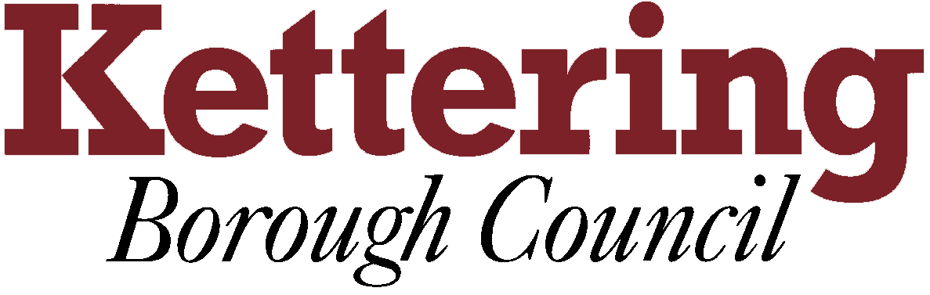

KETTERING BOROUGH TENANTS FORUM

Thursday 8th January 2015

Draft Housing Strategy and Action Plan 2015-20
This report asks the Tenants Forum to participate in the consultation on the draft Housing Strategy and Action Plan 2015-20.
For Information

1 Introduction

1.1 You will recall that in November a paper was presented outlining our new approach to the Housing Strategy and our timetable for consultation.

1.2 This report provides the Tenants Forum with an update on the production of our Housing Strategy and Action Plan for 2015-20.

1.3. We have now produced a draft Housing Strategy (Appendix A) and Action Plan (Appendix B) which are being consulted on from the 16th December 2014 to 3rd February 2015.

1.4. This report seeks to formally consult the Tenants Forum on the documents and seeks any feedback the Forum may have.

2 Housing Strategy Consultation

2.1 Kettering’s housing market as well as national policy has changed considerably since we last produced a Housing Strategy a number of years ago.

2.2 The purpose of our new Housing Strategy 2015-20 is to set out the main changes in the housing market, identify the key challenges in delivering new homes and housing services locally, and inform on what action will be required to help meet both current and future housing needs and aspirations.

2.3 The Housing Strategy 2015-20 will provide the over-arching strategic document to inform future housing related plans, strategies and policies.

2.4 Our three key strategic aims for our Housing Strategy 2015-20 are:

- Increasing housing supply across all tenures
- Ensuring decent, safe and healthy homes
- Helping people to live independently

2.5 Accompanying the Housing Strategy will be a Housing Strategy Action Plan 2015-20 which will set out detailed objectives and outcomes for each of the themes above. The Action Plan will be kept under review and updated regularly in order to reflect changes in policy, practice or economic conditions

2.6 The consultation on the housing strategy will run from the 16th December until the 3rd February 2015 and we would welcome your feedback

2.7 We are seeking views on whether you think the strategic aims are appropriate and whether you agree with the proposed objectives for each one. You are also invited to comment on the draft Action Plan and whether you think there are things that need to be included within that.

2.8 Comments from the consultation will be taken on board and a final version of the Housing Strategy and Action Plan will be taken to Executive Committee on the 18th February and Full Council on the 25th February seeking formal approval.

3 Summary and Action

3.1 Copies of the draft Housing Strategy and Action Plan 2015-20 have been made available to the Tenants Forum. The documents are also available on the Council’s website on the homepage.

3.2 Please have a look at the documents and provide any comments that you have by the deadline of the 3rd February 2015. This can be done by emailing me directly katieprati@kettering.gov.uk, emailing the housing strategy mailbox – housingstrategy@kettering.gov.uk or by completing the short survey which can be found on our website. Alternatively if you wish to provide comments in writing please send them to the council offices marked for my attention.

Katie Prati, 18th December 2014

