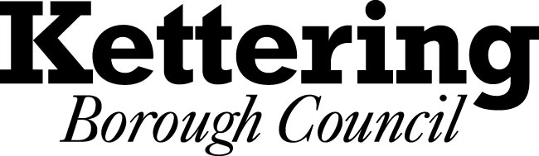

NOTICE OF INTENTION TO HOLD ALL OR PART OF AN EXECUTIVE MEETING IN PRIVATE
THE LOCAL AUTHORITIES (EXECUTIVE ARRANGEMENTS) (MEETINGS AND ACCESS TO INFORMATION) (ENGLAND) REGULATIONS 2012
Pursuant to paragraph 5 of the Local Authorities (Executive Arrangements) (Meetings and Access to Information) (England) Regulations 2012, notice is hereby given of the intention that part of the meeting of the Executive to be held on 11th February 2015 will be held in private.
The reason for the intention to hold part of the meeting in private is that the following items are due to be considered at the meeting, during which it is likely that, if members of the press and public were present, there would be disclosure of exempt information as defined in the relevant paragraph of Part 1 of Schedule 12A of the Local Government Act 1972: -
Date and Time of  Meeting | Key  Decision   | Work Programme  Ref No. | Report Title | Reason
18th February 2015 |  | A14/038 | Acquisition of Town Centre Premises | This report may be considered in private and confidential because it contains information relating to the financial and business affairs of a particular person including the authority holding the information
18th February 2015 |  | A14/039 | Energy Supply Options for Kettering Borough | This report may be considered in private and confidential because it contains information relating to the financial and business affairs of a particular person including the authority holding the information
18th February 2015 |  | A14/042 | Asset Management – Update Report | This report may be considered in private and confidential because it contains information relating to the financial and business affairs of a particular person including the authority holding the information
Representations may be received by the Council about why a particular decision should be open to the public. Any such representation should be made at least five clear days before the meeting is due to take place, in writing, to:
Sue Lyons
Head of Democratic and Legal Services
Municipal Offices
Bowling Green Road
Kettering NN15 7QX or by email to: suelyons@kettering.gov.uk

Dated: 19th December 2014

