To all Members | Direct Line: (01536) 534398  Email: anneireson@kettering.gov.uk  Our Ref: AI  Your Ref:  Date: 9th December 2014



Dear Councillor

You are summoned to a meeting of Kettering Borough Council to be held in the Council Chamber, Municipal Offices, Bowling Green Road, Kettering on Wednesday, 17th December 2014 at 7.00 pm.

Yours faithfully

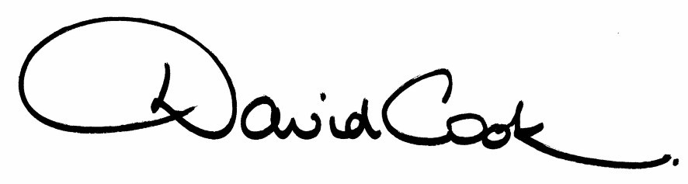

D Cook
Chief Executive

Prior to commencement of the meeting a Choir will entertain members
with festive songs

A G E N D A

1. Apologies.

2. Minutes of the meeting of the Council held on 24th September 2014 to be approved as a correct record and signed by the Mayor

3. Declarations of Interest:-

- Disclosable Pecuniary Interests
- Personal Interests

4. To receive any announcements from the Mayor and/or the Leader of the Council.

5. Report of the Chief Executive.

6. The Mayor to ask members of the public present if they want to speak on any item on the agenda.

Reports:

7. Standards Advisory Committee – Annual Report

8. Council Tax Support Scheme

9. Community Governance Review – Approval of Order to Implement Changes

10. Polling Place and Polling District Review

11. Revised Licensing Act 2003 Statement of Licensing Policy

12. Antisocial Behaviour, Crime and Policing Act 2014 – Scheme of Delegation

13. The Openness of Local Government Bodies Regulations 2014

14. To consider motions received in accordance with Council Procedure Rule 16 as follows:-

(i) To be proposed by Councillor Bishop and seconded by Councillor Don:-

"This council is proud of the excellent job it does managing the various Residents' Parking Schemes in the Borough and reaffirms its commitment to retaining control of our car parks and residents' parking schemes and resists moves to transfer them to the County Council."

(ii) To be proposed by Councillor Hakewill and seconded by Councillor Brown:-

"This council welcomes The National Pollinator Strategy published by the Department for Environment Food and Rural Affairs in November 2014. Awareness of the issues facing pollinators and the impact on global food production was successfully raised locally through the Mayoral initiative “Bringing the Bee back to the Borough” (2012-13). This council supports the concept of improving biodiversity in our towns, villages and countryside. The council requests the establishment of a Task and Finish Group to identify ways in which we (the Council) can seek to improve the plight of pollinators both in our own activities and by influencing others by our own example”.

15. To receive questions from members.

16. Any matters of urgency that the Mayor decides should be considered.
Fire Alarm

All meetings shall be adjourned immediately on the sounding of the fire alarm. The alarm is a continuous two-tone siren. On hearing the alarm please leave the building by the nearest emergency exit. There are emergency exits at both ends of the corridor outside the meeting rooms. On leaving the building please cross the car park and assemble on the grassed area by the church. Do not attempt to drive out of the car park as this may impede the arrival of emergency vehicles. Please do not return to the building until you are told it is safe to do so by a Council employee.

Toilets

There are toilets in the corridor off the main entrance to the building you came through to get to the meeting room.

Facilities for Babies and Children

If you wish to use a private area to feed your baby please ask a member of staff. There are changing facilities in the corridor off the main entrance adjacent to the toilets.

.Access for Disabled People

There are allocated parking bays outside the main entrance to the Municipal Offices for disabled people. The meeting rooms are located on the ground floor and access is gained for wheelchair users via the main entrance. If you require assistance, please ask the attendant on duty in the reception area.

No Smoking

Smoking is not permitted in the Municipal Offices.

