1. PURPOSE OF REPORT

This report provides a reminder / update of the following core issues:

- Provide Members with a summary of the case studies reported as part of the 2015/16 budget process;

- Remind Members of the Council’s medium term financial strategy and associated guiding principles;

- Illustrate the latest budget model, the delivery of efficiency savings for 2014/15 and the estimated level of budget savings that may be required over the next few years;

- CASE STUDY

  - Members will recall that in previous budget reports we have identified case studies as examples of good practice. The previous examples related to the new arrangements for the following:

- Generic warden service
- Recycling pilots
- Kettering Borough Training
- Partnership work with the Citizens Advice Bureau.
- VAT recovery
- Prevent Strategy funding
- Flexible Working
- Printing Function
- Market
- Managing homelessness
- Staff Sessions
- Attracting External Funding to the Borough

  - Through the monthly durable budget report a number of case studies have been included that highlight the financial benefit being received from various operational changes or external funding the Council has secured. The following table brings together the case studies that have been reported as part of 2015/16 budget process and the amounts shown in brackets show the financial benefit:

Month | Description
Nov 14 | New Homes Bonus – Empty Homes  The New Homes Bonus scheme was introduced in April 2011, it is a grant paid by central government to local councils for increasing the number of homes and to provide an incentive to accept housing growth. The bonus is a top slice from the overall government grant settlement.  In order for the Council to maximise the New Homes Bonus reward, the Council have worked closely with an external company to indentify the number of empty homes that are bought back into use. (£240,000)
Oct 14 | Disabled Facilities Grants (DFG’s)  The Council secured investment of just over £200,000 from the County Council towards additional investment into DFG’s. The result of the additional investment and the efficiencies from delivering the service in house has seen a significant reduction in the waiting list. (£200,000)  .
Sept 14 | Business Rates  In Autumn 2012 the Council helped influence and shape a number of changes to the Business Rates Retention Scheme that would become operational in April 2013. One of the key changes officers influenced was moving to a two year average baseline (rather than a 5 year average baseline). The baseline is the point from which growth is measured. Whilst a two year average did not benefit all districts across the country, two out of three benefited from this change and ALL Northamptonshire authorities benefited from this change. (£20m)
July 14 | Partnership Working – Internal Audit  The internal audit service for Kettering Borough Council was until April 2012 delivered in a joint arrangement with the Borough Council of Wellingborough under the name of ConsortiumAudit.  The board of ConsortiumAudit approved the market testing of the internal audit service in 2011 with the objective that the service would have a greater breadth of skills and be more sustainable and resilient. Following the market testing CWAS (Coventry and Warwickshire Audit Services) were awarded the contract for a three year period and have provided a more sustainable and resilient service.
Month | Description
June 14 | Capacity Funding  The Council were successful in a bid for £1,170,000 of capacity funding from the Department for Communities and Local Government. This funding enables the Council to move forward with an extraordinary project each element, though a distinct and specific requirement, will bring forward the delivery of 5,500 homes, 10,000 jobs 60MW of green energy and £1.2bn of economic activity. (£1,170,000)
April 14 | Partnerships – District Law  District Law is a joint legal service which was first set up in 2006 it consisted of Kettering and Wellingborough Council and was one of the first shared legal services in the country. District Law was expanded in 2013 to also take on the legal work of Daventry District Council. The service has been strengthened and is being successfully delivered across the three authorities.

3. BACKGROUND

  - At the April Executive meeting Members approved that the budget delivery framework used in the four previous budget rounds be used for the preparation of the 2015/16 budgets. Specifically, members approved;

“that the same methodology be applied to the formulation of the 2015/16 budget as it applied to the 2014/15 budget, with particular reliance on:-

- the existing guiding principles

- the existing modelling for recovery principles

- the existing budget containment strategy

- the existing eight workstreams”

  - The strategy has to date proved extremely successful and helped provide additional flexibilities from which to address the national funding challenges that face all local authorities.

  - This overall strategy provides the cornerstone on which the Council's long-standing success in both setting a ‘balanced budget’ and delivering within budget are founded. The framework consists of eight workstreams – as illustrated below;


Capital
Review
Service Plans
Fees and
Charges
Review
Prioritisation
Innovation
Group
Staff
Suggestions
Partnership
Working
Lobbying
Budget
Delivery
Framework

  - The financial strategies key ‘guiding principles’ supplemented by the ‘Modelling for Recovery Principles’ and the ‘Budget Containment strategies’ have provided a strong cornerstone for the Council’s medium term financial strategy. For ease of reference, these are reproduced here:-

Financial Strategy Guiding principles:

- Revenue balances should not fall below £1m and overall revenue reserves should not fall below 10% of net revenue expenditure;

- In setting the Council Tax, members should consider the medium term to ensure that a sustainable budgetary position is preserved (with due regard being given to any penalties that might apply);

- The level of household Council Tax to increase each year in line with inflation at least, where the budget is in deficit, to ensure resources remain consistent with budgeted costs;

- When setting the Capital Programme, consideration is given to allocating capital resources to schemes that are beneficial to the Council’s overall revenue budget position;

- To maximise the resources available to the Authority, the Council will actively lobby the Government on relevant issues (e.g. grant distribution/ planning fees).

Modelling for Recovery principles:

- Wherever possible, continue with all planned investments and programmes, to protect the local economy and lever in other investments;

- Given the strength of our Treasury position we should consider debt funding as a means of programme delivery or stimulus – if this can be shown to be sustainable and have a wider economic benefit;

- Organise our fiscal structures and business models to attract and retain the maximum amount of revenue within the local economy;

- To ensure all possible avenues are used within procurement rules to source locally;

- Protect the performance of Council services which come under particular strain;

- Work closely with partners in the voluntary, public and private sectors, to ensure optimum efficiency

Budget Containment Strategy:

- Where a specific grant which funds a specific service is withdrawn, the service stops;

- Where grant funding reduces, which Kettering Borough Council passports through to another organisation, the reduced sum continues to be passported, providing the end recipient organisation feels it can still provide a value-added service at that funding point.
- Where a function is transferred to another provider, the Council leaves all service-provision discussions, including any top-up funding, with the new provider;

- The Council would ordinarily neither seek to buffer nor profit from tax changes.

- The Council should not substitute itself as a provider / funder of services when another public provider cuts such a service.

  - There are a variety of other pressures that the Council is facing now or is likely to face in the coming years in order to best manage these pressures the Executive at it’s July meeting endorsed the following prioritisation ‘golden rules’.

Prioritisation ‘Golden Rules’:

- Revenue Impact – The item should have a positive material and causal impact on the Council’s revenue budget over the medium term. The impact should be material in nature.

- Fit with Key Priorities - There should be a direct and causal impact upon the achievement of the Council key priorities of;

- Better Town Centres
- Better Jobs
- Better Educational Offer

- Risk and Return Profile - The item / project should fit the Council’s risk and return appetite and also complement the overall portfolio of investment / assets.

- Investment Leverage - The item / project should ideally act as either an ‘invest to save’ type project or one that ‘pump primes’ other significant investment into the borough.

- Self Sufficiency - Given the continuing trend of reduction in central government grants, priority will be given to projects that assist in the Council moving further towards financial self sufficiency.

- Strategic Partnerships - The item should generally have a positive impact on the Council’s strategic partnerships and the Council’s long term strategic ambitions for the borough – eg, town centre development. In particular – items that support and help develop ‘scope’ rather than ‘scale’ will be prioritised.

4 BUDGET UPDATE – 2014/15

General Fund

  - From the most recent budget process, Members will recall that additional ongoing savings of £1,429,000 were required for this year (2014/15).

  - As previously reported to this Committee, the Council has identified ongoing budget savings of £1,329,000 and further in year savings of £100,000 are required. The budget delivery framework has continued to be used in order to identify where the £1,329,000 will be delivered from, the identified savings of £1,329,000 are summarised in Chart 1 below:

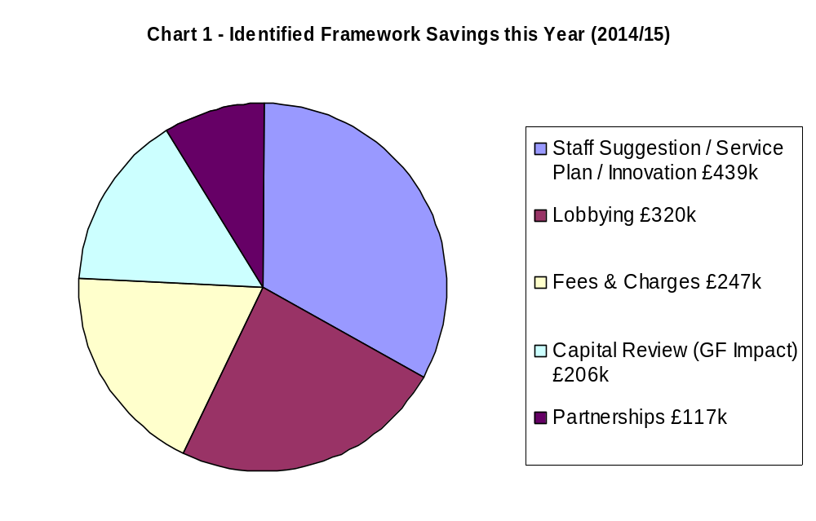
  - During the budget process, members were informed of a number of ‘big ticket’ items. These are typically items of large value that could have a disproportionate impact on the Council's budget if they moved in an adverse fashion. Consequently these are monitored very closely and members and officers may occasionally try to influence (through lobbying) any changes that may take place especially when such changes are triggered through changes in national policy. These items are included in the Councils ‘swing–o–meter’ as detailed at Appendix A.

Housing Revenue Account

  - A summary of HRA monitoring at 31st October is shown in Table 1. The Housing Revenue Account is currently projected to come in around budget.

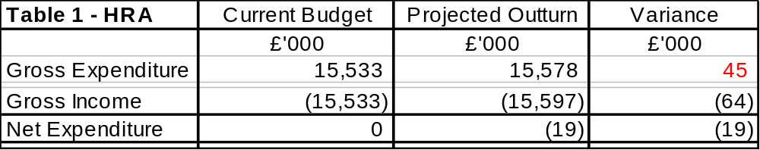

Capital Programme

  - A summary of the projected Capital Programme outturn monitoring statement as at 31st October 2014 is shown in Table 2.

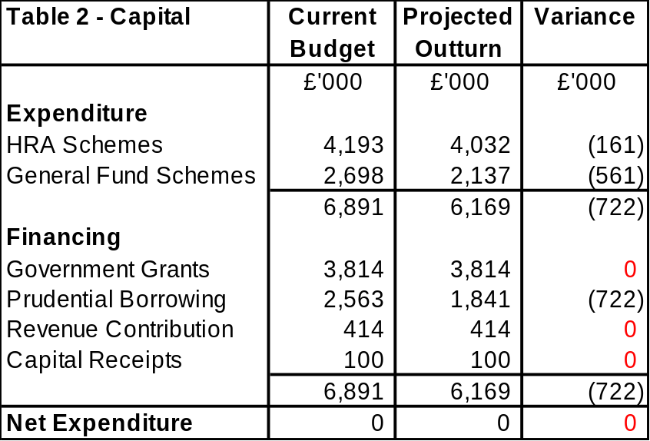

  - The HRA variance results from the average property price for the Empty Homes project being less than anticipated and the main General Fund variance results from the timing for the delivery of the Fleet maintenance facility being later than anticipated.

5 MEDIUM TERM FINANCIAL FORECAST

5.1 The Council’s latest Medium Term Financial Forecast is shown in Table 3.

- Zone of Predictability – this year and next (2014/15 - 2015/16)

The level of government funding has previously been announced for this year (2014/15) and provisional levels of funding were announced for next year (2015/16). The two previously identified areas of volatility , namely Business Rates Retention Scheme and Council Tax Support remain important variables that we continue to monitor closely.

Although we have received indicative grant allocations for next year, it is important to note that these are only indicative and could be affected by the upcoming Autumn Statement (due on the 3rd December). It is not uncommon to see some changes in national policy resulting from the Autumn Statement, there may be a greater likelihood of this given that it is the final Autumn Statement of the current Government.

A verbal update regarding the Autumn Statement will be provided to the Committee and we will no doubt need to keep the grant reductions under review for the January Report.

- Zone of Unpredictability – Medium Term (2016/17 – 2019/20)

Reference to the budget deficit figures (Table 3) illustrates the significant challenge that the Council faces in the medium term. Whereas uncertainty will continue to exist about the future levels of government grant post the 2015 General Election, it is fair to say that it will be an extremely challenging time for the authority.

The overall scale of budget reduction is very significant. The Council has done an impressive job of delivering a balanced budget despite having no council tax increase, no cuts to front line services, and no reduction to overall funding for the voluntary sector since 2011/12. This has only been achievable by following the budget guiding principles and making sure that other income sources, such as fees and charges, are harvested in line with their previously agreed guiding principles – this will remain important moving forward.

The reality of the Council being able to deliver a balanced budget in this period is looking increasingly fragile – the Council will need to carefully consider its main sources of income (Council Tax, Fees and Charges) at the same time as starting to consider its priorities for services (and levels of services) if a balanced budget is to be achieved in the medium term. The commonly referred to ‘triple zero’ success of recent times will not be achievable in the medium term, indeed any one element of this will put additional pressure on existing levels of service and resources.

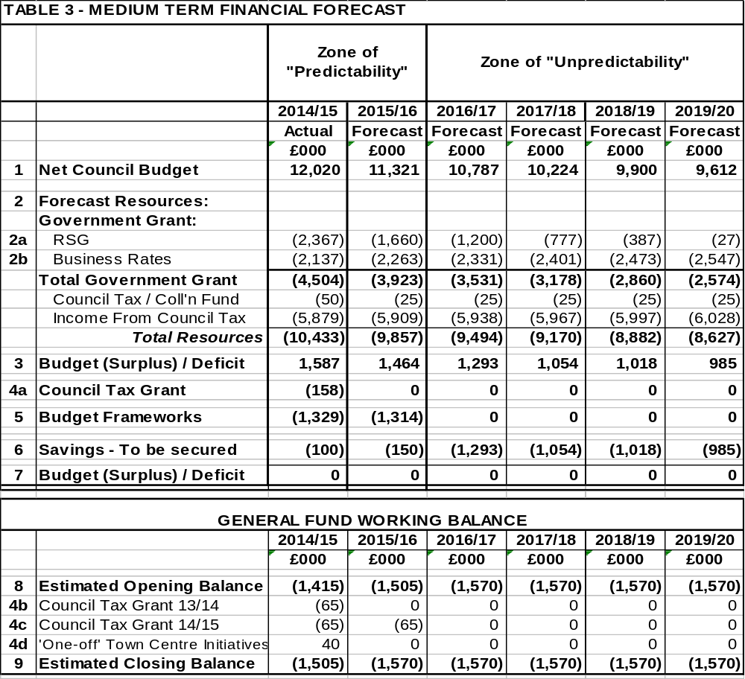
Notes to Medium Term Financial Forecast

1 Net Council Budget – This represents the net expenditure prior to the Budget Framework savings.

2 Forecast Resources – These are the Council's main funding streams (excluding fees and charges which are incorporated into Line 1). This illustrates the significant reduction in Central Government funding. To enable the total resources required to balance the budget to be identified, no assumptions have been made regarding future council tax increases. The small increase in revenue each year reflects anticipated housing growth in the borough.

The following assumptions have been made about future levels of government grant, these assumptions will continue to be reviewed as part of the budget process;

2015/16 (15.8%)
2016/17 (10.0%)
2017/18 (10.0%)
2018/19 (10.0%)
2019/20 (10.0%)

2a / 2b Revenue Support Grant / Business Rates - Following the introduction of the Business Rates Retention Scheme the local share of business rates will be uplifted by RPI each year until the system is reset in 2020 this is shown in line 2b. The full reduction in grant is therefore applied to the element that is provided through the Revenue Support Grant, which is detailed in Line 2a.

3 Budget (Surplus) / Deficit – This illustrates the gap between the budget and the total resources available before identifying budget framework savings.

4a Council Tax Grant – This is a grant the Council receives from central government for four years in return for freezing Council Tax in 2011/12. This is equivalent to the cash that would have been received if a 2.5% increase had been levied.

4b Council Tax Grant 2013/14 – This is a grant the Council receives from central government for two years in return for freezing Council Tax in 2013/14. This is equivalent to the cash that would have been received if a 1% increase had been levied. A Council Tax Freeze has ongoing implications as an increase in Council Tax generates income year on year.

4c Council Tax Grant 2014/15 - This is a grant the Council receives from central government for two years in return for freezing Council Tax in 2014/15.

4d Town Centre Initiatives – This relates to one off parking incentives and / or other town centre related items. Due to the one off nature this is being funded from the General Fund working balance rather than forming part of the base budget.

5 Budget Frameworks – This identifies the total savings required.

6 Savings to be secured – This identifies the total resources required to balance the budget in future years after 2014/15.

  - The Council’s medium term budget model will continue to be reviewed as we approach the forthcoming budget process. The key assumptions that underpin the detailed numbers will continue to be reviewed and refined as appropriate.

GENERAL FUND – 2015/16

  - As well as monitoring framework savings identified for 2014/15 work continues on identifying savings for the following year – 2015/16. Members are reminded of the current Medium Term Financial Forecast which required an additional £1,464,000 of savings to balance the budget in 2015/16. The savings target for 2015/16 has increased by £100,000 and results from the 2014/15 budget having unidentified savings of £100,000 following the Executives decision late in the budget process to implement a new car parking strategy, this takes the total savings target for 2015/16 to £1,564,000.

  - The previous budget report to this Committee in November outlined that savings of £1,114,000 had already been identified – meaning that additional on-going savings of £450,000 were required to ‘balance the budget’ by the time Council considered the budget in February 2015.

  - It is pleasing to report that additional on-going savings of a £200,000 have been identified - meaning that the remaining savings target for next year has now been reduced to £250,000.

  - Chart 2 illustrates how the identified savings are being delivered: 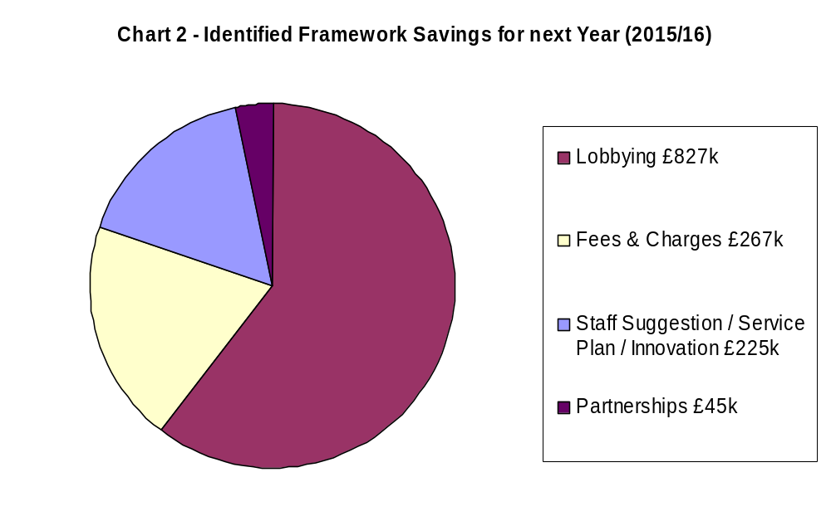

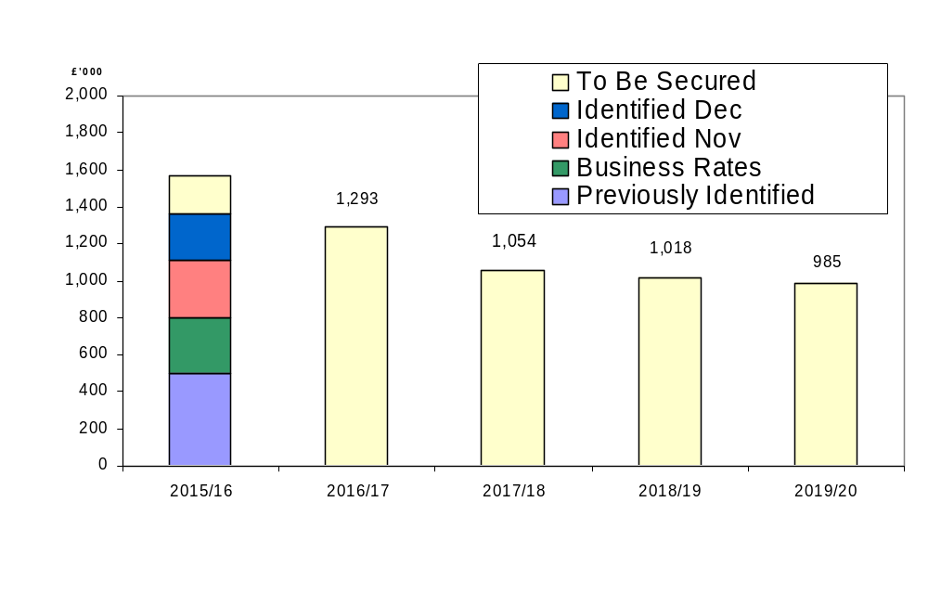
Chart 3 - Efficiency Savings
  - The Council’s success in delivering a balanced budget over the past five years has come from the Budget Delivery Framework (as outlined in Section 3.3) and particularly from the Staff Suggestions and Innovation Framework which has annually contributed to around 40% of the total savings target.

  - It was reported to the November Executive that savings of this magnitude are becoming increasingly difficult to maintain and over half of the savings identified to date for 2015/16 have been generated through the lobbying framework. It is going to become increasingly important to review the frameworks in future years as the reality of being able to deliver a balanced budget in the Medium Term (2016/17 – 2019/20) is looking increasingly fragile.

  - The Council’s impressive record in identifying and delivering efficiency savings in the past five years, including the current year (2014/15), are around £6.8m - as illustrated in Table 4;

Table 4 – Efficiency Savings | £000
2010/11 | 1,260
2011/12 | 1,910
2012/13 | 1,330
2013/14 | 950
Total | 5,450
2014/15 | 1,330
Total  % Cash Savings (Net Budget) | 6,780  66%

  - The scale and delivery of this level of efficiency savings is particularly impressive given that there has been no detrimental impact on the delivery of front line services and when considering the increased costs of utilities and inflation levels. Over the five year period (as detailed in Table 4) the efficiency savings will be equivalent to approximately 66% (85% in real terms) of the Council’s draft net budget (which stands at £10.4m for 2014/15).

  - Members are reminded that before the efficiency programme commenced a number of years ago, the Council was charging a level of Council tax below the national average yet delivering a level of performance that was above the national average. Despite having to deliver efficiency savings of £6.780m in the past five years, the Council’s level of council tax charged remains below the national average and performance remains above average.

  - This achievement is particularly commendable given that is has been achieved against the backcloth of no cuts to front line services, no increase in Council Tax and has preserved the overall funding level for the voluntary sector.

  - Members will recall the following illustration that summarises the Council’s overall position as being a ‘high performing / low cost’ local authority.

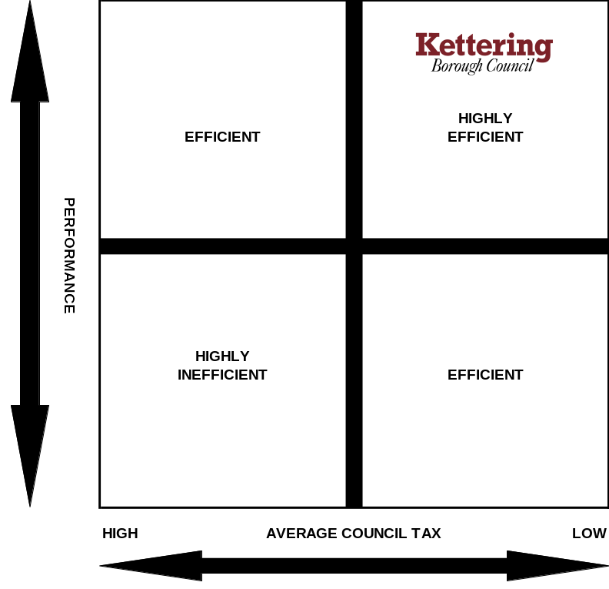

6 AUTUMN STATEMENT 2014

6.1 The Chancellor of the Exchequer is presenting the Autumn Statement to Parliament on 3rd December 2014. A verbal update will be provided at the Executive meeting on the key announcements likely to impact on Kettering Borough Council.

7 CONSULTATION AND CUSTOMER IMPACT
7.1 None as a direct consequence of this report. However members are reminded that the formal budget consultation period is from 14th January 2015 to 25th February 2015 when the Council sets its Council Tax for 2015/16. Comments from the consultation process will be reported to the Executive for consideration at it’s meeting on 18th February 2015.

8 POLICY IMPLICATIONS
8.1 None as a direct consequence of this report.

9 USE OF RESOURCES
9.1 As detailed throughout this report.

10. RECOMMENDATIONS

That the Executive;

  - Note the success the Council has achieved from the case studies;

  - Note the Council’s Medium Term Financial Strategy and associated guiding principles;

  - Consider any implications in respect of the Autumn Statement and consider them as the budget process progresses.

Background Papers: Previous Reports/Minutes:
Title of Document: Various Monthly Durable Budget Reports Contact Officers: M Dickenson

