1 PURPOSE OF REPORT

To provide an update to the Executive Committee of the recent announcement by the Department for Transport of the proposed funding package for J10a of the A14.

2 BACKGROUND INFORMATION

2.1 Kettering Borough lies within the South East Midlands, which is predominantly a growth area, and is expected to facilitate growth of some 13,100 homes and 16,200 new jobs by 2021.

2.2 Members have made their priorities for infrastructure and jobs-led growth clear – these are the prerequisites of growth. Members have indicated they wish to use the growth agenda to leverage three key and interrelated ambitions for the borough; namely:-

- A better offer for our town centres
- A better education and training offer
- A better employment offer – high grade, higher density jobs

  - The mutually supportive role of these three aspirations cannot be over-stated. The town centres and the skills base will be persuasive to inward investors. Similarly, high grade employment supports vibrant town centres.

  - This report highlights the recent announcement of a funding package from the Department for Transport for the proposed Junction 10a on the A14, and gives some context for that news.

- JUNCTION 10A: A TIMELINE

  - On December 1st 2014 the Government announced that it will provide vital funding for a new A14 junction 10A as part of the Department of Transports Road Investment Strategy for the Midlands. It is worth taking the time to step back and appreciate the hard work and dedication that has gone into achieving this important commitment. For the sake of clarity this report outlines some of the key achievements below; and then includes the main dates in pictorial form.

  - When granting outline planning permission for the East of Kettering SUE in April 2010, Kettering Borough Council’s Planning Committee placed requirements on the developer, Alledge Brook, to assess the precise need for, and then deliver a new junction on the A14 to ensure that the road network was sufficiently robust to cater for the increased traffic flows generated by the development.

  - The Strategic Masterplan of the East Kettering SUE highlights the importance of Junction 10a as a key gateway into the development, as well as the whole of Kettering (the proposed junction is highlighted in pink to the bottom right):

  - Though Junction 10a was directly linked to the East Kettering SUE, it also plays an important role in Kettering’s wider growth agenda – being intrinsically linked with the Junction 10 Business Park and the proposed Energy Park. As such, in 2011 a Steering Group was established with representation from each of the main stakeholders to assess how best to bring forward the various developments. The relationship with the Junction 10 Business Park is clear when you consider the Masterplan for that development:

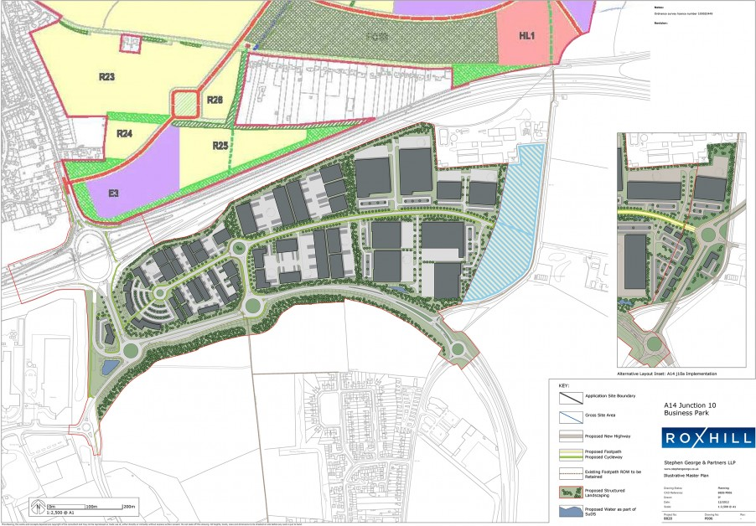

  - In 2012 Kettering Borough Council engaged with Local Partnerships – part owned by the Local Government Association and the Treasury – to conduct a ‘Green Book’ financial appraisal of Kettering’s growth projects as a means of showcasing the investment case for Junction 10a. This piece of work fed into a conference by the Local Government Association and British Property Federation - attended by Chief Secretary to the Treasury, Danny Alexander MP, and other leading lights of the development world.

  - The Green Book Assessment set out that investment in Junction 10a, and the associated relief road ‘Weekley Warkton Avenue’ would result in £1.2bn of economic activity. This piece of work has been key to securing greater Government interest in the scheme, and is a good illustration of the role lobbying has played so far.

  - The S106 Agreement, which was originally signed in March 2010, was revised in September 2013 so that it operated as a roof tax – a key part of the process as it has enabled the developer to commit to bring forward key infrastructure. This change in the S106 has improved cash flow and their ability to finance some of the infrastructure. It has also led the developer to be able to fund part of the proposed Junction 10a – something that they had not been able to do previously.

  - The precise details of the relevant highway conditions were amended by the Planning Committee in October 2013 as part of wider piece of work aimed at delivering a more efficient and deliverable permission for all parties. The complexities of delivering large scale development of this kind are such that each stage requires careful consideration, and often a review of previous work is required to ensure that blockages and labour-intensive schedules are not included where unnecessary.

  - Alongside the hard work being put in by the Borough Council, a great deal of lobbying activity took place during 2012-13, with a number of key Government officials and Ministers targeted. These have included (in no particular order) Mark Prisk MP, Greg Clarke MP, Nick Clegg MP, Terrie Alafat, Lord Deighton, Danny Alexander MP, Eric Pickles MP, Sir Merrick Cockell, Robert Goodwill MP, Brandon Lewis MP, and Greg Barker MP. These approaches were made in a number of different ways, and have involved the assistance and support of our strategic partners at NEP, SEMLEP, NCC, NNJPU, NNDC, the developers and other partner organisations. It is clear to us that this partnership approach has been key to delivering the progress made to date.

  - This led to the establishment of a regular cross-Governmental Department working group (Strategic Partners Group) in 2013, which meets at Kettering on a 6 weekly basis. It enables the locality (comprising KBC, NCC, developers, LEPs, etc) to speak directly with officials from the Department for Transport (DfT), Highways Agency (HA), Homes and Communities Agency (HCA), Department for Communities and Local Government (DCLG) and Department for Business, Innovation and Skills (BIS) – and together work on a strategy for the delivery of the growth projects in Kettering. A sub-group (Technical Working Group) was also established to meet monthly and focus specifically on Junction 10a and the Weekley Warkton Avenue (WWA), comprising KBC, NCC, DfT, HA and the developers.

  - Another milestone was secured in May 2014 when the trigger for Junction 10a was altered from 1750 to 2700 homes. This followed further research and investigation into the exact capacity of existing infrastructure. The developer, along with the Highways Authority (NCC) and HA, showed that more housing could be delivered before Junction 10a was required; something that was key from a viability and cash flow perspective.

  - The s106 Agreement was subject to a further alteration in October 2014 to enable the developer and Homes and Communities Agency to come to an agreement on the funding and delivery of key infrastructure on site, including the first primary school and various accesses and connection roads.

  - The Sub-Group referred to above (3.10) set about establishing how best to secure funding for Junction 10a and WWA. During 2014 two documents were produced. Firstly, led by the developer, a Strategic Business Case Plus (SBCP) was delivered (Feb 2014), which set an outline case for Government investment in J10a. It used the Green Book Assessment as a benchmark with additional transport work undertaken by Peter Bretts Associates and the HA. This document fed into discussions with the Commercial Secretary to the Treasury, Lord Deighton. KBC’s involvement in these discussions was paid for via the £1.2m of Capacity Funding secured in 2013. This has been key in enabling KBC to continue the level of staff resource focus on delivering the growth agenda. The SBCP included a draft design for the new junction, and connecting roads:

  - Following the meetings with Lord Deighton, the DfT gave notice that it intended to take the business case forward, and did so during the summer and autumn of 2014. Once the DfT Business Case was finalised earlier this year, Ministers were persuaded of the case for investment – and J10a was included within the Road Investment Strategy as part of the 2014 Autumn Statement announcements.

  - The new junction, once built, will provide a vital link to new housing, education and business employment developments in the area, particularly the East of Kettering Sustainable Urban Extension (SUE). It is anticipated that the new junction 10A will help unlock hundreds of millions of pounds of private sector investment in housing and jobs in the immediate area. It’s importance in terms of East Kettering SUE is clearly identified on the following page – with J10a shown in pink in the bottom right of the plan and WWA in pink in the top left.

  - The information contained within this part of the report is referenced within the illustration below, which sets out the key milestones within the last 4 years.

- ROAD INVESTMENT STRATEGY

  - The Government’s Road Investment Strategy is a £15 billion plan to triple levels of spending by the end of the decade to increase the capacity and condition of England’s roads. It was announced on 1 December 2014 by Transport Secretary Patrick McLoughlin and Chief Secretary to the Treasury Danny Alexander.

  - Kettering Borough Council has been lobbying hard with partners from both the public and private sector for a number of years for an additional junction on the A14.

  - The precise wording of the announcement made, under a heading of “Schemes committed subject to other contributions” was:

“A14: a new grade separated junction 10a east of Kettering, along with closure of east facing slip roads at junction 10, to support the East Kettering Sustainable Urban Extension”

  - More detail will follow, which will indicate the potential sum of funding being made available, and how the process is going to work in terms of the DfT funding and developer contribution ratio. This is most likely to require further meetings of the Strategic Partners Group and the Technical Working Group.

- POLICY IMPLICATIONS AND USE OF RESOURCES

  - Members have made their priorities for infrastructure and jobs-led growth clear – these are the prerequisites of growth. Members have indicated they wish to use the growth agenda to leverage three key and interrelated ambitions for the borough; namely:-

- A better offer for our town centres
- A better education and training offer
- A better employment offer – high grade, higher density jobs

5.2 More information on the details of the funding package will no doubt be released in due course. It is anticipated that the junction will be a DfT scheme and the developer will be required to contribute their agreed element directly to DfT.
6 RECOMMENDATION

That the Executive Committee welcomes the Government’s announcement and recognise the significant and successful lobbying effort that the Council and its partners have undertaken over the past few years to ensure that the business case was made and ultimately a successful outcome achieved.

