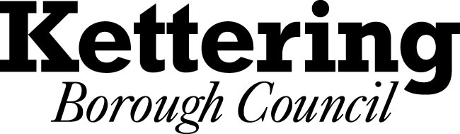

STANDARDS ADVISORY COMMITTEE

ANNUAL REPORT 2013/14

1. INTRODUCTION BY THE CHAIR OF THE STANDARDS ADVISORY COMMITTEE

  - I have pleasure in presenting the first Annual Report of the Standards Advisory Committee. This report covers the period from 1 April 2013 to 31 March 2014.

- INFORMATION

  - The Localism Act 2011 (the Act) completely removed the old Standards Regime with effect from the 1 July 2012. Under the Act there remained a duty to maintain high standards of conduct and to adopt a Code of Conduct and to have arrangements in place to deal with complaints of breach of the Code.

  - The Standards Committee was instrumental in considering proposals for a new Standards Framework. At its meeting on 12th June 2012 the Standards Committee agreed new arrangements for adoption by Council. The arrangements closely followed those already in place as it was generally agreed that they had served the Council well for many years. The Council adopted the new Code of Conduct and the Arrangements at its meeting on 4 July 2012. The new arrangements have now been in place for almost eighteen months.

  - Although the statutory requirement to have a Standards Committee was removed, an advisory committee model was adopted which retained the independent membership of the previous committee to help strengthen public confidence in the system. All the existing Independent Members have remained on the Committee.

  - The Act included a duty to appoint an Independent Person. The Council appointed Mr Mike Sawford as the Independent Member at its meeting on 22nd January 2013. The appointment was for an initial term of 12 months, commencing from 22nd January with authority delegated to the Chief Executive, in consultation with the Chair of The Standards Advisory Committee, to extend the appointment for up to a further three years. Mr Sawford's appointment was extended on 24th January 2014 for a further twelve-month period.
- MEMBERS OF THE STANDARDS COMMITTEE

  - The Standards Advisory Committee comprises of five independent members, two Town or Parish Councillors and three Borough Councillors.

  - In 2012/13 the Independent members received an annual allowance as follows:-

- Chair: £2,615
- Independent members: £653
- Independent Person: £653

  - The level of allowances was reviewed by the Council’s Independent Review Panel in 2012. It recommended that a further review of the allowances be undertaken in 2014 when the impact of the changes to the regime become clearer.

  - The Members of the Committee for 2013/14 were:

Independent Members

Ms Julie Miller (Chair)
Mr Stuart Kilpatrick
Mr Brian Christie
Mr Phil Carter
Mr Lloyd Landry

Town/Parish Representatives

Mr Neil Matthew (Town/Parish Council)
1 Vacancy

Borough Councillors

Councillor Scott Edwards
Councillor Ruth Groome
Councillor Ellie Manns

  - The Independent Person is not a member of the Standards Advisory Committee but is entitled to receive copies of the agenda and attend meetings of the Committee.

- ISSUES CONSIDERED BY THE STANDARDS/STANDARDS ADVISORY COMMITTEE DURING 2013/14

The Standards Advisory Committee met to consider the Local Government Association's Guidance for Councillors and Officers on Probity in Planning. The Advisory Committee recommended to the Planning Committee that changes be made to the Council's current planning guidance for members to reflect the changes.

- COMPLAINTS

4.1 The Monitoring Officer did not receive any formal complaints under the new arrangements during the year 2013/14.

4.2 The Monitoring Officer has advised the Town and Parish Councils on issues relating to the Code of Conduct and other matters. However, to date no formal complaints have been received.

5. TRAINING

5.1 Standards Training for Kettering Borough Council Members took place on 9th December 2013.

5.2 Members have been provided with updates of the new Code by the Monitoring Officer on relevant issues including Disclosable Pecuniary Interests and Council Tax and Government Guidance on Openness and Transparency. The Standards Advisory Committee has also issued Councillors with Information on the Code of Conduct.

