- PURPOSE OF REPORT

To inform Members of the North Northamptonshire Green Infrastructure Delivery Plan.

2. INTRODUCTION

  - Policy 5 of the North Northamptonshire Core Spatial Strategy (CSS) aims to secure a net gain in green infrastructure through protection and enhancement of assets and the creation of multi functional areas of green space. The policy identifies Sub-regional and local green infrastructure corridors.

  - One of the key mechanisms to deliver Policy 5 and Green Infrastructure is Policy 5b: ‘using developer contributions to facilitate improvements to [green infrastructure corridor] quality and robustness’. One of the challenges to implementing Policy 5 – and Policy 5b in particular – is making the connection between green infrastructure policy and project delivery on the ground.

  - The North Northamptonshire Green Infrastructure Delivery Strategy (GIDP), attached at appendix 1, has been prepared to address this and to help implement policy 5 of the CSS. The GIDP was endorsed by Planning Policy Committee on 18 June 2014.

GREEN INFRASTRUCTURE DELIVERY PLAN

  - The GIDP provides evidence to progress delivery on a range of green infrastructure projects across North Northamptonshire. It provides project details and evidence to inform discussions with developers to deliver green infrastructure benefits in the short to medium term.

  - Projects in the GIDP address a range of local needs. These needs are primarily a response to growth and development, and include increasing visitor capacity of existing sites, improving the visitor experience and addressing greenspace deficits. Many of the projects will also mitigate habitat and/or site deterioration that often results from recreational pressure. Some projects link to broader policy goals on climate change and water quality.

  - The GIDP projects deliver a variety of benefits for access, biodiversity, cultural heritage, inward investment and other themes in Northamptonshire Arc’s Towards a Naturally Resilient Northamptonshire. Many of the projects also address local greenspace deficiencies. These have been identified through the spatial application of Natural England’s Accessible Natural Greenspace Standard (ANGSt), which is based on the principle that everyone should have access to good quality natural greenspace near to where they live.

  - The GIDP will be reviewed periodically, to accommodate new projects which come forward and those that are completed. Many of the current projects have been in development for some time and are deliverable in the short to medium term. As the GIDP is reviewed there will be opportunities to examine local green infrastructure gaps in more detail and plan new projects to address these gaps. It will also allow time to bring forward projects which are still being developed to meet needs.

GREEN INFRASTRUCTURE IN KETTERING BOROUGH

  - Northamptonshire’s sub-regional green infrastructure corridors broadly follow the main river valleys and tributaries. The sub-regional network is complemented by local green infrastructure corridors. These cover a variety of land uses and provide opportunities for projects and investment at a smaller, more local scale.

  - Kettering’s main settlements are located on the Ise sub-regional corridor. Local corridors extend through the surrounding countryside, providing valuable habitat and walking routes at a smaller scale. The borough’s green infrastructure network includes Wicksteed Park, grassland habitats along the River Ise, woodlands of Rockingham Forest and various Rights of Way. As Kettering grows however, the increase in population will put additional pressure on existing assets. Therefore, projects have been identified that will support the current network and make valuable improvements over the next 10 years to meet the needs of the growing population.

  - Figure 1 illustrates the green infrastructure network within Kettering Borough. Also depicted are the locations of key green infrastructure projects included in the GIDP. These projects are located within the sub-regional corridor, and will most directly benefit Kettering and Desborough. A range of aspirational projects in the smaller settlements will be located in both the sub-regional and local corridors.

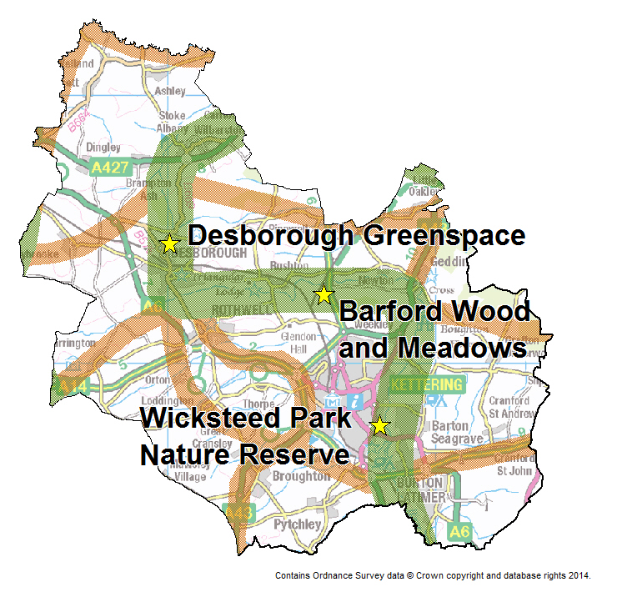
Figure 1: sub-regional (green) and local (brown) green infrastructure corridors and projects identified in the GIDP.

  - Below are those projects presented in detail in Appendix 3 to the Green Infrastructure Delivery Plan, to facilitate case officer discussions with developers. The GIPD also includes a list of projects which are longer term aspirations which require further investigation. Some of the projects reflect the aspirations of other Green Infrastructure stakeholders. Other projects were identified in the PPG17 Open Space Assessment (December 2007) and therefore require review before they are progressed.

Project | Description | Start date | Duration to completion | Initial cost | Annual cost
Barford Wood and Meadows | Bridge construction to permit livestock access to SSSI for habitat management | 2016 |  | £40,000 | TBD
Desborough Greenspace | Provision of >20 ha greenspace in north Desborough | 2011 | 10 years | £400,000
Wicksteed Park Nature Reserve: connection to Southfield Farm Marsh | Linkage of existing nature reserves and improved measures to protect water quality | TBD |  | £1,000,000
Leftover Spaces: Greener Places | Development of community-led greenspaces in major settlements | 2012 | 3 years | £216,000 | £20,000
Rockingham Forest for Life | Tree planting for carbon sequestration, wood fuel supply and public access | TBD | Ongoing | £6,999,300 | TBD
Note: TBD = to be decided.

2.12 Organisations involved in the preparation of the document have included: Nene Valley Nature Improvement Area, River Nene Regional Park, Northamptonshire Wildlife Trust, Kettering Borough Council, East Northamptonshire Council, Borough Council of Wellingborough, Corby Borough Council, Rockingham Forest Trust, Groundwork Northamptonshire, English Heritage, Northamptonshire County Council, Natural England, and the Environment Agency.

3. RECOMMENDATION

That Members note the Green Infrastructure Delivery Plan.

Contact Officer: Julia Baish – Development Officer

Appendix 1: The GIDP

