- PURPOSE OF REPORT

To inform Members of the North Northamptonshire Green Infrastructure Delivery Plan and to ask Members to endorse this document to be used to deliver green infrastructure improvements across the Borough.

2. INTRODUCTION

  - Green infrastructure improves quality of life for residents and enhances biodiversity, habitat connectivity and ecosystem services. Northamptonshire’s sub-regional and local green infrastructure corridors were delineated in 2006 by the River Nene Regional Park. Since then green infrastructure’s importance has been enshrined in policy at both the national (National Planning Policy Framework paragraphs 99 and 114) and local levels in both plans and strategies.

  - As recognised in Policy 5 of the 2008 North Northamptonshire Core Spatial Strategy, green infrastructure ‘promote[s] recreation and tourism, public access, green education, biodiversity, water management, the protection and enhancement of the local landscape and historic assets and mitigation of climate change’. This is echoed in the recently published ‘Local Economic Assessment for Northamptonshire’ by Oxford Economics for Northamptonshire Enterprise Partnership where it is stated that ‘The improvement of existing and creation of new green infrastructure should be prioritised, especially in areas of greatest need’.

  - Highlighting the importance of a robust green infrastructure network, Policy 5 aims to secure a net gain in green infrastructure; protect the integrity of existing networks; and promote improvements where possible. One of the key mechanisms to deliver Policy 5 and Green Infrastructure is Policy 5b: ‘using developer contributions to facilitate improvements to [green infrastructure corridor] quality and robustness’. One of the challenges to implementing Policy 5 – and Policy 5b in particular – is making the connection between green infrastructure policy and project delivery on the ground.

  - In their initial response to the 2010 consultation on the North Northamptonshire Draft Developer Contributions Supplementary Planning Document, Natural England objected to the document ‘due to the absence of a Green Infrastructure Development Strategy’. Natural England asserted that ‘additional Green Infrastructure can be necessary to make development acceptable in planning terms, that strategic Green Infrastructure will be directly related to development within its catchment area, and that a nominal level of contribution per dwelling can be fairly and reasonably related in scale to development’. They identified the need to ‘[provide] the detail of the projects which financial contributions from developers will be spent on’ and outlined key elements that they would expect a green infrastructure development strategy to include.

  - At present however, North Northamptonshire has no mechanism to link green infrastructure policy to green infrastructure delivery. To address this and Natural England’s delivery concerns, a partnership approach involving the local authorities, central government agencies and third sector organisations have identified a range of green infrastructure projects which, if completed, would help implement Policy 5.

GREEN INFRASTRUCTURE DELIVERY PLAN

  - The North Northamptonshire Green Infrastructure Delivery Plan (GIDP) (Appendix 1) has been written to help planners to implement Policy 5. The GIDP supplies the evidence needed for planners to progress delivery on a range of green infrastructure projects across North Northamptonshire. It has been written specifically for planning officers, and provides project details and evidence to inform discussions with developers to deliver green infrastructure benefits in the short to medium term. For each project the GIDP specifies links to development, policy drivers, project aims, benefits, delivery timescales, contact information and costs.

  - Projects in the GIDP address a range of local needs. These needs are primarily a response to growth and development, and include increasing visitor capacity of existing sites, improving the visitor experience and addressing greenspace deficits. Many of the projects will also mitigate habitat and/or site deterioration that often results from recreational pressure. Some projects link to broader policy goals on climate change and water quality.

  - The GIDP projects deliver a variety of benefits for access, biodiversity, cultural heritage, inward investment and other themes in Northamptonshire Arc’s Towards a Naturally Resilient Northamptonshire. Many of the projects also address local greenspace deficiencies. These have been identified through the spatial application of Natural England’s Accessible Natural Greenspace Standard (ANGSt), which is based on the principle that everyone should have access to good quality natural greenspace near to where they live.

  - The GIDP will be reviewed periodically, to accommodate new projects which come forward and those that are completed. Many of the current projects have been in development for some time and are deliverable in the short to medium term. As the GIDP is reviewed there will be opportunities to examine local green infrastructure gaps in more detail and plan new projects to address these gaps. It will also allow time to bring forward projects which are still being developed to meet needs.

  - Several projects relate to, or are within the catchment of the Upper Nene Valley Gravel Pits Special Protection Area (SPA). As instructed by Natural England this has been addressed in the details for each project affected. An Appropriate Assessment (Appendix 2) has also been produced for the GIDP as a whole and approved by Natural England (Appendix 3).

  - While the GIDP relates specifically to development contributions to green infrastructure (through Community Infrastructure Levy or s106), project funding is likely to come from a variety of sources. These include central and local government, lottery funds, Landfill Communities Fund and charitable trusts. In most cases development contributions will not be the only funding source identified. The GIDP project details include funds both required and already secured, and identify a range of potential funding sources for each project. While development contributions are needed, it is important to illustrate that they are a part of a broader funding strategy and are not simply being expected to resource green infrastructure in general terms.

GREEN INFRASTRUCTURE IN KETTERING BOROUGH

  - Northamptonshire’s sub-regional green infrastructure corridors broadly follow the main river valleys and tributaries. The sub-regional network is complemented by local green infrastructure corridors. These cover a variety of land uses and provide opportunities for projects and investment at a smaller, more local scale.

  - Kettering’s main settlements are located on the Ise sub-regional corridor. Local corridors extend through the surrounding countryside, providing valuable habitat and walking routes at a smaller scale. The borough’s green infrastructure network includes Wicksteed Park, grassland habitats along the River Ise, woodlands of Rockingham Forest and various Rights of Way. As Kettering grows however, the increase in population will put additional pressure on existing assets. Therefore, projects have been identified that will support the current network and make valuable improvements over the next 10 years to meet the needs of the growing population.

  - Figure 1 illustrates the green infrastructure network within Kettering Borough. Also depicted are the locations of key green infrastructure projects included in the GIDP. These projects are located within the sub-regional corridor, and will most directly benefit Kettering and Desborough. A range of aspirational projects in the smaller settlements will be located in both the sub-regional and local corridors.

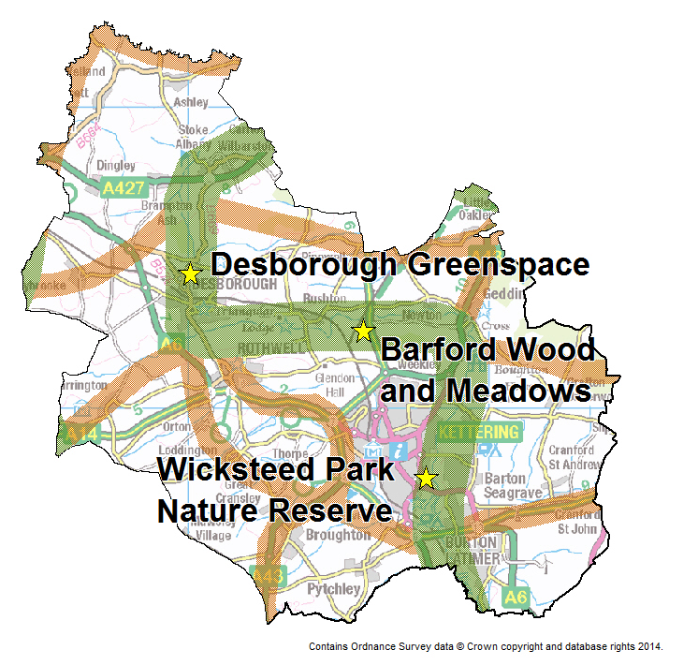
Figure 1: sub-regional (green) and local (brown) green infrastructure corridors and projects identified in the GIDP.

  - Below are key green infrastructure projects planned or underway in Kettering Borough. Those in italics are presented in detail in Appendix 3 to the Green Infrastructure Delivery Plan, to facilitate case officer discussions with developers. Those not in italics are longer term aspirations which require further investigation. Some of the projects reflect the aspirations of other Green Infrastructure stakeholders. Other projects were identified in the PPG17 Open Space Assessment (December 2007) and therefore require review before they are progressed.

Project | Description | Start date | Duration to completion | Initial cost | Annual cost
Barford Wood and Meadows | Bridge construction to permit livestock access to SSSI for habitat management | 2016 |  | £40,000 | TBD
Desborough Greenspace | Provision of >20 ha greenspace in north Desborough | 2011 | 10 years | £400,000
Wicksteed Park Nature Reserve: connection to Southfield Farm Marsh | Linkage of existing nature reserves and improved measures to protect water quality | TBD |  | £1,000,000
Leftover Spaces: Greener Places | Development of community-led greenspaces in major settlements | 2012 | 3 years | £216,000 | £20,000
Rockingham Forest for Life | Tree planting for carbon sequestration, wood fuel supply and public access | TBD | Ongoing | £6,999,300 | TBD
Longer term projects:
Kettering outskirts | Long term aim for the council to provide 3 new natural and semi-natural sites on the outskirts of Kettering | TBD |  | £75.000
Kettering amenity space | Creation of 3 new amenity greenspaces in Kettering: one in the northwest and two in the south | TBD |  | £75,000
West Kettering | Greenspace creation in south and northwest Kettering | TBD |  | £400,000
Westfield Gardens, Kettering (Meadow Road Park and Slade Brooke | New Residential Quarter development: greenspace remodelling to include community outdoor flexible space near brook that includes street skate use. Part of town centre redevelopment | TBD |  | £500,000
Burton Latimer Greenspace | Council to investigate changing an amenity greenspace to natural/semi-natural provision in south Burton Latimer | TBD |  | £50,000
Burton Latimer Park | Provision of new park and garden in south Burton Latimer | 2016 |  | £200,000
Desborough Parks | Provision of new park or garden in east and west Desborough | TBD |  | £100,000
Desborough pocket parks | Creation of two pocket parks in Desborough | TBD |  | £200,000
Tailby Meadow expansion, Desborough | Expansion of existing nature reserve to accommodate more visitor pressure | TBD |  | £200,000
Rothwell amenity | Provision of a new amenity greenspace in north Rothwell | TBD |  | £25,000
Rothwell park | Provision of a new park and garden in west Rothwell | TBD |  | £200,000
Broughton and Mawsley | Provision of a new amenity greenspace in Broughton and Mawsley | TBD |  | £50,000
Geddington greenspace | Provision of natural or semi-natural greenspace in Geddington | TBD |  | £50,000
Pytchley | Provision of accessible natural or semi-natural greenspace in Pytchley | TBD |  | £50,000
Wilbarston | Provision of a new natural or semi-natural greenspace in Wilbarston | TBD |  | £50,000
Note: TBD = to be decided.

  - The Green Infrastructure Delivery Plan will help officers to focus resources on these projects that will deliver green infrastructure benefits in the short to medium term. It will provide officers with the evidence needed to inform discussions with developers and deliver Policy 5 of the North Northamptonshire Core Spatial Strategy.

3. CONSULTATION

  - Consultation has been undertaken with key organisations during the production of the GIDP. Organisations involved in the preparation of the document have included: Nene Valley Nature Improvement Area, River Nene Regional Park, Northamptonshire Wildlife Trust, Kettering Borough Council, East Northamptonshire Council, Borough Council of Wellingborough, Corby Borough Council, Rockingham Forest Trust, Groundwork Northamptonshire, English Heritage, Northamptonshire County Council, Natural England, and the Environment Agency.

4. POLICY IMPLICATIONS

  - The North Northamptonshire Green Infrastructure Delivery Plan will assist in the delivery of policy 5 of the North Northamptonshire Core Spatial Strategy.

- FINANCIAL/RESOURCE IMPLICATIONS

5.1 None directly related to the report. The GIDP will assist in negotiations for S106 contributions towards identified projects and in submitting briefs for external funding sources.

6. RECOMMENDATION

That Members note the Green Infrastructure Delivery Plan and endorse the projects in Kettering Borough for use as a basis to deliver green infrastructure improvements across the Borough.

Contact Officer: Julia Baish – Development Officer

Appendix 1: The GIDP plus appendices.

Appendix 2: The Appropriate Assessment

Appendix 3: Natural England’s letter of approval on the Appropriate Assessment

