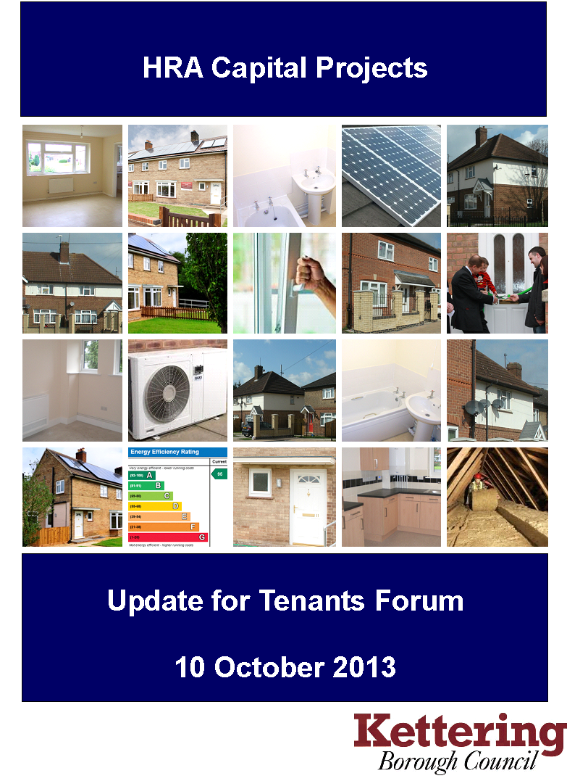

HEADLINES

- Work to convert the redundant warden’s house at The Lawns into two one-bedroom flats for elderly wheelchair users has been completed on programme and within budget. As well as increasing our stock of smaller homes, the new flats will produce an annual rental income of £7,100.

- Tenders have now been invited to reinstate curb edgings and resurface footpaths and access roads at Windsor Gardens. Work is due to start in November 2013.

Notes

Spend shows the position as at 7th October 2013

Cost Centre | Project | Budget  £
H420 | Improving Access for Disabled People | 458,000
H430 | Decent Homes – Electrical Upgrades | 208,000
H435 | Decent Homes - Kitchen & Bathroom Renewal | 318,000
H440 | Door Entry Systems | 50,000
H441 | Decent Homes - Window Renewal | 146,000
H442 | Decent Homes - Central Heating | 297,000
H443 | Decent Homes – Re-Roofing | 250,000
H445 | Decent Homes – External Wall Repairs | 40,000
H446 | Composite Door Replacements | 214,000
H447 | Major Voids | 350,000
H448 | Structural Improvements | 164,000
H449 | External Wall Insulation | 110,000
H450 | Environmental Improvements - Highfields | 40,000
H455 | Decent Homes - Replace Oil Tanks | 38,000
H456 | Decent Homes - Fire Precautions (Fire Doors) | 70,000
H457 | Decent Homes - Other Works | 40,000
H458 | Loft and Internal Wall Insulation | 29,000
H459 | Sheltered Housing – External Area Enhancements | 45,000
H460 | Conversion of Wardens Flat | 60,000
H461 | Refurbishment - Hampden Crescent | 150,000
H462 | Decent Homes - Fire Precautions | 108,000
H463 | Homes for the Future | 75,000
TOTAL |  | 3,260,000

Cost centre | H440
Project name | Door Entry Systems
Description | A rolling programme to install door entry systems to blocks of flats
Status | On-site |  |  |  | Units |  | 169
Budget | £50,000 | Spend |  | £26,549 | Projection |  | £50,000
Contractor | Entrotec
Programme |  |  | Now |  |  | Last
Programme | Brief |  | Jan-13 |  |  | -
Programme | Sketch scheme |  | Feb-13 |  |  | -
Programme | Tender approval |  | N/A |  |  | -
Programme | Start on site |  | Aug-13 |  |  | -
Programme | Completion |  | Mar-14 |  |  | -
Comments | 1 block completed. 9 further blocks to be completed and 18 programming units to be upgraded by year end.

Cost centre | H441
Project name | Window Renewal
Description | A rolling programme for the installation of replacement UPVC windows.
Status | On-site |  |  |  | Units |  | 32
Budget | £146,000 | Spend |  | £44,133 | Projection |  | £76,000
Contractor | Astraseal
Programme |  |  | Now |  |  | Last
Programme | Brief |  | N/A |  |  | -
Programme | Sketch scheme |  | Dec-12 |  |  | -
Programme | Tender approval |  | Apr-13 |  |  | -
Programme | Start on site |  | May-13 |  |  | -
Programme | Completion |  | Dec-13 |  |  | -
Comments | St Andrews Court and Spring Gardens are complete. Further works at Yeomans Court are to be tendered, with a view to completion within budget this year.

Cost centre | H443
Project name | Roof Renewal
Description | Replacement of existing tiled roofing to various properties throughout the Borough
Status | On-site |  |  |  | Units |  | 55
Budget | £250,000 | Spend |  | £15,438 | Projection |  | £220,000
Contractor | Warkton Roofing
Programme |  |  | Now |  |  | Last
Programme | Brief |  | N/A |  |  | -
Programme | Sketch scheme |  | N/A |  |  | -
Programme | Tender approval |  | May-13 |  |  | -
Programme | Start on site |  | Aug-13 |  |  | -
Programme | Completion |  | Mar-14 |  |  | -
Comments | Work commenced in August. 7 properties now completed.  On target to complete all 55 units within budget by year end.

Cost centre | H447
Project name | Void Repairs and Improvements
Description | Major repair works to void properties
Status | On-site |  |  |  | Units |  | 50
Budget | £350,000 | Spend |  | £194,001 | Projection |  | £350,000
Contractor | A L Holland
Programme |  |  | Now |  |  | Last
Programme | Brief |  | N/A |  |  | -
Programme | Sketch scheme |  | N/A |  |  | -
Programme | Tender approval |  | Jun-10 |  |  | -
Programme | Start on site |  | Apr-13 |  |  | -
Programme | Completion |  | Mar-14 |  |  | -
Comments | Works completed to 15 properties.  On target to complete 50 units by year end and on budget.

Cost centre | H448
Project name | Structural Improvements
Description | Ad hoc underpinning and damp proofing works identified through surveys
Status | On-site |  |  |  | Units |  | 82
Budget | £164,000 | Spend |  | £85,178 | Projection |  | £164,000
Contractor | Various
Programme |  |  | Now |  |  | Last
Programme | Brief |  | N/A |  |  | -
Programme | Sketch scheme |  | N/A |  |  | -
Programme | Tender approval |  | N/A |  |  | -
Programme | Start on site |  | Apr-13 |  |  | -
Programme | Completion |  | Mar-14 |  |  | -
Comments | Works completed to 17 properties.  On target to complete 82 units on budget by year end.

Cost centre | H449
Project name | External Insulation
Description | Installation of external wall insulation on properties without mains gas where construction does not permit installation of cavity wall insulation
Status | On-site |  |  |  | Units |  | 16
Budget | £110,000 | Spend |  | £25,671 | Projection |  | £95,000
Contractor | Goldsmith and Son
Programme |  |  | Now |  |  | Last
Programme | Brief |  | Feb-13 |  |  | -
Programme | Sketch scheme |  | Apr-13 |  |  | -
Programme | Tender approval |  | May-13 |  |  | -
Programme | Start on site |  | Jul-13 |  |  | -
Programme | Completion |  | Mar-14 |  |  | -
Comments | Works completed to 8 properties. Grant funding of £39,000 from Scottish Power has been obtained under the ECO scheme.  On target to complete 16 units within budget by year end.

Cost centre | H450
Project name | Environmental improvements – Highfield Road Estate
Description | New recycling and bin areas to three blocks on Highfield Road Estate
Status | Feasibility Study |  |  |  | Units |  | 18
Budget | £40,000 | Spend |  | £0 | Projection |  | £45,000
Contractor | N/A
Programme |  |  | Now |  |  | Last
Programme | Brief |  | Feb-13 |  |  | -
Programme | Sketch scheme |  | Mar-13 |  |  | -
Programme | Tender approval |  | Dec-13 |  |  | -
Programme | Start on site |  | Feb-14 |  |  | -
Programme | Completion |  | Mar-14 |  |  | -
Comments | Tenant consultation exercise undertaken in August and September

Cost centre | H456
Project name | Decent Homes- Fire Precautions
Description | Replacement of timber fire doors in flats with GRP doors
Status | Tender stage |  |  |  | Units |  | 72
Budget | £70,000 | Spend |  | £4,483 | Projection |  | £54,000
Contractor | Permador
Programme |  |  | Now |  |  | Last
Programme | Brief |  | Sep-12 |  |  | -
Programme | Sketch scheme |  | Nov-12 |  |  | -
Programme | Tender approval |  | May-13 |  |  | -
Programme | Start on site |  | Nov-13 |  |  | -
Programme | Completion |  | Mar-14 |  |  | -
Comments | Tender awarded for £54,000. Work to commence on-site in Nov 2013.  On target to complete 72 units within budget by year end.

Cost centre | H457
Project name | Decent Homes – Other Works
Description | Works to address properties identified as potentially non-decent during 2013
Status | On-site |  |  |  | Units |  | 4
Budget | £40,000 | Spend |  | £28,624 | Projection |  | £40,000
Contractor | A L Holland
Programme |  |  | Now |  |  | Last
Programme | Brief |  | Feb-13 |  |  | -
Programme | Sketch scheme |  | May-13 |  |  | -
Programme | Tender approval |  | Jul-13 |  |  | -
Programme | Start on site |  | Aug-13 |  |  | -
Programme | Completion |  | Mar-13 |  |  | -
Comments | Two properties completed to date.  On target to complete all four units on budget by year end.

Cost centre | H458
Project name | Internal Wall Insulation
Description | Provision of wall and loft insulation to increase energy efficiency
Status | Complete |  |  |  | Units |  | 30
Budget | £29,000 | Spend |  | £9,802 | Projection |  | £9,802
Contractor | SIG Energy Management
Programme |  |  | Now |  |  | Last
Programme | Brief |  | N/A |  |  | -
Programme | Sketch scheme |  | N/A |  |  | -
Programme | Tender approval |  | N/A |  |  | -
Programme | Start on site |  | N/A |  |  | -
Programme | Completion |  | N/A |  |  | -
Comments | All work was completed in 2012/13.A payment was made at the beginning of 2013/14 for work completed in 2012/13. Remaining budget is to be reallocated.

Cost centre | H459
Project name | Car Park Enhancements
Description | Resurfacing and repairs to various garage areas and sheltered housing car parks throughout the Borough
Status | Tender stage |  |  |  | Units |  | 74
Budget | £45,000 | Spend |  | £345 | Projection |  | £45,000
Contractor | N/A
Programme |  |  | Now |  |  | Last
Programme | Brief |  | Aug-13 |  |  | -
Programme | Sketch scheme |  | Sep-13 |  |  | -
Programme | Tender approval |  | Oct-13 |  |  | -
Programme | Start on site |  | Nov-13 |  |  | -
Programme | Completion |  | Dec-13 |  |  | -
Comments | Works are currently out to tender for Windsor Gardens. Tender opening will be on 21 October.

Cost centre | H460
Project name | Conversion of Warden’s House
Description | Conversion of warden’s house at the Lawns sheltered housing scheme to provide two one-bedroom flats for wheelchair users.
Status | Complete |  |  |  | Units |  | 2
Budget | £60,000 | Spend |  | £51,189 | Projection |  | £51,189
Contractor | Boothville Roofing
Programme |  |  | Now |  |  | Last
Programme | Brief |  | 2011 |  |  | -
Programme | Sketch scheme |  | Feb-13 |  |  | -
Programme | Tender approval |  | Mar-13 |  |  | -
Programme | Start on site |  | Apr-13 |  |  | -
Programme | Completion |  | Sep-13 |  |  | -
Comments | Work completed in September 2013 – on programme and £12,000 below budget

Cost centre | H461
Project name | Hampden Crescent – Regeneration
Description | Refurbishment of Hampden Crescent flats and environmental improvements
Status | Feasibility stage |  |  |  | Units
Budget | £150,000 | Spend |  | £0 | Projection |  | £150,000
Contractor | N/A
Programme |  |  | Now |  |  | Last
Programme | Brief |  | May -12 |  |  | -
Programme | Sketch scheme |  | N/A |  |  | -
Programme | Tender approval |  | N/A |  |  | -
Programme | Start on site |  | N/A |  |  | -
Programme | Completion |  | N/A |  |  | -
Comments | Designs prepared and circulated to tenants in September

Cost centre | H462
Project name | Decent Homes – Fire Precautions
Description | Various remedial works identified during fire risk assessments
Status | On-site |  |  |  | Units
Budget | £108,000 | Spend |  | £17,922 | Projection |  | £108,000
Contractor | Smith Fire
Programme |  |  | Now |  |  | Last
Programme | Brief |  | Jul-11 |  |  | -
Programme | Sketch scheme |  | Sep-11 |  |  | -
Programme | Tender approval |  | Mar-13 |  |  | -
Programme | Start on site |  | May-13 |  |  | -
Programme | Completion |  | Mar-14 |  |  | -
Comments | Stage 1 (Barnes Close and Whiteford Drive) complete  Stage 2 (George Street and Saunders Close) commenced Sep 13 and due for completion in October. Tenders are out for Stage 3 (The Lawns).

Cost centre | H463
Project name | Homes for the Future
Description | Full refurbishment of pre-1945 properties to provide modern amenities, enhanced energy efficiency and a thirty year life free of major maintenance works
Status | Feasibility stage |  |  |  | Units
Budget | £75,000 | Spend |  | £0 | Projection |  | £75,000
Contractor | N/A
Programme |  |  | Now |  |  | Last
Programme | Brief |  | N/A |  |  | -
Programme | Sketch scheme |  | N/A |  |  | -
Programme | Tender approval |  | N/A |  |  | -
Programme | Start on site |  | N/A |  |  | -
Programme | Completion |  | N/A |  |  | -
Comments | Project on hold pending approval of ‘Homes for the Future’ proposals

Cost centre | H420
Project name | Improving Access for Disabled People
Description | Installation of aids and adaptations to council housing across the Borough
Status | On-site |  |  |  | Units |  | 65
Budget | £458,000 | Spend |  | £112,200 | Projection |  | £458,000
Contractor | KBC Environmental Care
Programme |  |  | Now |  |  | Last
Programme | Brief |  |  |  |  | -
Programme | Sketch scheme |  |  |  |  | -
Programme | Tender approval |  |  |  |  | -
Programme | Start on site |  |  |  |  | -
Programme | Completion |  |  |  |  | -
Comments | On target to complete all 65 units within budget by year end.

Cost centre | H430
Project name | Decent Homes – Electrical Upgrades
Description | Rolling programme to upgrade electrical installations
Status | On-site |  |  |  | Units |  | 89
Budget | £208,000 | Spend |  | £65,000 | Projection |  | £208,000
Contractor | KBC Environmental Care
Programme |  |  | Now |  |  | Last
Programme | Brief |  |  |  |  | -
Programme | Sketch scheme |  |  |  |  | -
Programme | Tender approval |  |  |  |  | -
Programme | Start on site |  |  |  |  | -
Programme | Completion |  |  |  |  | -
Comments | On target to complete all units within budget by year end

Cost centre | H435
Project name | Kitchen and bathroom renewal
Description | Rolling programme of kitchens and bathroom refurbishment
Status | On-site |  |  |  | Units |  | 32
Budget | £318,000 | Spend |  | £195,000 | Projection |  | £318,000
Contractor | KBC Environmental Care
Programme |  |  | Now |  |  | Last
Programme | Brief |  |  |  |  | -
Programme | Sketch scheme |  |  |  |  | -
Programme | Tender approval |  |  |  |  | -
Programme | Start on site |  |  |  |  | -
Programme | Completion |  |  |  |  | -
Comments | On target to complete all units within budget by year end

Cost centre | H442
Project name | Central Heating Upgrades
Description | Rolling programme of central heating boiler replacement
Status | On-site |  |  |  | Units |  | 156
Budget | £297,000 | Spend |  | £107,000 | Projection |  | £297,000
Contractor | KBC Environmental Care
Programme |  |  | Now |  |  | Last
Programme | Brief |  |  |  |  | -
Programme | Sketch scheme |  |  |  |  | -
Programme | Tender approval |  |  |  |  | -
Programme | Start on site |  |  |  |  | -
Programme | Completion |  |  |  |  | -
Comments | On target to complete all units within budget by year end.

Cost centre | H445
Project name | Decent Homes – External Wall Repairs
Description | Brickwork repairs to various properties in Desborough
Status | On-site |  |  |  | Units |  | 30
Budget | £40,000 | Spend |  | £27,000 | Projection |  | £40,000
Contractor | KBC Environmental Care
Programme |  |  | Now |  |  | Last
Programme | Brief |  |  |  |  | -
Programme | Sketch scheme |  |  |  |  | -
Programme | Tender approval |  |  |  |  | -
Programme | Start on site |  |  |  |  | -
Programme | Completion |  |  |  |  | -
Comments | Programme fell behind last month due to weather, but will catch up and complete all units on budget by year end.

Cost centre | H446
Project name | External Doors
Description | Rolling programme of external door replacements
Status | On-site |  |  |  | Units |  | 256
Budget | £214,000 | Spend |  | £130,000 | Projection |  | £214,000
Contractor | KBC Environmental Care
Programme |  |  | Now |  |  | Last
Programme | Brief |  |  |  |  | -
Programme | Sketch scheme |  |  |  |  | -
Programme | Tender approval |  |  |  |  | -
Programme | Start on site |  |  |  |  | -
Programme | Completion |  |  |  |  | -
Comments | On target to complete all units within budget by year end.

Cost centre | H455
Project name | Decent Homes – Replace Oil Tanks
Description | Replacement of central heating oil tanks in rural properties
Status | Complete |  |  |  | Units |  | 12
Budget | £38,000 | Spend |  | £18,000 | Projection |  | £38,000
Contractor | KBC Environmental Care
Programme |  |  | Now |  |  | Last
Programme | Brief |  |  |  |  | -
Programme | Sketch scheme |  |  |  |  | -
Programme | Tender approval |  |  |  |  | -
Programme | Start on site |  |  |  |  | -
Programme | Completion |  |  |  |  | -
Comments | Completed all units in initial programme. 13 extra properties have been added to the programme for completion within budget by year end.

