Appendix A

Kettering
Youth Council Small Grant Application Form

You can apply for up to £800 for your project.

The funding can pay for any activity or equipment, which you think would be good for young people in Kettering.

Just fill out this form and return it to the addresses on the back page.

PLEASE NOTE: You must be 19 or under to complete this form!

Question 1: What is Your BIG Idea?

Question 2: Who will benefit from the project idea?

Question 3: Which neighbourhood(s) will this project be based in?

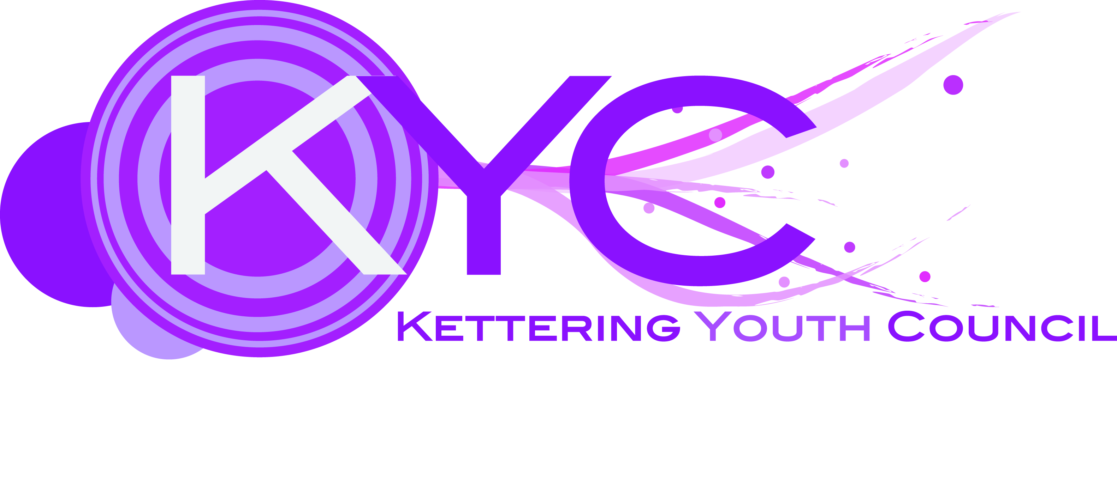
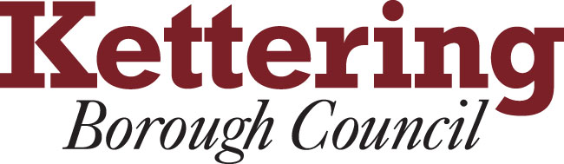

Question 4: How will young people from disadvantage backgrounds benefit from this project?

Question 5. How will your project help young people? Please add “yes” to the appropriate boxes:

My project……. | Yes ?
-will help young people be healthy
-will help young people achieve and enjoy life
-will help young people stay safe
-will contribute towards a young persons financial well being
-will help young people make a positive contribution in their neighbourhood

Question 6. Which local organisations do you think might be able to help to make your project happen?

Question 7. How much funding are you applying for?

Question 8. Please list what the funding will be used for?

Your details
Name: …………………………………………………………………………………………

My address is: …………………………………………………………………………………………..

……………………………………………………………………….………………….

Postcode: …………………………………………………………………………………………

Telephone: ………………………………………………………………….

Mobile: …………………………………………………………………….

Email: ……………………………………………………………………………………….

Thank you for completing this form

Please return your form to:
Kettering Youth Council
c/o Steven Edwards Tel 01536 534170
Community services Officer Fax 01536 410795
Kettering Borough Council eMail stevenedwards@kettering.gov.uk
Bowling Green Road
Kettering Borough Council NN15 7QX

What happens next?

1. Your form will be looked at by the Youth Council on the dates below.

2. We will choose the best and most appropriate ideas. If your idea is chosen we will contact you to find out a bit more about your idea.

3. Once the money has been agreed the youth council and any other organisations you have identified will work to make your idea a reality. Of course if your idea does not make it to the shortlist we will let you know, so please include an email address on this form.

4. When the money has been allocated, evidence of spend must be kept to prove you have spent the money on the agreed outcomes.

